AAAGCD President’s Report Executive Meeting – August 24, 2022
Greetings to our Executive Committee 2022:
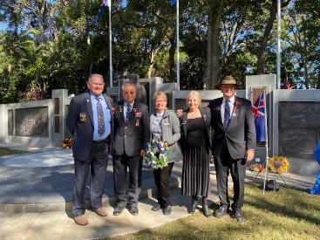
Over the past few weeks, I have, again, been involved in a variety of AAAGCD matters.
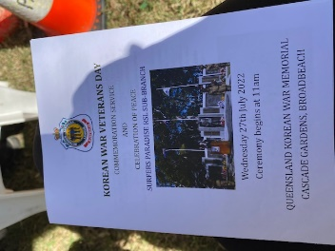
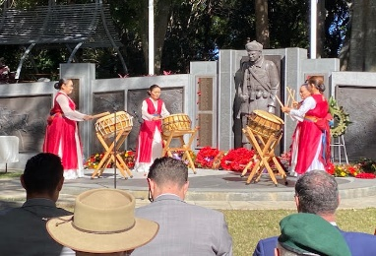
VP Keith Shackley and I represented the AAAGCD and laid a wreath at the Korean War Veteran’s Day Commemorative Service on July 27, 2022 in Cascade Gardens. It was an amazing remembrance service with many in attendance. Along with excellent speeches by Korean Embassy Officials, local Korean representatives, MP’s, and Councilors, we enjoyed the award presentations for many local Korean school representatives and a wonderful musical presentation by a local Korean drum corps. A sumptuous lunch followed, and we were delighted to have a chance to catch up AAA Brisbane President Mike and VP/Sec’y, Teresa Pokoj – and further enhance our close relationship with our Brissie AAA friends.
GOLD COAST VOLUNTEERS AWARDS: There will be a new round of Central Gold Coast Volunteer Awards coming out in the near future – any suggestions for a nominee?
EXPRESSIONS OF INTEREST (EOI) FOR THE 2022/23 VOLUNTEERS GRANT FROM ANGIE BELL
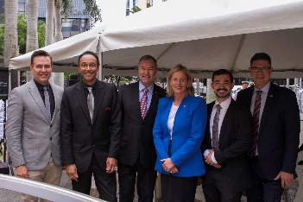
The Volunteers Grant aims to help community organisations support the efforts of Australia’s volunteers, support the inclusion of vulnerable people through volunteering; and encourage, support and increase participation in volunteering.

Grants of between $1,000 and $5,000 are available to eligible not-for-profit community organisations. This funding can be used for activities including:
- The purchase of small equipment
- Transport costs of volunteers with a disability
- Fuel costs incurred by volunteers
- Training for volunteers
- Background screening checks of volunteers
- Promoting awareness of and increasing participation in volunteers and;
- Adapting practices to support volunteers’ safety in the COVID-19 pandemic environment

EOI, please complete the form and return to my office by COB Friday 23 September 2022. Applications required by November 28, 2022. Carole will make this application for tents and sound equipment if agreed to today.

NOTICE OF EXECUTIVE MEETING OF THE FEDERATION OF AUSTRALIAN-AMERICAN ASSOCIATIONS. The meeting will be held at 1300 on Saturday, 10 September 2022, via Zoom. Carole and Keith will attend. Amber may attend as Federal Secretary.
NOTICE OF AAAGCD AGM - Southport Community Centre 6 Lawson Street at 6.00 pm on Wednesday evening, 14th September, 2022. Second Invitation available today. Please note - we require a quorum to enact business at this meeting – spread the word. I will do the inspection and safety training at the Southport Community Centre next w next Wednesday, Aug 31 at 10.30am as required for room use.
New Member Development. In the event of a last-minute cancellation, I rang through to the Gold Coast Show organizers (Contact Fernanda 5504 5587 T-F) requesting a gratis booth based on a last-minute cancellation. She will get back to me this arvo or tomorrow morning if a spot becomes available. Be ready to act quick!

I also rang Helensvale Town Centre regarding the use of their Community Advertisement Booth - and am still waiting to hear back. I also contacted the Pines Shopping Centre Elanora again to find out about our filed a request for a free booth on a weekend sometime in the near future.
THANKSGIVING 2022 - Well, it has been organized! After an excellent experience at Spaghetti and Jazz for Thanksgiving last year, we have rebooked for 2022. I will approach Captain Candy for sponsorship as well as Colin Fruk from American Chamber of Commerce in Canberra. Who else can help with sponsorship/ raffle prizes? Second Question, should we do Octoberfest this year as well?

2022 THANKSGIVING DINNER
INVITATION
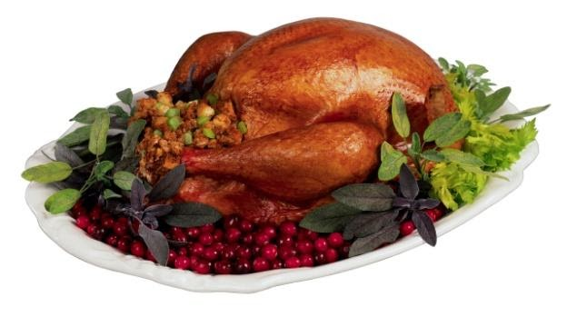
Thursday 24th November 2022
Spaghetti and Jazz Restaurant
30-34 Commerce Drive, Robina Queensland 4226
Time: 6:30 pm for 7:00 pm
TABLES OF 8
(or we will place you/your party on a table)
Live Music by Colin Atkinson and Special Guest

Free drink on arrival, cash bar thereafter.
Traditional whole Turkey/Stuffing/Gravy/Cranberry Sauce/ BJ’s Pumpkin Pie
$65 for members & $75 non-members

I look forward to continuing to work with you all in the next few months to deliver a rewarding and enjoyable program of activities/involvements – all suggestions/assistance encouraged! Goals for September 2022 – Continue to work on FB Page and Website now that Fred has returned – Welcome back Fred!, organize AGM and New Committee members and begin planning for a Christmas Activity? and 2023 Event Schedule.

Respectfully Submitted, Carole Olland Morris - AAAGCD President, 2021-2022

