AAAGCD President’s Report Executive Meeting – July 27, 2022
Greetings to our Executive Committee 2022:
Over the past few weeks, I have, again, been involved in a variety of AAAGCD matters.
We were very pleased with the turnout for our ‘last minute change of venue’ July 4th Celebration Party at our house in early July 2022. Over 25 attended with good conversation, excellent musical performances by Richard Williams and Dan Dan, a very informative talk of the significance of the Fourth of July by member, Stephen Weinstein and some fun Trivia and prizes organized by myself – PLUS the food was plentiful and sumptuous. A very happy 70th birthday for Richard was also acknowledged and celebrated!
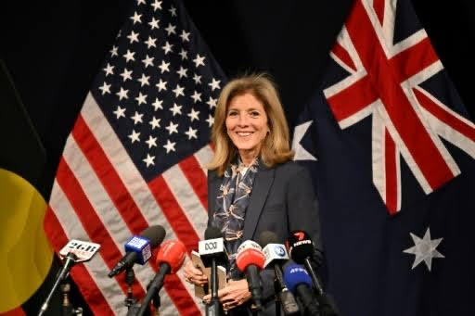
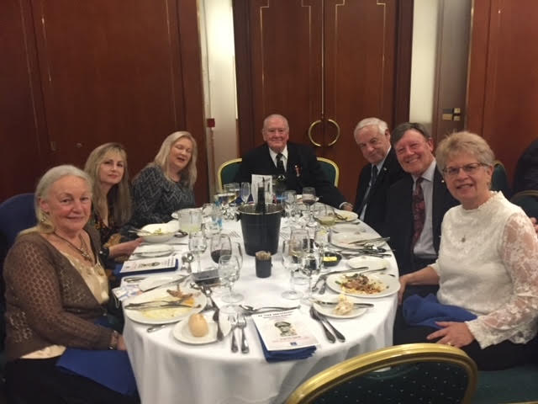
On July 22th, Dr Philip Morris and I represented the AAAGCD at the General McArthur Annual Dinner supporting the General McArthur Museum, Brisbane as it marked the 80th Anniversary since McArthur’s arrival in Brisbane. It was nice to catch up with friends Barry Thiess, Dorothy Carroll, Mike Harris, AAA Brisbane President and Teresa Pokoj, AAA Brisbane Treasurer/Sec’y as well as Narelle and the Ladies of the American Legion and other new friends. I also had the opportunity to meet up with Trevor Moss, Special Agent NCIS (a lovely man from Maryland!) and Colin Fruk, American Chamber of Commerce in Australia and we discussed various ways in which the AAAGCD might formally welcome our new US Ambassador to Australia, Caroline Kennedy. I subsequently contacted Trevor by email the next morning to further discuss this matter (see attached correspondence).
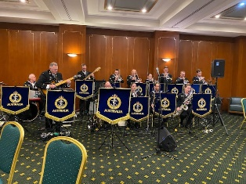
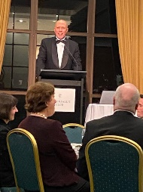
I also had an opportunity to say a brief “hello” to guest speaker, Mr Peter Dutton who gave a remarkable speech. (I will try to get a copy from Barry Thiess for your perusal). Overall, it was a lovely evening with a delicious dinner at the Tattersall’s Club Brisbane and excellent entertainment by the RAN Band – Those folks can play!
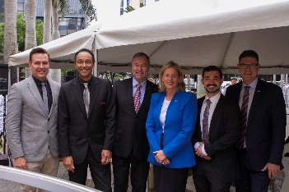
I recently had a bit of time to look through all the BOCS 2022 photos and Alan did an amazing job, as photographer, once again. I thought the photo of our local representatives was so nice that I sent an email to all with a grateful acknowledgement for their attendance and participation. (Email attached)
New Member Development. I have continued to send messages through to the Gold Coast Show organizers (Contact Fernanda 5504 5587 T-F) requesting a gratis booth based on a last minute cancellation. See attached correspondence.
I also rang Helensvale Town Centre after our June meeting and spoke with Sophie Lawson (5630 5110) who was to send me a form to fill out about using their Community Advertisement Booth again - and am still waiting to hear back. I also contacted the Pines Shopping Centre Elanora and filed a request for a free booth on a weekend sometime in the near future.
There will be a new round of Central Gold Coast Volunteer Awards coming out in the near future – any suggestions for a nominee? Goals for August 2022 – Continue to work on FB Page and Website, organize AGM and New Committee members and begin planning for Thanksgiving 2022. Would we want to do a Oktoberfest again as well?
I look forward to continuing to work with you all in the next few months to deliver a rewarding and enjoyable program of activities – all suggestions/assistance encouraged!
Respectfully Submitted, Carole Olland Morris - AAAGCD President, 2021-2022

