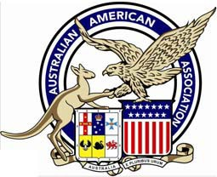

AUSTRALIAN AMERICAN ASSOCIATION
Gold Coast Division
www.australianamericanassociationgoldcoast.com

REMINDER TO KEEP THE DATE!

The President and Management Committee cordially invite you and your friends to attend the annual

THANKSGIVING DINNER

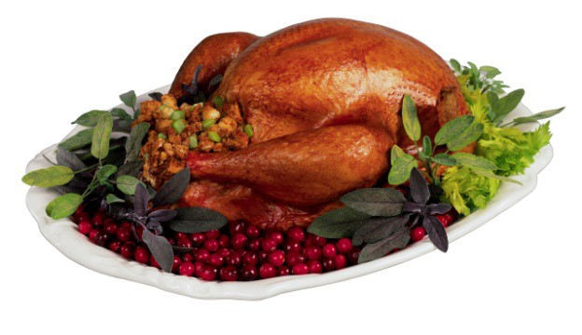
Thursday 28 November 2019
Location to be determined
6:30pm for 7:00pm

Traditional Turkey & Stuffing, Cranberry Sauce, Mashed potato and gravy, along with BillieJo McCann’s Pumpkin Pie

FOR INFORMATION see website: www.australianamericanassociationgoldcoast.com

Billie Jo McCann, Secretary or Faye Brutlag, President
billiejo@sincorp.com - 0416290412 faye_aaa-gcd@live.com.au – 5579 8080

