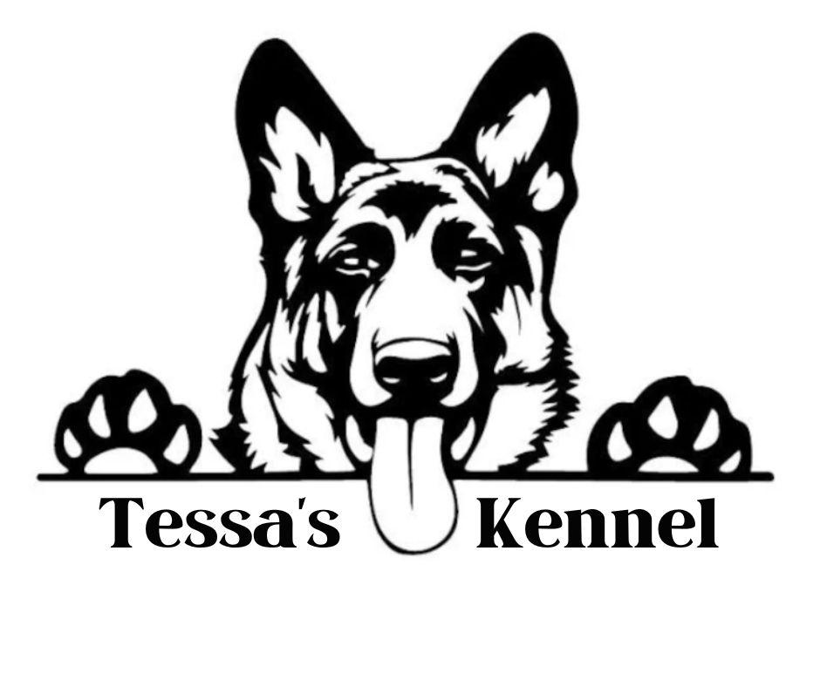

Welcome to the family and congratulations on your new puppy!

I want to make this contract for your puppy or dog to be as simple as possible, yet still binding. From the time your puppy was born I have cared for him/her as if they were mine. They have been in my home and around my farm, which has exposed them to children, adults, other dogs, cats, chickens, ducks, and goats. Since they are raised in my house, or in a house setting, they have also been exposed to normal household noises to hopefully make the transition easier. Early neurological stimulation is key to a well rounded dog.

All puppies NEED to be on puppy food until they are one year old. As the Buyer, this is your responsibility to ensure adequate nutrition for your growing puppy. The brand that you use needs to be high in protein and as natural as you can get. Stay clear of bi-products and fillers since these are not healthy for your puppy/dog. Your puppy has been on Diamond or Diamond Naturals while he/she has been in my care (This is subject to change due to supply)

Your new puppy has been dewormed every two weeks starting at just two weeks old. (so 2,4,6, and 8 weeks old)

He/she also received their first round of vaccines at their 8 week appointment. As the Buyer, it is your responsibility to get your puppy into your vet for all the required puppy visits and then yearly afterwards. Do not have your puppy out in public or around other random dogs until your puppy is fully vaccinated.

As a German Shepherd owner, it is important that you let your new pup get all the hormones he/she needs for proper development. Dogs should never be spayed or neutered before two years of age. By signing this contract you, the buyer/owner, are agreeing to not fix them any sooner so your dogs bones, ligaments, and muscles can grow as they should. As a pet owner, it is your responsibility to take all precautions necessary to prevent tying with any other dog. Breeding your dog is strictly PROHIBITED, unless you have purchased full rights to your puppy. Breeding your dog can, and will, result in a $10,000 fine if breeding is done on purpose. Tessa’s Kennel LLC has full legal rights to the lines from dogs produced by Tessa’s Kennel LLC. All legal fees acquired due to breaching this legal contract will be the sole responsibility of the buyer/new owner.

If you plan on breeding your dog after 2 years of age, then all required health testing and X-rays need completed.

As a Breeder, I will stand behind my dogs for their entire life.
My dogs will NEVER be in a shelter.

As the Buyer, it is your responsibility to your new puppy, and to this contract, to keep him or her safe, loved, and healthy. By signing this contract you, the Buyer, agree to never neglect, abuse, mistreat, or put this puppy in any harm for the duration of his/her life. Adequate shelter, food, fencing, and medical attention is required for the life of this dog. If this is not upheld by you, the Buyer, you will forfeit the puppy/dog and no refund will be given. Any legal fees, court costs, travel expense, transport cost if an outside company is used, and personal time lost, that are acquired due to your neglect and not abiding by this contract, will be your sole responsibility as the Buyer/Owner.

A puppy is a lifelong commitment. Even if you get a new house, a new job, or even a new spouse/partner. IF you, the Buyer, need to rehome this puppy/dog for a legitimate reason, I, the Breeder, MUST be contacted. Rehoming your puppy/dog without I, the Breeders permission, can and will, result in a $10,000 fine.

The puppy is guaranteed to be in good health at the time of sale.
The puppy will be up to date on shots and worming at the time of pick up of the puppy. Again, it is very important that you continue the vaccinations and dewormings. Please do not expose your puppy to other dogs that are not vaccinated until he/she has completed the entire vaccination schedule - around 16-20 weeks old. This includes public location such as stores and parks.

The puppy will have been vet checked, and deemed in good health at the time of sale.
The buyer, at their own expense should have the puppy examined by a Licensed Vet within 72 hours of receiving the puppy. Documentation must be sent to the breeder within ten days in order for the Health Guarantee to be honored.
If within 72 hours, a Licensed Vet finds the puppy to be unhealthy or unfit for sale, the puppy may be returned for another puppy when it comes available, or a full refund may be granted, but buyer/owner must pay for any transportation costs, AND ALL PAPERWORK must be returned with the puppy - provided the puppy has not been injured or neglected. The veterinarian must provide a written statement deeming the puppy “unhealthy for purchase”.

This guarantee does not cover any health issues caused by neglect or injury from the buyer. Buyer also agrees to return the dog and paperwork to Breeder if at any time the dog is neglected or no longer wanted without any refunds! Buyer also will come to take the dog if there is proof, or reason to believe, it has been neglected.

The BREEDER does not guarantee show quality or working ability of the pup.
The BREEDER does not guarantee size, coat, color, undescended testicles, umbilical hernia, Coccidiosis, Giardia, External/Internal parasites.

BREEDER has had the puppy examined by a licensed veterinarian, puppy has been vaccinated for Distemper, Parvovirus, Adenovirus, Hepatitis. BREEDER has provided treatment for Coccidiosis, Giardia and Internal parasites. (A record of these treatments have been supplied to the buyer.) These parasites can be resistant to treatments and/or the stress of going to a new home can cause symptoms to reappear, buyer has been advised to have a fecal check at puppy's first check-up. If necessary your vet will administer additional medication at that time. In addition, BREEDER IS NOT RESPONSIBLE FOR ILLNESS DUE TO BUYER'S NEGLIGENCE!
BREEDER IS NOT RESPONSIBLE FOR ANY VET BILLS AFTER PUPPY HAS LEFT TESSA’S KENNEL LLC.
The breeder can not assume responsibility for this puppy after 72 hours of the sale. It is the responsibility of the buyer to care for the puppy properly and keep it free from harm. Please remember that your puppy must be treated with great care and protected from danger.
The breeder is not responsible for puppies which develop Hypoglycemia after the puppy is in the new owner’s possession.

The breeder gives a one year guarantee against any congenital defects of the puppy. Buyer/owner must give all vet records of the diagnosis and MUST have two veterinarians opinions. If this should occur, then the puppy will be returned to the breeder, and the buyer will receive another puppy of the same breed when there is one available. Transportation fees to return the puppy will be the Breeders responsibility. Transportation of the new replacement puppy will be the buyer/owner responsibility. All breeding dogs are DNA tested to avoid congenital defects as much as possible. This will not cover any cosmetic issues due to skin infection or mites. Only bathe your puppy at most 1 time a month and buy wet wipes in between baths while the puppy is under 12 months.

With any new puppy buyer we also request there be at MINIMUM updated photos of the puppy every 3 months until 1 year old. Then one updated photo per year. All updates must be loaded to the family page so make sure you’re already added in.

The BREEDER neither makes, nor implies, any warranties or guarantees, express or implied, other than those written in the agreement above. This document constitutes the entire agreement between the BREEDER and BUYER with respect to this sale. The BUYER'S signature below indicates that he/she has read, agree's and does understand all the conditions of the SALE'S AGREEMENT and HEALTH GUARANTEE at time of sell.

All puppies MUST be paid in full before leaving Tessa’s Kennel.

Buyers please fill out your contact information below and sign at the bottom.

Buyers Name:

Buyers Phone Number:

Buyers Email:

Today's Date:

Buyer Signature:

