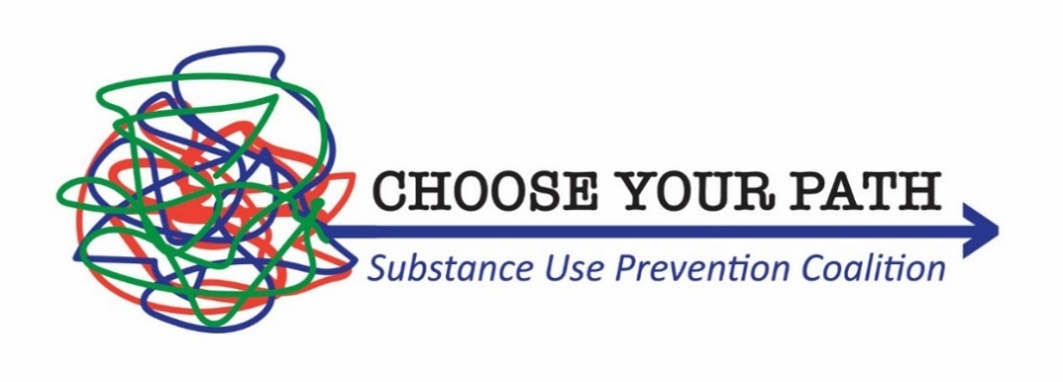

Tuesday September 8, 2026, at 11:30am at the Wauconda Park District Room A/B

Introductions- Welcome
Executive Board Report
- Choose Your Path Coalitions Updates
- Choose Your Path Executive Board – Vacant Positions

Projector Coordinator
- Drug Free Community Grant Overview
- $15,000 Underage drinking grant awarded

Reports – 12 Sectors
- Youth Advisory Board (Megan B.)–
- Parent (Carrie W.) –
- Business (Tracy L.) –
- Media (Maria W.) –
- School (Dr. Brian W. & Dr. Todd L.) –
- Youth-Serving Organizations (Tim S.) –
- Law Enforcement () –
- Religious/Fraternal Organizations (Daniel D.) –
- Civic/Volunteer Groups (Mark K.) –
- Healthcare Professionals (Keeley G.) –
- State/Local/Tribal Government Agencies (Senator Darby H.) –
- Other organizations involved in reducing substance abuse (Danielle R.) –

Adjournment

Reminder the next meeting will be at 11:30am on October 13th at Wauconda Park District.

Notes:

