Sun | Mon | Tue | Wed | Thu | Fri | Sat
2 | 3 | 4 | 5 | 6 | 7 | 8
Colton Baker  & Ariana Toby |  |  | Kamron Melton |  | Emilie Tritschler
9 | 10 | 11 | 12 | 13 | 14 | 15
 | 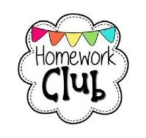  Boys & Girls 8th Grade Night  Returns!  Lkjf;lasdjf;lkaasdfasdfasdfjsdf | Program Begins | Meeting After School |  | Report Cards  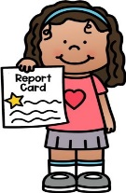 | Alicia Male  Aiden Garcia  &  Leilah Harris
16 | 17 | 18 | 19 | 20 | 21 | 22
 | NO SCHOOL  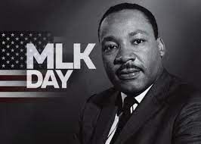 | Board of Ed  Meeting  6pm |  | Marley Trail |  | Milo Stroehlein
23 | 24 | 25 | 26 | 27 | 28 | 29
 |  |  |  |  | 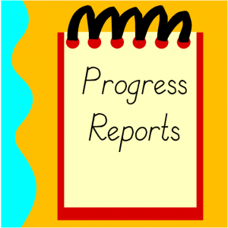
30 | 31

