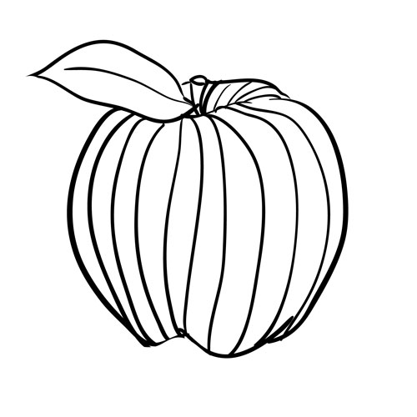

\*\*\* - the thickness or thinness of a line.

\*\*\* - Lines that change direction gradually

\*\*\* - lines made from a combination of diagonal lines

\*\*\* - lines that slant

\*\*\* lines follow the contours of the object.

**\*\*\* of Art :**

**\*\*\***

made by \*\*\*

By Author

\*\*\* - lines that move up and down without any slant

\*\*\* - lines that are parallel to the horizon

