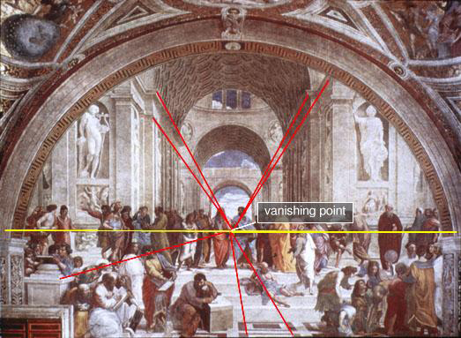

***\*\*\****  – A regular repletion of the elements of art to create a sense of rhythm and/or movement

***\*\*\****-

***

***

***

***\*\*\**** – How the elements work together, fit together, so the artwork looks complete

***\*\*\**** – An assortment of lines, shapes, colors and other elements of art in the artwork

***\*\*\**** – How parts fit together to make a whole – Size relation and scales

The **School** **of Athens** (1509-11) By Raphael

**\*\*\* of Art**

- describe the ways that artist use the elements of art in creating a work of art

made by ***

By Author

***\*\*\**** – Repetition of the elements of art

***\*\*\**** – Main idea What “grabs” your attention

