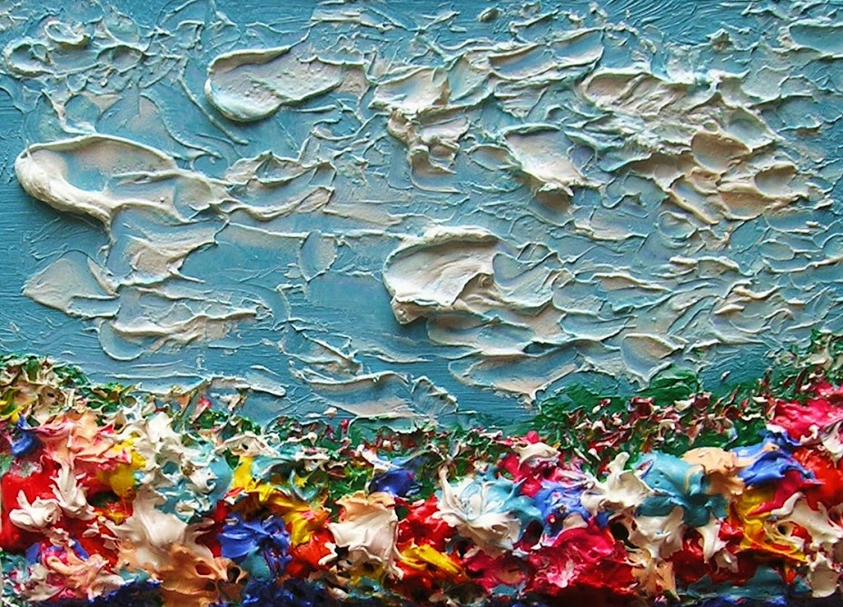

**\*\*\* textures** - reflect light evenly

**\*\*\* textures** - reflect light unevenly

**\*\*\*** - 2-D patterns created by the repetition of lines of shapes

**\*\*\*** - a painting technique in which the paint is built up on the surface to create a texture.

**\*\*\* of Art: \*\*\***

**\*\*\* Texture**

By \*\*\*

Texture refers to the way an object \*\*\* to the touch or \*\*\* as it may feel if it were touched.

**\*\*\* texture** - the illusion of a 3-D surface Simulated- imitate real textures

