Thank you for reading this excerpt from my book. May the Lord bless you. You can purchase the full book at Amazon. George C. Duke



MENU
3 Foreword 8 Origination of Conspiracy
14 Conspiracy, Conspiracy, Conspiracy
22 United Nations Building
25 The first Conspiracy made on Mankind
38 Satan’s Triumph against Mankind
43 The Nephilim Conspiracy
56 Was Adam and Eve White
62 Satan’s Conspiracy against Job
67 The Conspiracy against the Son of God
90 Did Jesus conspire with Judas
96 Satan’s war with the Son of God
99 Satan conspires to use Religion
106 The Conspiracy of the Antechrist
116 The Awakening of the Reformation
122 Rise and fall of Christianity in Great Britain
130 The Rise and fall of Christianity in the USA 135 Satan’s New Conspiracy
153 The Muslim Conspiracy?
163 Conspiracy against the President
176 The plot 183-The Missionary Conspiracy 192 The Cop Conspiracies
201-210 Various Conspiracy Theories
211 There are 3 People in the Godhead
215 Bible Study on the Godhead
234 Alien Conspiracy & Final Warning
247 Satan’s Final Conspiracy & My Prophecy

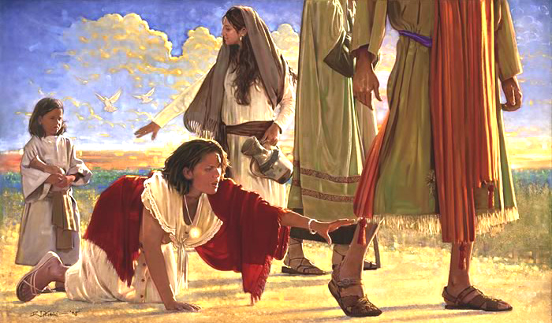

FOREWORD

How many times in your life have you been physically, mentally, or spiritually hurt by others? The hurt could have been caused by an enemy which is understandable but many times it can be caused by our friends, relatives, fellow employees, a boss, Officials in high places, Politicians, Ministers, or even by fellow church members. As you think about being hurt by others how many times have you hurt someone? It is factual for me to point out that from the day of our birth until the day that we die we will be hurt or we will hurt others. It is for that reason that Jesus Christ taught us to forgive. But we have to admit that it is sometimes very difficult to forgive those that have despitefully used us. Also we find it easier to forgive the enemy that has hurt us rather than to forgive the ones we love. All through one’s life there will be those that hurt. It is a part of life. There also will be those that conspire against us as well as there will be times we will conspire against others. Why is it that we face these situations? There is a power that uses our mind to tempt us in order to create havoc. It is my desire to expose the one that places the schemes, temptations, or the conspiracies in our mind, but we need to realize that we are responsible for the final actions that we allow to occur. The enemy only succeeds if we obey his suggestion. Since we are living in the age of Conspiracy, our minds are subject to either think or devise schemes that involve us or others. Think about this.

A man was sitting in his office one day when a thought entered into his mind. Instantly he began to dwell upon it and then realized this is not a thought that I would normally think of because it is so inappropriate. Why would I think this way?

The fact is we all have thoughts that come into our mind that cause us to later wonder, “Why did I think that way? Am I out of my mind?” I remember a young evangelist that preached really hard against sin and the temptations of the flesh.



One day he was riding in the car with a Pastor that had a very strict standard. As they drove along, they passed a young pretty girl that was walking down the street in tight shorts. As they passed her the young minister kept looking at her saying, “look at that, look at that, look at that”, then turning to look some more he noted the Pastor looking at him and said, “Look at that it’s a abomination before God.” Maybe you should stop looking at her the Pastor told him. The Pastor had noticed that this young man had been drawn in by his own desires of the flesh and had obeyed the voice that had spoken to him. Yes we do have thoughts that suddenly arise in our mind and even sometimes a voice that speaks to us. It could be something that if we responded to, it could cause us to perform an act that later we might regret. Daily we find that we have to resist suggestive thoughts and ideas that enter into the train of thought. Many times, they are directing us to do an evil deed or to lust. Then it happens we follow through on the suggestion. We allow the lust of the eye, the lust of the flesh or pride to take over and we find ourselves obeying the carnal side of self. From the birth of man till his death he struggles with right and wrong. Because we are born in sin and shaped in iniquity there is a continual warfare that we endure. We might want to blame God for this but it was not God that created us this way. When he created Adam and Eve, he created them free from sin. But he also allowed them to freely choose to obey or not to obey. They only had one choice to make.

God did not desire for man to fall from grace or to fail him, but when he did, he gave him a small still voice that would bring conviction. But because men and women love their sinful ways, they would destroy that Godly voice in the early stages of their life. A good example of being born in sin is, “how a child learns to lie!” The parent does not sit a child down and tell them how to tell a lie, they automatically learn. If you tell a child not to touch something and you walk into the room and he has disobeyed you, when you look at him and ask, “Did you do that?” Normally he will say, No.” I remember an old illustration that showed an Angel on one shoulder and Satan on the other one whispering to the person. The one represented the right way and the other the wrong way. It was in the beginning of time when the first conspiracy was formed that would eventually shape the lives of everyone that would be born of woman. It is because of the conspirator and the recognition of our own weaknesses that we must force ourselves to forgive those that come against us, If we fail to forgive then it is impossible for us to be forgiven. Keep reminding yourself that you are not perfect and that there is one that attempts to control everyone that is born of man. Do not allow yourself to be caught up in the treachery that he uses to bring you down. Do not ever believe what you hear from Friends, Relatives, Politicians, Church members, even ministers unless you get the other side of the story. I would like to share with you the birth and also some of the ancient conspiracies as well as recent ones. This book could not hold all of the conspiracies that have occurred. Remember we are required to forgive. So let us find out who the conspirator is that speaks to us. Look out he might be speaking to you right now.

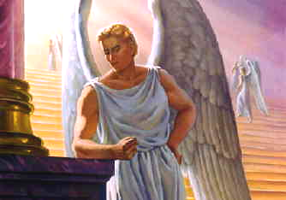

The Origination of Conspiracy

Let me begin by introducing you to the first conspirator. His name is Lucifer. The story of Lucifer involves the head archangel who wanted ultimate power for himself, rebelled against God, and therefore was cast out of heaven. It has been stated he was the chief Musician in God’s heavenly choir. There are those that also say that this is the reason why so many songs are sensual and are used to stimulate mankind in the ways of sin that are not of God.
Lucifer is typically depicted with horns and a demonic expression, sometimes standing in a fiery hell and carrying a pitchfork. Prior to his fall from heaven, he often appears angelic with a bright face. Some refer to him as a bright and morning star. If he was the bright morning star then apparently, he was also a handsome Angelic being that appealed to the other Angels because of his beauty, cleverness, agility and ability to lead. Apparently, it was because of his charm and cunning ways that he was able to turn many of the Angelic host against their creator the great IAM. I would like to ask you if you think that anyone could ever be more powerful than the one that created them. Did Lucifer really believe that he could become more powerful than God? Is it possible that one so wise and cunning could have been so deceived by himself? As we study the word of God in the beginning, we discover that Satan did fail in his rebellion against God the creator of heaven and earth. Also after being cast down to Earth he continued in this rebellion. God had seen what Lucifer had done in his conspiracy of deceiving Eve. With his victory over Adam and Eve, Satan was able to claim the rights of Adam that God had given to him. That was the right to oversee this world. Lucifer now had assumed that right. During the time that he would have dominion, he would be called the god of this world. So, when one makes the statement, “Oh I serve God!” They are telling the truth whether they realize it or not. Either they are serving the god of this world or they are serving the God that created this world. For those that say that they do not believe in God, I can assure them that there is a god they serve that does not require them to have faith in him. Since Lucifer was now in control, he would be able to tempt and use mankind in various ways to create turmoil. Man would have to call on God to receive God’s help when he needed him. Is God in control? The answer is yes. But the god of this world is until man asks for the creator to intervene or when God decides to override him.
Satan and his demons main desire is to keep man from serving the great I Am and to keep him in sin so that his final destiny is eternal death. Satan knows how much God loved man and his desire for him to serve him. The one restriction that God placed upon Satan was that he could not force man to sin but he could tempt him and even plant thoughts into his mind and/or the mind of others in order for man to choose between right and wrong. Satan also has the power to possess those that allow him to. Remember Satan does not rest night or day in his warfare against God and Man. There is only one way that man can totally defeat him and that is by being born again. When one is born again, he can truthfully say “Greater is he that is in me than he that is in the world.” When one is fully born again according to God’s way found in Acts chapter two and verse thirty eight he becomes a son of God. The bible states that, “as many as received him to them he gave the power to become sons of God. That power is in receiving God’s Spirit which we receive through faith, true repentance, and the new birth. Mark 16:17 says, and these signs shall follow them that believe; in my name they shall cast out devils; they shall speak with new tongues. Satan can not possess one filled with God’s Spirit. This is the reason that Satan does not mind you being religious but he does not want you to be born again. He knows that as a son of God he has given you his Spirit to use for: casting out devils, healing, miracles, and deliverance for self and also for others. You have the power so use it for the glory of God because if you fail to utilize that power especially in your own life Satan is sure to overcome you. When I first was born again, I did not understand this power of demon possession until one night a young man came to the altar that was possessed with a demon spirit. Lacking faith, I failed that night but after fasting and praying we were able to cast the Spirit out of him.


I remember him falling on the floor and as the evil spirit came out, he foamed at the mouth. All of a sudden, he rose up lifted his hands and began to speak in tongues as the Spirit of God gave the utterance. Over the years I had to use the power that is in the name of Jesus to cast out spirits especially when I was a Missionary to the British Isles. I remember one night in High Wycombe England while ministering in the service in the Guild Hall a young girl came to the altar and began to shake and scream. When I realized it was an evil spirit, I realized that we had many people in the service that night that were not filled with the Holy Spirit. I began to seek what I should do and God enlightened me to bind the spirit in her. The reason that a spirit should not be cast out of a person in a group where there are some unfilled with the Spirit of God is because when a evil spirit is cast out, it looks for another vessel to enter. Those that are not filled with Gods Spirit are open and need to be protected. Before I left that night, I asked Billy Graham to make sure to pray for deliverance for this young lady. Many years later I found out that she committed suicide. That is what Satan desires for each of us because he would love for us to leave this world as a unrepented sinner. Evil spirits desire a body to possess and you must make sure you do not play around with spirits which inhabit witches, soothsayers, and those that have turned themselves over to the devil. Lucifer has his army going to and fro looking for those they can devour.
Lucifer means "light bearer." While many believe that Lucifer has brought evil into the world and seek spiritual protection from him, others invoke Lucifer's power in order to gain spiritual strength. Lucifer is also found in many religions, including Christianity, the Bahai Faith, Judaism and Islam, and is generally considered to be a personification of evil. It was in the beginning that he gave birth to the first conspiracy.

