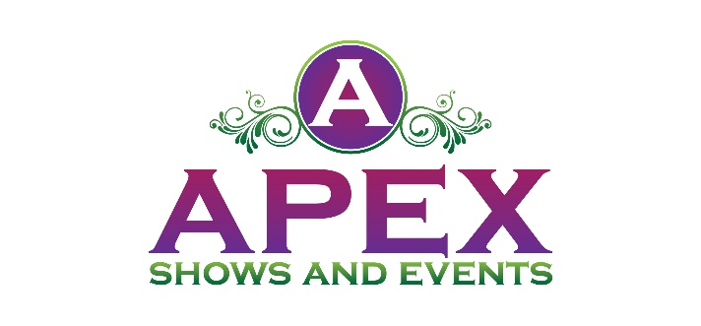
Sponsorship
2025 WAUKESHA COUNTY SPLASH FEST
WAUKESHA COUNTY EXPO
August 2nd from 10 a.m. - 7 p.m.

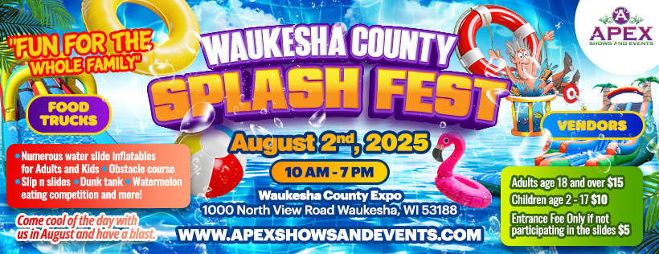

Waukesha County Splash Fest
Come and join us at the Waukesha County Splash Fest, a vibrant and exciting festival located at Waukesha County Expo. This festival promises a day filled with inflatable water slides for kids and adults, vendors with fun, laughter, and great memories.

What to Expect
Come cool off for the day with us in August for the Waukesha County Splash Fest. Numerous water slide bounce houses, water obstacle courses, slip n slides, dunk tank, and watermelon eating contest. Dive into a world of water slides, indulge in local cuisine, or simply relax and enjoy the atmosphere. "Fun for the Whole Family"

Location
Set in Waukesha County Expo. It's the perfect setting for our Splash Fest, a place where water, sky, and fun come together.

Benefits of Being a Sponsor

Your brand will be in front of a large crowd of kids and families.
Sponsorship Opportunities

PLATINUM PACKAGE
$1500.00

The Platinum Package is our top level of Sponsorship. This is available to eight Sponsors. This package includes the following:
- Sponsor logo will be on the entrance banner at the event
- Sponsor logo will be included in print media and social media marketing
- Logo will appear on Apex Shows and Events website
- 4 individual social media posts one month before event
- Sponsor name recognition on 30 second event radio commercial with 2 local stations a week before the event.
- Sponsor name on vendor maps
- 12x12 Vendor Booth Space if needed. (Sponsor to provide tent)

GOLD PACKAGE
$750.00
The Gold Package is our premier level of Sponsorship. This package includes the following:
- Sponsor logo will be on the entrance banner at the event
- Sponsor logo will be included in print media and social media marketing
- Logo will appear on Apex Shows and Events website
- 2 individual social media posts two weeks before event
- Sponsor name on vendor maps
- 12x12 Vendor Booth Space if needed.

SILVER PACKAGE
$300.00

The Silver Package is our entry level of Sponsorship plans. This package includes the
following:
- Sponsor logo will be included in print media and social media marketing
- Logo will appear on Apex Shows and Events website
- 1 individual social media post one week before event

- LEVEL I: Platinum Package
- LEVEL II: Gold Package
- LEVEL III: Silver Package

Please accept my payment of $ ________ by: Check ____ Money Order ____
If you pay by credit card a 3% service fee will be added.

Signature _____________________________________
Today’s date___________________________________
Company Name ________________________________
Contact Name _____________________________________
Address________________________________________________________________
City / State / Zip Code ________________________________________________________________
Telephone ___________________________
Email Address ___________________________________

www.apexshowsandevents.com
Apex Shows and Events LLC
5220 Medina Road
Pensacola Florida 32507
• 850-376-9350
christie@apexshowsandevents.com

