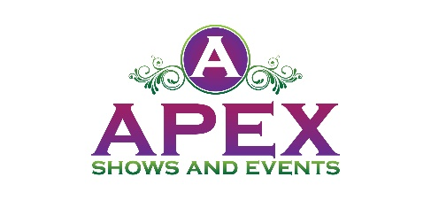
Sponsorship
Space Coast Tribute Fest 2022
Cocoa Riverfront Park, Cocoa, Florida
April 16th from 11 a.m. – 10:30 p.m.
April 17th from 11 a.m. – 8:30 p.m.

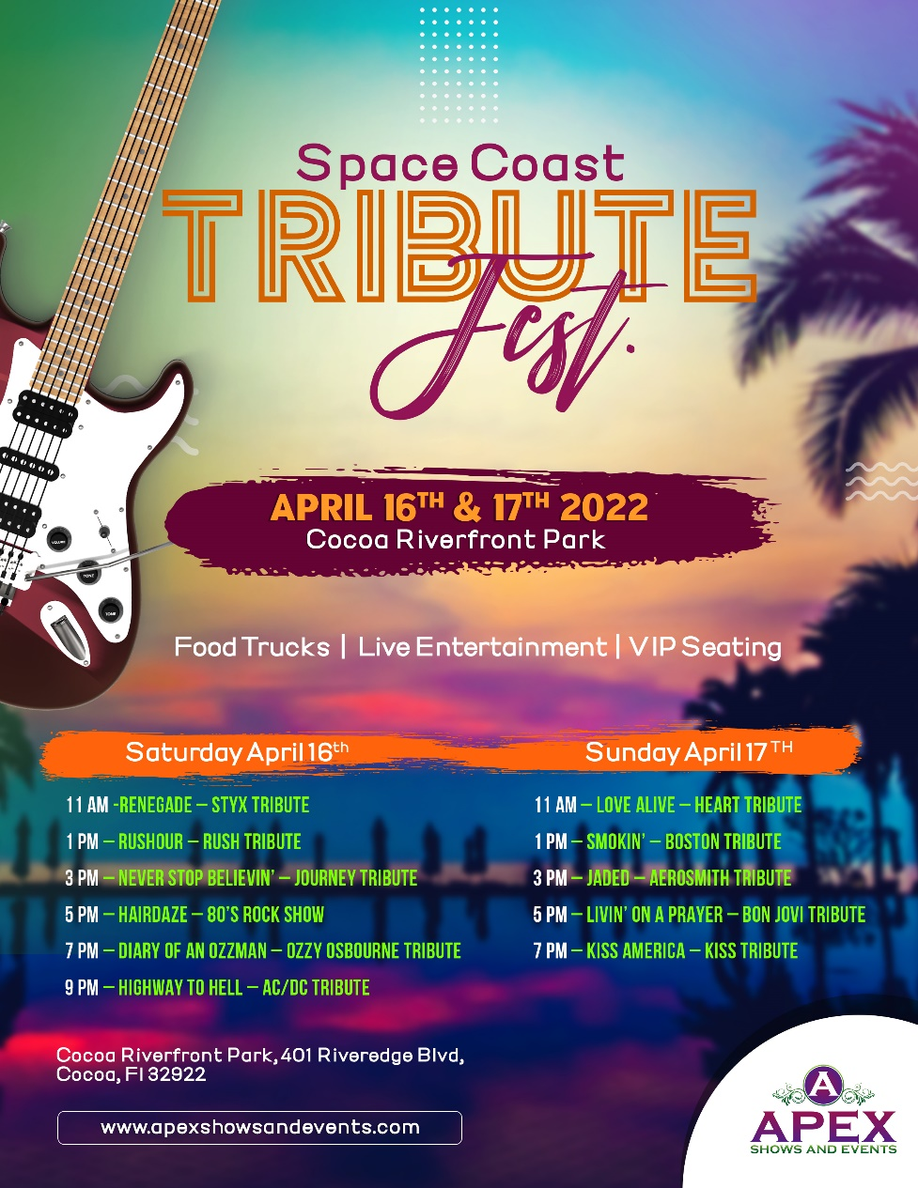
Your support is so greatly appreciated. Thank you for your interest in being a sponsor for our Space Coast Tribute Fest at Cocoa Riverfront Park. We will have 11 awesome tribute bands coming to Cocoa over two days.

We are beginning to offer limited sponsorship opportunities for companies we think would be a good fit for our audience.

We are happy to customize an advertising / sponsorship package that puts your name and your brand in front of the thousands who will migrate to Cocoa Riverfront Park to attend Space Coast Tribute Fest. Packages can be designed to meet every budget with prices ranging from $1000 to $10,000 and tailored to help you reach specific segments within your clientele.
​
Our company, Apex Shows and Events is an event management company that handles numerous events locally as well as Nationally.

Advertising and promotional opportunities include high quality banners for stage and entrance, radio coverage, TV, social media advertising with mentions, and much more. We really have something for every advertising budget!

Benefits of Being a Sponsor

Your brand will be in front of a large crowd of music fans.
Sponsorship Opportunities

PLATINUM PACKAGE
$10,000.00

The Platinum Package is our top level of Sponsorship. There will only be 6 sponsors in this category. This package includes the following:

- Sponsor logo will be on television commercials and mentioned on radio commercials.
- Sponsor logo will be on the stage banner.
- Sponsor logo will be on fencing barricade banners surrounding the event.
- Sponsor logo on VIP only laminate for VIP ticket holders.
- Sponsor name recognition on 30 second event radio commercial with 3 local stations a week and a half before the event.
- Sponsor logo will be on the entrance banner at the event.
- Sponsor logo on back of Space Coast Tribute Fest T-Shirt.
- Sponsor logo will be included in print media and social media marketing.
- Logo will appear on Apex Shows and Events website
- 4 individual social media posts one month before event.
- 8 VIP admission music fest passes to the event.
- 12x12 Vendor Booth Space if needed.

GOLD PACKAGE
$4500.00
The Gold Package is our premier level of Sponsorship. There will only be 10 sponsors in this category. This package includes the following:
- Sponsor logo will be on the entrance banner at the event.
- Sponsor logo on back of Space Coast Tribute Fests T-Shirt.
- Sponsor logo will be included in print media and social media marketing.
- Logo will appear on Apex Shows and Events website.
- 2 individual social media posts two weeks before event.
- 6 VIP admission music fest passes to the event.
- 12x12 Vendor Booth Space if needed.

SILVER PACKAGE
$1000.00

The Silver Package is our entry level of Sponsorship plans. This package includes the
following:
- Sponsor logo will be included in print media and social media marketing.
- Sponsor logo on back of the Space Coast Tribute Fests T-Shirt.
- Logo will appear on Apex Shows and Events website.
- 1 individual social media post one week before event.
- 4 General admission music fest passes to the event.
- 12x12 Vendor Booth Space if needed.

- LEVEL I: Platinum Package
- LEVEL II: Gold Package
- LEVEL III: Silver Package

Please accept my payment of $ ________ by: Check ____ Money Order ____ Credit Card_____

Signature _____________________________________
Today’s date___________________________________
Company Name ________________________________
Contact Name _____________________________________
Address________________________________________________________________
City / State / Zip Code ________________________________________________________________
Telephone ___________________________
Email Address ___________________________________

COMPLETE AND RETURN TO: Apex Shows and Events
Make checks payable to Apex Shows and Events– 5220 Medina Road Pensacola, Florida 32507
www.apexshowsandevents.com
Christie Sachse, Event Promotor • 850-376-9370
Christie@apexshowsandevents.com

