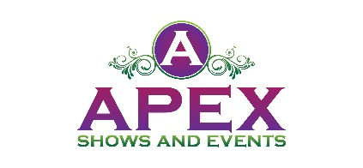
Sponsorship
COUNTRY WAVE FEST
Casino Beach
20 Casino Beach Blvd. Pensacola, FL 32561
Saturday October 22nd, 2022, from 11 a.m. – 10:30 p.m.
Come join the GREATEST PARTY OF THE YEAR and join us for the 1st annual Country Wave Fest at Casino Beach, Pensacola Florida. We will have live local hot Country bands playing all day at the pavilion, food trucks, vendors, as well as raffles and much more!
Number Juan Tequila will be there selling the comedian Ron White’s famous Tatorade Margarita drink and having raffles at their booth. We will be raffling off stand up autographed cardboard cutouts of Ron White, and a few of his Number Juan Tequila bottles as well. The Number Juan Tour Bus will be parked at the event.
The Honky Tonk Splash Plunge will be from 2:30 – 3:30. Make a splash to improve the lives of companion animals in our community. Portion of proceeds benefits the Pensacola Humane Society.
Sponsorship deadline is August 1st 2022.

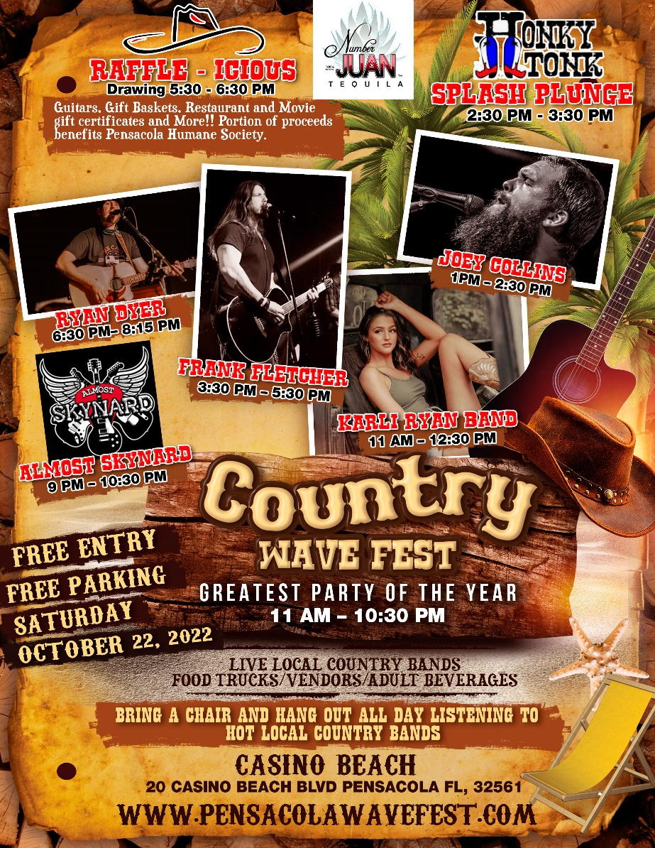

Benefits of Being a Sponsor

Your brand will be in front of a large crowd of families and country music lovers!
Sponsorship Opportunities

NUMBER JUAN PACKAGE
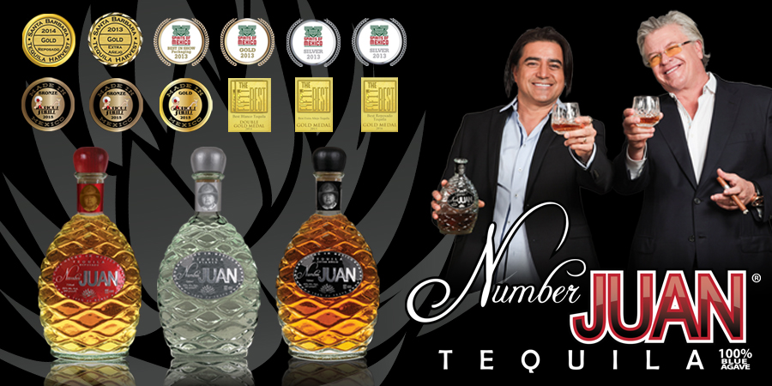
$5,000.00

The Number Juan Package is our top level of Sponsorship. There will only be 6 sponsors in this category. This package includes the following:

- Sponsor name will be mentioned together with Ron White’s Number Juan Tequila on Cat Country radio commercials a week and a half before the event.
- Sponsor logo will be included on local billboards advertising event.
- Sponsor will be mentioned on television commercials on WEAR TV.
- Sponsor logo will be on the stage banner. Wave Fest provides banner.
- Sponsor logo will be on fencing barricade banners surrounding the food trucks. Sponsor can supply own banner or ours.
- Sponsor logo will be on the entrance banner at the event.
- Sponsor logo will be included in print media and social media marketing.
- Logo will appear on Wave Fests website
- Sponsor logo on raffle booth table.
- Sponsor name on vendor maps.
- 6 individual social media posts one month before event.
- 12x12 Vendor Booth Space if needed.

PLATINUM PACKAGE
$2000.00
The Gold Package is our premier level of Sponsorship. There will only be 10 sponsors in this category. This package includes the following:
- Sponsor logo will be on fencing barricade banners surrounding the food trucks. Sponsor can supply own banner or ours.
- Sponsor logo will be on the entrance banner at the event.
- Sponsor logo will be included in print media and social media marketing.
- Sponsor logo will appear on Wave Fests website.
- Sponsor logo on raffle booth table.
- Sponsor name on vendor maps.
- 4 individual social media posts two weeks before event.
- 12x12 Vendor Booth Space if needed.

GOLD PACKAGE
$1000.00
The Gold Package is our premier level of Sponsorship. There will only be 10 sponsors in this category. This package includes the following:
- Sponsor logo will be on the entrance banner at the event.
- Sponsor logo will be included in print media and social media marketing.
- Sponsor logo will appear on Wave Fests website.
- Sponsor name on raffle booth table.
- Sponsor name on vendor maps.
- 2 individual social media posts two weeks before event.
- 12x12 Vendor Booth Space if needed.

SILVER PACKAGE
$500.00

The Silver Package is our entry level of Sponsorship plans. This package includes the
following:
- Sponsor logo will be included in print media and social media marketing.
- Sponsor logo will appear on Wave Fests website.
- Sponsor name on raffle booth table.
- Sponsor name on vendor maps.
- 1 individual social media post one week before event.

- Number Juan Package
- Platinum Package
- Gold Package
- Silver Package

Please accept my payment of $ ________ by: Check ____ Money Order ____

Signature _____________________________________
Today’s date___________________________________
Company Name ________________________________
Contact Name _____________________________________
Address________________________________________________________________
City / State / Zip Code ________________________________________________________________
Telephone ___________________________
Email Address ___________________________________

COMPLETE AND RETURN TO: Apex Shows and Events
5220 Medina Road Pensacola , Florida 32507
www.wavefest.com
christie@apexshowsandevents.com
850-376-9350

