
Sponsorship
Navarre Fall Market
Navarre Park
November 7th, 2026, from 10 a.m. - 5 p.m.

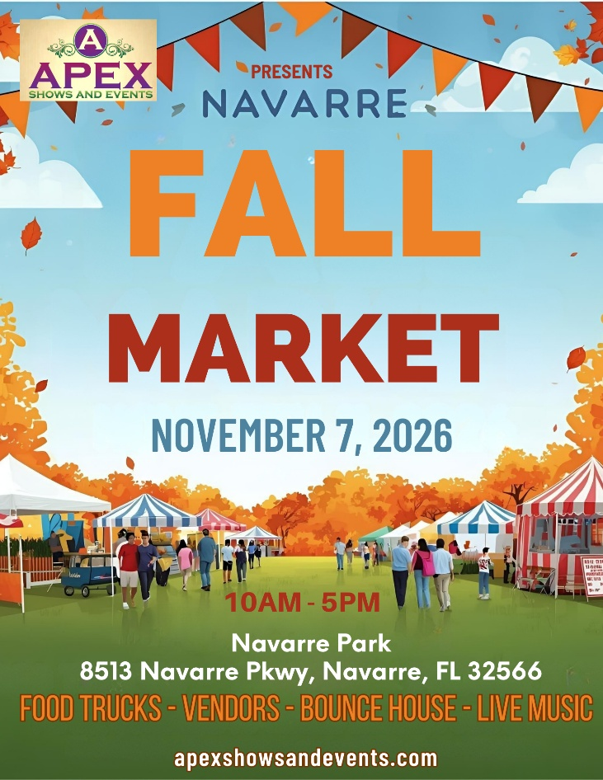
We will have vendors exhibiting and selling gifts, crafts, jewelry, personal care products and much more! The event will take place at Navarre Park. This is a family-friendly event.
There will be Food Trucks, Vendors, Live Entertainment, and a bounce house for the kids.

Benefits of Being a Sponsor

Your brand will be in front of a large crowd of kids and families.
Sponsorship Opportunities

PLATINUM PACKAGE
$1500.00

The Platinum Package is our top level of Sponsorship. This is available to eight Sponsors. This package includes the following:
- Sponsor logo will be on the entrance banner at the event
- Sponsor logo will be included in print media and social media marketing
- Logo will appear on Apex Shows and Events website
- 4 individual social media posts one month before event
- Sponsor name recognition on 30 second event radio commercial with 2 local stations a week before the event.
- Sponsor name on vendor maps
- 12x12 Vendor Booth Space (Sponsor to provide tent)

GOLD PACKAGE
$750.00
The Gold Package is our premier level of Sponsorship. This is available to five Sponsors. This package includes the following:
- Sponsor logo will be on the entrance banner at the event
- Sponsor logo will be included in print media and social media marketing
- Logo will appear on Apex Shows and Events website
- 2 individual social media posts two weeks before event
- Sponsor name on vendor maps
- 12x12 Vendor Booth Space

SILVER PACKAGE
$300.00

The Silver Package is our entry level of Sponsorship plans. This package includes the
following:
- Sponsor logo will be included in print media and social media marketing
- Logo will appear on Apex Shows and Events website
- 1 individual social media post one week before event

- LEVEL I: Platinum Package
- LEVEL II: Gold Package
- LEVEL III: Silver Package

Please accept my payment of $ ________ by: Check ____ Money Order ____

Signature _____________________________________
Today’s date___________________________________
Company Name ________________________________
Contact Name _____________________________________
Address________________________________________________________________
City / State / Zip Code ________________________________________________________________
Telephone ___________________________
Email Address ___________________________________

www.apexshowsandevents.com
• 850-376-9350
christie@apexshowsandevents.com

