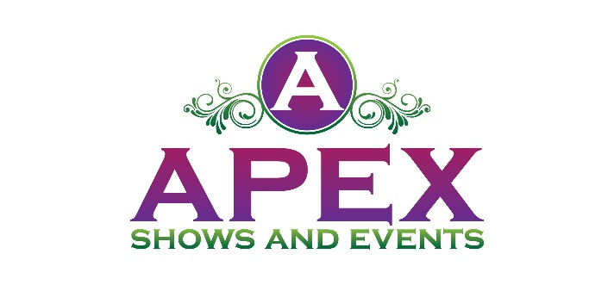
Sponsorship
Spring Navarre Market
Navarre Park
March 7th, 2026, from 10 a.m. - 5 p.m.

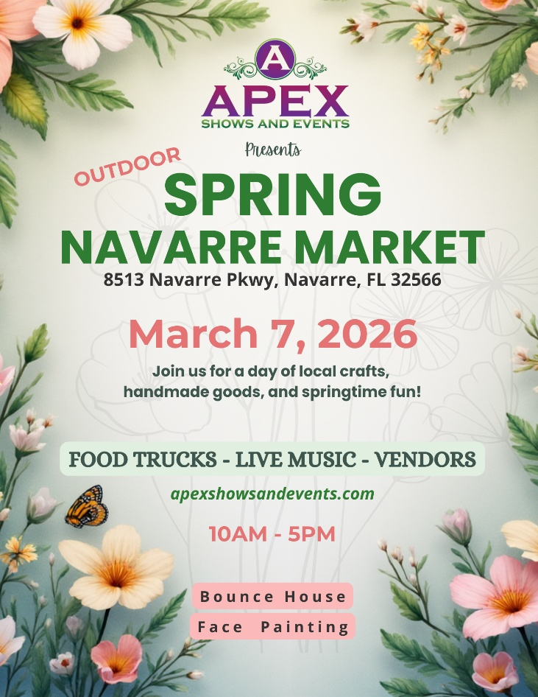
Tempt your taste buds and come hungry at this year’s Spring Navarre’s Market. The fest will feature a number of the city’s finest food trucks! We also will have vendors exhibiting and selling gifts, crafts, jewelry, personal care products and much more! The event will take place at Navarre Park. This is a family-friendly event.
There will be Food Trucks, Vendors, Live Entertainment, and a bounce house for the kids.

Benefits of Being a Sponsor

Your brand will be in front of a large crowd of kids and families.
Sponsorship Opportunities

PLATINUM PACKAGE
$1500.00

The Platinum Package is our top level of Sponsorship. This is available to eight Sponsors. This package includes the following:
- Sponsor logo will be on the entrance banner at the event
- Sponsor logo will be included in print media and social media marketing
- Logo will appear on Apex Shows and Events website
- 4 individual social media posts one month before event
- Sponsor name recognition on 30 second event radio commercial with 2 local stations a week before the event.
- Sponsor name on vendor maps
- 12x12 Vendor Booth Space (Sponsor to provide tent)

GOLD PACKAGE
$750.00
The Gold Package is our premier level of Sponsorship. This is available to five Sponsors. This package includes the following:
- Sponsor logo will be on the entrance banner at the event
- Sponsor logo will be included in print media and social media marketing
- Logo will appear on Apex Shows and Events website
- 2 individual social media posts two weeks before event
- Sponsor name on vendor maps
- 12x12 Vendor Booth Space

SILVER PACKAGE
$300.00

The Silver Package is our entry level of Sponsorship plans. This package includes the
following:
- Sponsor logo will be included in print media and social media marketing
- Logo will appear on Apex Shows and Events website
- 1 individual social media post one week before event

- LEVEL I: Platinum Package
- LEVEL II: Gold Package
- LEVEL III: Silver Package

Please accept my payment of $ ________ by: Check ____ Money Order ____

Signature _____________________________________
Today’s date___________________________________
Company Name ________________________________
Contact Name _____________________________________
Address________________________________________________________________
City / State / Zip Code ________________________________________________________________
Telephone ___________________________
Email Address ___________________________________

www.apexshowsandevents.com
• 850-376-9350
christie@apexshowsandevents.com

