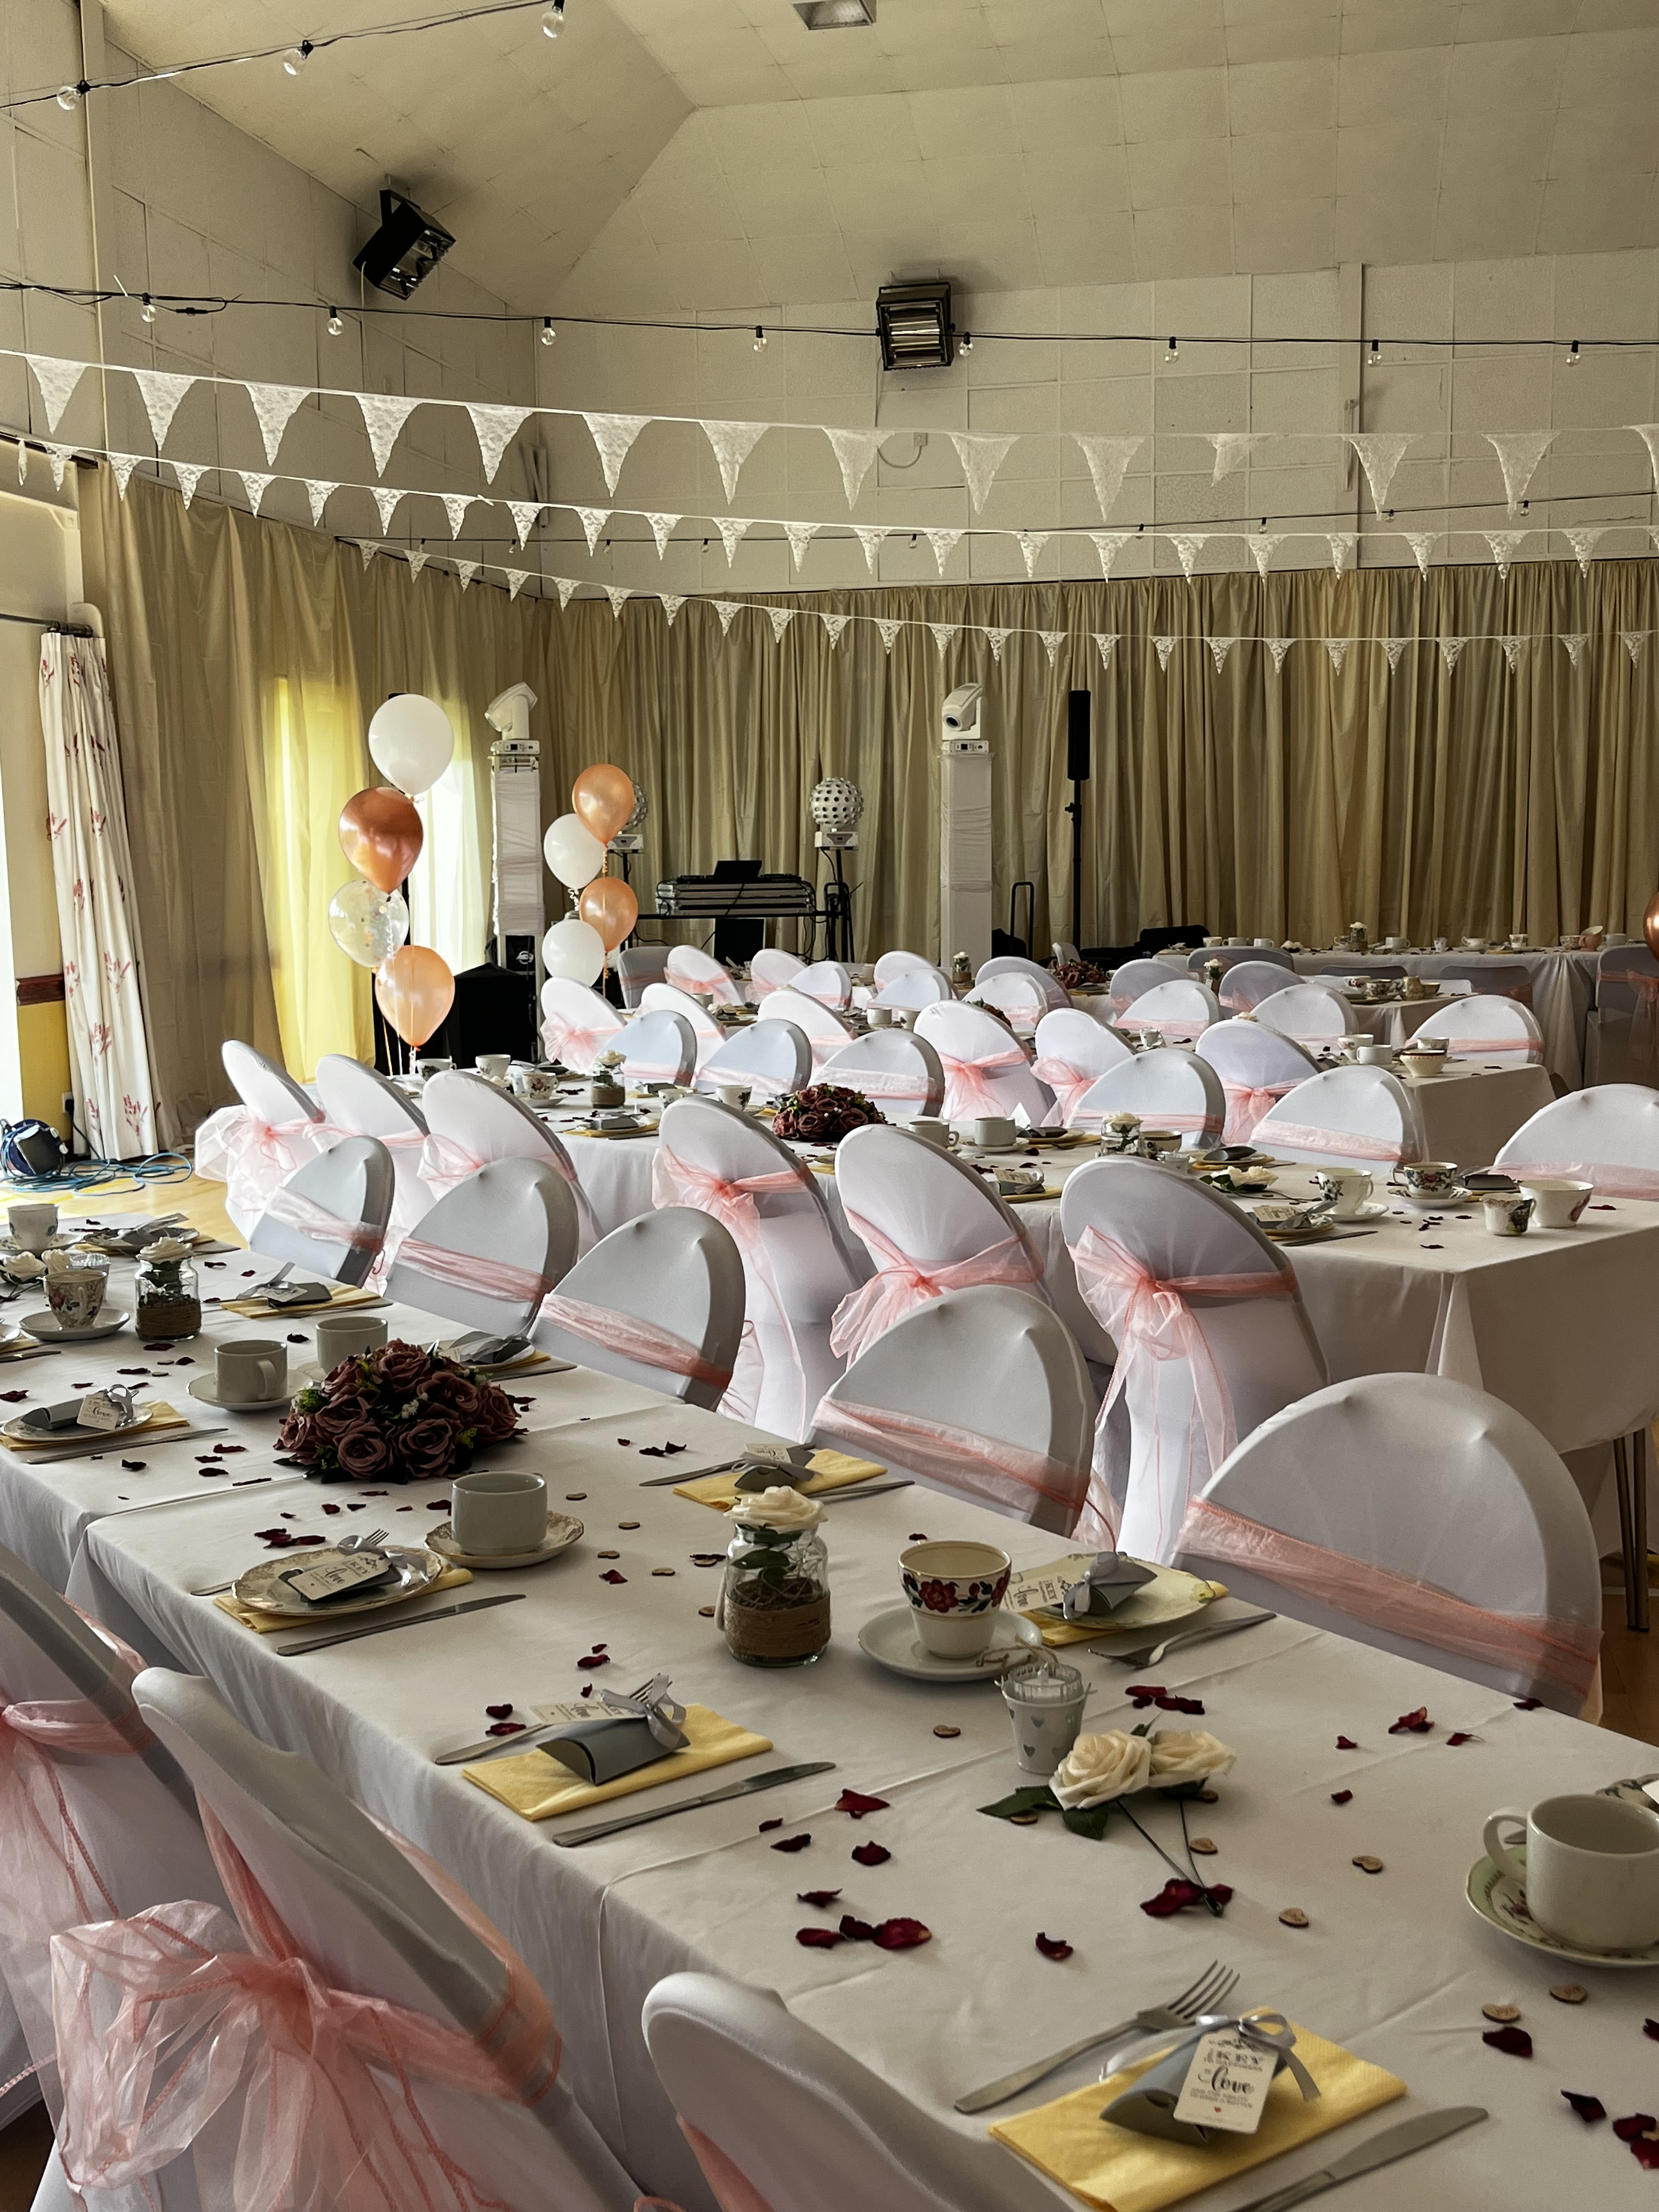
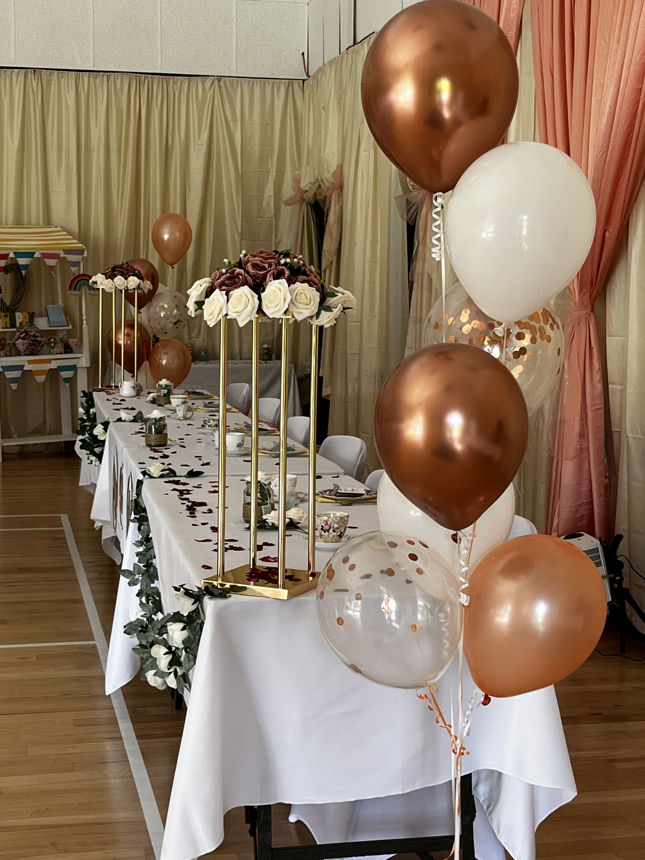
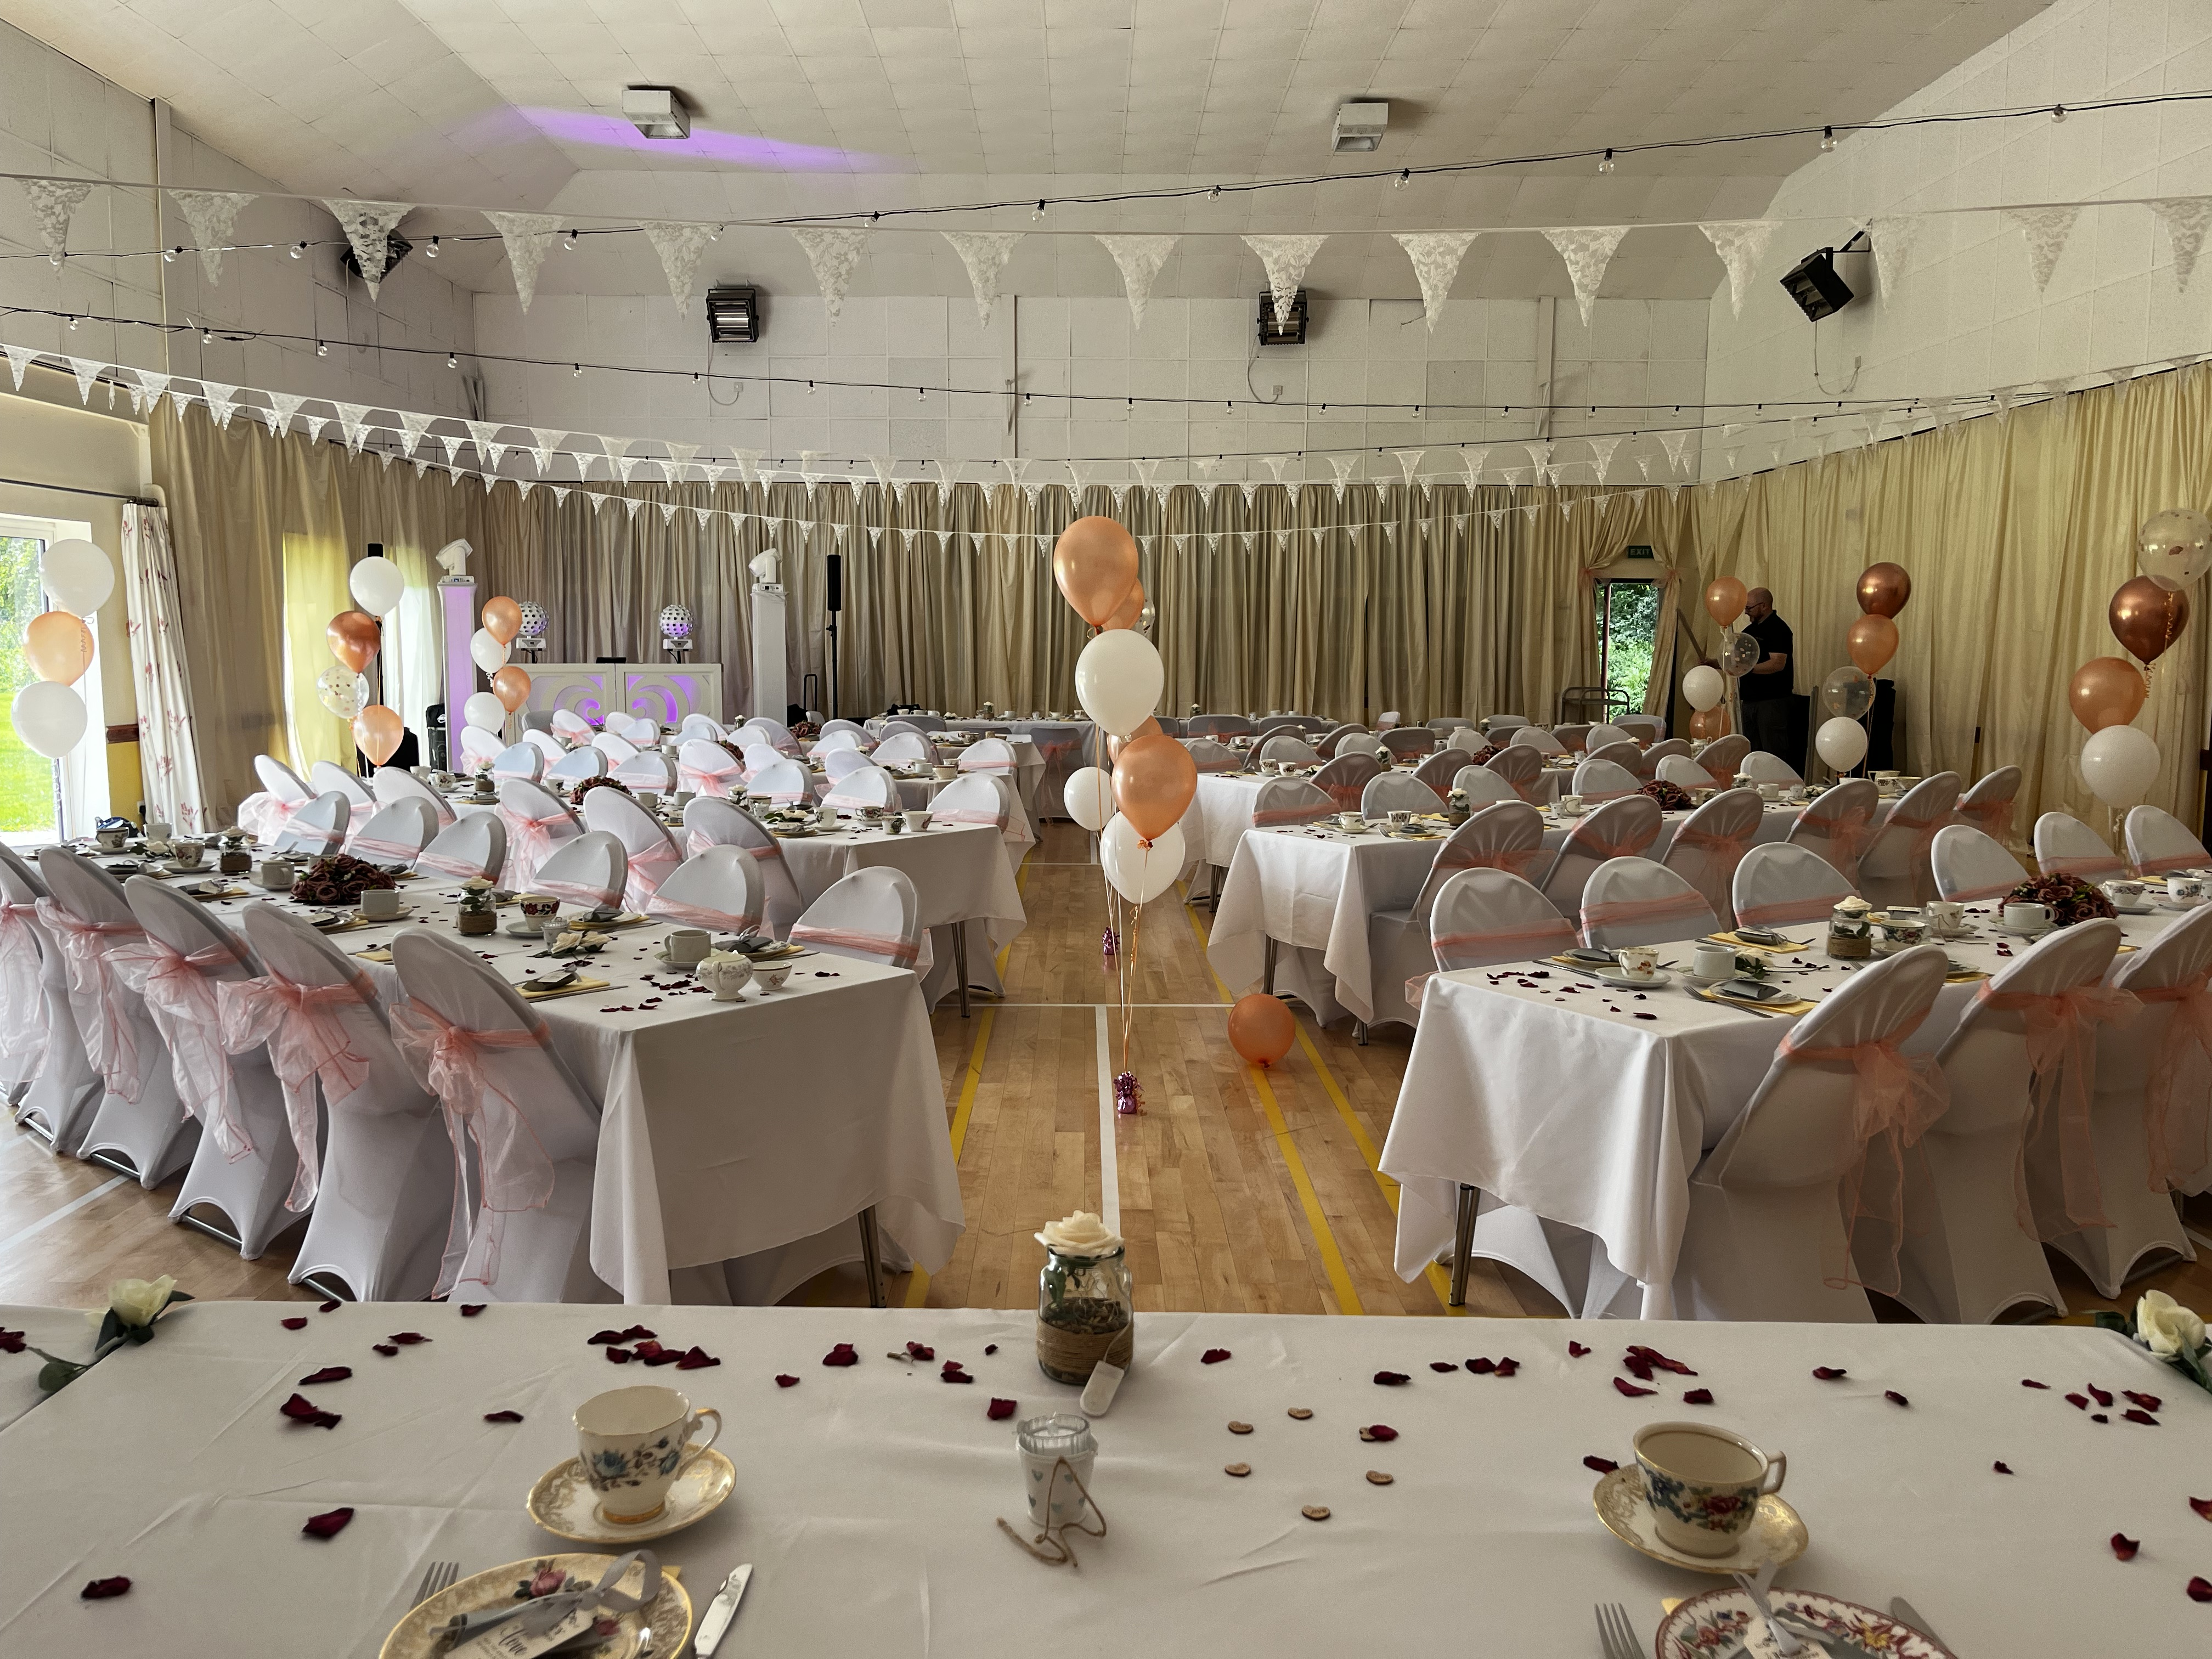
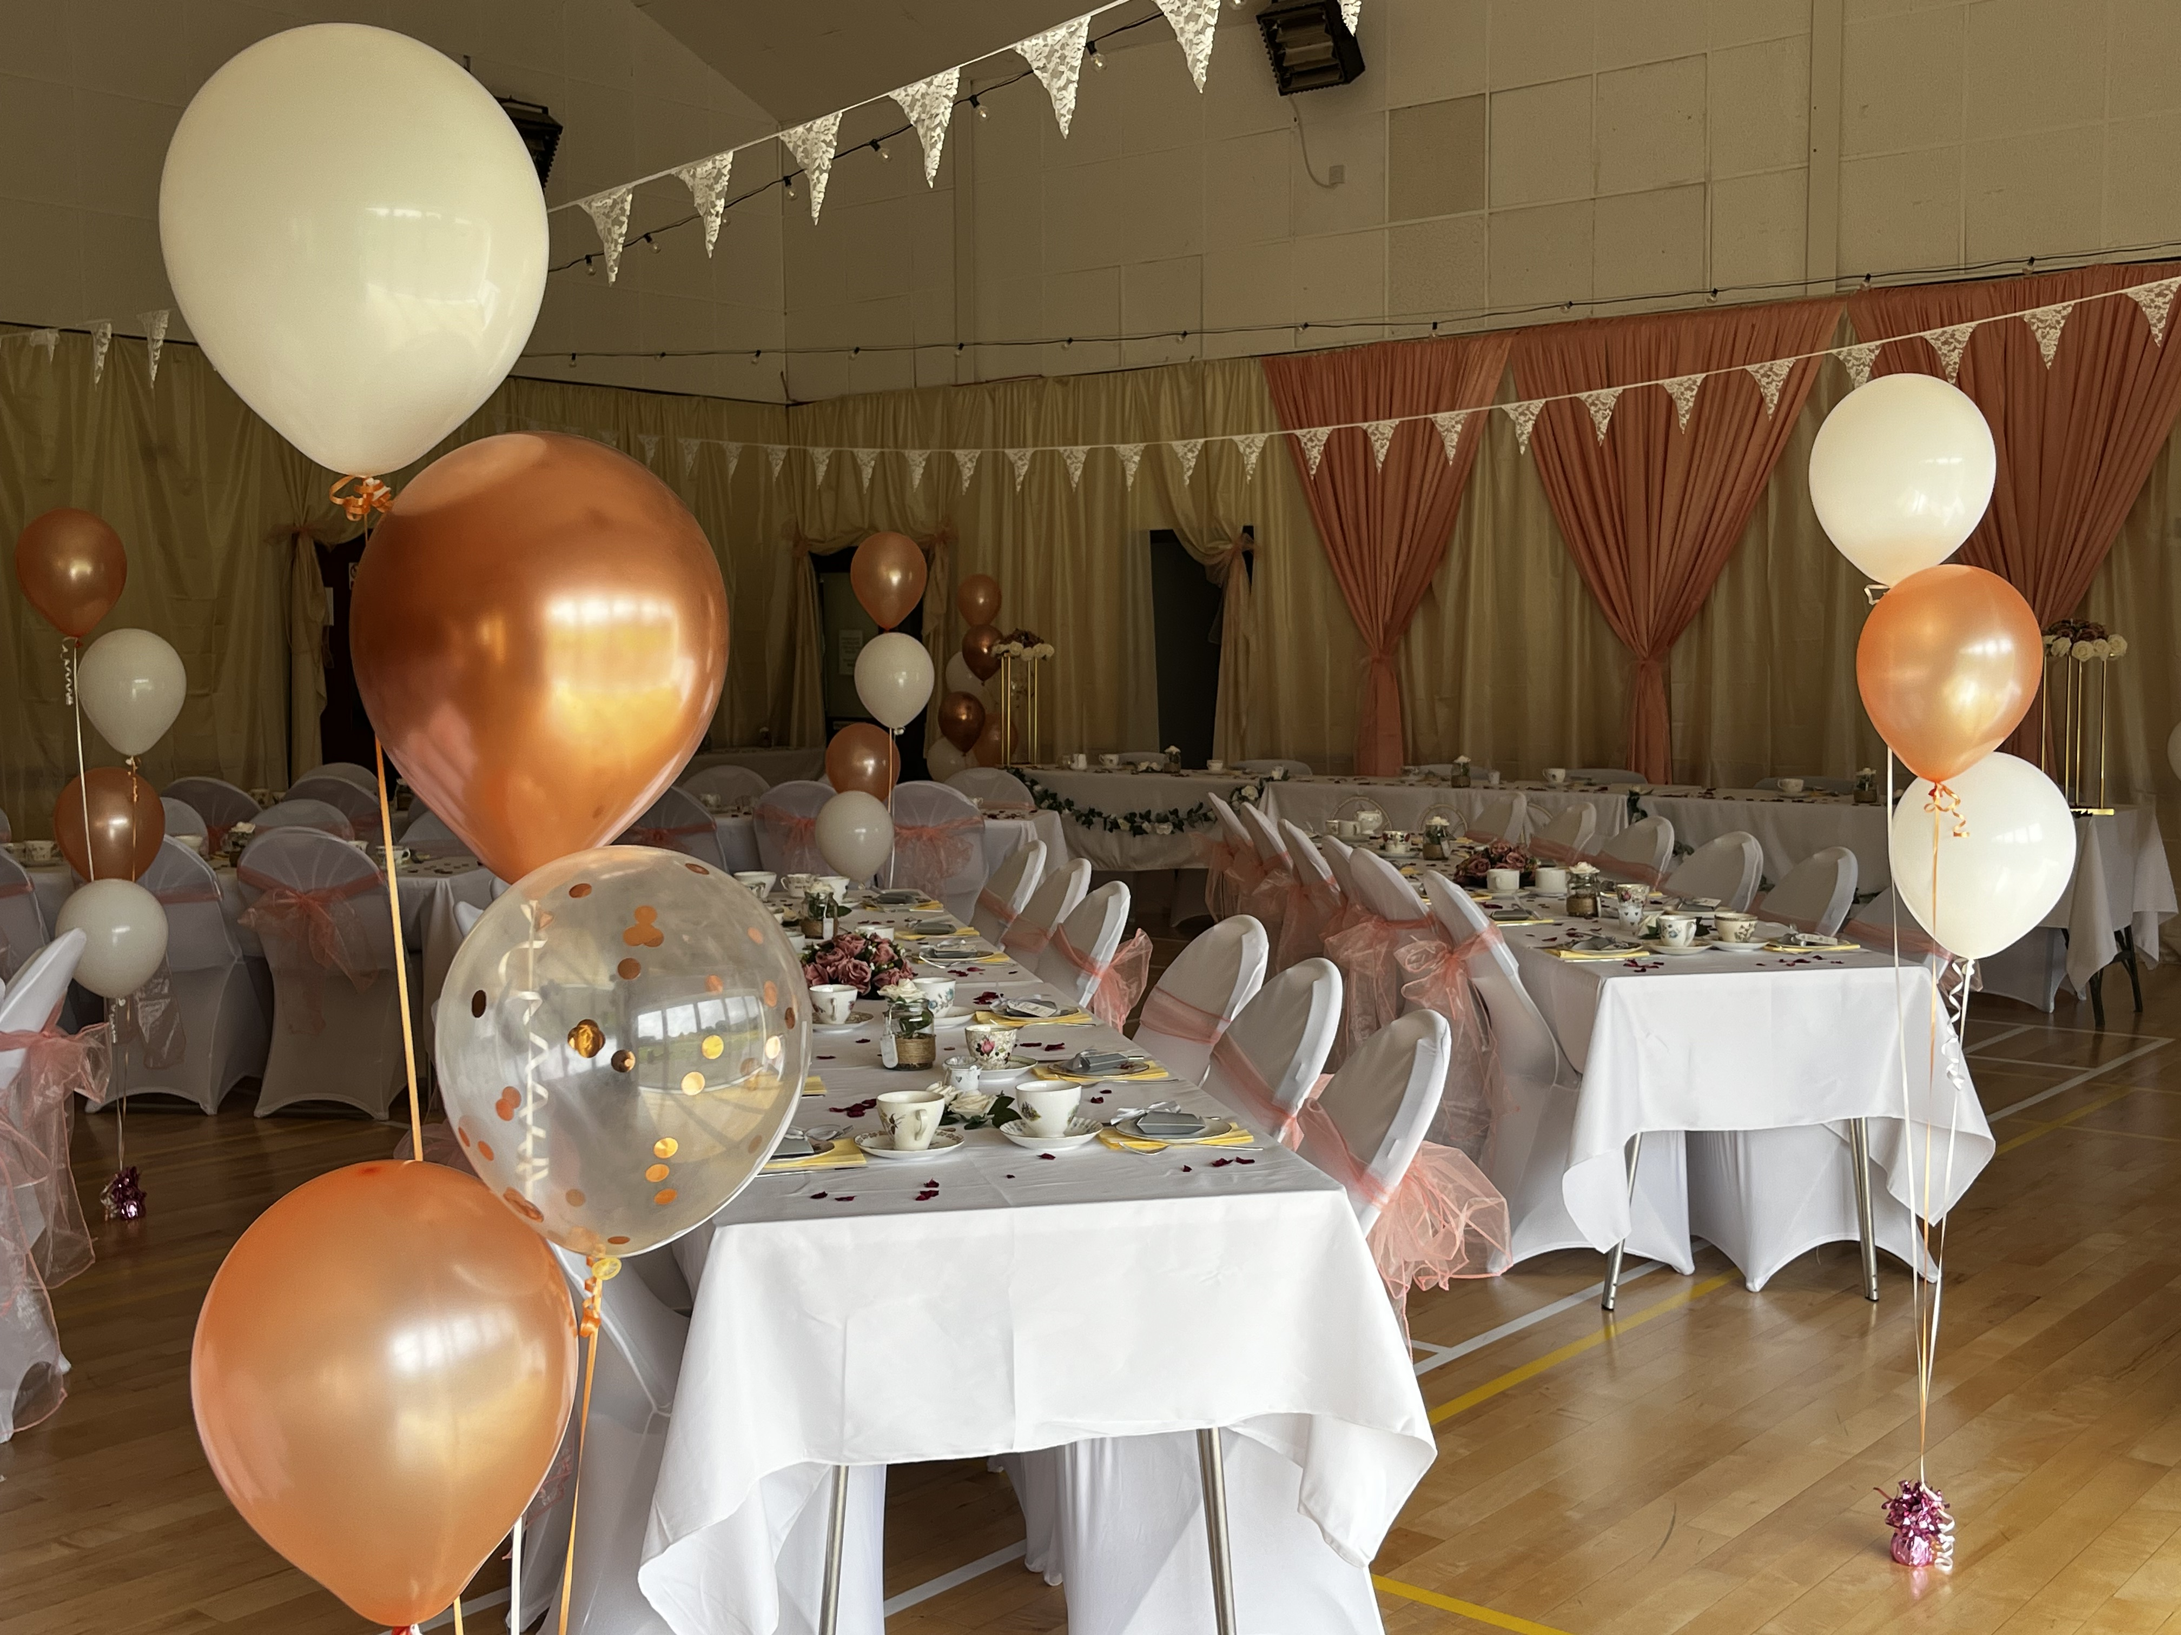
Getting Started

Codford Village Hall Weddings
  - Contact Katie Detheridge
  - villagehallcodford@gmail.com

Contact Janine at either 07539936746 or email villagehallcodford@gmail.com to arrange a time to come and view the hall and our grounds to see if we can make your wedding reception dreams come true. Please be aware that we are unable to perform weddings on site, but our hall can seat 180 people for a sit-down meal and your caterers will have full use of our kitchen. Your booking will cover the whole weekend starting Friday from 6pm-midnight to set up; from 9am on Saturday until midnight for the wedding; from 8am – 12 noon on Sunday for clear up.

What’s Included?
- Tables and chairs for up to 180 people
- A fully licensed bar
- Exclusive use of the small bar attached to the hall
- An option for a late license
- Full use of the kitchen
- Use of the field and playground
- Full use of the car park
- Outside space for food trucks (at hirers own cost)

 |  | Booking Times  Friday 6pm-midnight  Saturday 9am-midnight  Sunday 8am-noon  If you require extra time, it will be charged at £10 an hour.

Costings

Village residents £550.00
Non-residents £675.00
£50.00 non-refundable deposit due at time of booking. Balance due 6 weeks before the event.
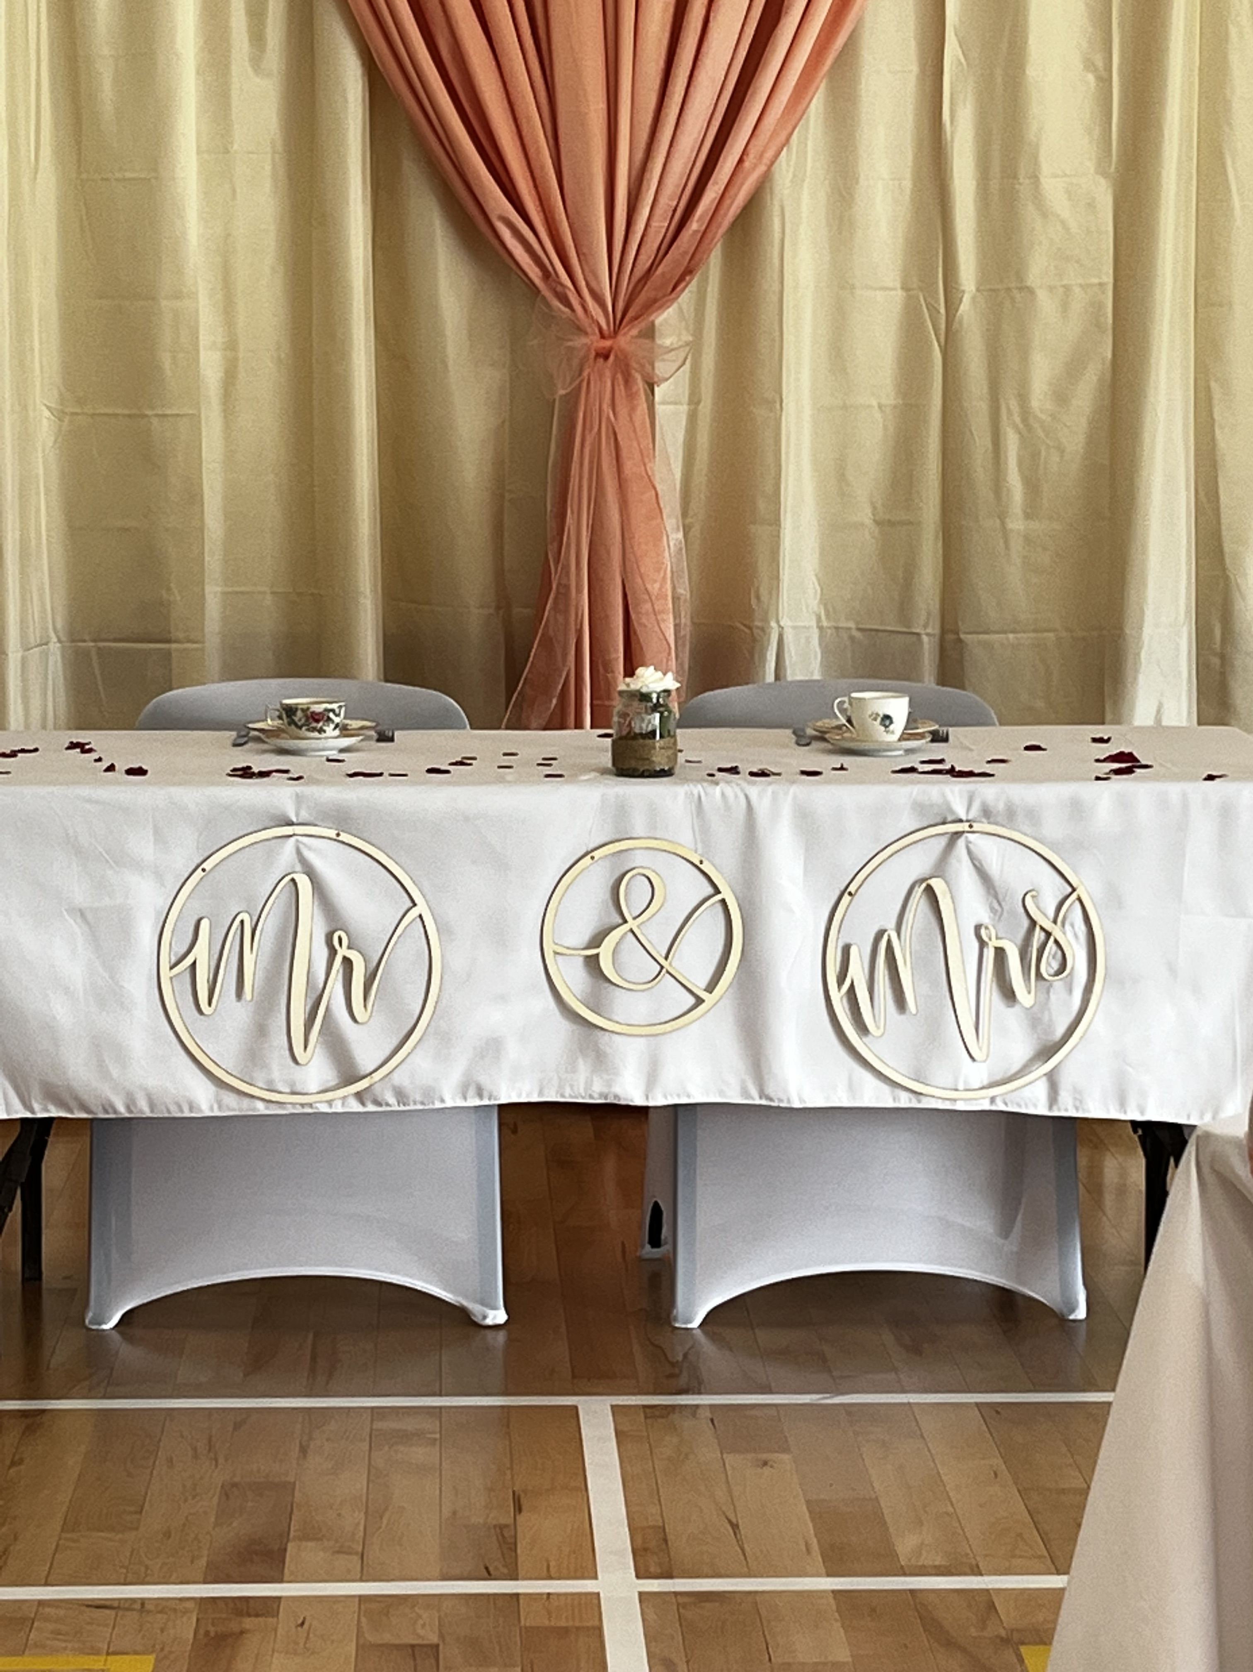 |  | Additional Charges  Marquee hire £75.00  Cancellations are less any costs to the Village Hall

