MARK AND BRAND APPLICATION

THE EFFECTIVE DATE OF THIS APPLICATION IS AUGUST 31, 2021 TO AUGUST 31, 2031
THE RENEWAL PERIOD FOR THIS BRAND IS AUGUST 31, 2031 TO FEBRUARY 28, 2032
This form shall only be used to record a single brand or mark for one or more locations on an animal.

Please print or type information (* Required information):

The undersigned hereby makes application for the registration and recording of the following mark(s) and/or brand(s) by the County Clerk of Calhoun County, Texas:

* New: Renewal:

Contact Information:

Release: Transfer:

* Owner/Agent: Ranch/Business Name:
* Address:

* City: Phone:
Brand/Mark Information: Male:

* Specie: Cattle: Horse:

* State: * Zip: Email:
Female:

Swine: Sheep: Goat:

Ear Marks Only:

Volume/Book:

BRAND
Page: Cert#:

MARK

Draw the Brand  If multiple brands, please use additional application. | Right Ear Left Ear
 | 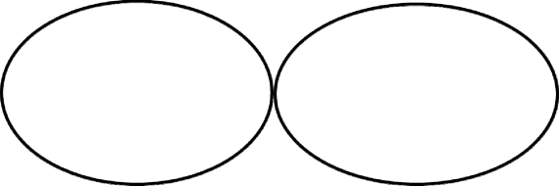

* Brand Location on Animal:

* Brand Description:

Left
Right
All Locations Shoulder Side/Rib Flank Hip/Loin
Thigh Jaw/Face/Nose Tail/Back
Other:

Electronic Chip#: Tattoos:

* Signature of Applicant: (Owner/Agent)

Date: ______________

By: _________________________________, Deputy Anna Goodman, Calhoun County Clerk

OR:

State of Texas§
County of Calhoun§
Before me the undersigned authority, on this day personally appeared _____________________
____________________________________________________________________________________
known to me to be the person(s) whose names is/are subscribed to the foregoing certificate and acknowledged to me that __he(y) executed the same for the purpose and consideration therein expressed.
Given under my hand and seal of office, this the _____ day of _________________, A.D. 20___.

____________________________________
Notary Public, State of Texas

