- Go to the following link: https://calhouncountytx-web.tylerhost.net/web/user/disclaimer

- Click “I Accept”

- Select the box “Fraud Notify”

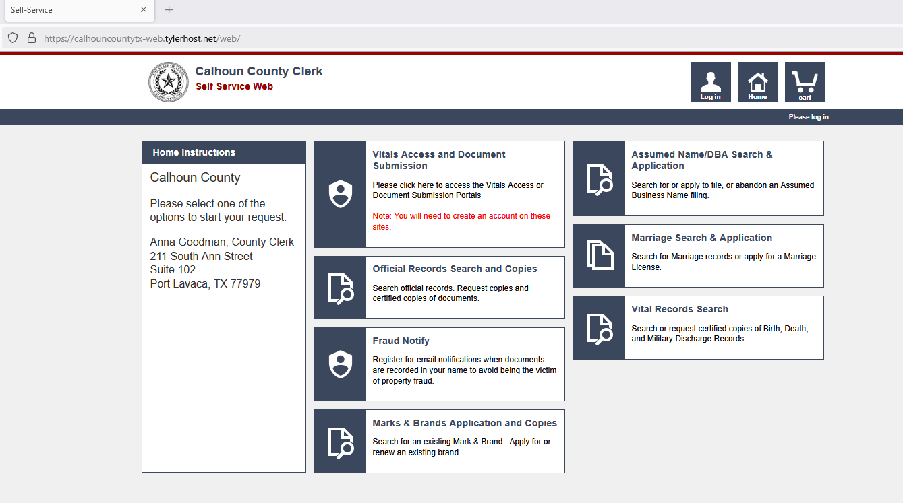

- Click the box “Sign Up”
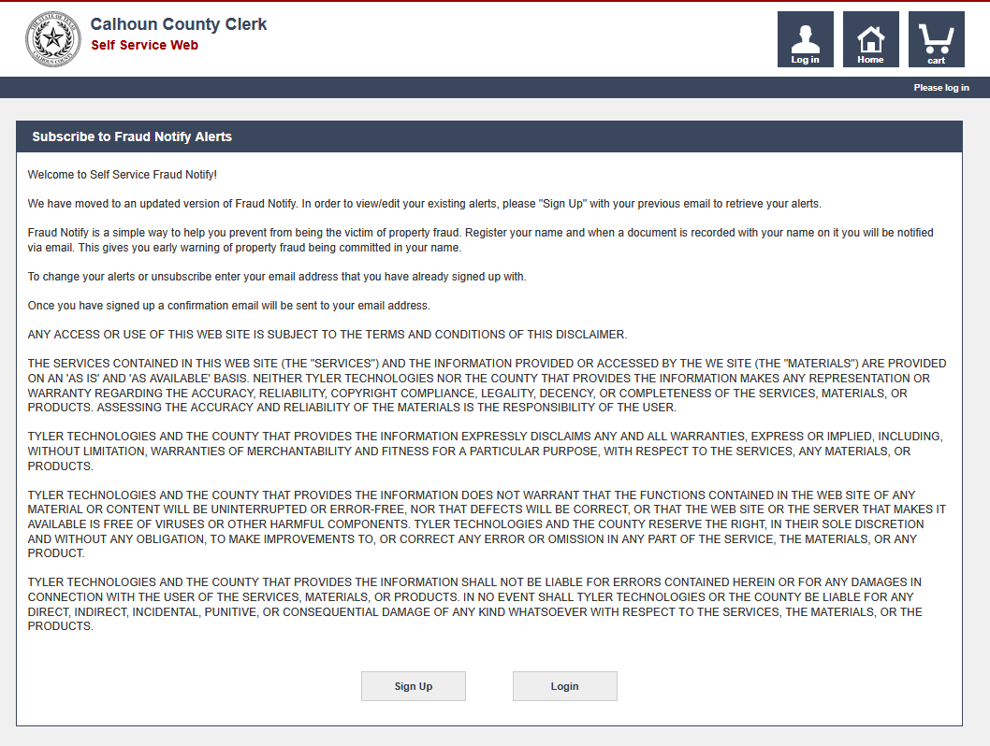

- Complete the “Add Account Details” information
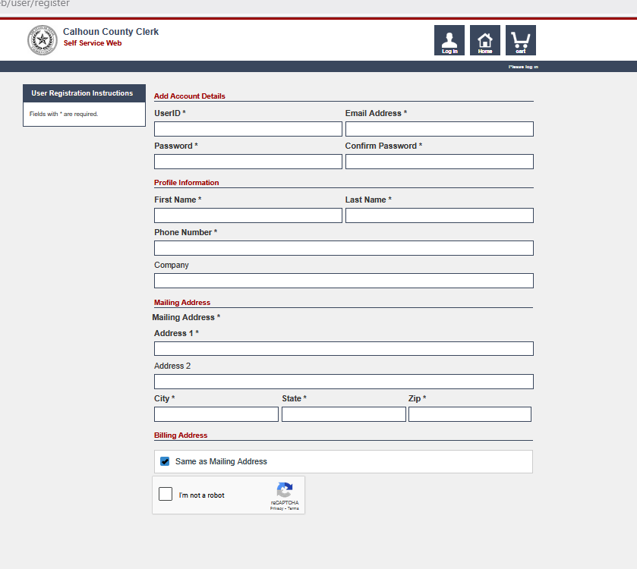

- Click “Submit”

- You should then see a message like the one below.

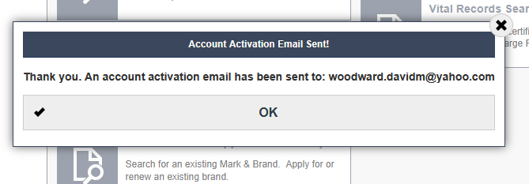

- Click “OK”

- Go to your email and verify.

- Now you can “Login” https://calhouncountytx-web.tylerhost.net/web/user/disclaimer
**Note this might now work if you are using the Firefox browser.**

- Enter in all the names that you want to be alerted by email.
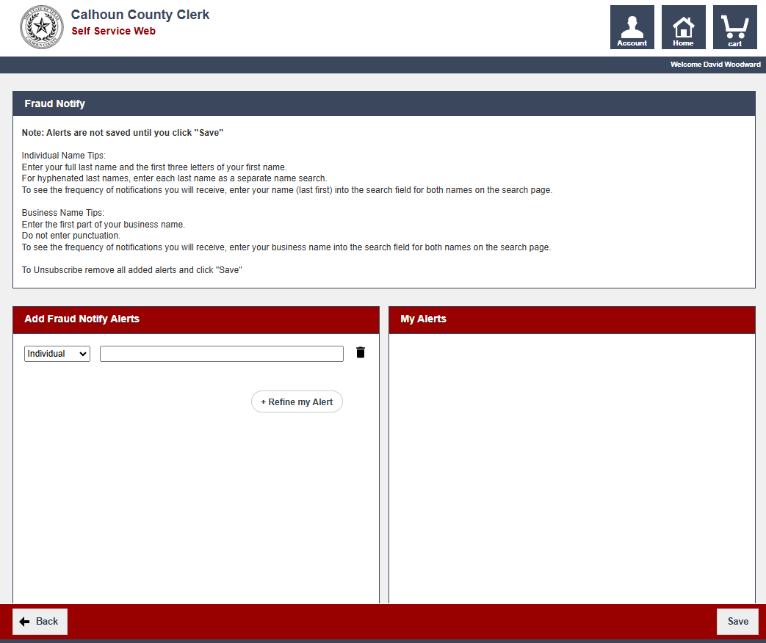

Sample of how you should enter in names because of indexing:

Doe John M
Doe John
Doe J

**It is recommended that you use different variations of your name. Also, you might want to enter names of those who have granted you any time of property because the fraudulent document that was attempting to be filed changed the name of the Grantee which might be your name that was omitted. For example using my information:

Grantee: Mickey Mouse

Grantee: Anna M Goodman

Property: Disneyland

In my Fraud Guard account I will list the following to be alerted:

Mouse Mickey
Mickey Mouse
Mouse M
Goodman Anna M
Goodman Anna
Goodman A

