COUNTY HOLIDAY SCHEDULE FOR 2020
GOOD FRIDAY FRIDAY, APRIL 10

MEMORIAL DAY MONDAY, MAY 25

INDEPENDENCE DAY FRIDAY, JULY 3
LABOR DAY MONDAY, SEPTEMBER 7
VETERANS’ DAY WEDNESDAY, NOVEMBER 11

THANKSGIVING DAY THURDSAY, NOVEMBER 26
FRIDAY, NOVEMBER 27
CHRISTMAS DAY THURSDAY, DECEMBER 24
FRIDAY, DECEMBER 25

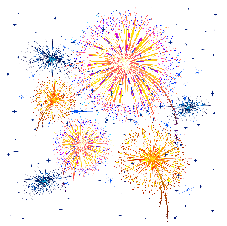
NEW YEAR’S EVE THURSDAY, DECEMBER 31

NEW YEAR’S DAY FRIDAY, JANUARY 1, 2021

