At Home Physiotherapy for Rotator Cuff Repair and Total Shoulder Arthroplasty, Anatomic and Reverse.

The rotator cuff is a group of four muscles that attach from the shoulder-blade (scapula) to the top of the humerus. These muscles work together to help stabilise and move the shoulder. They allow the large muscles of the shoulder (deltoid, pectoralis, trapezius, and latissimus) to move the upper limb into the desired position. These are essential for the function of anatomic shoulder arthroplasty and for part of the function of the reverse total shoulder arthroplasty. If you are recovering from any of these operations, the following document can be used for education and rehabilitation guidance for rotator cuff surgery or arthroplasty. As part of the rotator cuff is often taken down with shoulder replacement surgery, it is good to follow the instructions and exercises to possibly improve your outcomes and function.

The rotator cuff repair requires time to heal after surgical procedure and then physiotherapy to guide the movement of the shoulder and improve muscle and shoulder function without stressing the surgical repair.

We base our rehabilitation on phases, determined by time since surgery. All rehabilitation is designed to improve your function, but may also cause some discomfort. We expect some discomfort and pain, but one should not be reduced to tears or try to skip steps and push faster than the protocol. It is a tight balance between healing and regaining movement to give you the best shoulder outcome possible.

This document is aimed to assist home rehabilitation. If you have a planned rehabilitation program with your physiotherapist, please follow those exercises that may be directed and individualized better for you. This is to assist those who are finding it difficult to access physio during this time period. Please click on the blue text below for links to videos to assist rehabilitation.

At any time you are concerned regarding your rotator cuff rehabilitation or experience excessive pain that fails to settle with analgesia, contact your shoulder surgeon.

PHASE 1: (post op weeks 0-2)
Aims during this phase are to allow pain to settle, wounds to heal, and ensure the hand, wrist and elbow do not get stiff, whilst allowing the shoulder soft tissues to begin healing.

INSTRUCTIONS:
No Driving
Stay in immobiliser, only off for showers and exercises.
Release wrist strap and use hand in front of body for light tasks.
Elbow – active flexion and extension (bending and straightening) without weight as tolerated.

CAUTIONS:
Keep incision clean and dry – if wet by shower – remove superficial dressing, leave strips intact, pat dry with clean towel, apply simple dressing – bandaid etc.
No lifting objects.
No moving shoulder behind body, above head, or external rotation (turning arm out away from body) greater than 30 degrees.
If you have had a biceps procedure, perform all elbow flexion and extension (bending and straightening the elbow), shown in videos, using the non operative arm to move the elbow of the operated arm.

EXERCISES:
Complete each exercise at least 10 times in each session. Complete 4 sessions per day.
Scapular positioning.
Clasp hands together in front of body at abdomen height, comfortable level. Pull shoulder blade up, back, down and then relax. Then shoulder blades forward, up, back, down, relax. Repeat these steps. This exercise can be performed in the immobiliser if you do not feel comfortable getting out of immobiliser or advised not to by physician.
https://youtu.be/bdVKaCnApSI

See figures below for rehab.
Pendular exercises:
With operated arm out of immobilizer, bend forward at the waist using non-operated arm for balance on a chair or counter. Let operated arm hang down like the pendulum on a clock. Gently swing arm forward and backwards. Repeat 10 repetitions. Then draw circles in a clockwise direction with your hand, repeating 10 times.

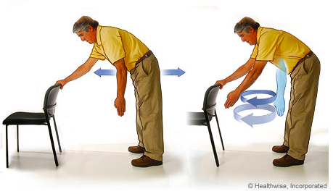

Hand, wrist and elbow range of motion exercises.
https://youtu.be/iUBYzusqH9Y

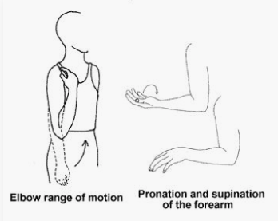
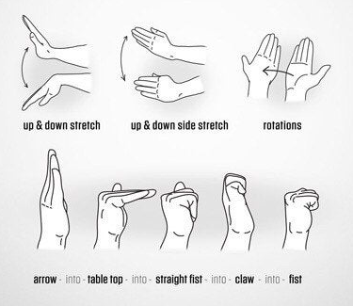
PHASE 2: Weeks 2-6
Aims during this period are to start moving the shoulder decreasing the risk of stiffness, limiting function; and allow the rotator cuff to heal with minimal stress on the healing repair.

INSTRUCTIONS:
No driving until 6 weeks post operatively.
Immobiliser at night, unless advised by Doctor.
Out of immobiliser in house, relaxing, shower, at dinner table. Use immobiliser when outside, during transport, or in a crowded place (avoid these now).

CAUTIONS:
No excessive movement behind back.
No supporting body weight with operative arm.

EXERCISES:
Add to phase 1 exercises.
These exercises are PASSIVE exercises. This means the non operative arm does all the movements to the operative shoulder. The aim is to allow shoulder movement between the shoulder blade and the humerus, not compensating by using the shoulder blade to move the arm. It is difficult to do this by yourself, but a good idea to have someone else do the exercise in front of you, or watch you do it with the non operative shoulder first, then operative; or complete exercises in a mirror and assess your own form.

Forward flexion – passive
Whilst standing, clasp the operative side wrist with the non operative hand. Slowly raise your hands, using the non operative hand to power the movement, to the level of your eyes. You may not get to this level initially, as this is the aim for the first three to four weeks. Then slowly clasp your operative arm higher and higher towards the elbow, always raising to the same level, the eye line. This slowly increases your flexion range to 130-140 degrees when holding the elbow. Aim is to get to this level by weeks 5-6. Ensure to keep the operative side elbow straight during these exercises.

Passive forward flexion in the supine/lying down position:
https://youtu.be/Uo361tmpcms

Can also do whilst lying down on bed and raising arm to similar level.

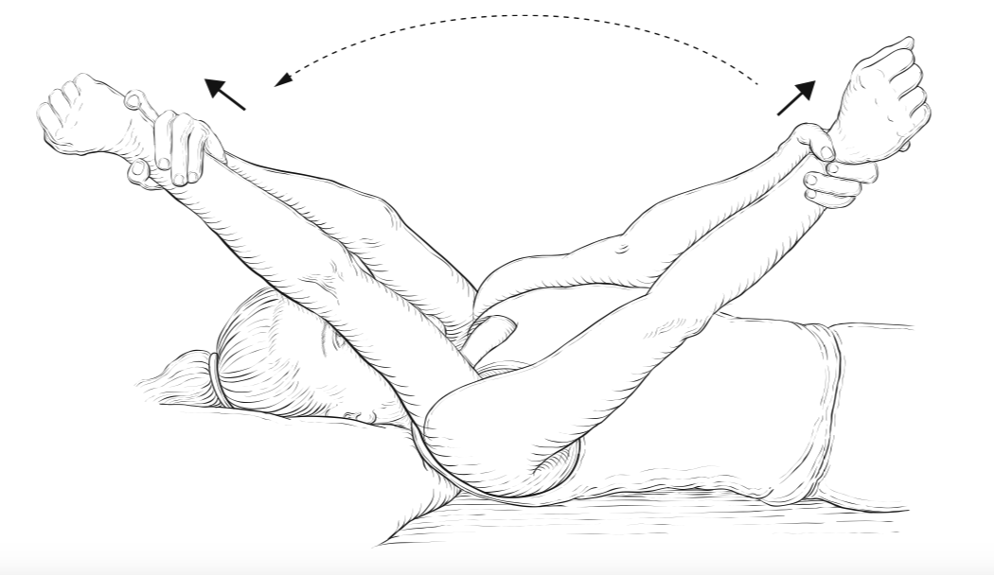

Passive forward flexion in standing position:
https://youtu.be/Jmbi9byK1H4
Passive forward flexion in the seated position:
https://youtu.be/LASO0iKlGhU

External rotation – passive.
With the operative arm by the side, clasp hands together. Then move non-operative arm across body until the operative arm is approximately 30 degrees, out away from the body, from straight ahead. Or if access to a broom, hockey stick or golf club, use this to assist your range of motion. Over hand grasp the stick/club at shoulder width apart and elbows bent at 90 degrees. It is important to keep the bent elbow of the operative arm, held against the side of your body. Then slowly use the non operative arm to externally rotate (turn out) the operative arm to 30 degrees for 4-6 weeks, then slowly increase the range to 45 degrees until 8th week post op.

Passive external rotation:
https://youtu.be/cI8NJaEdGUk
Passive external rotation – with a stick/cane, as below:
https://youtu.be/JDInQSiMrfc

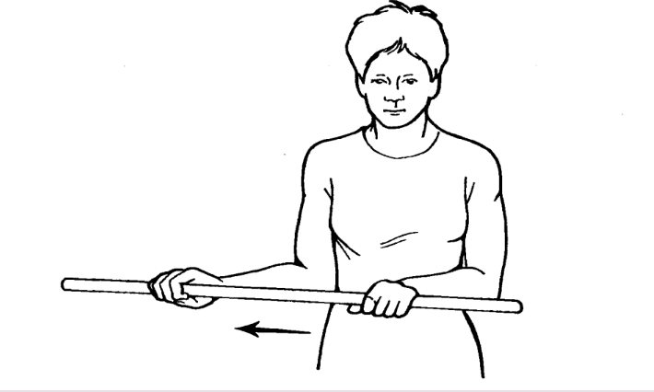
Abduction of shoulder – passive.
This is performed to assist in the movement of the arm, out to the side, away from the body. This should be done to approximately 90 degrees in the first 4-6 weeks after the operation, then increase to the same range as the non operative side. Extra care needs to be taken if a subscapularis tendon has been repaired; and follow your surgeon’s instructions.

Passive abduction:
https://youtu.be/_takCiVNIDk

PHASE 3 – Weeks 7-14
Aims:
During this time period the rotator cuff is still weak at its’ healing site, but getting stronger every day. The aims during this period are to start activating the muscles, and achieve full range of motion with the power of the repaired rotator cuff. This will require some further stretching of the shoulder in all directions, the use of passive range of motion and using the operative muscles to help. No weights or strengthening until 16 weeks post operatively.

INSTRUCTIONS:
No longer in sling.
OK to drive if physically able. If your shoulder is not recovered, or not safe to do so, please avoid driving.
No heavy lifting/weights/strengthening yet.

CAUTIONS:
Pushing up out of chair.

EXERCISES:
Forward flexion, continue with exercises in phase 2, pushing to same flexion as non operative side. Aim to use operative muscles to assist movement. There are other options to help flexion if finding difficult. In standing position:
https://youtu.be/UbWTvM17Jhs

Alternative 1: Throw towel over door, hold on either side with both hands, then slowly squat to lower body, thus raising arms.
Alternative 2: Using a towel similar to option 1, or placing hands on wall, slowly flex forwards at hip, leaving hands on same position on wall or towel, this will slowly increase your flexion.
https://youtu.be/qzbjOqb4jGk
Alternative 3: As you gain strength and control, using your hands to slowly climb the wall using your rotator cuff.
https://youtu.be/YAmta2JYao8

External rotation – use prior exercises, aim for full range of motion as to non operative side.
Focus on using muscles in operative arm to move arm into position, and the non operative arm to provide the additional power to help it get to the desired position.

Using muscles on operative and non operative shoulders.
https://youtu.be/VF8Kw-VAWOc

Alternatives for External rotation.
Alternative 1: stand in an open door, with elbow by the side of body. Hold the door jam with the operative side and ensure elbow stays next to body, slowly rotate body to externally rotate the operative shoulder. Some people find shuffling their feet slightly and looking down at feet to ensure not rotating through the body, is helpful (see diagram below).

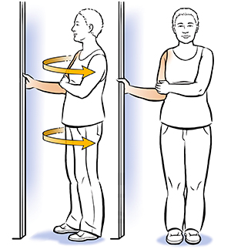

Internal rotation – active assisted range of motion and passive stretches.
The process for the internal rotation exercise, is similar to the external rotation exercises with the broom/hockey stick or golf club.
For internal rotation, initially, hold a stick in both hands behind your back and help with your non-operative arm to move your operative arm across and up your low back. To progress this exercise, you can then move to clasping hands behind back when range improves. Alternatively, you can use a towel behind the back, and extend the non operative elbow to pull the operative arm to internal rotation.
https://youtu.be/NYVFwpXSKDU

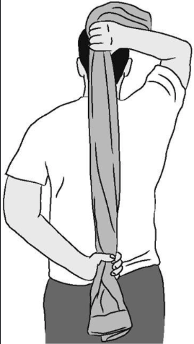

Functional exercises- use the arm for normal activities. Try to focus on normal activities and push the shoulder to get to those activities – washing hair, reaching top shelf, pulling up pants, doing up brassier.

PHASE 4: weeks 14-23
Aims:
To return to full normal activities and slowly introduce strengthening and sport/hobby specific goals. The rotator cuff is healing at this stage and the scar tissue is starting to align and strengthen. This is the time to start strengthening the rotator cuff beginning with light weights or resistance; and ensure you have full range of motion. It is important to continue to work hard on keeping this range of motion.

INSTRUCTIONS:
Full house hold duties and cares.
No heavy lifting, manual job etc.

CAUTIONS:
Aggressive strengthening or activity can still lead to re-tear at this time period.

EXERCISES:
As above.
To strengthen, initially aim to complete the range of motion without need of assistance from your non-operative arm.
Start to do all range of motion and gradually increase resistance. If you have the elastic bands from a physiotherapist already – use them as directed. If not, use hand held weights, either real exercise weights or improvise. For example, you can start with a small water bottle filled with water, about 0.5Kg or 1lb. You can increase size of water bottle, or change to tins of food, etc. if unable to access hand-held weights.
https://youtu.be/ArPLpO-K8b0
Additional rotator cuff strengthening with forward flexion can be achieved using a towel. Grip a tea towel or bath towel at shoulder width apart, place tension on the towel, guided by pain and the force from the non operative shoulder. Focus on keeping the shoulders level, the towel taught and slowly reach as high as you can.
https://youtu.be/6TzZBvvI-a8

See pictures below for exercise options for strengthening and range of motion.
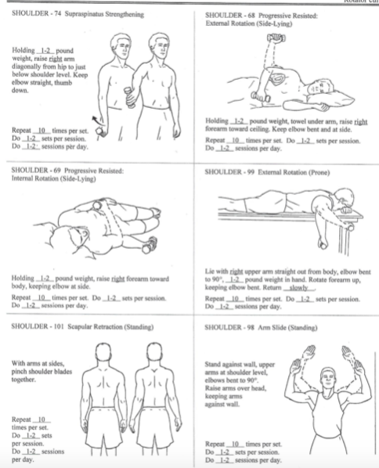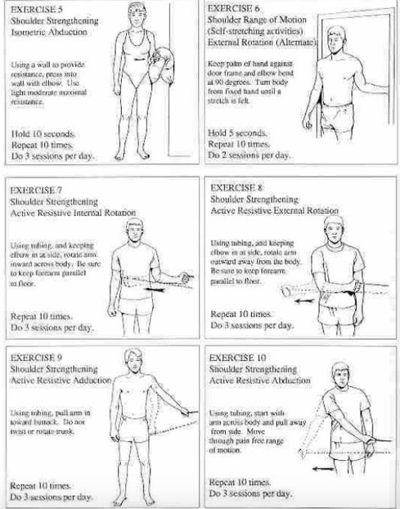

PHASE 5: Weeks 24 – onwards
Return to full duties and sports as tolerated.
Continue to work on rotator cuff strengthening to prevent further injury, and complete exercises on both shoulders.

