PC: Apple MacBook Pro (14", M2 Pro 2023) with Serato DJ Software

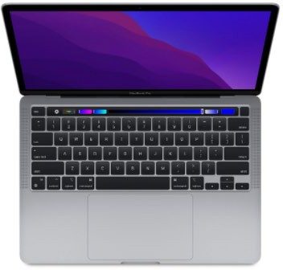

Pioneer DDJDJ 1000 SRT Controller with Odyssey Flight Case Pioneer 4-Channel Controller

<https://www.pioneerdj.com/en-us/product/controller/ddj-1000srt/black/overview/>

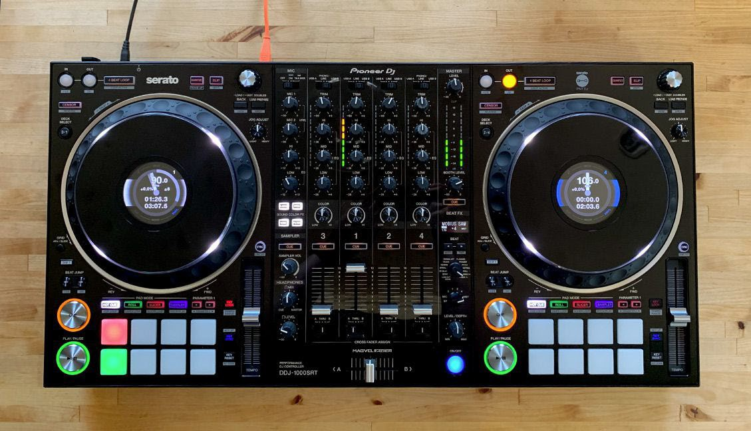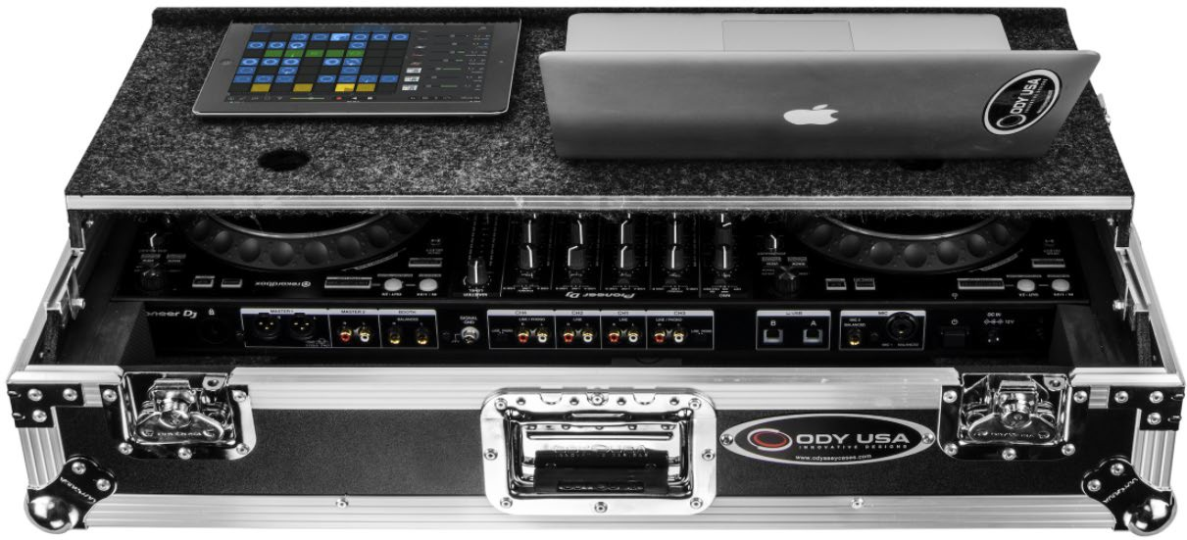

**X2 QSC 10” K10.2 2000 Watt Two-Way Powered PA Speakers w/flight case**

[https://www.qsc.com/live-sound/products/loudspeakers/powered-loudspeakers/qsc-k2-seriestm-](https://www.qsc.com/live-sound/products/loudspeakers/powered-loudspeakers/qsc-k2-seriestm-new/k102/) [new/k102/](https://www.qsc.com/live-sound/products/loudspeakers/powered-loudspeakers/qsc-k2-seriestm-new/k102/)

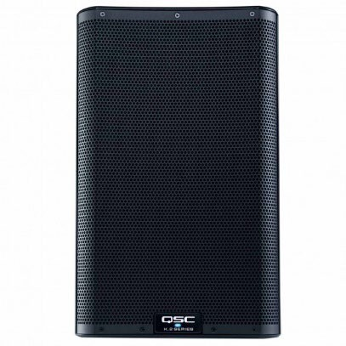

X2 QSC KS212C Act ive Dual 12-inch 3600 Watt Cardioid Subwoofers w/bags

<https://www.qsc.com/live-sound/products/loudspeakers/powered-subwoofers/ks212c/>

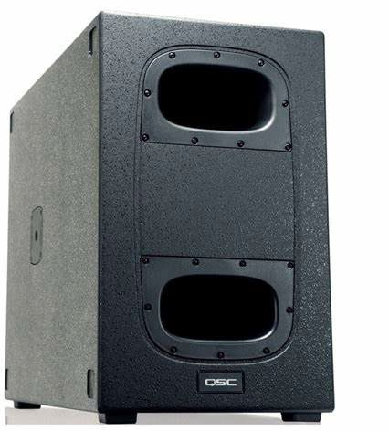

**X2 QSC 8” K8.2 2000 Watt Two-Way Se lf-Powered PA Speakers w/bags** [https://www.qsc.com/live-sound/products/loudspeakers/powered-loudspeakers/qsc-k2-seriestm-](https://www.qsc.com/live-sound/products/loudspeakers/powered-loudspeakers/qsc-k2-seriestm-new/k82/) [new/k82/](https://www.qsc.com/live-sound/products/loudspeakers/powered-loudspeakers/qsc-k2-seriestm-new/k82/)

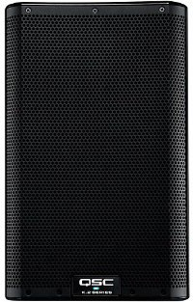

-Used for smaller events and often ceremonies

Chauvet DJ Gigabar Move+ 5-in-1 Integrated Lighting System (2023 Models) | (Own 2) | 1 = 100 People

[CHAUVET DJ GigBAR Move + ILS 5-in-1 Lighting System | Guitar Center](https://www.guitarcenter.com/CHAUVET-DJ/GigBAR-Move-ILS-5-in-1-Lighting-System-1500000373545.gc)

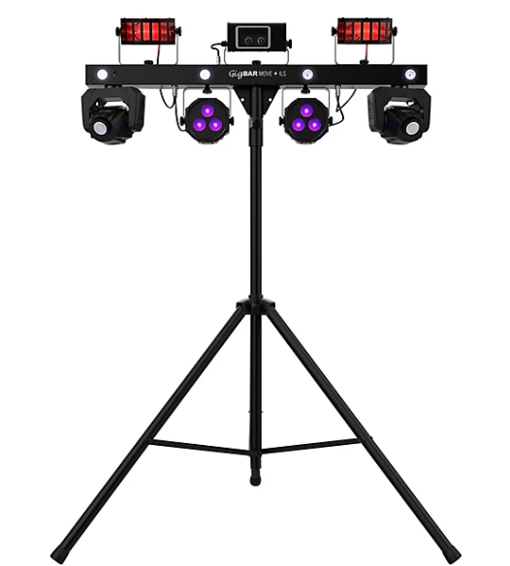 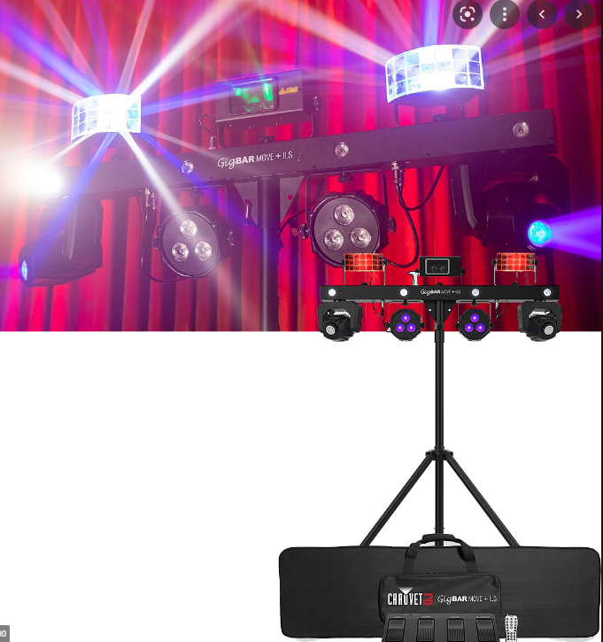

CHAUVET DJ Travel Case for GigBAR Move, GigBAR Move + ILS

[CHAUVET DJ Travel Case for GigBAR Move, GigBAR Move + ILS | Guitar Center](https://www.guitarcenter.com/CHAUVET-DJ/Travel-Case-for-GigBAR-2-GigBAR-Move-GigBAR-Move-ILS.gc)

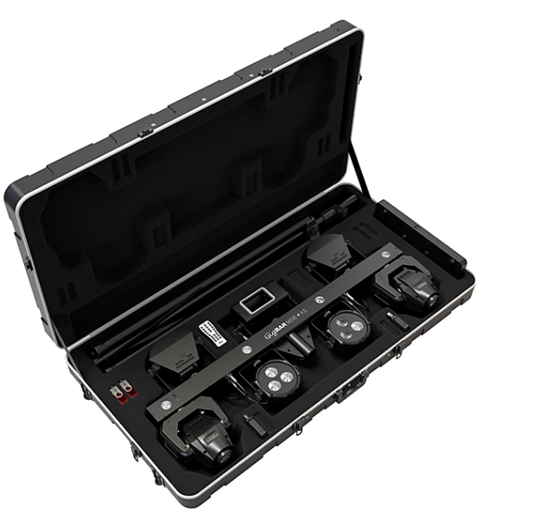

Chauvet DJ Integrated Lighting System Command Light Controller w/case

[Chauvet DJ ILS Command Controller | Sweetwater](https://www.sweetwater.com/store/detail/ILSCommand--chauvet-dj-ils-command-controller)

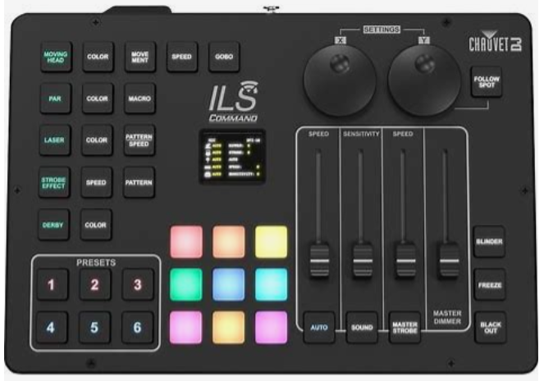

Shure SLXD124/85 Combo System With SLXD1 Bodypack, SLXD4 Receiver, SM58 and WL185 Lavalier Microphone Band G58

[Shure SLXD124/85 Combo System With SLXD1 Bodypack, SLXD4 Receiver, SM58 and WL185 Lavalier Microphone Band G58 | Guitar Center](https://www.guitarcenter.com/Shure/SLXD124-85-Combo-System-with-SLXD1-Bodypack-SLXD4-Receiver-SM58-and-WL185-Lavalier-Microphone-Band-G58-1500000323496.gc?cntry=us&source=4WWRWXMP&msclkid=e26993289dd612cd7f17f604dc47ff0e&utm_source=bing&utm_medium=cpc&utm_campaign=**LP%20-%20Shop%20-%20Pro%20Audio%20-%20Microphones%20%26%20Wireless%20Systems%20-%20Wireless%20Systems&utm_term=4578366489521472&utm_content=1500000323496%20%7C%20Shure%20SLXD124%2F85%20Combo%20System%20with%20SLXD1%20Bodypack,%20SLXD4%20Receiver,%20SM58%20and%20WL185%20Lavalier%20Microphone%20Band%20G58%20%7C%20%24999%20USD)

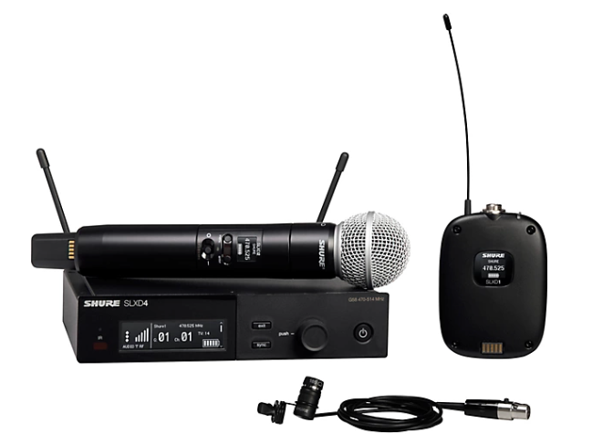

*Dual Mic version available in selected packages.

SKB Cases - iSeries 1711-6 Shure SLX-D / QLX-D Case

<https://www.skbcases.com/products/i-series-1711-6-shure-slx-d-qlx-d-case>

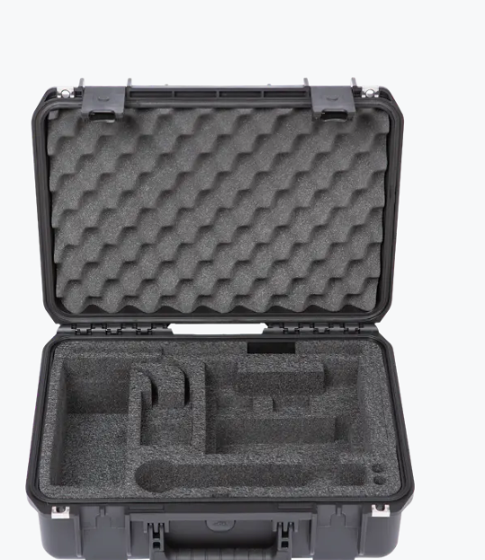

Pioneer HDJ-X10 Professional DJ Headphones Black

<https://www.pioneerdj.com/en-us/product/headphones/hdj-x10/black/overview/>

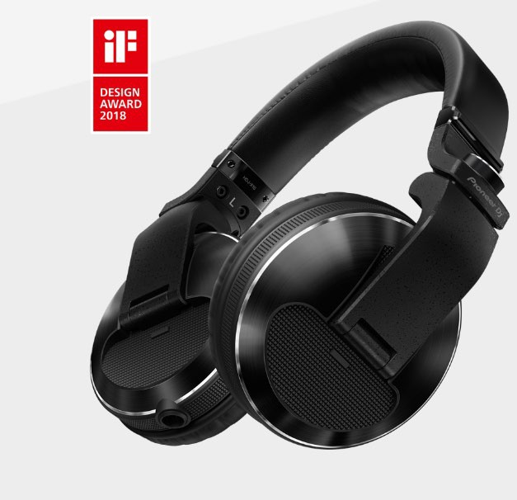

X6 Furman SS6B 6 Plug Surge Protector

<https://www.guitarcenter.com/Furman/SS-6B-Surge-Block-1273888004990.gc>

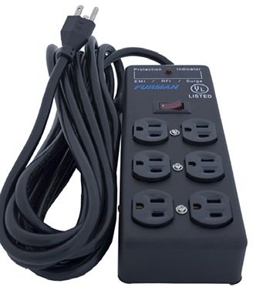

Mounted in Case: Furman M8 9-Out let Power Conditioner & Distribution System

<https://www.guitarcenter.com/Livewire/9-Outlet-Power-Conditioner-and-Distribution-System.gc>

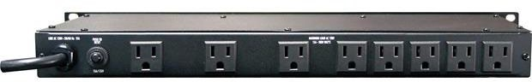

ADJ Pro Event Table II with Black Table Scrim & Pro-Shelfs

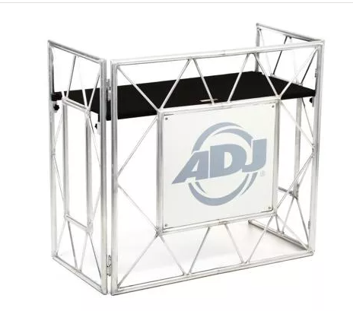 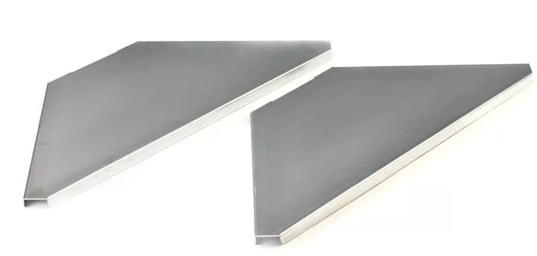

Yam aha MG10XU 10-Channel Mixer

<https://usa.yamaha.com/products/proaudio/mixers/mg_series_xu_model/index.html>

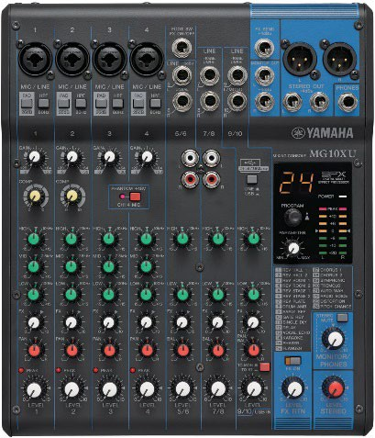

ADJ WMX1 Standalone DMX Lighting Controller

<https://www.sweetwater.com/store/detail/WMX1--adj-wmx1-standalone-dmx-lighting-controller>

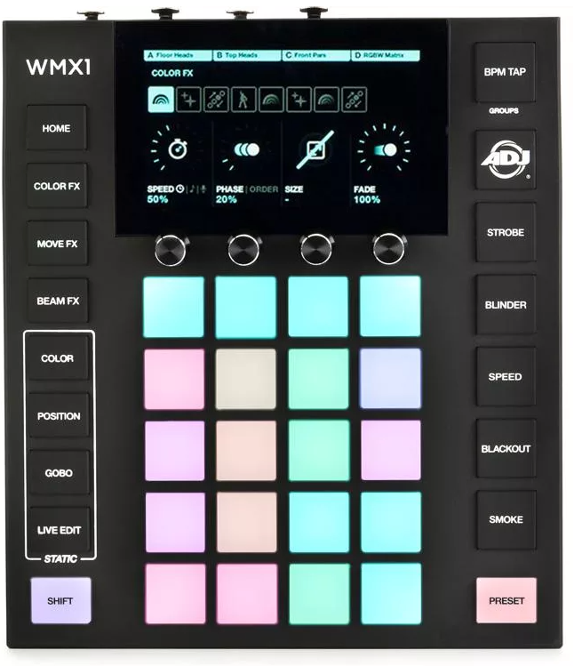

Donner Wireless Trasnmitters/Receiver

[Amazon.com: Donner DMX512 Wireless Controller Dfi DJ 2.4G Wireless DMX 7 Receivers with Light Dome& 1 Transmitter LED Lighting Control 8PCS : Everything Else](https://www.amazon.com/Donner-Wireless-Receiver-Indicators-Transmitter/dp/B00L25ZNP4/ref=asc_df_B00L25ZNP4/?tag=hyprod-20&linkCode=df0&hvadid=309780951986&hvpos=&hvnetw=g&hvrand=11298744481903623651&hvpone=&hvptwo=&hvqmt=&hvdev=c&hvdvcmdl=&hvlocint=&hvlocphy=9033471&hvtargid=pla-599043088724&th=1)

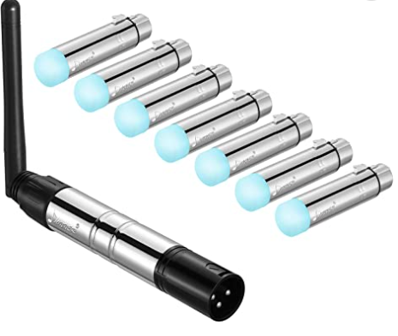

Both Light in g Wireless Battery Powered Par Lights

S6 6x18w RGBWA UV wireless dmx lights (Own 20)

<https://www.bothlighting.com/products/smart-dj-6x18w-rgbwa-uv-6in1-wireless-dmx-led-uplighting-82>

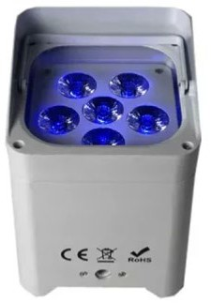

Bothlighting Titan Tubes

[Bothlighting Both Titan IP65 Wireless LED Battery PIXEL Light RGBWA Wireless 360 Tube DMX&IR Remote&App control](https://www.bothlighting.com/products/bothlighting-both-titan-ip65-wireless-led-battery-pixel-light-rgbwa-wireless-360-tube-dmxir-remoteapp-control)

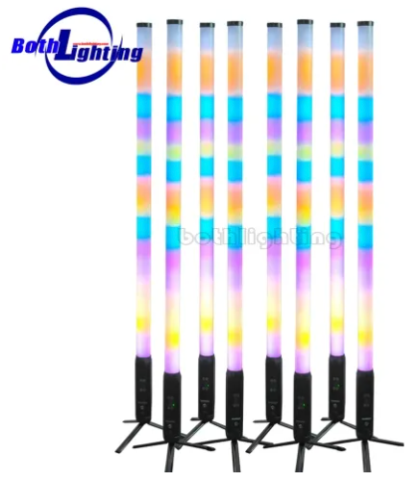

Foam Glow Wands

<https://www.amazon.com/gp/product/B0B7QRLXM7/ref=ppx_yo_dt_b_asin_title_o00_s00?ie=UTF8&th=1>

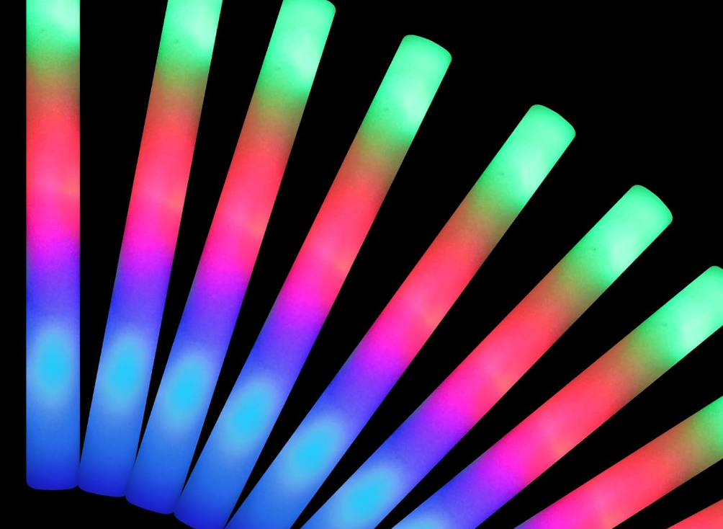

*Offered in selected packages

Ultimate Support TS-90B Te le lock Tripod Speaker Stands

https://www.ult im atesupport .com /products/ts-90b

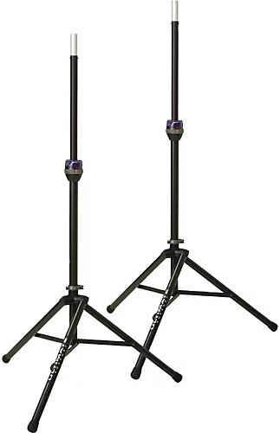

PRORECK Speaker Stand Cover Tripod Stand Skirt Skrims

