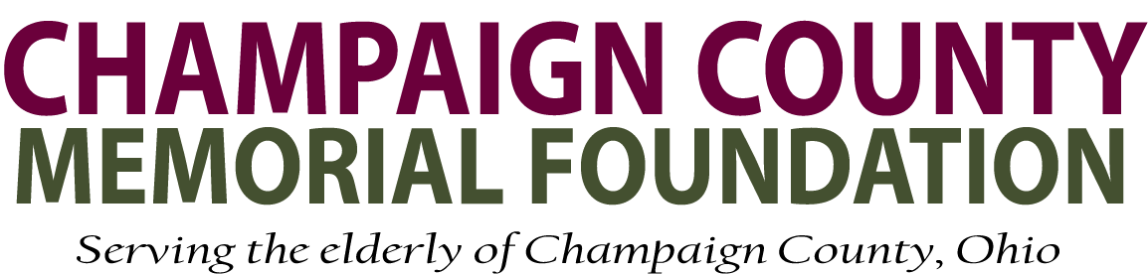

Grant Application Guidelines and Instructions

- Organizations, programs, or projects that directly serve senior citizens – especially the underserved seniors - in Champaign County, Ohio will be considered for a grant. If you have questions concerning your eligibility, please contact us via the website or call a contact below.

- Smaller grant requests may be instructed to use the short grant form.

- The grant application is available at our website as a document on the Grants page as a Microsoft Word document or a PDF. Be sure to save the file after downloading before beginning to fill in the request, re-saving as you go. Please do not submit a handwritten proposal.

- TEN (10) copies of your grant request are due with the submission of, and in addition to, the original grant application.

- Every grant request is read thoroughly. To expedite this process for the Program Committee, we ask the following:
  - Be succinct as possible.
  - Use proper format for writing. For example, please use proper names, do not use all capitals, set font size to 12, and use single spacing.
  - Staple grants in the upper left-hand corner. Do not use plastic covers or sheet protectors.

- Please include only 1 (one) copy of any supplemental materials you decide useful. These should be combined into one larger envelope.

- Completed grant applications may be mailed to the Champaign County Memorial Foundation at:

Champaign County Memorial Foundation
PO Box 866
Urbana, Ohio 43078-0866

If you still have a question concerning your grant, please contact:
Bill Miller, president (937) 243-6847
Vicki Henson, treasurer (937) 750-3574

