DUKE OF CONNAUGH KINDERGARTEN-GRADE 8 LUNCH MENU SEPT/OCT 2021
MON. SEPT 27 | TUE. SEPT 28 | WED. SEPT 29 | THURS. SEPT 30 | FRI. OCT 1
Grilled Cheese___  Fruit/Veg__ | Cheese, Lettuce, Tomato__ Sub__  Fruit/Veg__ | Meatball __or Veggie__ Subs  Fruit/Veg__ | Chicken__ or Cheese___  Quesadillas  Fruit/Veg__ | Jam/Wow Butter__  Sandwich  Fruit/Veg__
MON. OCT4 | TUE. OCT 5 | WED. OCT 6 | THURS. OCT 7 | FRI. OCT 8
English Muffin Pizza__  Fruit/Veg__ | Chicken Salad __or Veggie__  Sub  Fruit/Veg__ | Beef __or Veggie __ Hamburgers  Fruit/Veg__ | Cheese Quesadillas _  Fruit/Veg_ | Bagel w/Cream Cheese __  Fruit/Veg__
MON OCT 11 | TUE. OCT 12 | WED. OCT 13 | THURS. OCT 14 | FRI. OCT 15
THANKSGIVING DAY  NO SCHOOL 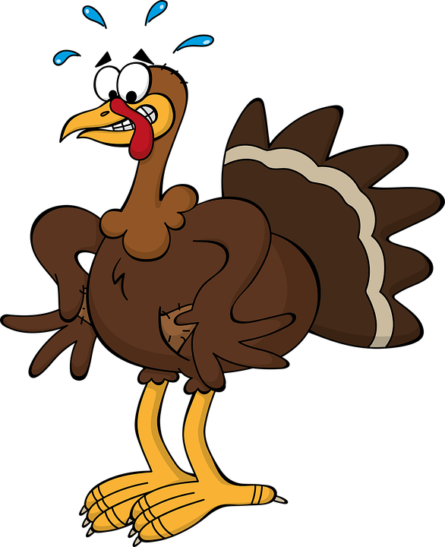 | Cheese, Lettuce, Tomato__ Sub__  Fruit/Veg__ | Meatball __or Veggie__ Subs  Fruit/Veg__ | Cheese, Lettuce, Tomato__ Sub__  Fruit/Veg__ | Jam/Wow Butter__  Sandwich  Fruit/Veg__
MON. OCT 18 | TUE. OCT 19 | WED. OCT 20 | THURS. OCT 21 | FRI. OCT 22
Grilled Cheese___  Fruit/Veg__ | Egg__ or Tofu__ Salad__  Sandwich  Fruit/Veg__ | Beef __or Bean __ Burrito  Fruit/Veg__ | Chicken__ or Cheese___  Quesadillas  Fruit/Veg__ | Bagel w/Cream Cheese __  Fruit/Veg__
MON. OCT 25 | TUE. OCT 26 | WED. OCT 27 | THURS. OCT 28 | FRI. OCT 29
English Muffin Pizza__  Fruit/Veg__ | Chicken Salad __or Veggie__  Sub  Fruit/Veg__ | Meatball __or Veggie__ Subs  Fruit/Veg__ | Cheese Quesadillas__  Fruit/Veg__ | Jam/Wow Butter__  Sandwich  Fruit/Veg__

If you wish to have your child participate in the Lunch Program, it is important that this form is signed and returned along with your payment. Your signature tells us you are giving us permission to provide your child with lunch. Please be sure to fill out any allergies or dietary restrictions so we can be aware of them as well. Please note in the case of a forgotten lunch etc., a lunch will always be provided.
Lunch can be purchased by pre-registering for daily, weekly or monthly. Lunch is $2.00 per day, or $48.00 for
the month of Sept/Oct payment can be made by cash or cheque made payable to Duke of Connaught. Please ONLY check the days that your child will be having lunch, sign and return by, Thursday Sept, 23, 2021. It's always a good idea to make a copy of the menu so your child will know what is for lunch and you will have a record of the days you have signed up for. All food will be individually wrapped or packaged excluding whole or fruit sections. No drinks will be provided. A vegetarian option is available, this menu is Halal acceptable.
Please note: In addition to contributing to the cost of food, a portion of this month’s payment may go towards the purchase of new equipment for the program if required. Given the change in the way and amount of food being delivered this year due to the current situation we are offering lunch “THIS YEAR ONLY $2.00 per meal a day.

Name of student________________________________________
Teacher’s Name_____________________ Room #_______
Allergies or Sensitivities_________________________________ Vegetarian__

Parent’s Signature________________________________________
Number of Lunches_____ x $2.00=$______

