DUKE OF CONNAUGH KINDERGARTEN-HOT LUNCH MENU SEPT/OCT 2022
MON. SEPT 19 | TUE. SEPT 20 | WED. SEPT 21 | THURS. SEPT 22 | FRI. SEPT 23
Mac & Cheese__  Fruit/Veg  Water/Milk | Cheese__ or Cheese bean__  Quesadillas  Fruit/Veg  Water/Milk | Meatball__ or Vegball__  Sub  Fruit/Veg  Water/Milk | Chicken Salad __or Veggie__ Sub  Fruit/Veg  Water/Milk | Grilled Cheese__  Fruit/Veg  Water/Milk
MON. SEPT 26 | TUE. SEPT 27 | WED. SEPT 28 | THURS. SEPT 29 | FRI. SEPT 30
Spaghetti w/Tomato Sauce__or w/Olive Oil__  Fruit/Veg  Water/Milk | Beef __or Bean Burrito__  Fruit/Veg  Water/Milk | Beef__ or Veggie __Chili  Fruit/Veg  Water/Milk | Million Dollar Chicken__ or  w/Tofu__  Fruit/Veg  Water/Milk | Pizza English Muffin__  Fruit/Veg  Water/Milk
MON. OCT 3 | TUE. OCT 4 | WED. OCT 5 | THURS. OCT 6 | FRI. OCT 7
Penne Pasta w/Alfredo _  or w/Olive Oil__  Fruit/Veg  Water/Milk | Beef __or Veggie__ Hamburgers  Fruit/Veg  Water/Milk | Meatball__ or Vegball__  Sub  Fruit/Veg  Water/Milk | Chicken__ or Veg Fried Rice__  Fruit/Veg  Water/Milk | PA DAY  NO SCHOOL
MON OCT 1O | TUE. OCT 11 | WED. OCT 12 | THURS. OCT 13 | FRI. OCT 14
THANKSGIVING DAY  NO SCHOOL  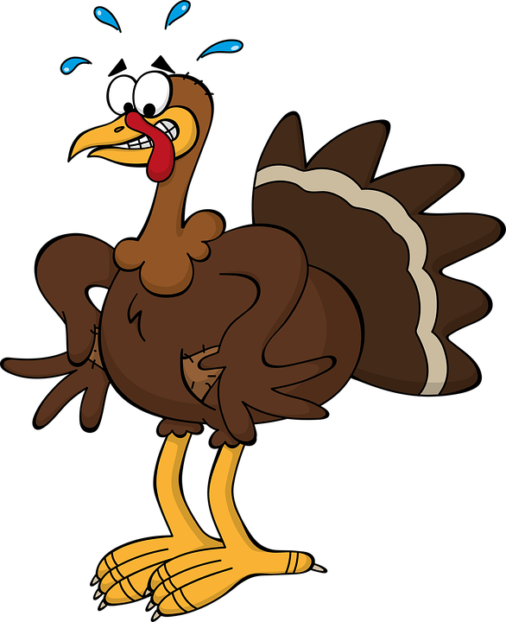 | Beef__or Veggie__w/Taco Chips  Fruit/Veg  Water/Milk | Beef __ or Veggie__ Sloppy Joe  Fruit/Veg  Water/Milk | Chicken Salad __or Veggie__ Sub  Fruit/Veg  Water/Milk | Grilled Cheese__  Fruit/Veg  Water/Milk
MON. OCT 17 | TUE. OCT 18 | WED. OCT 19 | THURS. OCT 20 | FRI. OCT 21
Mac & Cheese__  Fruit/Veg  Water/Milk | Beef Lasagna__ Veg Lasagna__  Fruit/Veg  Water/Milk | Meatball__ or Vegball__  Sub  Fruit/Veg  Water/Milk | Million Dollar Chicken__ or w/Tofu__  Fruit/Veg  Water/Milk | Pizza English Muffin__  Fruit/Veg  Water/Milk
MON. OCT 24 | TUE. OCT 25 | WED. OCT 27 | THURS. OCT 27 | FRI. OCT 28
Spaghetti w/Tomato Sauce__or w/Olive Oil__  Fruit/Veg  Water/Milk | Breakfast for Lunch  Pancakes__  Fruit/Veg  Water/Milk | Beef__ Veggie__ Chili  Fruit/Veg  Water/Milk | Chicken__ or Veg Fried Rice__  Fruit/Veg  Water/Milk | Grilled Cheese__  Fruit/Veg  Water/Milk
MON. OCT 31
Penne Pasta w/Alfredo _
or w/Olive Oil__
Fruit/Veg
Water/Milk

If you wish to have your child participate in the Lunch Program, it is important that this form is signed and returned along with your payment. Our Hot Lunch pricing has returned to the original cost prior to Covid.
Your signature tells us you are giving us permission to provide your child with lunch. Please note, a lunch will always be provided regardless of the situation.
Lunch can be purchased by pre-registering for daily, weekly or monthly. Lunch is $3.00 per day, or $87.00 for
the month of Sept/Oct payment can be made by cash or cheque ONLY, made payable to Duke of Connaught. Please ONLY check the days that your child will be having lunch, sign and return by, September 16, 2022. It's always a good idea to make a copy of the menu so your child will know what is for lunch and you will have a record of the days you have signed up for. All Kindergarten lunches will be delivered to the classroom in a Bento Box. a choice of water or milk will be provided. A vegetarian option is available, this menu is Halal acceptable.
Please note: In addition to contributing to the cost of food, a portion of this month’s payment may go towards the purchase of new equipment for the program if required.

Name of student________________________________________
Teacher’s Name_____________________ Room #_______
Allergies or Sensitivities_________________________________ Vegetarian__
Parent’s Signature________________________________________
Number of Lunches_____ x $3.00=$______

DUKE OF CONNAUGH GRADES 1-8 HOT LUNCH MENU SEPT/OCT 2022
MON. SEPT 19 | TUE. SEPT 20 | WED. SEPT 21 | THURS. SEPT 22 | FRI. SEPT 23
Mac & Cheese__  Fruit/Veg  Water/Milk | Cheese__ or Cheese bean__  Quesadillas  Fruit/Veg  Water/Milk | Meatball__ or Vegball__  Sub  Fruit/Veg  Water/Milk | Chicken Salad __or Veggie__ Sub  Fruit/Veg  Water/Milk | Grilled Cheese__  Fruit/Veg  Water/Milk
MON. SEPT 26 | TUE. SEPT 27 | WED. SEPT 28 | THURS. SEPT 29 | FRI. SEPT 30
Spaghetti w/Tomato Sauce__or w/Olive Oil__  Fruit/Veg  Water/Milk | Beef __or Bean Burrito__  Fruit/Veg  Water/Milk | Beef__ or Veggie __Chili  Fruit/Veg  Water/Milk | Million Dollar Chicken__ or  w/Tofu__  Fruit/Veg  Water/Milk | Pizza English Muffin__  Fruit/Veg  Water/Milk
MON. OCT 3 | TUE. OCT 4 | WED. OCT 5 | THURS. OCT 6 | FRI. OCT 7
Penne Pasta w/Alfredo _  or w/Olive Oil__  Fruit/Veg  Water/Milk | Beef __or Veggie__ Hamburgers  Fruit/Veg  Water/Milk | Meatball__ or Vegball__  Sub  Fruit/Veg  Water/Milk | Chicken__ or Veg Fried Rice__  Fruit/Veg  Water/Milk | PA DAY  NO SCHOOL
MON OCT 1O | TUE. OCT 11 | WED. OCT 12 | THURS. OCT 13 | FRI. OCT 14
THANKSGIVING DAY  NO SCHOOL | Beef__or Veggie__w/Taco Chips  Fruit/Veg  Water/Milk | Beef __ or Veggie__ Sloppy Joe  Fruit/Veg  Water/Milk | Chicken Salad __or Veggie__ Sub  Fruit/Veg  Water/Milk | Grilled Cheese__  Fruit/Veg  Water/Milk
MON. OCT 17 | TUE. OCT 18 | WED. OCT 19 | THURS. OCT 20 | FRI. OCT 21
Mac & Cheese__  Fruit/Veg  Water/Milk | Beef Lasagna__ Veg Lasagna__  Fruit/Veg  Water/Milk | Meatball__ or Vegball__  Sub  Fruit/Veg  Water/Milk | Million Dollar Chicken__ or w/Tofu__  Fruit/Veg  Water/Milk | Pizza English Muffin__  Fruit/Veg  Water/Milk
MON. OCT 24 | TUE. OCT 25 | WED. OCT 27 | THURS. OCT 27 | FRI. OCT 28
Spaghetti w/Tomato Sauce__or w/Olive Oil__  Fruit/Veg  Water/Milk | Breakfast for Lunch  Pancakes__  Fruit/Veg  Water/Milk | Beef__ Veggie__ Chili  Fruit/Veg  Water/Milk | Chicken__ or Veg Fried Rice__  Fruit/Veg  Water/Milk | Grilled Cheese__  Fruit/Veg  Water/Milk
MON. OCT 31
Penne Pasta w/Alfredo _
or w/Olive Oil__
Fruit/Veg
Water/Milk

If you wish to have your child participate in the Lunch Program, it is important that this form is signed and returned along with your payment. Our Hot Lunch pricing has returned to the original cost prior to Covid.
Your signature tells us you are giving us permission to provide your child with lunch. Please note, a lunch will always be provided regardless of the situation.
Lunch can be purchased by pre-registering for daily, weekly or monthly. Lunch is $3.50 per day, or 101.50 for
the month of Sept/Oct payment can be made by cash or cheque ONLY, made payable to Duke of Connaught. Please ONLY check the days that your child will be having lunch, sign and return by, September 16, 2022. It's always a good idea to make a copy of the menu so your child will know what is for lunch and you will have a record of the days you have signed up for. A vegetarian option is available, this menu is Halal acceptable.
Please note: In addition to contributing to the cost of food, a portion of this month’s payment may go towards the purchase of new equipment for the program if required.

Name of student________________________________________
Teacher’s Name_____________________ Room #_______
Allergies or Sensitivities_________________________________ Vegetarian__
Parent’s Signature________________________________________
Number of Lunches_____ x $3.50=$______

