Sharp Park: Japanese Internment

Shortly after Japan bombed Pearl Harbor on Dec. 7, 1941, President Franklin D. Roosevelt signed Executive Order 9066, which allowed the military to force people of Japanese descent, including American citizens, into internment centers, a shameful chapter of American history.
Japanese Americans that the government considered “highly dangerous” were assembled at Sharp Park, which opened in a former Depression-era relief camp. They were community leaders, Buddhist priests, scholars and others deemed influential by the government.
The most comprehensive account by a Japanese internee of Sharp Park comes from Yamato Ichihashi. He was 16 years old when he immigrated from Japan to San Francisco in 1894, a time when Asians faced heavy racism. Ichihashi was a determined scholar, attending Lowell High School, then Stanford, and eventually Harvard, where he got his doctorate. He accepted a position at Stanford, teaching international relations and Japanese studies.
“He may have been the most esteemed or certainly one of the most esteemed members of the Japanese American community nationally,” said Gordon Chang, a Stanford professor who has studied Ichihashi’s life.
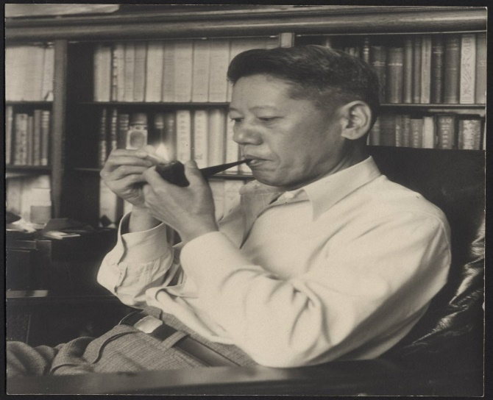
According to Chang, Ichihashi thought of himself as an American, naming his son Woodrow, after President Woodrow Wilson. When the war began, he publicly condemned the Japanese military for starting conflict with the United States and purchased $100 U.S. war bonds every month.
In May 1942, Ichihashi and his wife, Kei, saw signs around Stanford’s campus instructing people of Japanese ancestry to report to a spot with only what they could carry. When they arrived, they were taken to the Santa Anita Racetrack near Los Angeles. After they were shuffled to different camps, Ichihashi was informed he alone would be transferred back to the Bay Area — to Sharp Park.
He was separated from Kei and Woodrow for two months while incarcerated at Sharp Park. According to his diaries, there were tall iron net fences that surrounded the camp with 10 army barracks within it.
“I was pleasantly surprised at the make-up of this camp, particularly [after] my experience at the crowded Santa Anita Center. When I reached there, the flowers were in full bloom; the sight was delightful to the eye. Treatment was satisfactory– food abundant though often too greasy and powerfully seasoned with garlic; supplies were freely given such as toothbrush and paste. Sheets and pillowcases were changed every Monday, blankets were clean.”
Because Sharp Park specifically held Japanese Americans with supposed influence, the U.S. government treated them carefully for fear of Japanese armies treating American prisoners poorly. Sharp Park held about 500 prisoners, compared to the thousands at other camps. Ichihashi was held at Sharp Park from late August to late October 1942 before being reunited with his family at Tule Lake.
Over the next three years that Ichihashi was incarcerated, he continued to keep diaries of the day-to-day happenings inside the camps. As the years went on, he wrote less.
“He accumulated a substantial portion [of his experiences] but this material became less rich because he’s sort of reduced to just an internee and no longer a scholar,” said Chang. “He very much felt this was a challenge to his dignity and his prestige and he tried to recreate for himself a sort of world in which he was highly regarded, but in a prison camp, he’s just a number.”
When the imprisonment of Japanese Americans ended in 1945, the Ichihashis were released, but they did not look forward to returning. Anti-Japanese sentiment was still high, and leaving the camps felt dangerous. While imprisoned, many Japanese Americans lost their homes and businesses, and their possessions were stolen.
Ichihashi was a changed man. “His professional career had been crushed and he was no longer an active faculty member,” Chang said. “His marriage fell apart; he was disaffected with his son. After he got out, he was very much a broken person, as many of the older Japanese Americans were.”
Ichihashi had worked hard to assimilate and achieve the supposed American dream. But it wasn’t enough. “There is this long history in the United States of those from Asia being held as somehow perpetually foreign,” said Chang. In the eyes of the U.S. government, Ichihashi was a dangerous foreigner, and that classification destroyed him.
--Excerpted from KQED Bay Curious 2022

