Part 1 - Seeing Your Dog

recognizing fear, anxiety, and stress by reading dog body language,
identifying critical periods of development and categories of socialization

“Many future behavior problems can be prevented through proper socialization, including:
1) aggression to dogs and people
2)fear of people, places and things
3)anxiety-related problems
4)nuisance behaviors such as jumping, chewing, stealing objects, and excessive barking”
(Puppy Start Right Martin, K. DVM and D. Martin, RVT (2011) page 25)

Part 2 - Building Trust: taking treats, eye contact and more
Part 3 - Positive Reinforcement Training basics
Part 4 – Building Confidence with Environmental Enrichment
Part 5 – Look at That – Socialization while standing still
Part 6 – Active Socialization with approach and retreat

Fear, Anxiety, Stress poster (in 2 parts, below) from www.fearfreehappyhomes.com
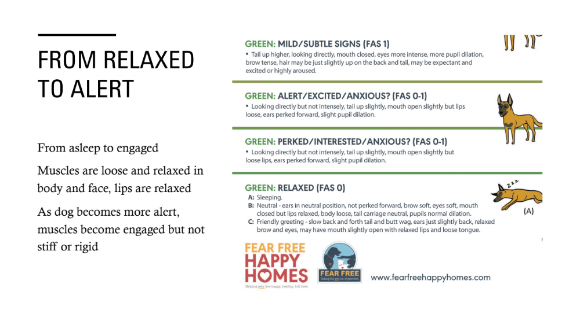
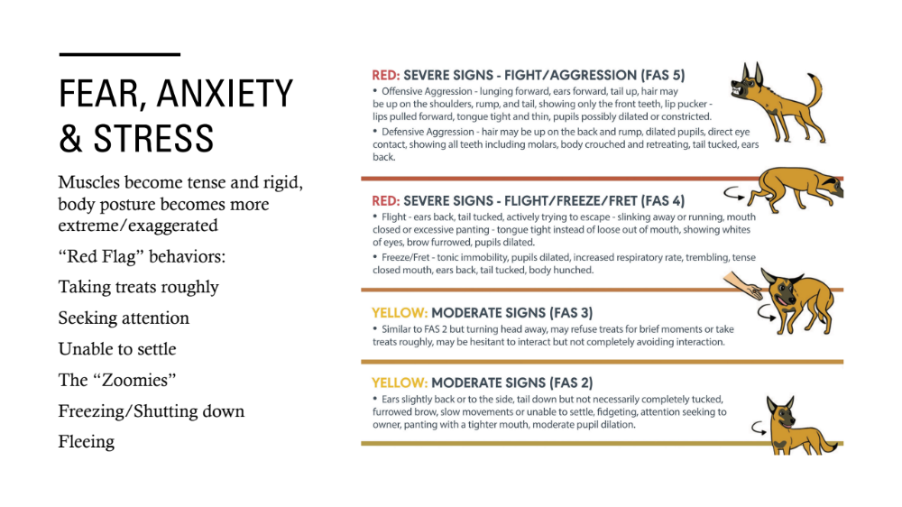

Seeing your dog - look at the big picture first, what is your overall impression?
relaxed or tense?
excited or calm?
do I feel safe or not safe?

Body language does change with growth and development, increased mobility of body parts
and expression with maturity, then decreases with extreme age.

Tail – what is the resting position? Movement and activity change tail position.
lowered tail indicates stress
raised tail indicates arousal

Head – relaxed or tense?
Eye shape: relaxed to round to narrowed
Brows: relaxed to raised
Pupils: relaxed to dilated
Ears: relaxed to forward, up or back
(can move independently)
Mouth: open to closed, lips relaxed to tight
Teeth exposed to displayed

Indicators of stress/anxiety:
Whale eye (whites of eyes exposed) ears often pulled back
“Anxiety face” may look blank/flat, eyes dilated, round, body still

Socialization – a lifelong process of successfully* pairing encounters with novel stimuli and
new environments with positive reinforcement for the dog
*without causing fear or avoidance

Categories of Socialization
Environments – indoors, outdoors, public and private spaces
People – different ages and appearances, variety of movements
Animals – pets, farm animals, wildlife
Novel Objects – vehicles, household appliances, yard equipment
Sounds – indoors, outdoors, natural and artificial
Surfaces – indoors, outdoors, different textures

Developmental periods
Prenatal – in utero
Neonatal – birth to 12 days – limited sensory perception
Transitional – 12 days to 3 weeks - eyes open, start walking, ears open
Socialization – 3 weeks to 12-16 weeks - open to new experiences
Juvenile – 12 weeks to sexual maturity – becomes more fearful, permanent teeth
Adolescent – sexual to social maturity (2 – 3 years) – becomes more independent
Adult – social maturity 2 – 3 years to 7+ years – play behavior may decrease
Senior – 7+ years and onward – activity level may decrease

Socialization Periods
Primary Socialization: 3-5 weeks of age, learn to be a dog, brain not fully developed yet
1st Fear Period: about 1 week period within 8-10 weeks of age (avoid trauma)
Secondary Socialization: 6 -12 (up to 16 weeks old) puppies naturally less fearful
2nd Fear Period 1-3 weeks long within 6 to 14 months of age (avoid trauma)

References
- Canine Behavior A Photo Illustrated Handbook Barbara Handelman (2008)
- Fear in Dogs Lynda Taylor MSc (2020)
- From Fearful to Fear Free Becker, M. et. al. (2017)
- Puppy Start Right Kenneth M. Martin, DVM & Debbie Martin, RVT,VTS (Behavior) (2011)
- American Veterinary Society of Animal Behavior www.avsab.org
- see AVSAB Resources tab for referrals and position papers
- www.fearfreehappyhomes.com

