**Date:** 9/16/19

**To:** Dr. Robabeh Jazaei

**From:** Zachary S.

**Cc:** Zachary S., Joshua J. and Kale M.

**Re:** Follow up memo to the Pressure Measurements lab

The objective for Lab #2 consisting of pressure measurements was to measure the pressure in a simple manometer and piezometer and compare the results with the theoretical pressure. Although there are many methods of measuring pressure, this lab focused on the measurements of a simple manometer, as well as, equations to calculate the pressure for a piezometer and manometer referenced in **Appendix A**.

The apparatus began by pumping air from the pressurized cylinder connected to the simple manometer and piezometer. Once enough pressure was built up, the group measured and recorded all heights (h1-h4) in the apparatus from the floor, as well as, the pressure indicated in the pressure gauge in (psi) units. This process was repeated with six trials of results for comparative analysis.

The results can be seen in **Appendix A** and **Appendix B**. Sample calculations can be seen in **Appendix C**. For example, in trial 1 the read pressure was 1.00 psi while the piezometer was calculated to be 14.844 psi and the manometer was calculated to be 41.361 psi. This gives a 4036% error which is very far off the original value of 1.00 psi the gauge read. The group was told ahead of time that the values will be far off due to the equipment not being calibrated. Since all the equipment the group was using was not calibrated, it makes sense that there is a very large percent error.

This lab was conducted to determine if the pressure measurements in a simple manometer and piezometer compared to the theoretical pressure. With the equipment not being calibrated, the data the group collected was inaccurate and led to a very large percent error. To improve the accuracy of this experiment, a way to calibrate the equipment as well as a more precise way to measure the height values will be needed to improve accuracy and match the theoretical value.

**Appendix A**

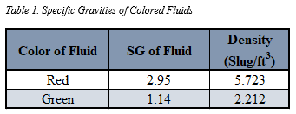

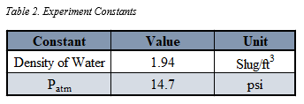

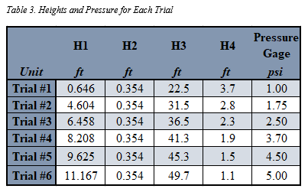

**Piezometer Equation**



**Simple Manometer Equation**



**Appendix B**

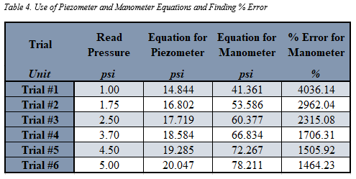

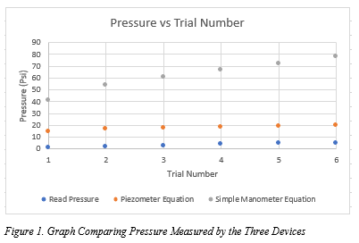

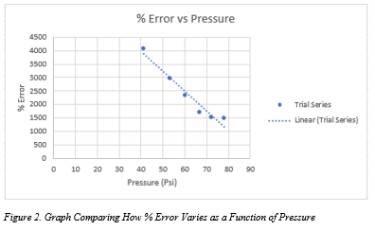

**Appendix C**

*Sample Calculations:*

