**Linear Momentum**

**Laboratory #5**

Prepared for

Dr. Robabeh Jazaei

Department of Civil and Environment Engineering

University of Wisconsin-Platteville

Prepared by:

Brian B., Mark B., Samuel E., Chris V.

Date Laboratory Performed: October 7, 2019

Date of Submittal: October 21, 2019

# Abstract

The product of mass and velocity vector of a body is referred to as Linear Momentum. The objective of this lab is to determine the force impact of the jet apparatus with twelve total trials on three different plate types including a flat 90 ̊ plate, hemispherical 180 ̊ plate, and a 120 ̊ cone plate. Results from all trials were recorded and used to determine if the percent error and standard error were uniform for each plate type over different velocities. After performing the experiment, it was noticed that the actual force, velocity and flow rate followed similar tendencies within each of the three plate types corresponding with amount of weight. For example, an increase in actual force, velocity and flow rate led to a decrease in percent error but no change in standard error.

Table of Contents

Abstract 2

Introduction 4

Procedure 4

Results and Discussions 8

Conclusions 11

Sample Calculations 12

References 13

Table of Figures

Figure 1: Linear Momentum Apparatus (Lab 5: Linear Momentum Handout) 5

Figure 2: Hemispherical Vane, 120o Vane, and Flat Vane (Lab 5: Linear Momentum Handout) 5

Figure 3: Assembly for vane (Lab 5: Linear Momentum Handout) 6

Figure 4: Water Jet's Effect on a Flat Surface 7

Figure 5: Water Jet's Effect on a Hemispherical 7

Figure 6: Water Jet's Effect on a 120° Conical 8

Table of Tables

Table 1: Experimental Data for Flat 9

Table 2: Experimental Data for Hemispherical 9

Table 3: Experimental Data for 120o Conical 9

Table 4: Standard Dev and % Error for Flat 10

Table 5: Standard Dev and % Error for Hemispherical 10

Table 6: Standard Dev and % Error for Conical 10

# Introduction

The impact of a jet on a different target measuring the net force on a target simulates the Engineering application of understanding hydraulic machinery as it relates to generating electricity. This experiment uses the idea of Newton’s second law of force equaling mass flow rate multiplied by the change in velocity and can be expressed as, F=ṁ (V1-V2). Linear momentum is the product of mass and velocity vector of a body in which Newton’s second law can also be expressed as the rate of change of the momentum of a body equaling the net force acting on a body. The flow rate entering a controlled volume equaling the flow rate exiting a controlled volume is used to find the steady flow rate and is known as the combination of energy and continuity equation. Using both Newton’s second law and the combination of energy and continuity equation, mass flow rate and change in velocity will be found to ultimately calculate the force acting on the plates.

# Procedure

The group started the experiment by leveling the apparatus shown in Figure 1. The pointer and the weight carrier were leveled prior to starting the experiment. The three vanes are the hemispherical vane, the 120o vane, and the flat vane. Once the weight carrier and pointer were leveled, the flat vane was selected as shown in Figure 2. After the flat vane has been selected, it is then assembled using the assembly shown in Figure 3 and is attached to the machine.

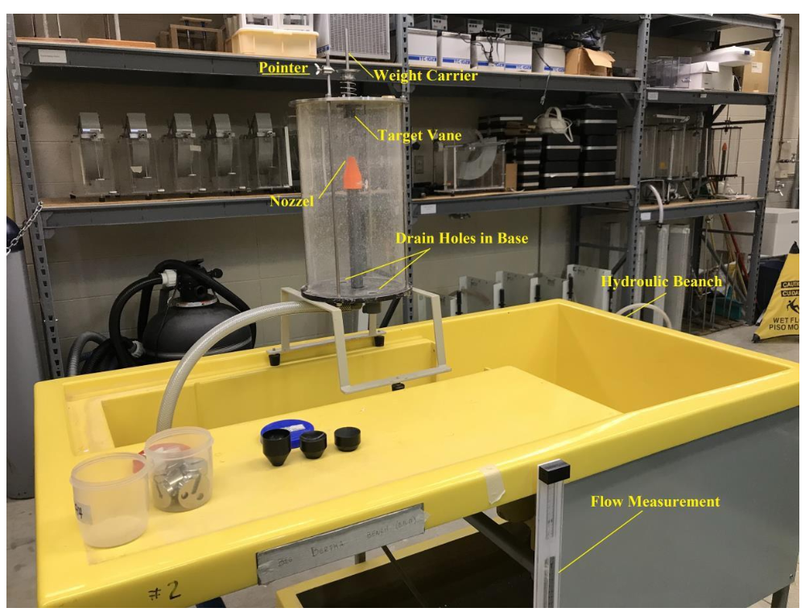

Figure : Linear Momentum Apparatus (Lab 5: Linear Momentum Handout)

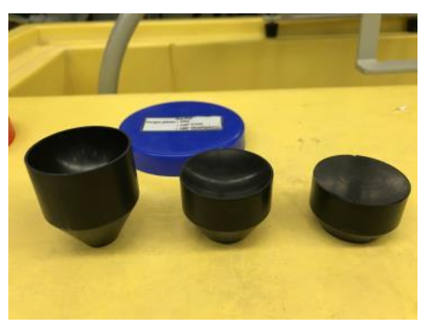

Figure : Hemispherical Vane, 120o Vane, and Flat Vane (Lab 5: Linear Momentum Handout)

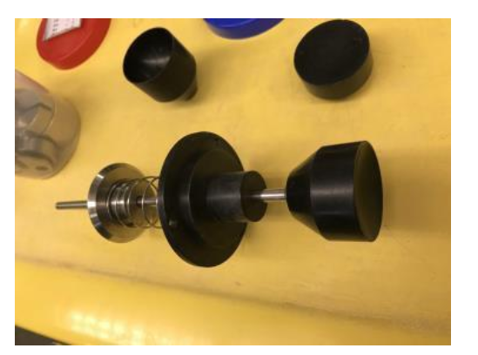

Figure : Assembly for vane (Lab 5: Linear Momentum Handout)

The group turned on the pump below the hydraulic bench and shot water up at the flat vane. The weight carrier rose above the pointer so the group added mass to the weight carrier to make it level with the pointer. The amount of mass was recorded. The group had to record the flow as well. The group did this by using the piezometer that is in the hydraulic bench and recording the time it took for water to rise from the 3 Liter mark to the 8 Liter mark. This marks the end of a trial. A total of 3 more trials were conducted with the flat vane and the mass added and flow were recorded. This process was repeated for the 120o vane and the hemispherical vane. The data can be seen in Results and Discussions.

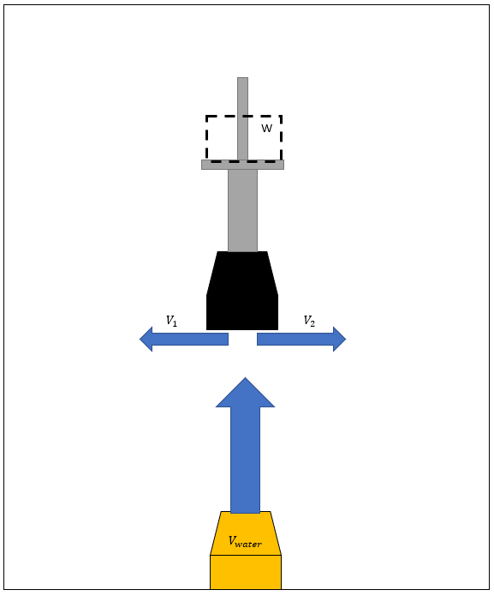

Figure : Water Jet's Effect on a Flat Surface

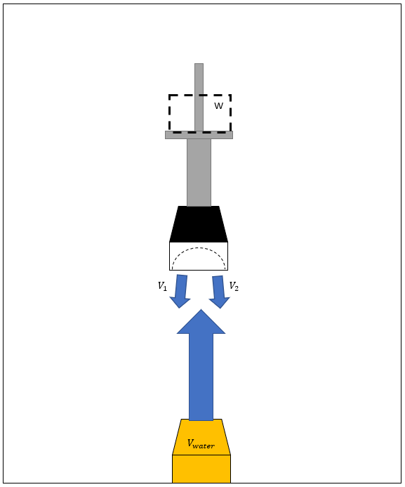

Figure : Water Jet's Effect on a Hemispherical

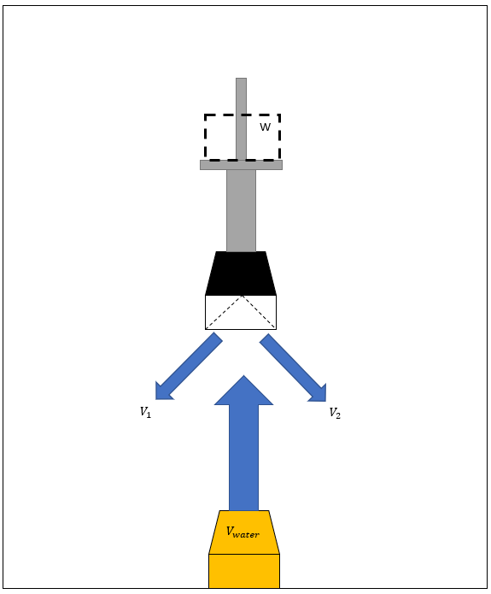

Figure : Water Jet's Effect on a 120° Conical

# Results and Discussions

The data found during the lab, as well as the data required to fully understand the purposed of this lab, can be found throughout Tables 1-3. As can be seen throughout Tables 3-6, this test is anything but accurate. The context of this lab does not properly take into effect other forces acting on the streams. The percent error tends to get better with the increase of the velocity, while the Standard Error is not affected. It is clear to see that the percent error does change with the type of plane that is being utilized. You cannot max out the weight on the plates, since the force of the water jet is directly related to that of the mass on the plate.

Table : Experimental Data for Flat

|  |  |  |  |  |  |  |  |  |
| --- | --- | --- | --- | --- | --- | --- | --- | --- |
| Flat | Mass (g) | Weight (N) | Volume of Water (lit) | Time (s) | Flow (lit/s) | Velocity (m/s) | Fpractical (N) | Factual (N) |
| Trial 1 | 100 | 981 | 5 | 25.46 | 0.196 | 10001.88 | 981 | 1964.23 |
| Trial 2 | 200 | 1962 | 5 | 19.32 | 0.259 | 13180.53 | 1962 | 3411.11 |
| Trial 3 | 300 | 2943 | 5 | 15.33 | 0.326 | 16611.08 | 2943 | 5417.84 |
| Trial 4 | 400 | 3924 | 5 | 13.52 | 0.370 | 18834.90 | 3924 | 6965.57 |

Table : Experimental Data for Hemispherical

|  |  |  |  |  |  |  |  |  |
| --- | --- | --- | --- | --- | --- | --- | --- | --- |
| Hemispherical | Weight (g) | Weight (N) | Volume of Water (lit) | Time (s) | Flow (lit/s) | Velocity (m/s) | Fpractical (N) | Factual (N) |
| Trial 1 | 100 | 981 | 5 | 36.00 | 0.139 | 7073.55 | 981 | 1677.12 |
| Trial 2 | 200 | 1962 | 5 | 28.83 | 0.173 | 8832.74 | 1962 | 2615.05 |
| Trial 3 | 300 | 2943 | 5 | 23.20 | 0.216 | 10976.20 | 2943 | 4038.25 |
| Trial 4 | 400 | 3924 | 5 | 20.26 | 0.247 | 12569.00 | 3924 | 5295.30 |

Table : Experimental Data for 120o Conical

|  |  |  |  |  |  |  |  |  |
| --- | --- | --- | --- | --- | --- | --- | --- | --- |
| 120o Conical | Weight (g) | Weight (N) | Volume of Water (lit) | Time (s) | Flow (lit/s) | Velocity (m/s) | Fpractical (N) | Factual (N) |
| Trial 1 | 100 | 981 | 5 | 32.25 | 0.155 | 7896.06 | 981 | 612.10 |
| Trial 2 | 200 | 1962 | 5 | 22.10 | 0.226 | 11522.53 | 1962 | 1303.45 |
| Trial 3 | 300 | 2943 | 5 | 18.25 | 0.274 | 13953.31 | 2943 | 1911.41 |
| Trial 4 | 400 | 3924 | 5 | 15.60 | 0.321 | 16323.58 | 3924 | 2615.96 |

Table : Standard Dev and % Error for Flat

|  |  |  |  |
| --- | --- | --- | --- |
| Flat | Mean (N) | Standard Dev (N) | % Error |
| Trial 1 | 4439.69 | 2475.45 | 100.23% |
| Trial 2 | 4439.688 | 1028.58 | 73.86% |
| Trial 3 | 4439.688 | 978.15 | 84.09% |
| Trial 4 | 4439.688 | 2525.88 | 77.51% |

Table : Standard Dev and % Error for Hemispherical

|  |  |  |  |
| --- | --- | --- | --- |
| Hemispherical | Mean (N) | Standard Dev (N) | % Error |
| Trial 1 | 3406.43 | 1729.31 | 70.96% |
| Trial 2 | 3406.43 | 791.38 | 33.28% |
| Trial 3 | 3406.43 | 631.82 | 37.22% |
| Trial 4 | 3406.43 | 1888.87 | 34.95% |

Table : Standard Dev and % Error for 120° Conical

|  |  |  |  |
| --- | --- | --- | --- |
| 120o Conical | Mean (N) | Standard Dev (N) | % Error |
| Trial 1 | 1610.73 | 998.63 | 37.60% |
| Trial 2 | 1610.731 | 307.28 | 33.57% |
| Trial 3 | 1610.731 | 300.68 | 35.05% |
| Trial 4 | 1610.731 | 1005.23 | 33.33% |

# Conclusions

After performing this experiment, a lot can be learned on the topic of force and linear momentum when observing the jet apparatus. The experiment concluded that an increase in force, velocity and flow correlates to a decrease in percent error. Although actual force was found, this experiment allotted room for unclarity when calculating the actual force from the results of the trials.

# Sample Calculations

*\*all sample calculations were carried out for hemispherical trial 1*

# References

Çengel Yunus A., & Cimbala, J. M. (2006). *Fluid mechanics: fundamentals and applications*.

Boston: McGraw-HillHigher Education.