
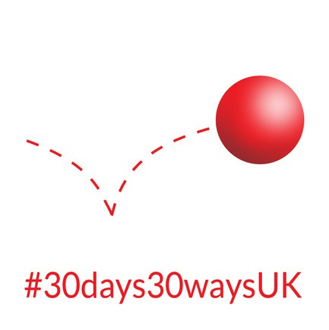
Supported by the stewardship of

Emergency Risk Communication
-Disaster Risk Reduction

2025 Campaign Programme

#30Days30WaysUK
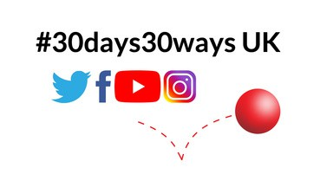

An emergency preparedness campaign on social media that connects, informs, and suggests activities to boost personal resilience during “September is Preparedness Month”





Distribution:
2025 Campaign Programme
#30Days30WaysUK
Neil Shaefer
2025-08-19 20:52:57
--------------------------------------------
x

EPS 30Days30WaysUK PWG; UK Emergency Planners; UK Emergency Responders; UK Local Government; Environment Agency, Highways, NHS, Met Office, Rail; NGO’s and charitable organisations; EM/Risk/DRR professionals & academics

Hi Everyone,

We’re excited to share that the annual #30days30waysUK September is Preparedness Month Programme is back for its 11th edition!

Here’s what’s coming up:
Find us on Resilience Direct – everything you need for the campaign in one place.
Partners Meeting: Wednesday, 7 August at 1pm (Microsoft Teams)
Final Pre-Flight Meeting: Wednesday, 21 August at 1pm (Microsoft Teams)
Weekly Roundtable Panels/Pod Casts: Join us each Friday at 11am in September (5, 12, 19, 26) for lively discussions with Cat 1 & 2 responders, NGOs, and more. Live on MS Teams, with recordings shared later via YouTube (@30days30waysUK).
The UK Household Preparedness Survey returns, hosted by West Northants Council – we’d love your help promoting it when links go live!

Invites are going out soon, and we’ll be finalising panel details by August.

If you’d like to get involved or join a session, please don’t hesitate to reach out. All links and updates will be shared via our website and social media.

For more information about the campaign, check out our new home on the Emergency Planning Society website: 👉30days30waysUK | The Emergency Planning Society (EPS)

Thanks for your continued support – we’re looking forward to another great year! Warm regards,
Joanne Maddams | co-founder,
Emergency Planning & Business Continuity Manager, West Northamptonshire Council Northampton, 10 July 2025

30days30waysuk@the-eps.org Resilience Direct Discussion Pages Resilience Direct 2025 Campaign Documents

2025 Campaign Programme
#30Days30WaysUK

Background
Since 2015, #30days30waysUK ‘September is Preparedness Month’ aims to boost personal and collective resilience and preparedness through daily themed all hazard information based on the National Risk Register (NRR), resources links and activities. Dissemination is via social media. The approach uses positive psychology, humour, and gamification to engage and inspire the public to “get equipped, make a plan, be informed”.

Rather than being simply directive, #30days30waysUK uses memes and narrative to:

Connect and facilitate the understanding of risks Empower personal preparedness through easy steps Inform recovery and resilience

Daily risk/preparedness themes are discussed under hashtag #30days30waysUK throughout ‘September is Preparedness Month’ across a wide range of partners. This enables the public to follow along at their leisure, accessing free resources such as informative video, household emergency plan leaflets and templates.

Weekly panel sessions will again take place as pioneered in 2022 and our annual household preparedness survey will run. To stay informed about the campaign, please sign up to our email 30days30waysuk@the-eps.org

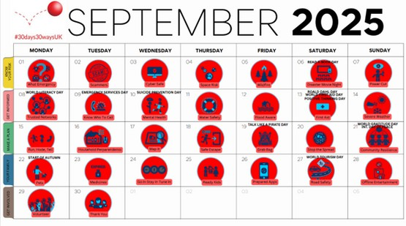
Programme 2025 – full size version on Resilience Direct

“The COVID-19 pandemic has also highlighted the critical role of
the public in preparing for and responding to rises…
Preparedness advice for the
public: (1) understand the risks (2) take steps to prepare (3) know
how to respond (4) help with recovery…”

National Risk Register 2020

"Building the UK's national
resilience: to establish a 'whole- of-society' approach to resilience so that individuals, businesses
and organisations all play a part... As part of this we will improve government
communications to the public on preparedness..."

Integrated Review 2021

"Active communication with the public about risk is a crucial
element of a comprehensive
resilience strategy… there is no evidence that providing the
public with risk and resilience information leads to panic
amongst the population … [the NRR] profile must be increased
through an active and continuing media campaign inc. via
social media…”

House of Lords, Select Committee on Risk Assessment and Risk
Planning, 2021

2025 Campaign Programme
#30Days30WaysUK

Daily Challenges

How to join
ALL welcome to inform and
Background 3
Daily Challenges 4
Themes 5

empower personal and community resilience ‘September is Preparedness Month’ #30days30waysUK

CREATE social media posts following the daily themes as per schedule:

empowering, reassuring engaging images/video link to local/national information and resources

SHARE

Preparedness Survey Daily Activity Links
@30days30waysUK posts with comment
#30days30waysUK key partners posts

LIKE

@30days30waysUK posts #30days30waysUK key partners posts
Mon 01 Sep
What Emergency 8



Annex - Resources 42
Tue 02 Sep | Scammers | 9
Wed 03 Sep | Cyber Safe | 10
Thu 04 Sep | Space Risk | 11
Fri 05 Sep | Wildfire | 12
Sat 06 Sep | Disaster Movie Night | 13
Sun 07 Sep | Power Cut | 14
Mon 08 Sep | Trusted Networks | 16
Tue 09 Sep | Know Who To Call | 17
Wed 10 Sep | Mental Health | 18
Thu 11 Sep | Water Safety | 19
Fri 12 Sep | Flood Aware | 20
Sat 13 Sep | First Aid | 21
Sun 14 Sep | Severe Weather | 22
Mon 15 Sep | Run, Hide, Tell | 24
Tue 16 Sep | Household Preparedness | 25
Wed 17 Sep | Mapping | 26
Thu 18 Sep | Safe Escape | 27
Fri 19 Sep | Grab Bag | 28
Sat 20 Sep | Stop The Spread | 29
Sun 21 Sep | Community and Business Resilience | 30
Mon 22 Sep | Pets | 32
Tue 23 Sep | Medicines | 33
Wed 24 Sep | Go In, Stay In, Tune In | 34
Thu 25 Sep | Ready Kids | 35
Fri 26 Sep | Prepared Apps | 36
Sat 27 Sep | Road Safety | 37
Sun 28 Sep | Off Line Entertainment | 38
Mon 29 Sep | Volunteer | 40
Tue 30 Sep | Thank you/Wrap | 41

2025 Campaign Programme
#30Days30WaysUK

Themes
This year we will have five main weekly themes throughout the month so that partners can take part on a daily basis or a weekly, as needed. Weeks start on a Monday.
Week One



Week Two


Week Three


Week Four



Week Five

KNOW YOUR RISK
By understanding and preparing for the risks you might encounter, you can significantly enhance your ability to respond effectively and recover from emergencies or disasters.

GET INFORMED
Getting reliable information during an emergency is crucial for making informed decisions and staying safe.

MAKE A PLAN
Creating an emergency plan is essential to ensure you and your family are prepared for various scenarios.

PROTECT YOUR FAMILY
Protecting your family, including children and pets, during emergencies involves proactive planning and acquiring essential skills.

GET INVOLVED
Getting reliable information during an emergency is crucial for making informed decisions and staying safe.

Creating
preparedness weekly themes can help
partners focus on different
aspects of emergency
preparedness
throughout the Month.

In l\lovember 1970, officials in Oregon, USA decided 10 blow up a rotting whale carcass. he whole thingi went horribly wrong.

Why do we bring this up? Well, this story r;;in teach u, 3
thing, about #coronavirus [I

How would you prepare fOf a d nos,u, inv �
.I. Make sure you haw a contacts 11st
W Prepare a - ab8ag
..- Ptan together as a household

- Prc-parcdKlds 30tJays30waysut

Howwould you prepare for a dinosaur

₀ n ". .,.
c1dDay Would you know what to do in
,hen someone needs FirstA1d?Check
.uk/fir.a-aid for advice, useful apps or d course near you Day 11 of
UK

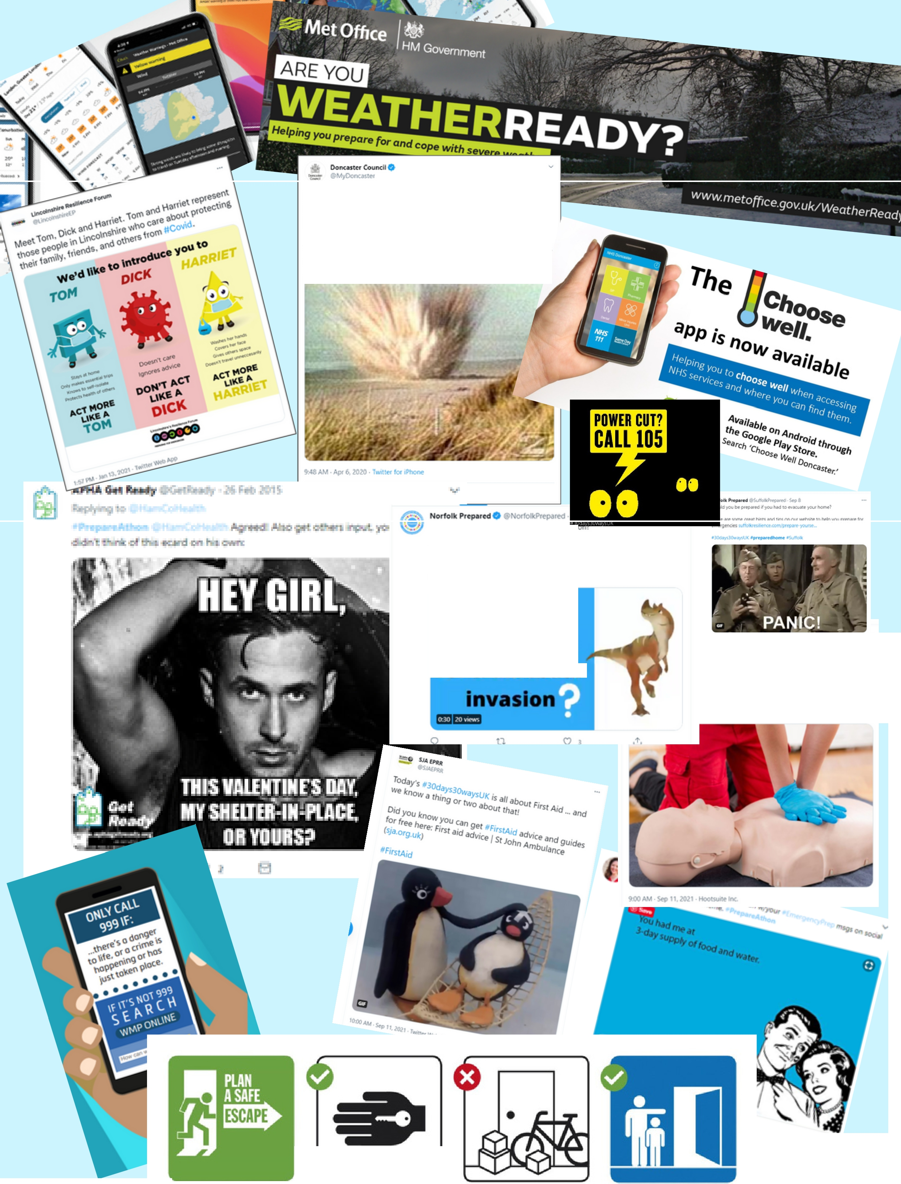

Plan an escape route Have keys ready Keeip exits free Practise your plan

WEEK ONE

Know Your Risk




2025 Campaign Programme

#30Days30WaysUK
Mon 01 Sep What Emergency

Scope

30days30waysUK introduction. What if? What is/is not an emergency? Introduction to hazards, risks, past events, local risk and resilience information.

Introduce/promote UK household preparedness survey

Lead & Key Partners

LRFs, local government & partners, health

Suggestion for Partners

Showcase past events and local risks
Link to your community risk register & resources Use/share 30days30waysUK YouTube video
resources e.g. CRR explained, Community Emergency Plan explained, What to plan and prepare for

Hashtags

Part of/ Day 1 #30days30waysUK; #PreparednessMonth #UnderstandRisk; #PlanAheadUK
Daily Challenge

Find your local Community Risk Register and identify your local risks.

Key Messages – top tips

Emergencies can happen with little or no warning Knowing about local risks informs & empowers Heed warnings, follow official advice (trusted networks will be discussed tomorrow on day 2) Help will arrive but may take some time, there is much you can do personally to be better prepared for all kinds of emergencies.


2025 Campaign Programme

#30Days30WaysUK
Tue 02 Sep Scammers

Scope

Fraud is when a person lies to you, or 'scams' you, to gain an advantage, such as taking your money or learning private information about you. This could be via email, text, phone or in person, either on the street or on your doorstep. Some adults may be especially vulnerable to fraud and financial abuse.

Promote UK household preparedness survey.

Lead & Key Partners

LRFs, local government & partners, Action Fraud, NCSC.

Suggestion for Partners

Share tips on how to spot scams
Share common scams and how to avoid them Common door step scams

Hashtags

#30days30waysUK; #PreparednessMonth; #Scams

Daily Challenge
Go to action fraud website and look at the a to z of fraud.

Key Messages – top tips

Verify Identities: Always verify the identity of the person or organization contacting you. Use official contact information rather than contact details provided in the message.
Be Skeptical: If something sounds too good to be true, it probably is. Be cautious of unsolicited offers or requests for urgent action.
Don’t Share Personal Information: Never share personal information, such as NI numbers, bank details, or passwords, unless you are certain of the recipient’s legitimacy.
Use Secure Websites: When shopping online, ensure the website is secure (look for "https://" and a padlock icon in the address bar).
Check Reviews and Ratings: Research the company or individual offering products, services, or investments. Look for reviews and ratings from trusted sources.
Use Strong Passwords: Use unique, strong passwords for different accounts and enable two-factor authentication whenever possible.
Monitor Accounts: Regularly check your bank and credit card statements for unauthorised transactions.


2025 Campaign Programme

#30Days30WaysUK
Wed 03 Sep Cyber Safe

Scope

Stay safe online, secure devices, use strong passwords, report suspicious activity e.g. email phishing scams, social media content. ‘Upgraded’ Action Fraud (Fraud Strategy).

Promote UK household preparedness survey .

Lead & Key Partners

LRFs, local government & partners, Action Fraud, NCSC

Suggestion for Partners

Share / link to official advice, top tips Share best practice

Hashtags

#30days30waysUK; #PreparednessMonth #CyberSafe #CyberAware #ActionFraud #TakeFive
Daily Challenge

Check you have passwords that meet standards. Have a look at this website to see how secure your password is: https://www.security.org/how-secure-is-my-password/

Key Messages – top tips

Fraud and cybercrime are ubiquitous, stay informed to avoid becoming a victim
Update devices, layers of security
Know who to report fraud and suspicious content


2025 Campaign Programme

#30Days30WaysUK
Thu 04 Sep Space Risk

Scope

Planetary Defense, Near Earth Objects (NEO), Space Risk. Asteroid risk is not yet on the NRR (only space weather) so raising awareness for asteroids and comets is important.

Promote UK household preparedness survey .

Lead & Key Partners

LRFs, local government & partners, community organisations

Suggestion for Partners

Share UN/UK AsteroidDay resources UK and intl. impact events in the past

Hashtags

#30days30waysUK; #PreparednessMonth #PlanetaryDefense #NEOs
Daily Challenge

Have a look at the Government’s National Space Strategy - www.gov.uk/government/publications/national-space- strategy

Key Messages – top tips

Do look up – why not become a citizen scientist


2025 Campaign Programme

#30Days30WaysUK
Fri 05 Sep Wildfire

Scope

Wildfire risk, prevention, grass fires, moor fires. Promote UK household preparedness survey .

Lead & Key Partners

FRS, NFCC, EA, LRFs, local government & partners

Suggestion for Partners

Share / link to official advice, top tips

Sources Suggestions: Climate Change and UK Wildfire POSTnote 603; MetOffice, England and Wales WildFireForum EWWF, NFCC Wildfire Prevention (social media resources zip folder); Northumberland FRS WildFire Prevention Toolkit; NYFRS toolkit, Kirklees Council Moorland Fire video; Communities Prepared blog,

Hashtags

#30days30waysUK; #PreparednessMonth #WildfireAware #WildFireSafety
Daily Challenge

Check information on how to prevent wildfires and follow local guidance when visiting the countryside.

Key Messages – top tips

Be #WildFireAware: respect warnings Spot a fire, stay clear, call 999
Make fires/BBQs in authorized areas only
Fully extinguish fires, dispose of cigarettes safely

2025 Campaign Programme

#30Days30WaysUK
Sat 06 Sep Disaster Movie Night

Scope

Fun day, disaster movies. Movie Night rings in the final week #30days30waysUK! Most memorable/incredible movie moments, disaster movie trivia, fiction/fact etc.

Promote UK household preparedness survey .

Lead & Key Partners

LRFs, local government & partners e.g. FRS – fire movies, EA – flood movies

Suggestion for Partners

Fun day, be creative
Science fact / fiction & disaster movies Vote / quiz on favorite movies
Share movie memes – guess the movie

Hashtags

#30days30waysUK; #PreparednessMonth #MovieNight #DisasterMovie

READ A BOOK DAY


Daily Challenge

Share what Disaster Movie is your favourite.

2025 Campaign Programme

#30Days30WaysUK
Sun 07 Sep Power Cut

Scope

Power cut safety and preparedness, to report call 105 (NI 03457 643643), priority registers, damaged power lines, candle fire hazard, extended outages fridge/freezer food safety; battery backup, power bank, safeguard sensitive equipment UPS

EMERGENCY ALERT TEST!
Promote UK household preparedness survey .

Lead & Key Partners

Electricity providers, network operators, FSA, LRFs, local government & partners

Suggestion for Partners


Share top tips for power cut preparedness, food safety
Share / link to power cut info & resources
Your rights, compensation and limits (e.g. freezer content)

Hashtags

#30days30waysUK; #PreparednessMonth #PowerCut
Daily Challenge

Check you have battery operated torches in a known place, ensure you have spare batteries too.

Key Messages – top tips

Prepare: follow network operator social media for local updates, save 105 to your contacts to report, power bank backup, torch etc.
Care: check on friends and neighbours, warm clothes, blankets, ready food
Share: this information, know about priority services registers.

WEEK TWO

Get Informed



2025 Campaign Programme

#30Days30WaysUK
Mon 08 Sep Trusted Networks

Scope

Find and follow credible, trusted resources for emergency and crisis information. Factcheck. Misinformation is a hazard; fake messages confuse with potentially serious consequences. Fight misinformation
e.g. Rand: Tools that fight disinformation online. Take care before you share.

WORLD LITERACY
DAY
Promote UK household preparedness survey .

Lead & Key Partners

LRFs, local government & partners, health

Suggestion for Partners

SHARE ; THINK before you post; 5Ws; EUdisinfo; Tag/link to your trusted partners
Report misinformation online WHO (with collab UKgov)
UNDRR True or false?

Hashtags

#30days30waysUK; #PreparednessMonth #TrustedNetworks #TakeCareBeforeYouShare (Pause UNESCO, UN archived)


Daily Challenge

Research and follow local trusted sources where you live so you can get factual information about the emergency.

Key Messages – top tips

Spot misinformation: SHARE checklist Fight misinformation: pause, #TakeCareBeforeYouShare
Report misinformation online

2025 Campaign Programme

#30Days30WaysUK
Tue 09 Sep Know Who To Call

Scope

Proper use of 101/999 including coastguard, mountain rescue. NHS 111; Gas emergency number 0800 111999; BTB 6-101-6; other local numbers; silent solution 999 and 55, what happens when you call 999 (e.g. Welsh Ambulance video; LFB video);

Note: avoid showcasing ‘bad behaviour’ as it reinforces social norms. Rather, showcase ‘good’ behaviour as positive role models.

Promote UK household preparedness survey .

Lead & Key Partners

Police, police control rooms, EM responders, LRFs, local government & partners, health

Suggestion for Partners

EMERGENCY SERVICES DAY


Showcase ‘make the right call’ Share links to online reporting

Hashtags

#30days30waysUK; #PreparednessMonth #MakeTheRightCall #BePreparedNotScared
Daily Challenge

Make a note of the correct numbers to ring in case of an emergency so you have them to hand if needed.

Key Messages – top tips

know when to call and who to call in an emergency wrong use leads to delays with potentially tragic consequences
non-life threatening 101 police, 111NHS life-threatening 999 ask for police /fire
/ambulance/coastguard (or police & mountain rescue)

2025 Campaign Programme

#30Days30WaysUK
Wed 10 Sep Mental Health

Scope

Good mental health/hygiene is fundamental to personal resilience; stress affects everyone; recognize the signs, access support & self-care; NHS services, UKHSA mental health first aid courses (adult, y oung people); September is also National Suicide Prevention Month.

SUICIDE
PREVENTION DAY
Promote UK household preparedness survey .

Lead & Key Partners

NHS, UKHSA, LRFs, local government & partners, mental health organisations & charities

Suggestion for Partners

Share tips & national resources: NHS: Every Mind Matters (Mind Plan) | Scot Clear Your Head | Wales How are you doing? | NI Mental Health
Promote local resources (link & tag) ‘Test your stress’ by BeMindful
Action for Happiness Calendar & App

Hashtags

#30days30waysUK #PreparednessMonth #MentalHealth #EveryMindMatters #ItsOkNotToBeOK


Daily Challenge

Do something today that makes you happy.

Key Messages – top tips

Mental hygiene – look after your mental health It’s ok not to be ok
Access support and learning locally and online


2025 Campaign Programme

#30Days30WaysUK
Thu 11 Sep Water Safety

Scope

Safety & preparedness near and on the water inc. severe weather, float to live, drowning prevention, beach safety, inflatables hazard.

Promote UK household preparedness survey .

Lead & Key Partners

Coastguard, RNLI, Met Office, local government & partners, health

Suggestion for Partners

Drowning prevention
RNLI resources ‘FloatToLive’ and ‘RespectTheWater’ Share water safety tips

Hashtags

#30days30waysUK #PreparednessMonth #RespectTheWater #DrowningPrevention #FloatToLive #999CoastGuard
Daily Challenge

Make sure you know the risks when you are around water and watch the FLOAT to live video.

Key Messages – top tips

See someone in trouble in the water, call 999 ask for fire service if you’re inland. At the coast ask for the coast guard
Know #FloatToLive, always #RespectTheWater


2025 Campaign Programme

#30Days30WaysUK
Fri 12 Sep Flood Aware

Scope

Flood risk, personal & property flood preparedness, food safety after a flood (FSA guidance), UKHSA Floods: cleaning up your home safely.

Promote UK household preparedness survey .

Lead & Key Partners

EA, FSA, HSA, NFF, LRFs, local government & partners

Suggestion for Partners

Local/National #floodaware #PrepareActSurvive Link to your community risk register & resources Food Safety & safe clean-up after a flood

Hashtags

#30days30waysUK; #PreparednessMonth #FloodAware #FloodReady #PrepareActSurvive #PlanAheadUK
Daily Challenge

Check you flood risk and if necessary sign up for flood alerts.

Key Messages – top tips

Check your flood risk, sign up for alerts
Get help during a flood, add floodline to your contacts
Never walk or drive through flood water Understand 3 levels of warnings, know what to do

2025 Campaign Programme

#30Days30WaysUK
Sat 13 Sep First Aid

Scope

IFRC theme 2023 ‘First Aid in the Digital World’; anyone can learn first aid, the public is responder 0 and crucial before responders arrive, first aid saves lives; first aid also for older adults, children, babies and pets. BRC WFAD2024;

Promote UK household preparedness survey .

Lead & Key Partners

Health, (air) ambulance, BRC / SJA, CitizenAid, LRFs, local government & partners

Suggestion for Partners

ROALD DAHL DAY

Share first aid tips, volunteering opportunities
Promote first aid apps and other free e-learning Promote first aid kit & contents
Examples of easy first aid skills

Hashtags

#30days30waysUK #PreparednessMonth #FirstAid #WorldFirstAidDay #WFAD2024
Daily Challenge

Learn a first aid skill and pass it on to colleagues and family members.

WORLD FIRST
AID DAY

Key Messages – top tips
POSITIVE THINKING DAY


Anyone can learn first aid, update and upgrade your skills
Knowing First Aid saves lives
Up to 59% of deaths from injury can be prevented by giving first aid before responders arrive (BRC)
Have a First Aid Kit handy (home, leisure, travel etc.)


2025 Campaign Programme

#30Days30WaysUK
Sun 14 Sep Severe Weather

Scope

Types of severe weather, impacts on health and property. Know what’s coming, official alerts - Met Office email, app, ColdWeatherAlerts, Heat-health Alert Service, Driving in Severe Weather, Health and wellbeing;

Promote UK household preparedness survey .

Lead & Key Partners

Met Office, LRFs, local government & partners, health

Suggestion for Partners

Promote Met Office app & @ metofficeUK warnings feed
Met Office Weather Warriors resources (7-11) (11-14)

Hashtags

#30days30waysUK; #PreparednessMonth #WeatherAware #WeatherReady #PlanAheadUK
Daily Challenge

Sign up for weather warnings so you can be ready for anything.

Key Messages – top tips

stay informed #WeatherAware, sign up for warnings heed warnings, know what actions to take, stay safe, check on friends, family and neighbours
planning a trip? Check ahead, prepare accordingly

WEEK THREE

Make A Plan




2025 Campaign Programme

#30Days30WaysUK
Mon 15 Sep Run, Hide, Tell

Scope

Personal security & safety, official Run Hide Tell / ACT resources

Promote UK household preparedness survey .

Lead & Key Partners

Terrorism police, police, LRFs, local government & partners

Suggestion for Partners

Share nationally & locally relevant resources
ACT campaign via bit.ly/ActionCountersTerrorism & ProtectUK
ACT e-learning designed for general public Video Life has no rewind button via
bit.ly/ActionCountersTerrorism2
Video Youth via bit.ly/VideoYouthRunHideTell
Video safe abroad via bit.ly/VIDEOstaysafeabroad #BeSafeBeSound resources

Hashtags

#30days30waysUK; #PreparednessMonth #CTawareness #BeSafeBeSound
Daily Challenge

Do the ACT e-learning so you are familiar with when you should report something.

Key Messages – top tips

Events/crowd safety: If you see something that doesn’t feel right ACT - report


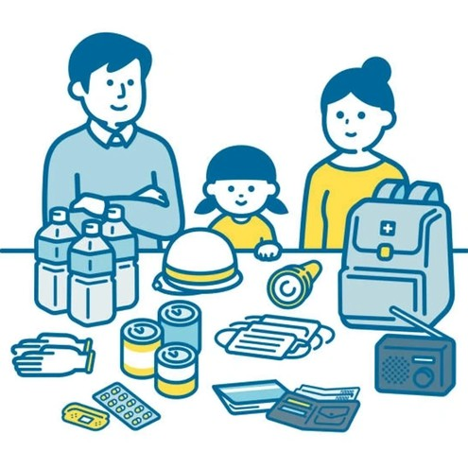
2025 Campaign Programme

#30Days30WaysUK
Tue 16 Sep Household Preparedness

Scope

All hazard household preparedness emergency supplies focused day, grab bag, depending on individual needs; min. 3 days household preparedness supplies are recommended to cover 5 core areas: first aid & hygiene, food & food preparation, tools & PPE, shelter & warmth, light & comms.

Promote UK household preparedness survey .

Lead & Key Partners

LRFs, local government & partners, health.

Suggestion for Partners

Share your local ‘Are you prepared?’ content Household Emergency Plans
Share top tips
Promote UK household preparedness survey

Hashtags

#30days30waysUK #PreparednessMonth #HouseholdPreparedness #GrabBag #EmergencyKit #PlanAheadUK
Daily Challenge

Start to put together you Household Emergency Plan.

Key Messages – top tips

Personal preparedness matters
Get equipped, make a plan, be informed Home supplies and grab bag
Plan how to evacuate pets or service animals if needed.
Teach family members how and when to shut off utilities (water, gas, electricity).
Consider specific needs of family members, including elderly, children, or individuals with disabilities.
Take part in the UK household preparedness survey

2025 Campaign Programme

#30Days30WaysUK
Wed 17 Sep Map It

Scope

Shared situational awareness. Hazard mapping. Emphasis on local risk, community risk registers (CRR) and community resilience resources. Also, offline maps and useful locator apps (e.g. What3Words)

Promote UK household preparedness survey .

Lead & Key Partners

LRFs & local partners, health, SAR, 4x4 response, @what3words

Suggestion for Partners

Share links to your local CRR & resilience resources Hazard hunt main risks via local maps

Hashtags

#30days30waysUK #PreparednessMonth #MapYourRisk #BeInformed
Daily Challenge

Take a look at What 3 Words and know how to tell the emergency services if you need to report an emergency.

Key Messages – top tips

Understand your local risk landscape
Support community resilience volunteers work with local planners to mitigate and prepare for a range of risks
Digital grab bag: offline maps; What3Words app to share precise location in case of emergency


2025 Campaign Programme

#30Days30WaysUK
Thu 18 Sep Safe Escape

Scope

Safe evacuation day & night, hazard check, clear fire escape routes, safe assembly points, get out stay out call 999.

Promote UK household preparedness survey .

Lead & Key Partners

LRFs, FRS, local government & partners

Suggestion for Partners

Share resources (NorfolkFire, StaffsFire, CheshireFire)
Promote local resources, free fire safety checks

Hashtags

#30days30waysUK; #PreparednessMonth #SafeEscape #FireSafety
Daily Challenge

Make your own safe escape plan and talk to you family about it so you are ready for anything.

Key Messages – top tips

regular hazard checks save lives
have a fire escape plan – best route is your normal route plus an alternative
communicate and practice your plan with the family in an emergency, get out stay out call 999

2025 Campaign Programme

#30Days30WaysUK
Fri 19 Sep Grab Bag

Scope

Prepare emergency kits with essential supplies like food, water, medications, first aid items, and important documents. Customize these kits based on specific risks you might face.

Promote UK household preparedness survey .

Lead & Key Partners

TALK LIKE A PIRATE
DAY
LRFs & local partners, health, voluntary sector

Suggestion for Partners

Share links to your preparedness advice/websites What do you keep in your grab bag?
Link to Household plan (Day 15)

Hashtags

#30days30waysUK #PreparednessMonth #Grab Bag #BePrepared

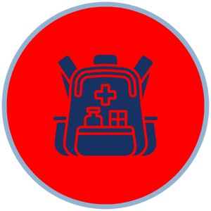
Daily Challenge

Put together your grab bag.

Key Messages – top tips

Flashlights and extra batteries First aid supplies
Medications
Copies of important documents (ID, insurance policies, medical records)
Cash Multipurpose tool
Personal hygiene items Whistle (to signal for help) Maps of the area


2025 Campaign Programme

#30Days30WaysUK
Sat 20 Sep Stop The Spread

Scope

Stop the spread of germs, Covid and beyond, hand washing, hand hygiene, use of face masks. Global handwashing day was 5/5/2023 (WHO).

Promote UK household preparedness survey .

Lead & Key Partners

Health, LRFs, local government & partners, community organisations.

Suggestion for Partners

Share good hand hygiene & handwashing resources Share your local best practice examples
Global Handwashing Day resources)

Hashtags

#30days30waysUK #PreparednessMonth #StopTheSpread
Daily Challenge

Keep washing your hands to stop the spread and educate others.

Key Messages – top tips

Save lives – clean your hands
Proper hand hygiene kills germs inc. covid, norovirus etc.
facemasks limit the spread of respiratory germs

2025 Campaign Programme

#30Days30WaysUK
Sun 21 Sep Community Resilience

Scope

Stay connected with your neighbours and community groups. They can share first hand information and support each other during emergencies.

WORLD GRATITUDE
DAY

INT DAY OF
PEACE
Promote UK household preparedness survey .

Lead & Key Partners

Health, LRFs, local government & partners, community organisations.

Suggestion for Partners

share community emergency plans
share your local best practice examples share community resilience initiatives

Hashtags

#30days30waysUK #PreparednessMonth #CommunityResilience


Daily Challenge

Connect with your neighbours. Ask locally if you have a community emergency plan, if you don't have a plan form a group to make one.

Key Messages – top tips

Engage with neighbours and community members to strengthen mutual support networks.
Participate in community emergency preparedness events and initiatives.

WEEK FOUR

Protect Your Family


2025 Campaign Programme

#30Days30WaysUK
Mon 22 Sep Pets

Scope

Emergency Preparedness for animals, animal welfare, leave no one behind, safe evacuation/shelter, local arrangements, pet first aid

Promote UK household preparedness survey .

Lead & Key Partners

FIRST DAY OF AUTUMN
LRFs, local government & partners, animal welfare organisations

Suggestion for Partners

Pet safety in emergencies
Share 30days30waysUK video resources (YouTube) Share 30days30waysUK pet alert & checklist

Hashtags

#30days30waysUK #PreparednessMonth #PetPreparedness #PreparedPets #PlanAheadUK

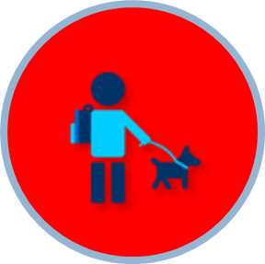
Daily Challenge

Check you have included your pets in your emergency plan. Have someone nearby that you could leave them with if you had to evacuate your home. Make sure you have your pets microchipped.

Key Messages – top tips

Preparedness must include the animals in your care Include pets in your household emergency plan Know Pet First Aid, have a pet first aid kit


2025 Campaign Programme

#30Days30WaysUK
Tue 23 Sep Medicines

Scope

Home medicine cabinet / first aid kit check, store medicine properly, safe disposal of out-of-date medication, replace expired medication; home ‘drugs bust’

Promote UK household preparedness survey.

Lead & Key Partners

Health, LRFs, local government & partners, community organisations

Suggestion for Partners

Showcase/share NHS First Aid Kit resources
NHS video Looking after you and your family – how ready are you

Hashtags

#30days30waysUK #PreparednessMonth #ChooseWell #DrugsBust #medicinecabinet
Daily Challenge

Go through your medicine box and properly dispose of those that are out of date.

Key Messages – top tips

Review your personal medicines to support self-care Stock, store, dispose of medications responsibly NHS medicine cabinet advice

2025 Campaign Programme

#30Days30WaysUK
Wed 24 Sep Go In Stay In Tune In

Scope

During an emergency, you may be asked to Go In, Stay In, Tune In until you get the all clear. This may be for a few hours/days.
All hazard household preparedness emergency supplies focused day, grab bag, depending on individual needs; min. 3 days household preparedness supplies are recommended to cover 5 core areas: first aid & hygiene, food & food preparation, tools & PPE, shelter & warmth, light & comms.

Promote UK household preparedness survey .

Lead & Key Partners

LRFs, local government & partners, health

Suggestion for Partners

Share your local ‘Are you prepared?’ content Share top tips
Promote UK household preparedness survey

Hashtags

#30days30waysUK #PreparednessMonth #GoInStayInTuneIn
Daily Challenge

Check your cupboards. Have you got enough supplies to last for 3 days without leaving your home?

Key Messages – top tips

Personal preparedness matters
Get equipped, make a plan, be informed Home supplies and grab bag
Take part in the UK household preparedness survey


2025 Campaign Programme

#30Days30WaysUK
Thu 25 Sep Ready Kids

Scope

Household emergency preparedness with and for children. Age appropriate activities e.g. BRC Pillow Case project (7-11), CUIDAR project;

Promote UK household preparedness survey .

Lead & Key Partners

LRFs, local government & partners, community organisations, youth groups, libraries, schools

Suggestion for Partners

Involve children and young people in planning Share local/national/intl. children’s resources Share 30days30waysUK.org.uk/kids content

Hashtags

#30days30waysUK #PreparednessMonth #readyKids #preparedKids #BePreparedNotScared #PlanAheadUK
Daily Challenge

Sit down with your kids and go through your emergency plan so they know what they should do in an emergency.

Key Messages – top tips

Involve children and young people when planning and preparing for emergencies in age-appropriate ways
Teach children when and how to call for help (day12) Discuss and practice your family emergency plan

https://www.kentprepared.org.uk/youth-resources https://ncr.glasgow.ac.uk/?page_id=1499


2025 Campaign Programme

#30Days30WaysUK
Fri 26 Sep Prepared Apps

Scope

Useful apps for health, safety, preparedness & first aid, “digital grab bag”, offline content e.g., maps, mark safe feature social media, ICE.

Note: avoid showcasing ‘bad behaviour’ as it reinforces social norms. Rather, showcase ‘good’ behaviour as positive role models.

Promote UK household preparedness survey .

Lead & Key Partners

App providers, LRFs, health, emergency services local government & partners.

Suggestion for Partners

Showcase & link to apps
Apps limitations (power, network), spare charging

Hashtags

#30days30waysUK; #PreparednessMonth #PreparedApp #PlanAheadUK
Daily Challenge

Download apps that can help you in an emergency.

Key Messages – top tips

Many useful and life saving apps are available Assemble a personalised ‘digital grab bag’ Update phone (or card) ICE contacts
Know how to use ‘mark safe’ features on social media

2025 Campaign Programme

#30Days30WaysUK
Sat 27 Sep Road Safety

Scope

THINK – be bright be seen; road safety, cycling, running, hiking also water sports; Hi-Viz car safety kit items Promote UK household preparedness survey.

Lead & Key Partners

Road Safety Partnerships, Highways, SAR, ambulance, health, LRFs, local government & partners

Suggestion for Partners

Be Bright Be Seen materials
Showcase Hi-Viz clothing and items

Hashtags

#30days30waysUK #PreparednessMonth #BeBrightBeSeen #RoadSafety

WORLD TOURISM
DAY

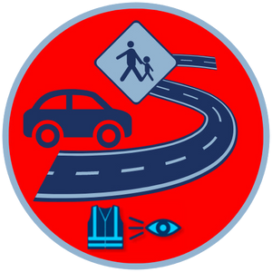
Daily Challenge

Make a grab bag for your car in case you are stuck on the highway and make sure you have hiviz so you are visible on darker evenings.

Key Messages – top tips

Hi-Viz items are cheap and save lives
Adults, kids, pets, outdoor, school travel etc. contexts
Bright colors insufficient – fluorescent/reflective items


2025 Campaign Programme

#30Days30WaysUK
Sun 28 Sep Offline Entertainment

Scope

Emergencies can mean delays and diversions. Not just kids get bored and frustrated. Offline entertainment and comfort items.

Promote UK household preparedness survey .

Lead & Key Partners

LRFs, local government & partners

Suggestion for Partners

Fun, light hearted day, share tips on offline entertainment
Comfort / entertainment for emergency kit / grab bag Check in with 30days30waysUK Bingo progress

Hashtags

#30days30waysUK #PreparednessMonth #neverbored #staybusy
Daily Challenge

What would you do if you had no internet? What games would you play to keep your family occupied?

Key Messages – top tips

Disruption can lead to waiting
Include suitable offline entertainment in your household emergency preparedness plan and kit

WEEK FIVE

Get Involved




2025 Campaign Programme

#30Days30WaysUK
Mon 29 Sep Volunteer

Scope

Voluntary organisations and social enterprises make a huge difference to UK resilience and preparedness.
Many are not well known. This day aims to raise local profiles and showcase local projects.

Promote UK household preparedness survey .

Lead & Key Partners

Voluntary, Health, LRFs, local government & partners, community organisations

Suggestion for Partners

Showcase/link to/tag local volunteer organisation Inspire singing up to volunteering

Hashtags

#30days30waysUK #PreparednessMonth #volunteer
Daily Challenge

Look at volunteering opportunities in your local area.

Key Messages – top tips

Volunteering is crucial to better preparedness and community resilience
Find and sign-up with an organisation near you


2025 Campaign Programme

#30Days30WaysUK
Tue 30 Sep Thankyou

Scope

Finale and wrap, best of, bingo review, survey reminder, public feedback, prize draw. Thank you and see you next year.

Promote UK household preparedness survey .

Lead & Key Partners

LRFs, local government & partners,

Suggestion for Partners

Sum up some of your core risk/preparedness messages
Share key landing pages for your local resilience info

Hashtags

#30days30waysUK #PreparednessMonth #BePreparedNotScared
Daily Challenge

Thank you. Complete the Survey.

Key Messages – top tips

Take part in the UK household preparedness survey Feedback
Thank you, see you next year

2025 Campaign Programme

#30Days30WaysUK

Alexander, D. 2019. Disaster myths blog: Common misconceptions about disaster

Brown, G. D., Largey, A., & McMullan, C. (2021). The influence of expertise on perceived and actual household disaster preparedness. Progress in Disaster Science, 9.

Deeming, H. 2017. Disaster Risk Reduction and the Sendai Framework - What does it mean for UK resilience practitioners. Emergency Planning College Occasional Papers

Dufty, N., 2020. Disaster Education, Communication and Engagement. John Wiley & Sons.

Developing a DRR Comms strategy collection, UNISDR Prevention Web

ICRC. 2017. How to use social media to better engage people affected by crises. Available at https://media.ifrc.org/ifrc/2017/10/1 1/new-guide-social-media-ocha-
ifrc icrc/

Pickering, C.J., O'Sullivan, T.L., Morris, A., Mark, C., McQuirk, D., Chan, E.Y., Guy,
E., Chan, G.K., Reddin, K., Throp, R. and Tsuzuki, S., 2018. The promotion of ‘Grab Bags’ as a disaster risk reduction strategy. PLOS currents, 10.

Poljansek et. al. 2017. Science for Disaster Risk Reduction “Communicating Disaster Risk” pp 388-440

Wood, N. and Kenny, C., 2017. Communicating Risk. POST Parliamentary Office of Science and Technology, Research briefings

Wukich, C., 2019. Preparing for disaster: social media use for household, organizational, and community preparedness. Risk, Hazards & Crisis in Public Policy, 10(2), pp.233-260

Annex - Resources
30days30waysUK website: https://www.the-eps.org/

@30days30waysUK –
facebook | Instagram | YouTube | google bookshelf

Contact:

Email - 30days30waysUK@the-eps.org

Collaboration space on Resilience Direct: https://collaborate.resilience.gov.uk/home/1 08077/Welcome-to-30-Days-30-Ways-UK- RD-Page

Open access google drive for graphics Campaign materials - Google Drive

Promotional Video - Watch on YouTube

