College/Career Objective
Motivated honors 2024 student athlete seeking an educational setting to pursue eventual collegiate Environmental Sciences degree, and collegiate Field Hockey (Goalie).

Education West Essex HS Class of 2024 September 2020 - Current
High School Honors & AP Classes, 3.95 Freshman Weighted GPA
Key Club, Pre Med Club, Varsity Field Hockey & Lacrosse

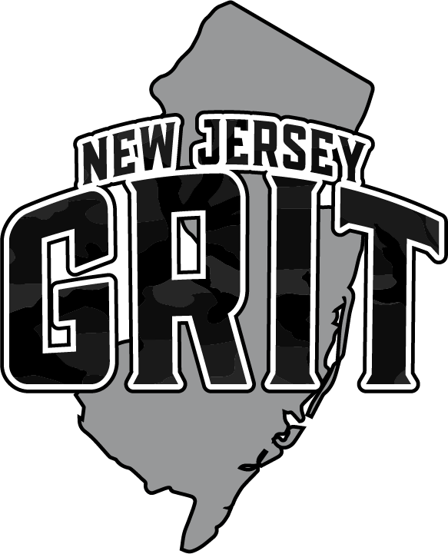
Athletics (NCAA #2010949361) Build: 5’7”, 135 lbs

Club Field Hockey (NJ GRIT: Coach Jill Cosse, Jill@NJGRITFieldHockey.com, 732-306-8332)
2013 - 2016: NJ Starz Field Hockey Club, U14 NIT, Disney Showcase U14 Gold
2017: Mid New Jersey Knights Field Hockey Club U14
2017 - 2020: New Heights Field Hockey Club (USAFH #1 U16 National Ranking)
2018: Futures Gold Medal Champion, U16 Disney Showcase Gold, U14 NIT, U16 Festival
2019: Futures Alternate, U14 RCCs, U16 NCCs 4th Place, U16 NIT, U16 Disney Showcase Bronze,
Middle School Captain, U16 Festival Top Bracket Gold with 6 Shut Outs
2020: U19 NITQ, U16 NIT Gold (Undefeated, 4 GA), U16 Disney Showcase Medal (Undefeated, 1 GA),
RCC U16, New Heights U16 & U19 Ranked #1 in Nation by USAFH, NJ GRIT U16 Black,
Shooting Star Gold (NJ GRIT Ruby U16B undefeated with 1 GA)
2021: U16S NIT 2nd Place, 5 GA, 43 Saves, 90% save rate
U19Q NIT Starting goalie (Split Time: 21 saves, 6 GAA, 78% Save Rate)
U19B Shooting Star Jamboree Undefeated Gold (3 GAA) & Goalie Showcase (#13)
Max Field Hockey Top 100 2024 Players to Watch, and 2021 National Player Combine selection
NJ GRIT U16 and U19 NCC Goalie
Nexus U16 Perform Player
West Essex High School Field Hockey (Coach Jill Cosse, jcosse@westex.org, 732-306-8332)
(2020 Ranked #2 in NJ, and #8 in the Nation MAX Field Hockey)
(2021 Ranked #3 in NJ, #2 NJ.com. #15 in Nation Max Field Hockey)
2020: Freshman Varsity Starter (every game)
Undefeated Season: 12-0-1, 11 shut outs, 38 shots on goal, 35 saves, 3 goals against, 92% save rate
NJSIAA North East Region A Sectional Champions (Tournament of Champions cancelled due to COVID)
1st Team All Conference, Super Essex Conference
2nd Team Essex/Union Conference All Stars (Red Division)
3rd Team, NJ All Group 2 Honors
1st Team, NJ FH Coaches Association All State Honors, Group 2

2021: Sophomore Varsity Starter (every game, 2nd year)
23-2 Record, 95 saves, 18 shutouts, 12 GAA, 89% save rate
NJ.com Top Goalies to Watch, on #1 Ranked NJ.com Team
NJ.com Top 100 Sophomores in Field Hockey (voted #7)
Essex County Champions
NJ North Group 2 State Champions
NJ Group 2 State Champions
NJ Tournament of Champions (TOC)
1st Team All Conference, Super Essex Conference
Highlights – www.njgritfieldhockey.com/abby-zanelli

SCUBA
2017 - Current: Master Scuba Diver Certified at age of 12 (+Rescue Diver Certified)
2018: World Record, Largest Underwater Air Symphony
(https://www.youtube.com/watch?v=DAQ0O82WdEY)
Other
2016 - 2019: STEPS Elite Lacrosse and Old Turnpike Middle School Field Hockey (Captain)
2016 - 2018: Old Turnpike Middle School Lacrosse
2017 - 2018: Old Turnpike Middle School Basketball Mascot
2019 - 2020: Old Turnpike Middle School Basketball and Softball (County Champs for both)
2016 - 2020: Tewksbury Township Rec Lacrosse
2021: West Essex High School Varsity Lacrosse – Goalie, Essex County Champions, Freedom East Conference Champions, State Finalist North Group 2, Ranked 16th in NJ, JV MVP

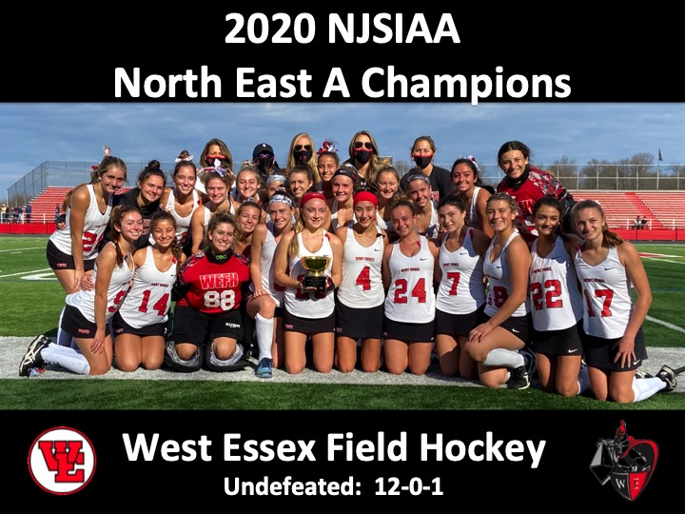
Volunteerism/Awards
2010 - 2019: Turn the Towns Teal (Ovarian Cancer Awareness Volunteer)
2010 – 2017: Tewksbury Rescue Squad Event Volunteer
2014 - 2018: Contenders Volunteer Coach (Special Needs Football)
2017 - 2018: Meals on Wheels Food Prep & Delivery
2016 – 2019: Lax for the Cure Fundraising
2018 - 2019: Wounded Warrior Project (Supplies for Soldiers)
2019 - 2020 President’s Volunteer Service Award Silver and Gold
2019: Help Paws (Supplies for St. Lucia Puppy Rescue)
2020: Hunterdon County Unsung Hero’s Award, & Audrey Lain Snyder Award for Stewardship
2020: COVID Food Bank & Animal Shelter Donations
2020: West Essex Field Hockey & NJ Avalanche Ice Hockey, Fight Cancer Fund Raising
2020: EDGE Field Hockey Camp Volunteer (28 Hours)
2021: “I Support the Girls” clothing drive for homeless women and girls
2021: Special Olympics Polar Plunge Fund Raiser
2021: West Essex “Captains” Camp Field Hockey Coach
2021: North Caldwell Color Run Volunteer

Parents: Cindy Zanelli, cbz@att.com, 908-432-2736 Paul Zanelli, zanellistrong@gmail.com, 908-432-9961

