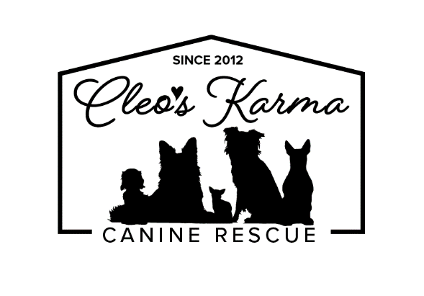
APPLICATION FOR ADOPTION

When finished, please email to cleoskarma@gmail.com or mail to:

PO Box 1176
Brooks, AB
T1R 1B9

Name:
Applicant Age:
Occupation:
Spouse/Partner/Roommate Name (if applicable):
Other occupant(s) Age:
Address:
Phone Number:
Email Address:

Dog(s) Name you want to adopt:

-OR-

Breed(s) of interest:
Gender:
Approximate age:
Any other specifications (ie. Color, etc.):

What has made you choose the animal you’ve chosen?

Please provide us with two personal references.

Name, Relationship, Phone:

Name, Relationship, Phone

Please list the name, address and telephone number of your current veterinarian.
If you no longer have a pet, please provide the name and phone number of the last veterinarian you did use.
If this is your first pet, please list the name and phone number of the veterinarian you would like to use, should you be approved to adopt the dog.

***PLEASE CALL YOUR VETERINARIAN TO RELEASE INFORMATION TO CLEO’S KARMA RESCUE PRIOR TO SUBMITTING THIS FORM.***

Do you currently own any animals? If yes, please tell me their age, gender, breed, size, general temperament towards other animals.

If you currently have dogs, are all dogs in your household vaccinated? Are all spayed/neutered?

Do you have children or regularly visiting grandchildren? If so, what are their ages? Have they interacted with large or small dogs before?

Are all the members in your household in agreement about adopting the dog you’ve chosen?

Do any of the members of your household have allergies, or suspected allergies, to animals?

Do you own your own home? If not, please list the name and telephone number of the
homeowner/landlord.
What type of home do you live in: house, apartment, condominium, etc? Please describe your home to me. Do you have a yard; if so, is it fenced? Does your family live in an urban, suburban, or rural setting?

How many hours a day will the dog be left home alone? When you are not home, where will the dog be (outside in pen, outside tied to run, outside in yard, inside free, inside enclosed in an area, or inside in a crate)?

What are the reasons behind your decision to adopt a dog now?

If you have previously owned dogs or other pets, please disclose their current status (passed on, lost, given away, stolen, etc.).

Do you travel often? If so, what do you plan on doing with your dog while you travel?

Who do you believe will be mostly responsible for the care of the dog?

Please tell me how much training you are willing to do with your dog. Do you plan on taking your dog or puppy to obedience classes?

Where and how will the dog be exercised each day?

Do you feel as though you have a thorough understanding of all the expenses that go along with dog ownership (ie. Shots, heartworm/tick preventatives, food, training, pet sitters/ kennelling, emergency vet care, grooming, nail trims, chew toys, etc.)?

For what reason(s) would you consider returning a dog to Cleo’s Karma Rescue?
*** Please understand that adopting a dog is a serious commitment to training, socializing, and caring for your dog. Consider carefully the chosen dog’s breed, age, and specific needs. ***

THANK YOU FOR TAKING THE TIME TO COMPLETE THIS APPLICATION. THE GOAL IS NOT TO BE INVASIVE, BUT TO PLACE EACH ANIMAL IN THE BEST POSSIBLE HOME.

*We are a private rescue; you assume ALL responsibilities for this dog once he/she is in your possession. Although a veterinarian examines each dog before it leaves our rescue, we do not guarantee the health of this or any animal we rescue. You assume all “behavioral” issues & agree to seek professional assistance in correcting any unacceptable behavior.

Your non-refundable adoption donation includes:
- spay/neuter
- microchip
- current, age-appropriate vaccinations (include Rabies, parvo, distemper, Bordetella/“kennel cough”)
- leash and collar

SIGNATURE, Date:

SIGNATURE, Date:

Thank you for your interest in adopting a rescued dog.
A member of our adoptions team will be in touch within 24 hours of receiving your completed form.
We thank you for your patience while our adoptions volunteers receive and process your application.

