February 2025 - Newsletter

Latest news
Our start to 2025 has been lovely, we have spent January settling in our new children and making sure they feel at home here at Bright Stars. During January we celebrated our 8th birthday with lots of party games, party food and a visit from mickey mouse!
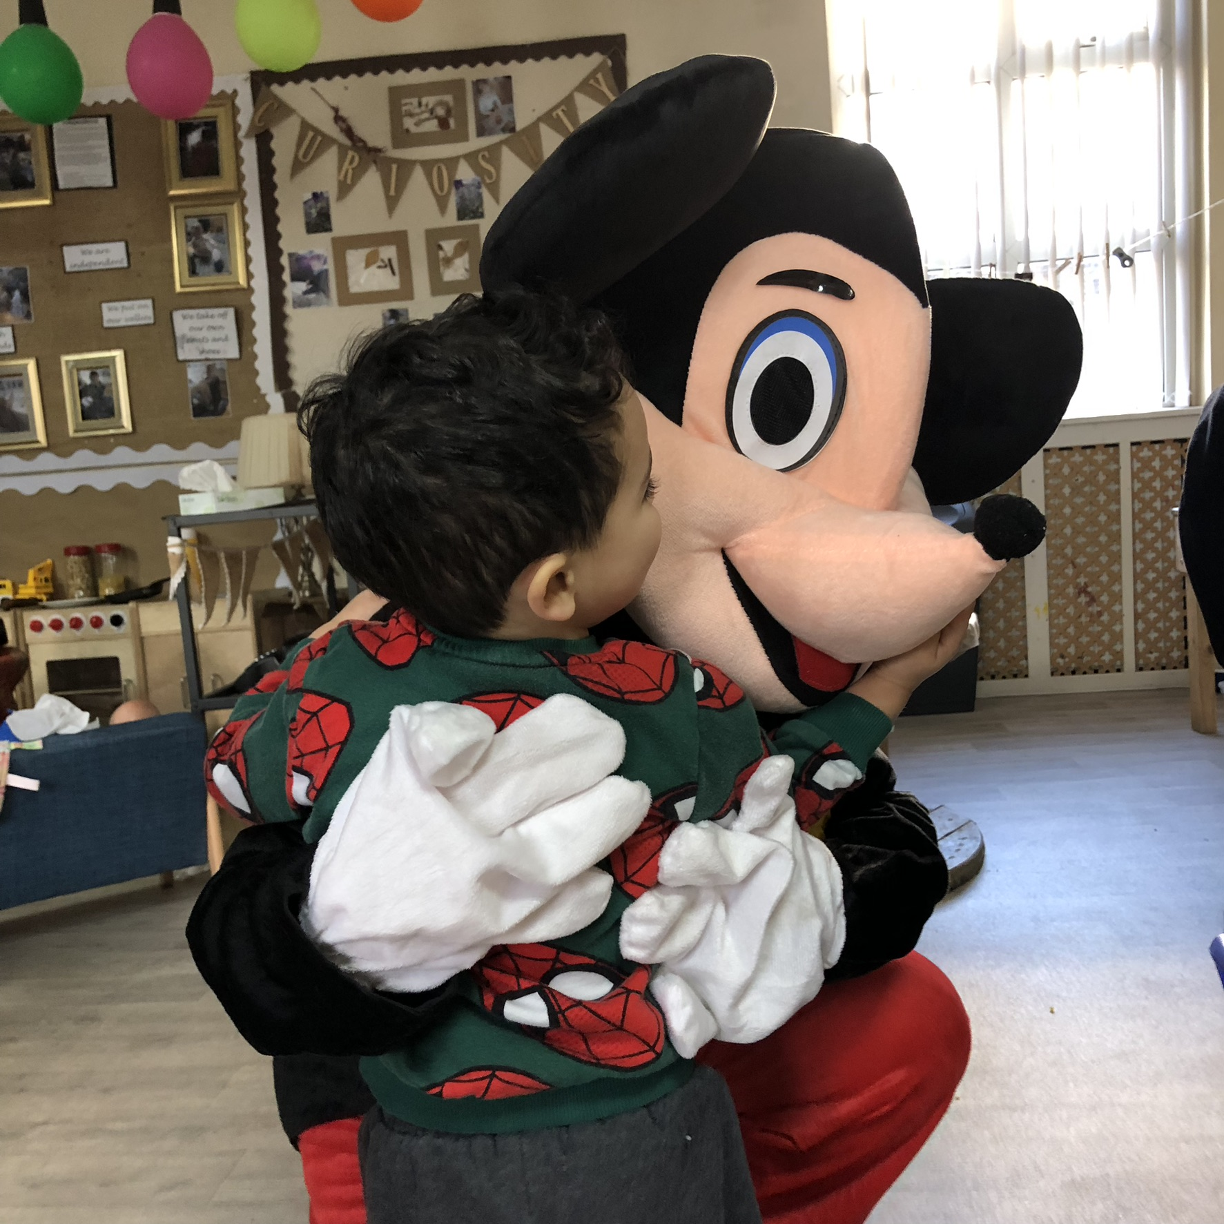
We have been so busy doing lots of fun activites, shooting stars have been busy completing the different topics in their curriculum whilst Protostar, Asterisk, Young Stellar Stars have been looking into all different colours. We also took part in celebrating the lunar new year, talking about festivals, celebrations, trying out skills at using chopsticks and eating yummy noodles.
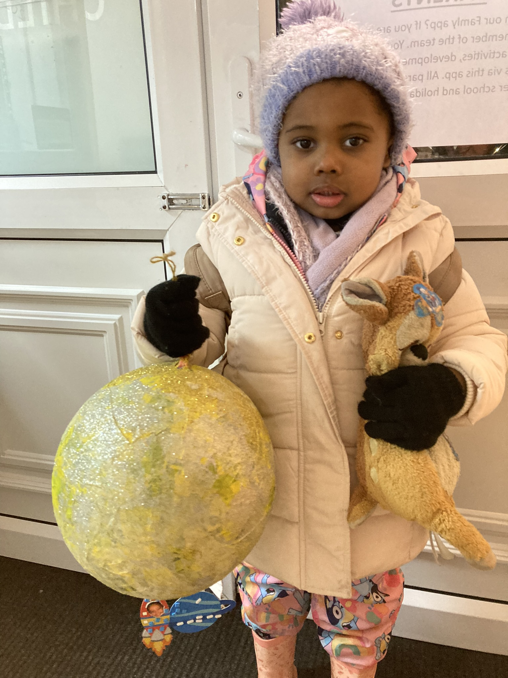

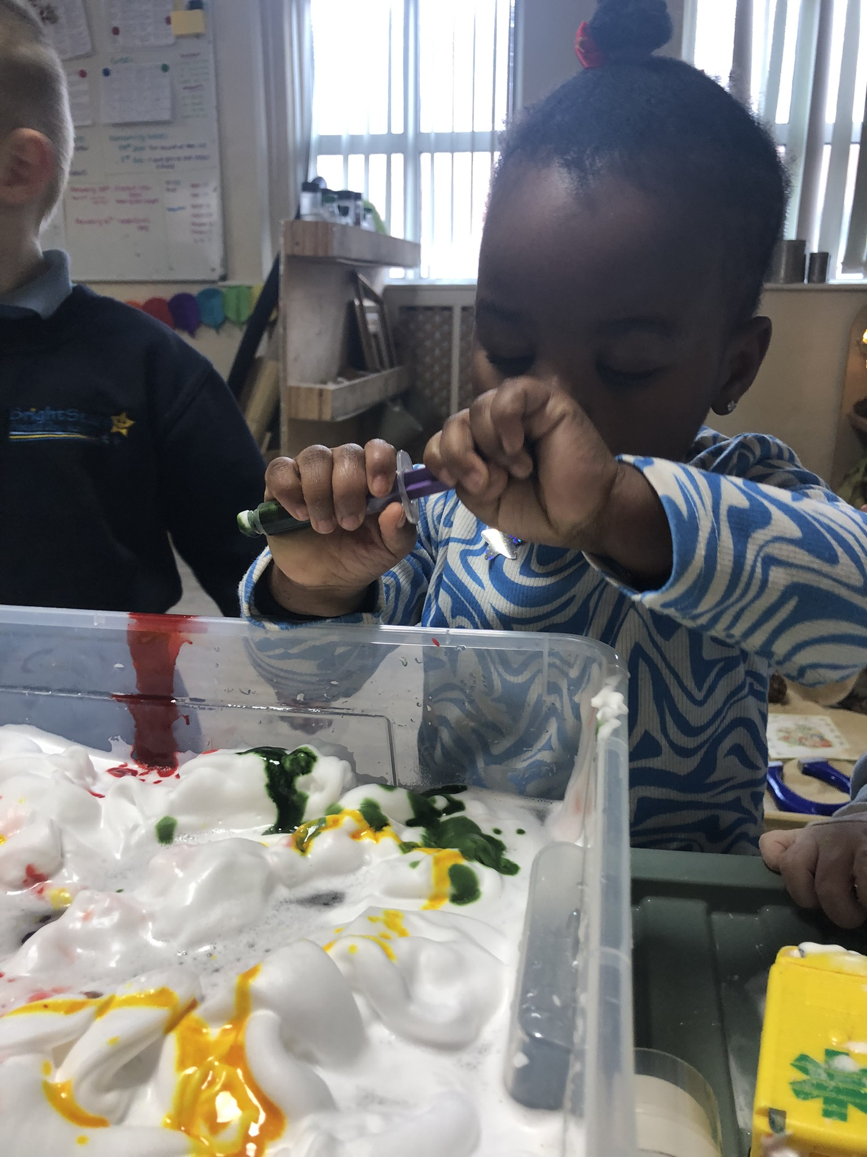

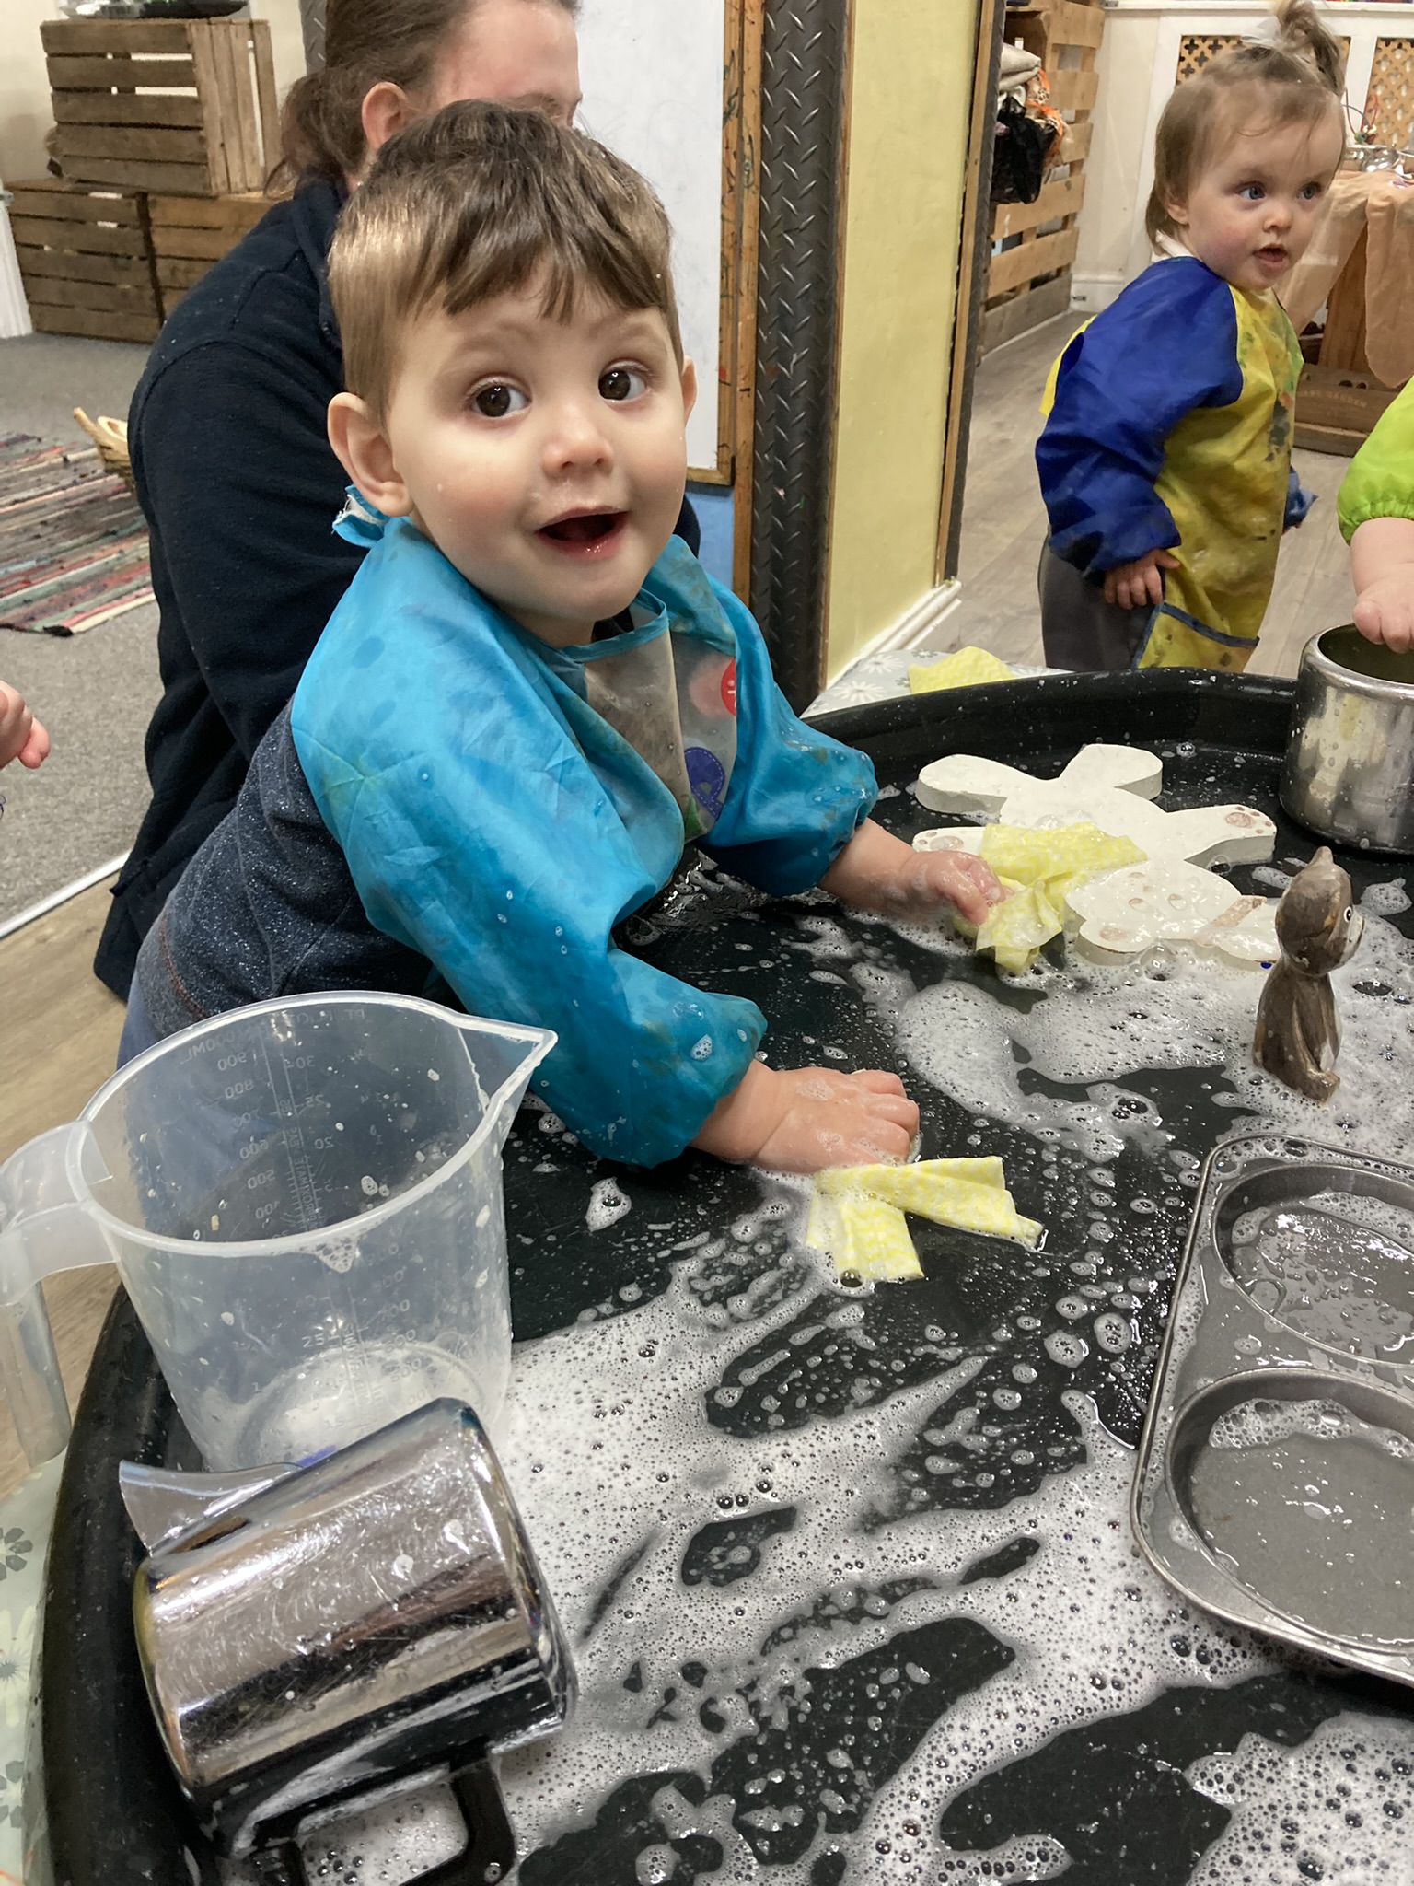

Library visits
The children have started to make regular visits to the local library in Ashton, 2-3s have created an account and go on a regular basis, picking and choosing their favourite books to bring back to nursery for reading. Babies have also recently started to have visits to the library taking part in the baby rhyme time on offer on the Wednesday morning whilst preschool have made their first visit in February. If children have time they may also visit the local shops for any resources they may need as well as stopping by Morrisons to see the local cat and have some toast!
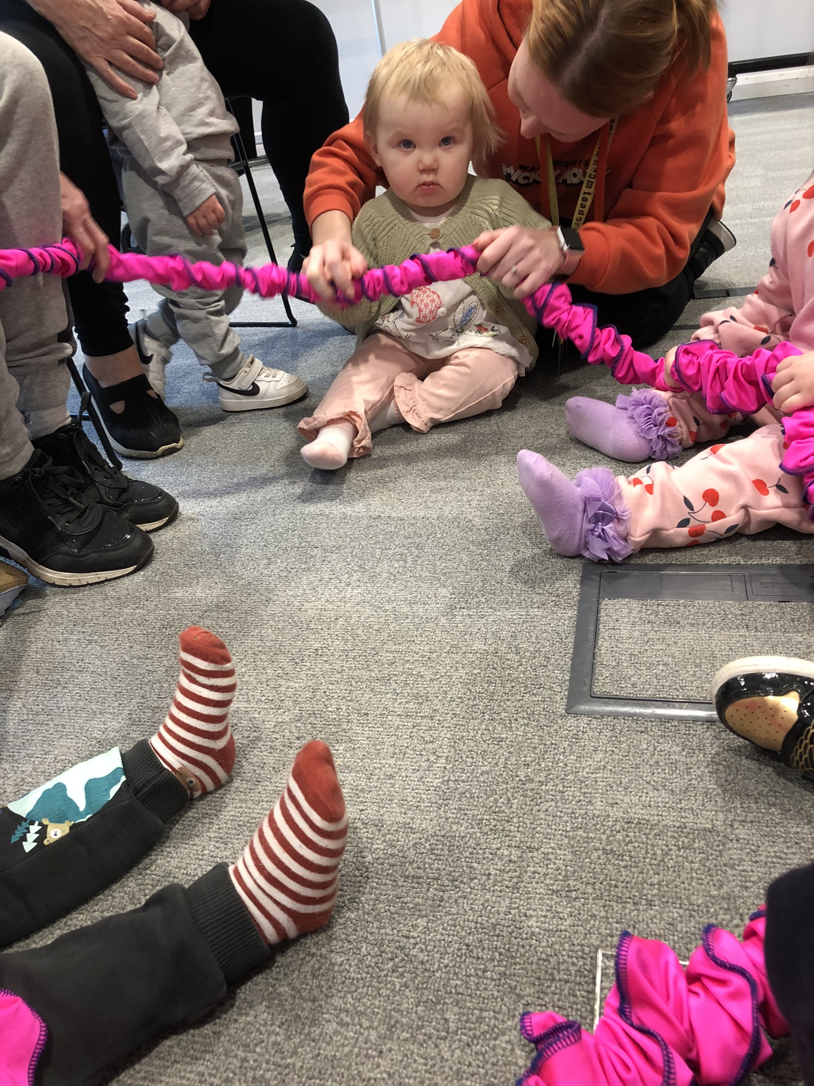

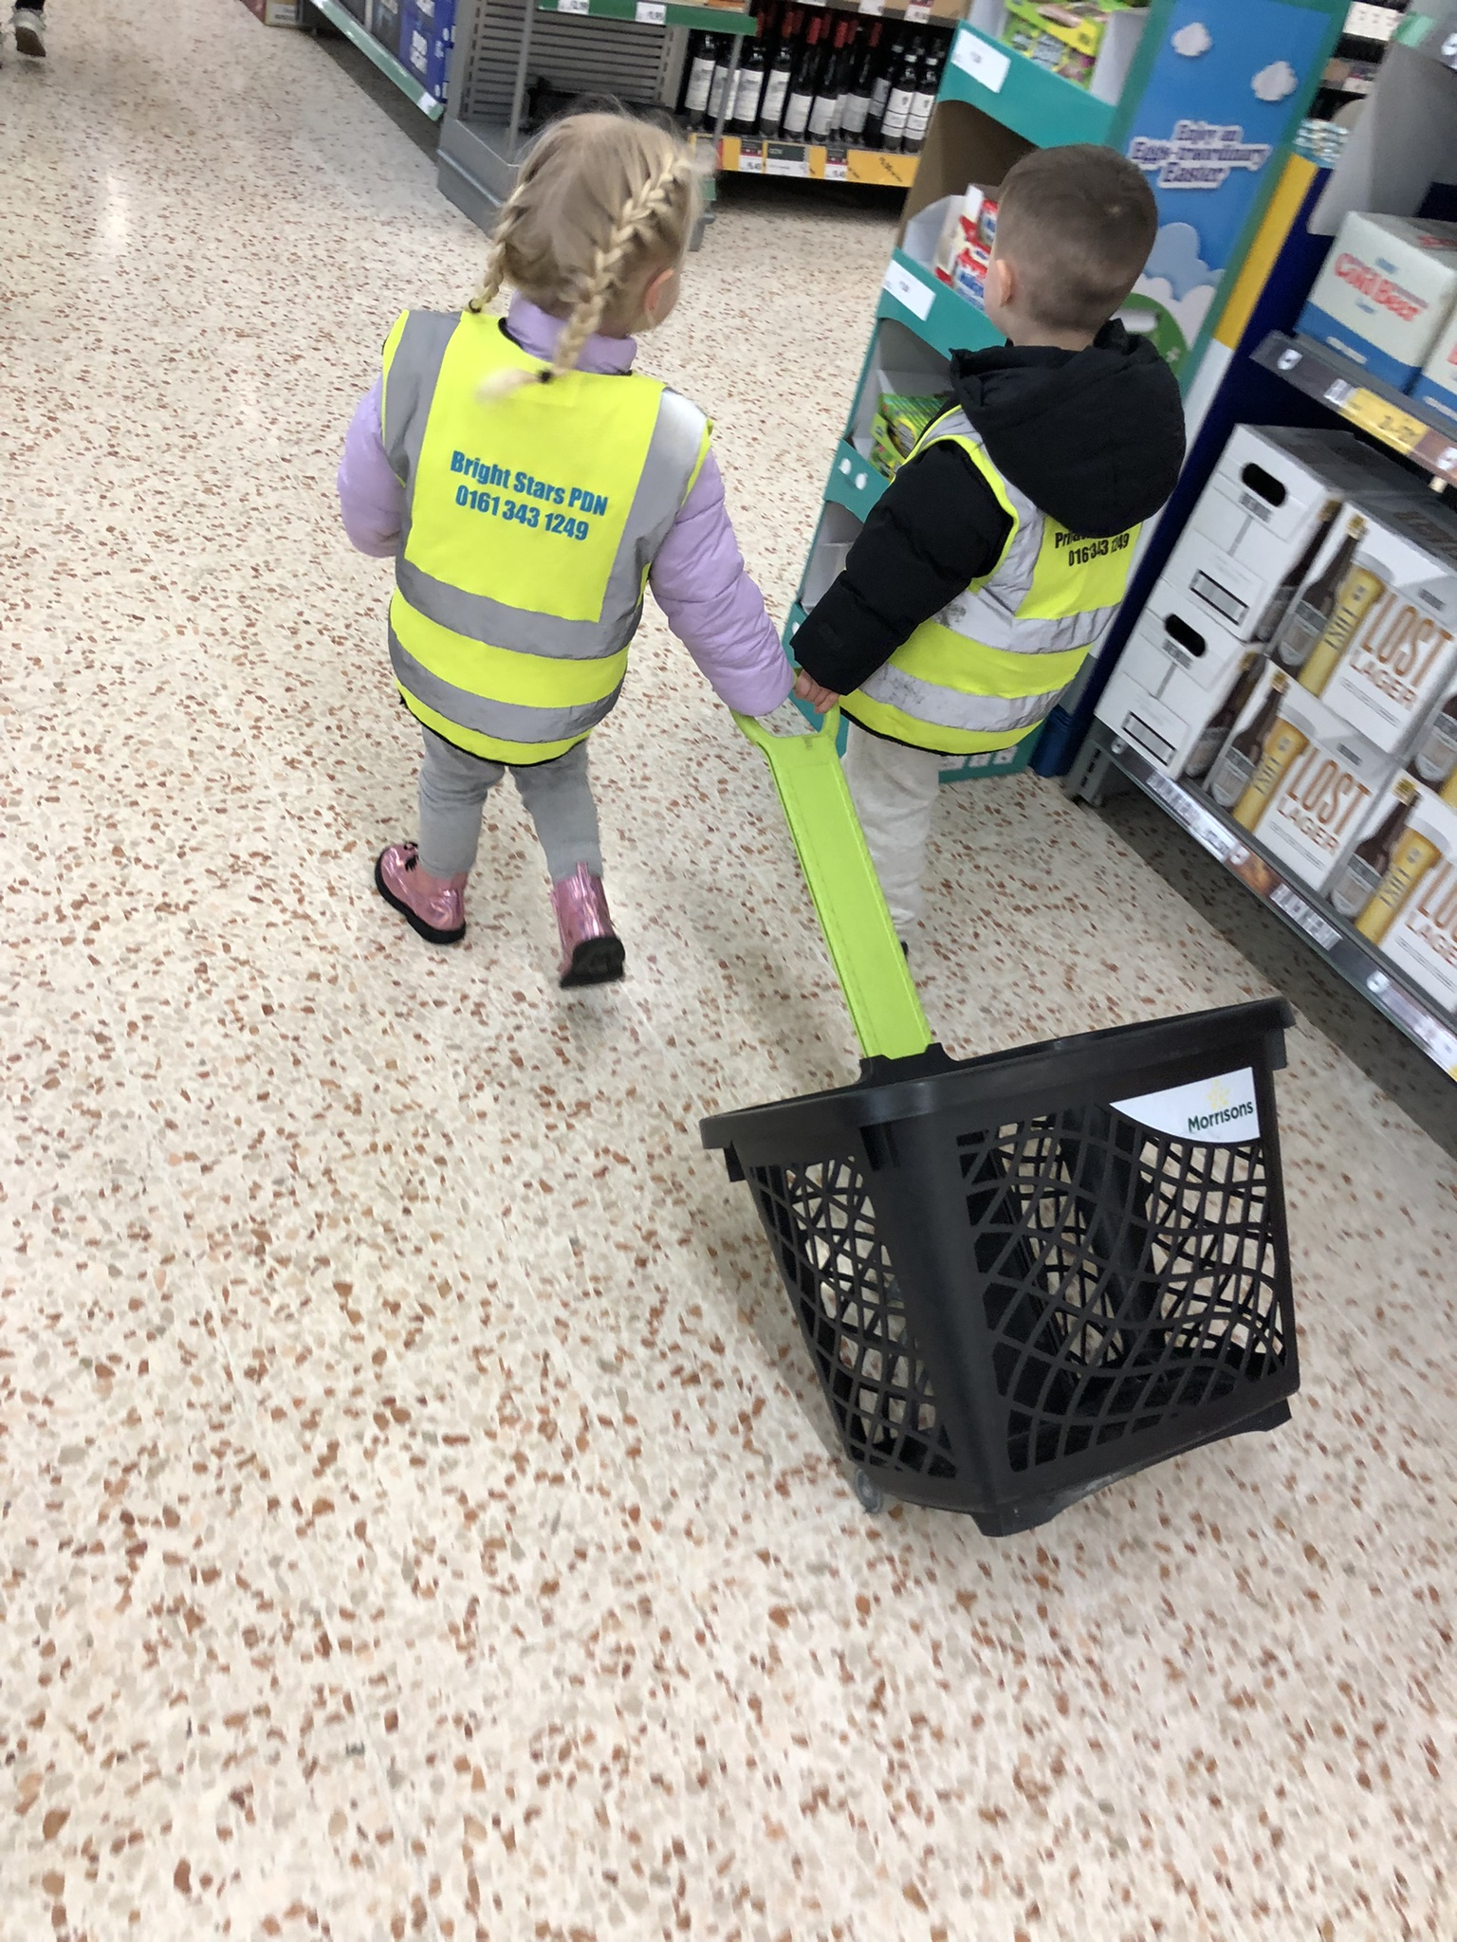

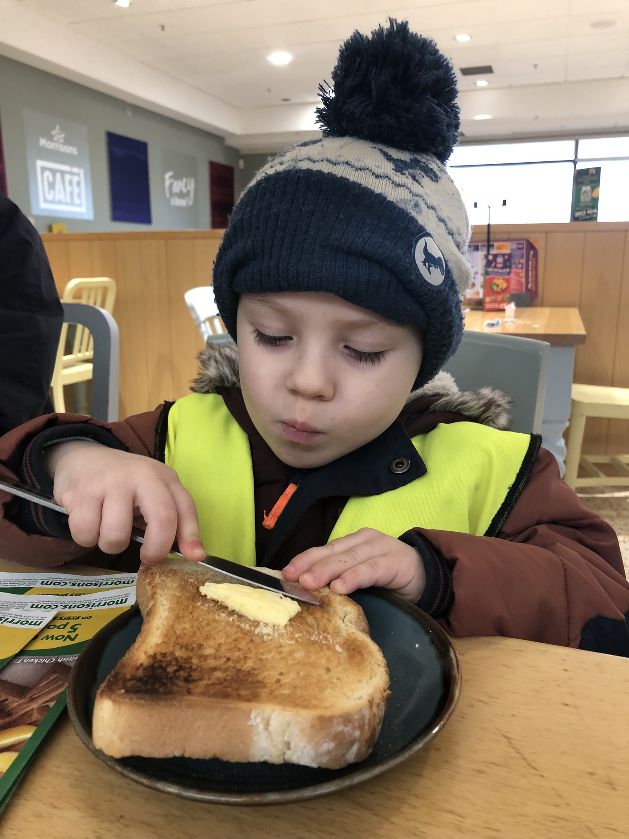

Things that are happening over this term:
Friday 14th – Valentine’s day – Come along dressed in red to spend the day celebrating kindness and friendships
Friday 28th February – Ramadan / St Davids Day
Tuesday 4th March – Pancake day – Special menu
Thursday 6th March – World book day
Friday 21st March – Red Nose Day
Friday 28th March – Mothers day workshop with parents (bookable)
Friday 29th March – Eid – Clay tealight making
Friday 28th March– Easter bonnet parade, bring in hats made at home
Monday 21st April- St Georges day
Wednesday 23rd- April Parents evening (Bookable)
Thursday 24th April – Parents evening (Bookable)
Friday 25th April – Parents evening (Bookable)
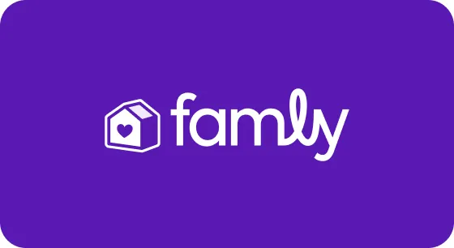
Wednesday 30th April- Graduation photographer

Famly
We have finally transitioned over to our new FAMLY app, we hope you are all finding it more imformative than the previsous platform. As practitoners we are loving the new set up and finding that interactions between parents and the Bright Stars team are stronger than ever! Don’t forget as a parent or carer you can upload photos and videos from home as an observations to share with your childs key person.
We are still working on the invoicing side and are having some teething issues but hopefully these will be ironed out over the next month or so. You can now set up your card payments via the app to make the process more streamlined and efficient. You can also download your statements as evidence of proof of payment.
Funding
Anybody eligible for funding and recieving a code, you will need to renew this code by the end of March to be eligible for the following term. Please make sure you do this ASAP and hand over that code to Jo for processing.
To check if you are eligible for funding please go to the following website: https://www.gov.uk/check-eligible-free-childcare-if-youre-working
What have we been up to?
Baby room and 2-3’s
Babies and 2-3s have been busy looking at all the different colours this month, they have focussed on all the primary colours, red, blue and yellow. This was extended in the 2-3s room with mixing and creating new colours. 2-3s also spent time going on colour hunts and bringing in lots of colourful items from home to share with their friends and the young stellar star room!


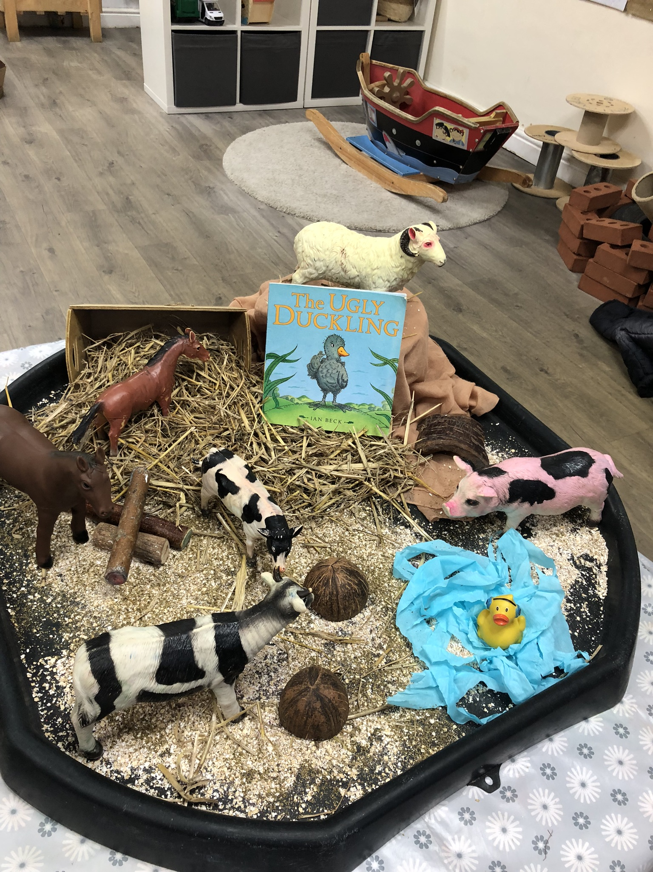

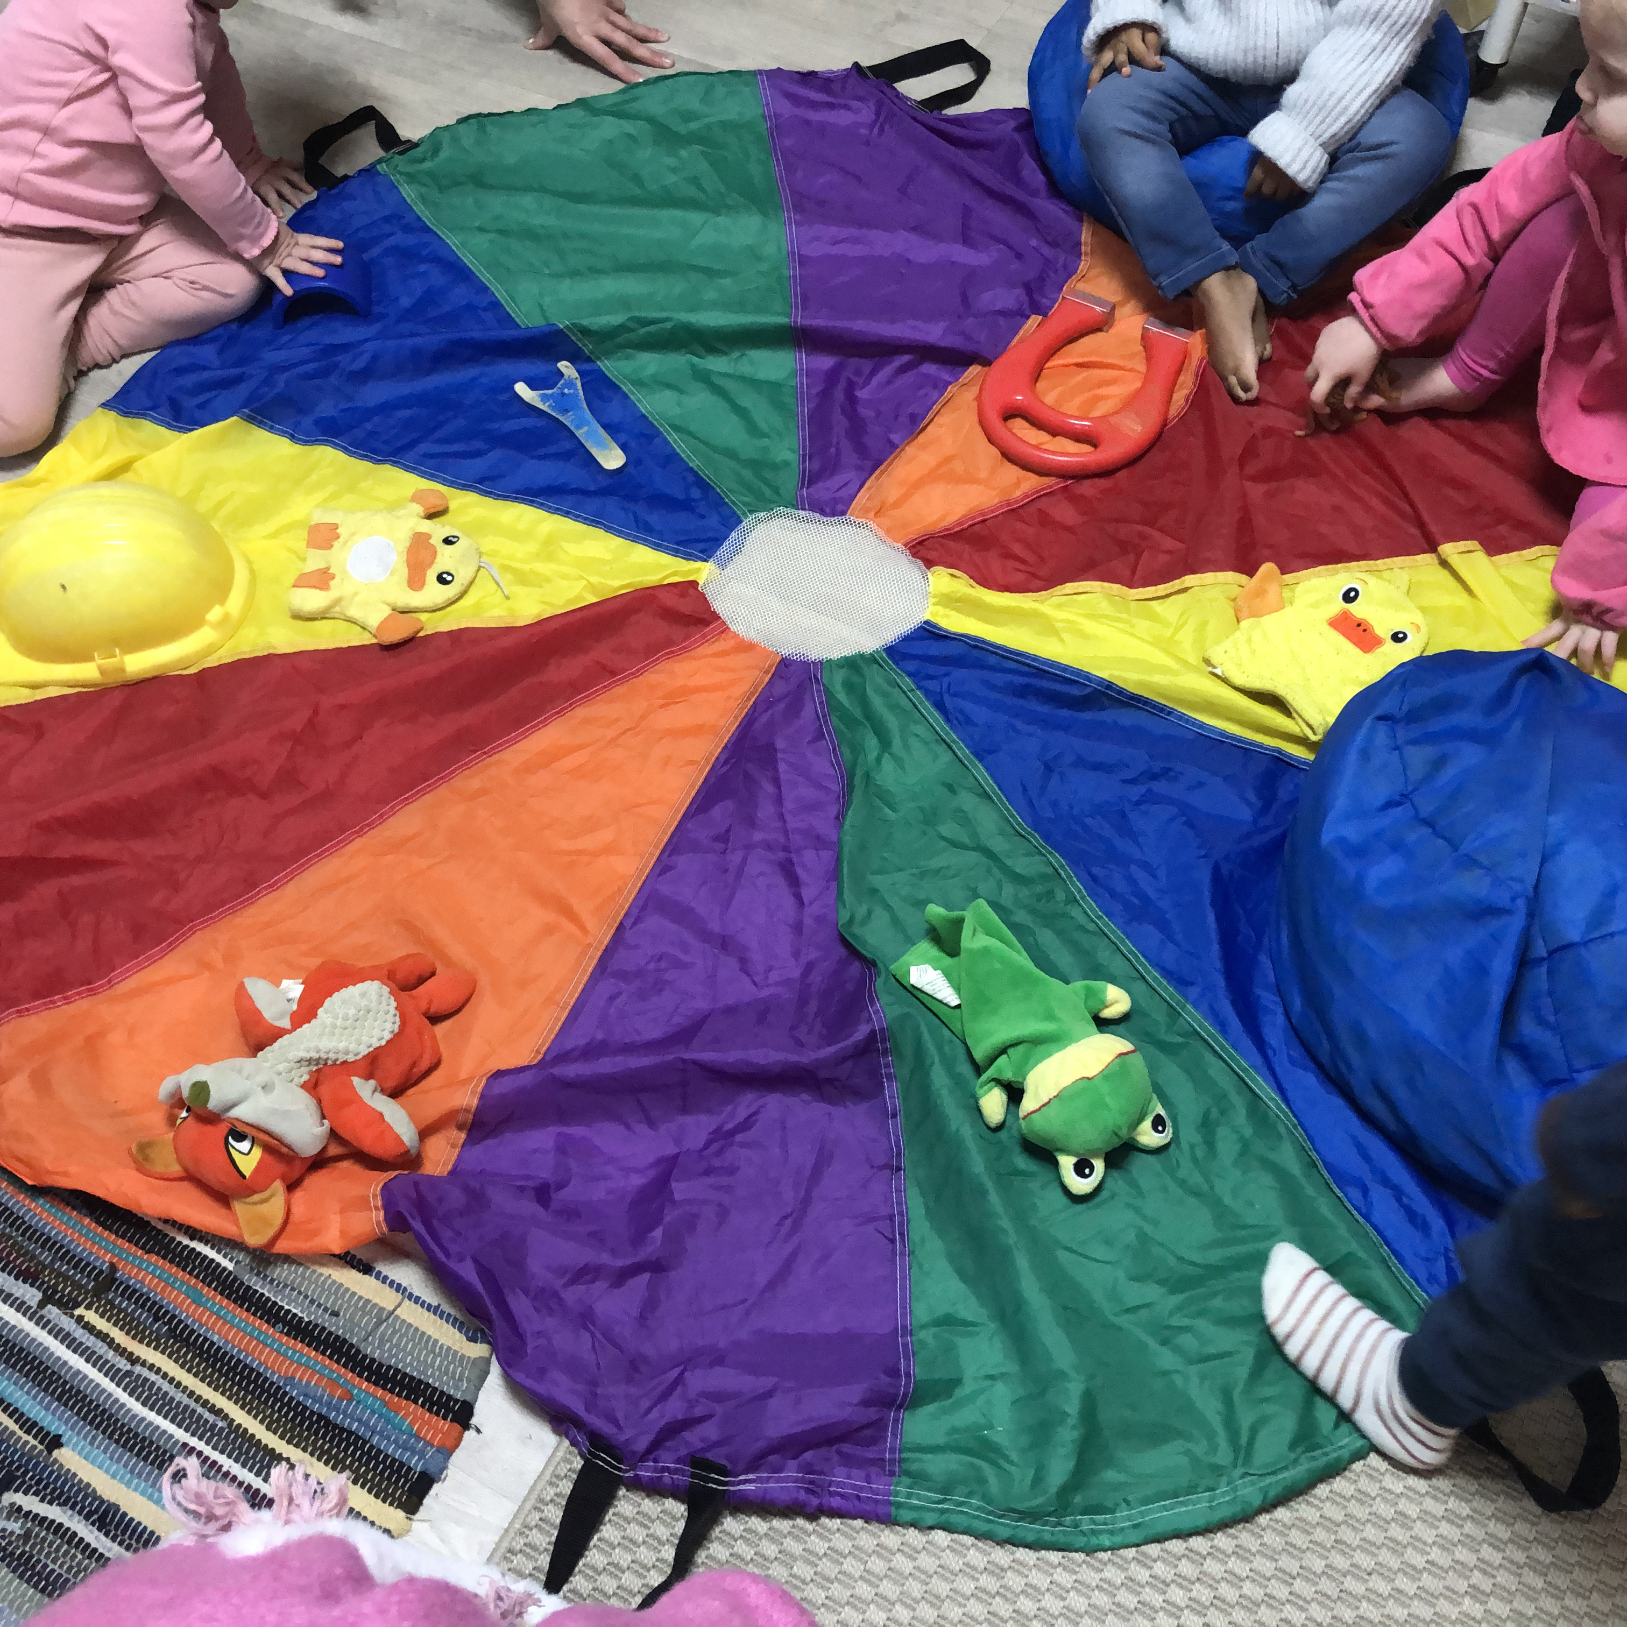

Preschool – Shooting stars
Shooting stars have completed lots of different topics in their room, they spent time reading and acting out fairy tale stories such as the ginger bread man and jack and the beanstalk whilst also going on a sea adventure and spending the week hunting down dinosaurs!
Children in the preschool room complete lots of different activiites throughout the day and weeks. Some of these activities are to aid them in their social and emotional development whilst others are to encourage independence and also fine and gross motor skills. Steph our phonics champion works hard to encorporate activiites around phonics and encourages lots of the children to take part.
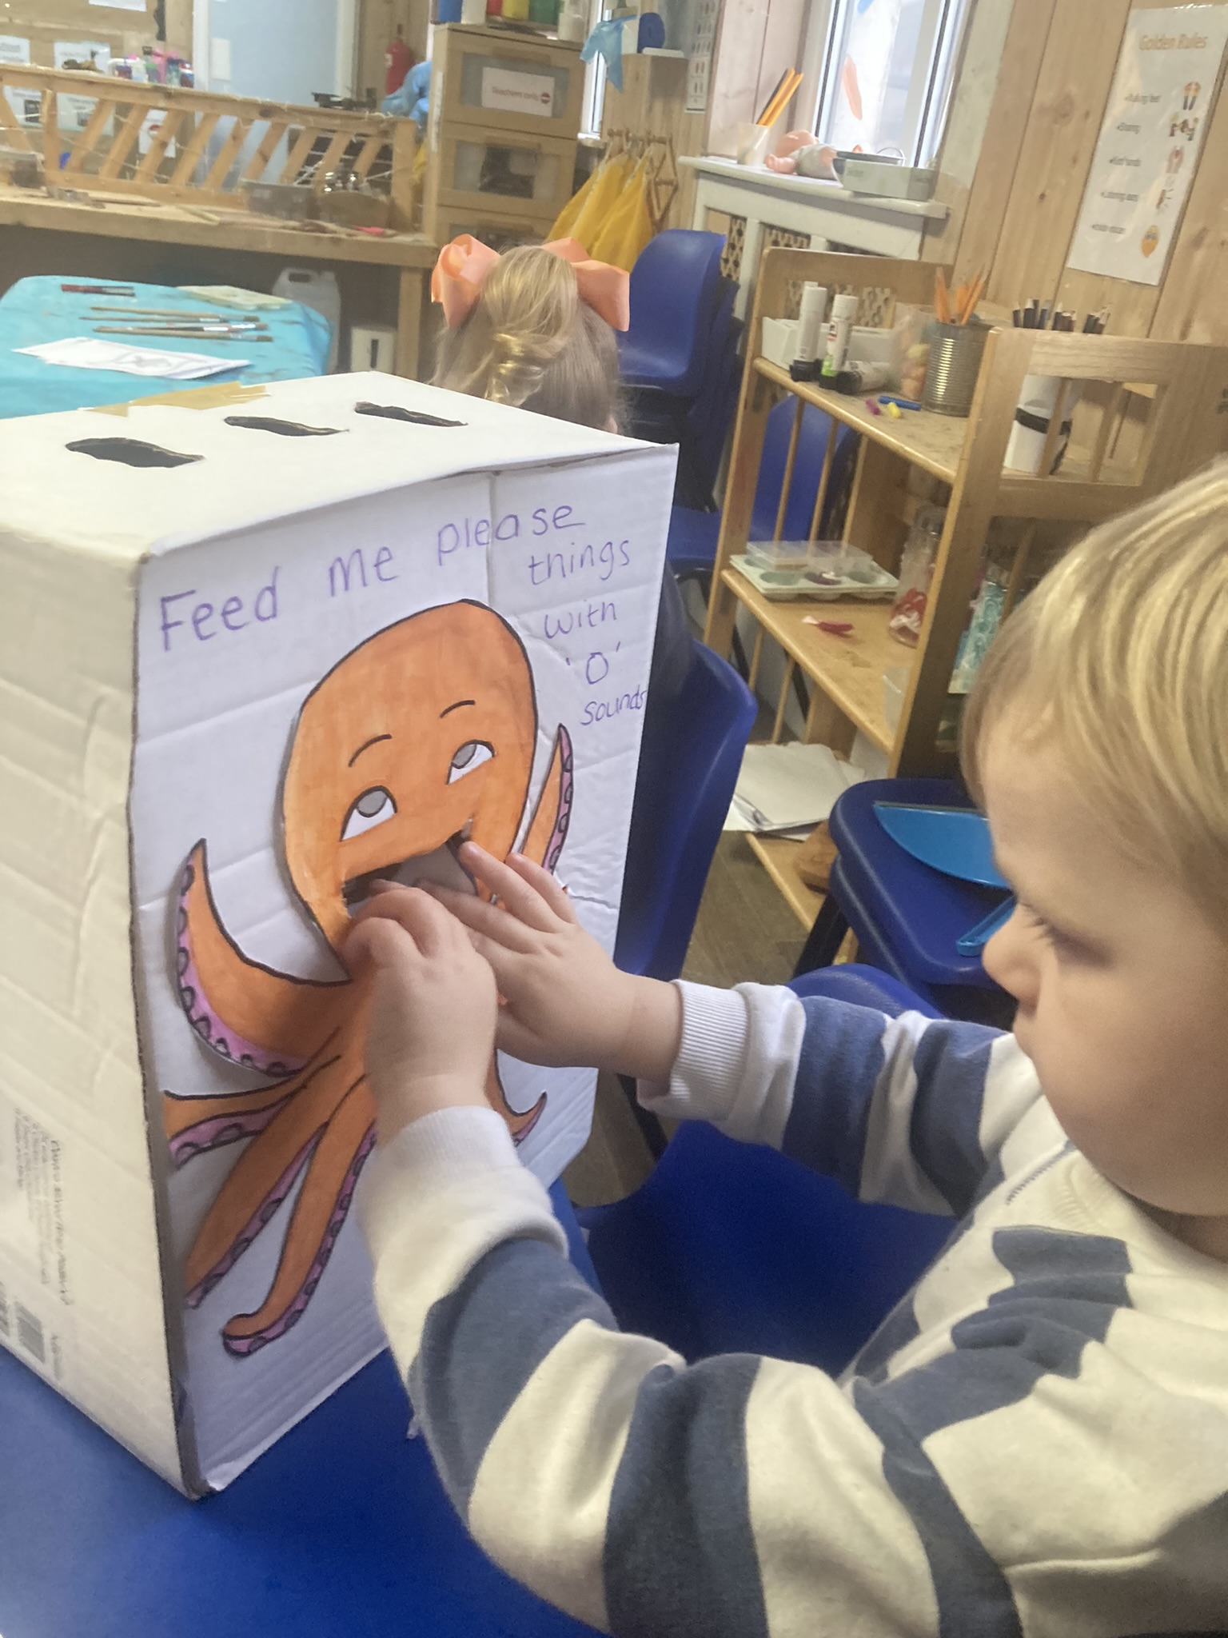

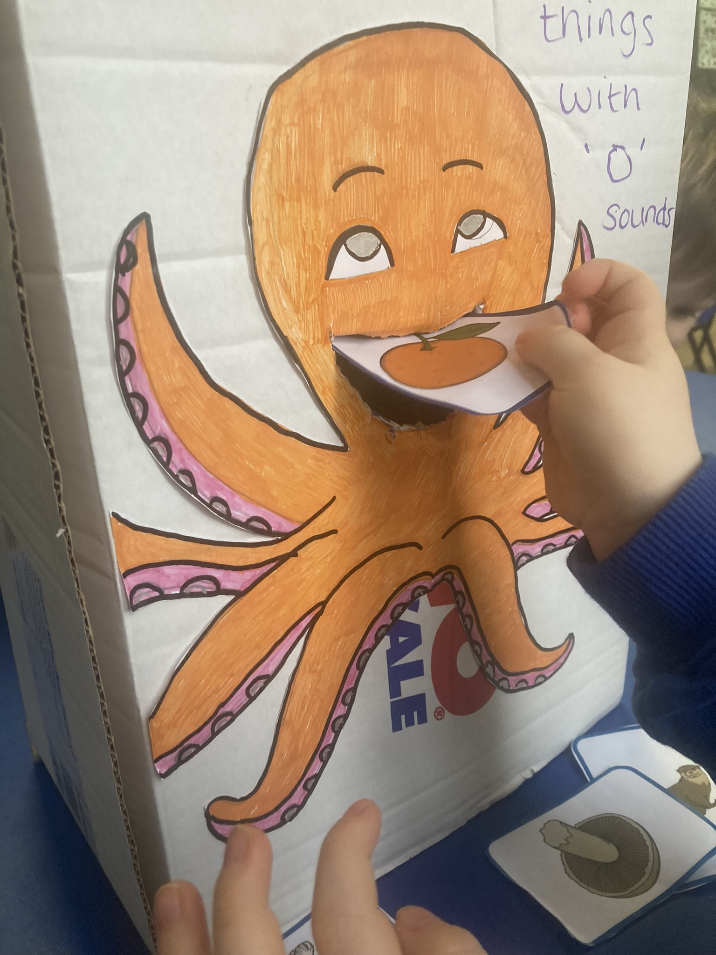

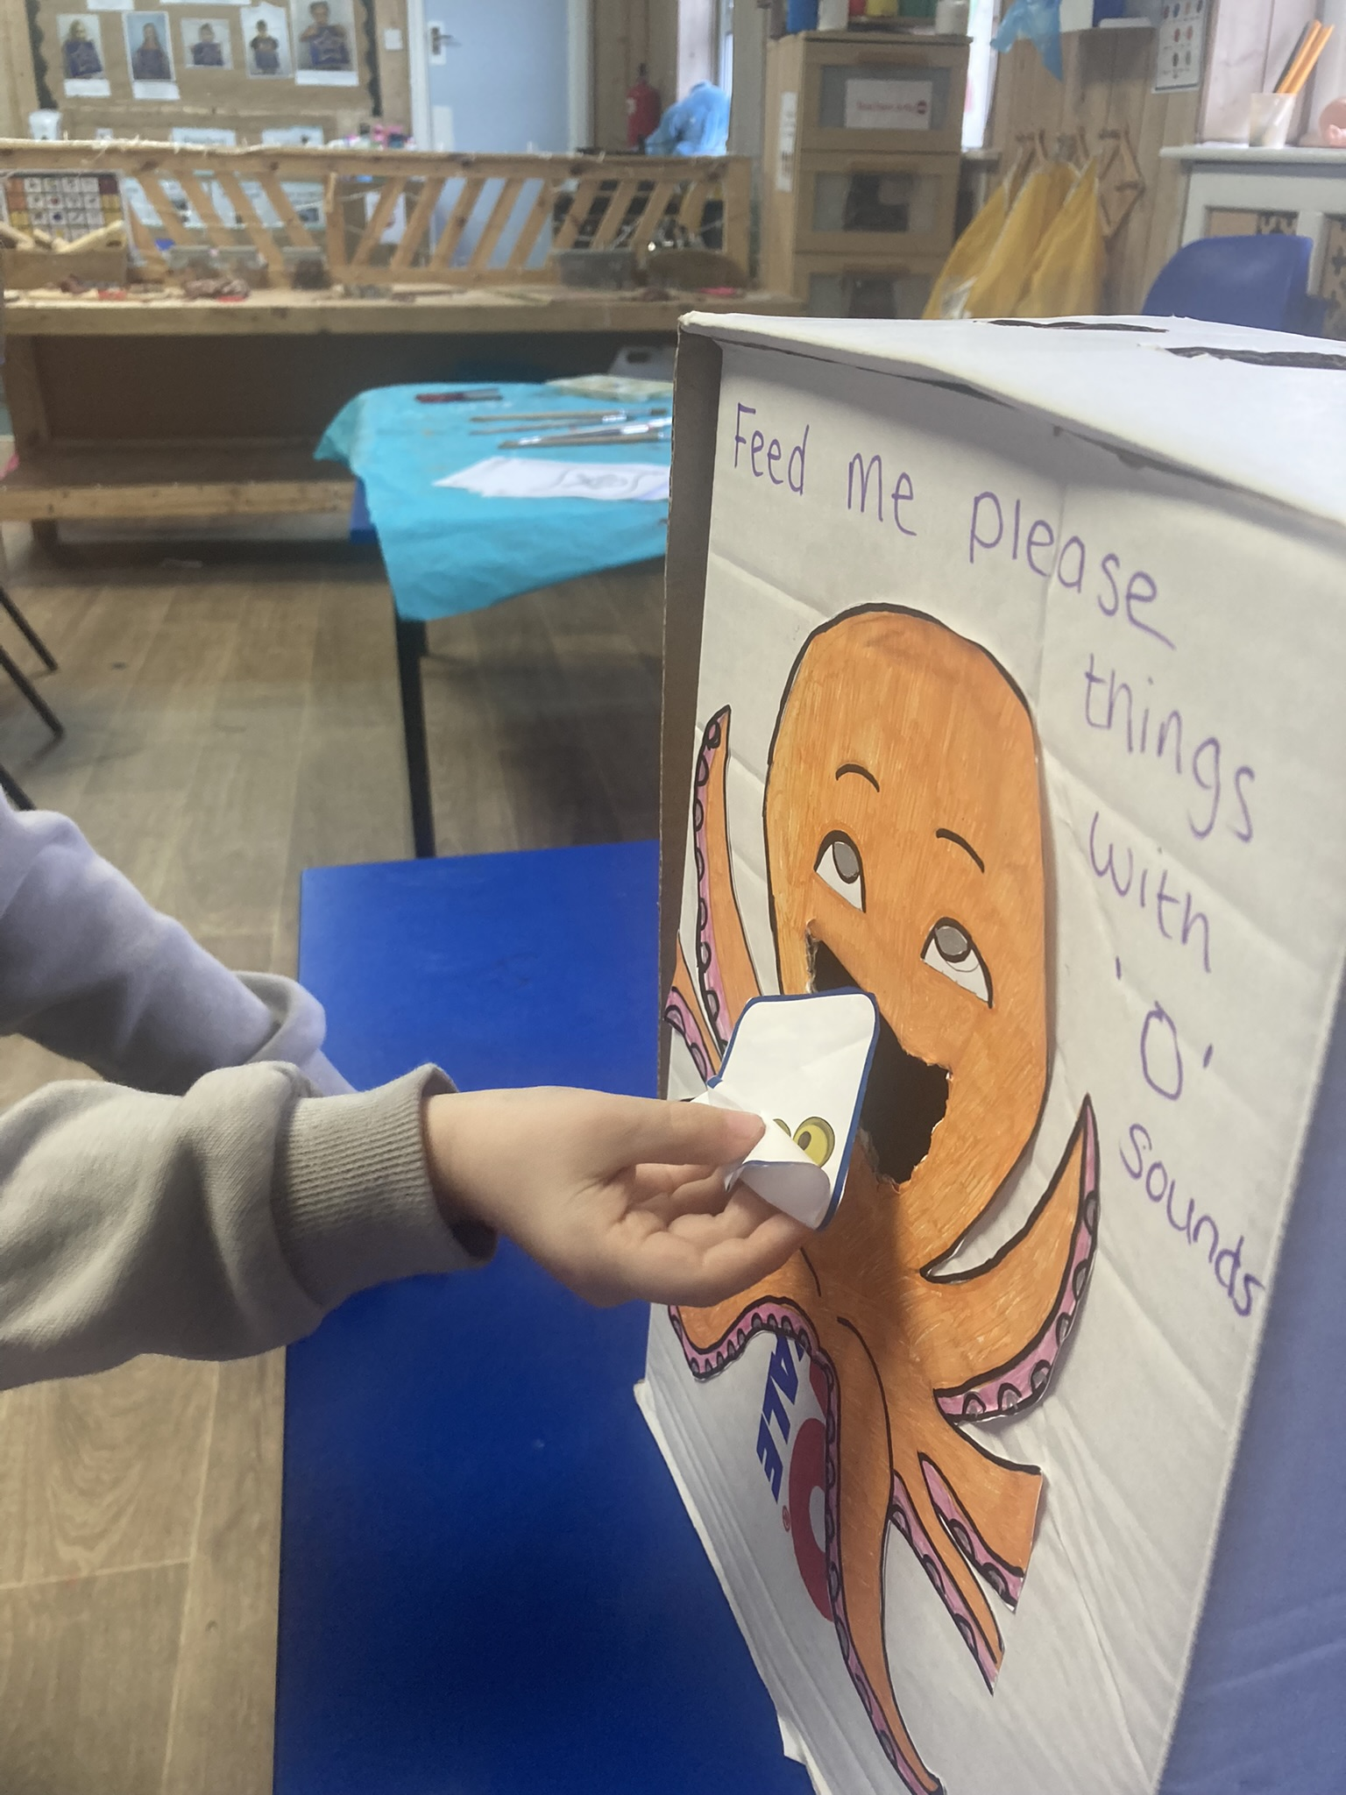

Permissions
Please can you ALL make sure you complete your permissions on the famly app, it is important that we have the most up to date information regarding what your child can and cannot do.
Absence reporting procedure
• If your child/family are going on holiday please request a holiday form from the office to complete, this will ensure your child is marked as “Holiday” for the relevant dates and that all key people are aware of your child/children’s absence to prevent a phone call or a house visit during your holiday.
• If your child is absent for any other reason illness/family day ect you must phone the nursery 0161 343 1249 or e-mail brightstarspdn@outlook.com to report your child’s absence at your earliest convenience, please to not use any messaging apps.
• If your child is absent due to a medical reason or long term illness/accident please inform us via a telephone call.
• If a parent/carer does not contact Bright Stars to report their child’s absence by 10.00am for a morning session or 2pm for an afternoon session our attendance officer, Child’s Key Person or Room leader will contact the parent/carer via telephone (not a messaging app) to ascertain the reason for the child’s absence
• If no contact is made despite attempts from the team at Bright Stars we then reserve the right to contact the emergency contacts on your child’s registration form
• If we don’t manage to make contact regardless of trying all contact numbers if we feel necessary 2 members of staff will make a home visit to ensure the family is safe and well
• Lastly if there is still no contact and we have safeguarding concerns we may call authorities to complete a welfare check
Let’s all work together to support your child’s attendance and punctuality. Please remember a simple phone call at the beginning of the sessions will prevent any unnecessary concern for the setting and we can document the reason for your child’s absence.

Term dates
Half term is
Monday 17th February – Friday 21st February
Easter holidays
Monday 31st March – Monday 21st April
You can now follow us on TIKTOK!
Many thanks - Jo, Claire and the Bright Stars team

