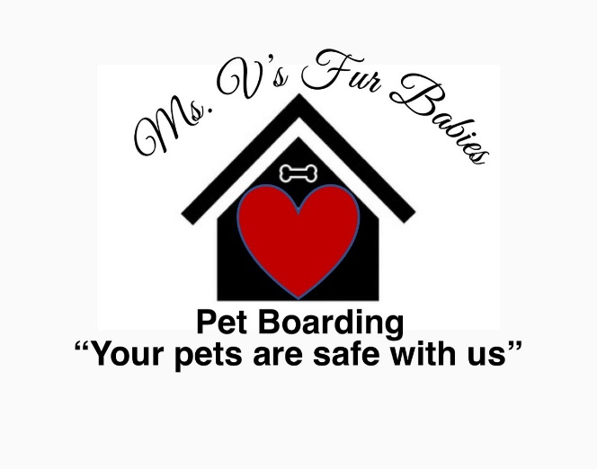

Client Photo Release Form

I give Ms. V’s Fur Babies Pet Boarding, Staff, Board Members and/or local media directed by Ms. V’s Fur Babies Pet Boarding, permission to use pictures and videos taken of me, any of my children and pets in publications promoting Ms. V’s Fur Babies Pet Boarding services.

_____________________________________ __________________
Customer or Parent Signature Date

_____________________________________ __________________
Staff/Volunteer Witness Date

