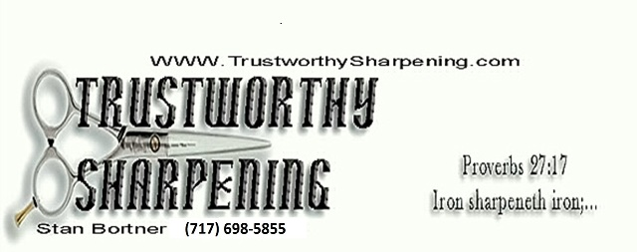

Hanover, Pa. 17331

***Professional Sharpening Since 1990***

**On Site Sharpening**

**2022 Price List**

**Now Accepting Credit Cards**

**WWW.TRUSTWORTHYSHARPENING.COM**

**Clipper Blades** **Scissors/Shears**

Standard Clipper Blades $5.00 Straight Shears Less than 8.5” $ 6.00

Ceramic Clipper Blades $5.00 Straight Shears 8.5” and Over $ 8.00

Wide & T84 Blades $7.00 Curved Shears Less than 8.5” $ 8.00

Horse Clipper Blade (Top) $4.00 Curved Shears 8.5” and Over $ 10.00

Horse Clipper Blade (Bottom) $5.00 Hair Thinners and Chunkers $ 7.00

“Claw” Clipper Blade (Top) $4.00 Bandage Scissors $ 6.00

“Claw” Clipper Blade (Bottom) $5.00 Straight Surgical $ 6.00

Arco “5 N 1” Clipper Blades $6.50 Curved Surgical $ 8.00

Nail Nippers $4.00 Tooth Elevator $ 7.00

**Professional and Home Kitchen Knife Sharpening .75 an inch (this is for the blade length only, not the handle & blade)**

**Animal Clipper Machine Repair and Cleaning Prices**

Clipper Machine Repair $20.00 per hour, plus parts

Oster/Sunbeam Machine Repair $25.00 per hour, plus parts

**All Machine Repairs come with free cleaning and lube**.

**On-Site Sharpening of all blades, shears, scissors, and most repairs. No more waiting weeks for the return of your equipment.**

**Get your blades done right, done RIGHT NOW!!**

*Clipper machine repair turnaround will depend on what parts need to be ordered

**Please include a check payable to Stan Bortner.

***Payment due when services rendered complete.

****$35.00 Fee for insufficient funds or other returned checks.