Thank you for choosing the equipment manufactured with great care by Shandong rippa Machinery Group Co., Ltd.!

This maintenance manual is part of the items delivered with the vehicle. Please ensure that your customer partners keep it safely. The maintenance and warranty instructions, as well as general operation guidance for the machine, can be found in this manual. Please keep it in a safe place after reading.
Shandong Rippa Machinery Group Co., Ltd. Official Website: rippa.com
Contact information for sales: Whatsapp:+86 18863701285. Email: rippagroup@rippa.com
After-sales service contact information: Whatsapp:+86 18853708983. Email:service@rippa.com
Group customer service contact information: Tel：0537-2339712. Whatsapp：+86 18863723638.
Email：customerservice@rippa.com.
Shandong Rippa Machinery Group Co., Ltd.
July 2025

Attention
Content marked with a 'Notice'label indicates important considerations for operating the machinery; disregarding this information may result in erroneous operations.
Introduction Notification information
●The agreements outlined in this manual and the user manuals on the official website clarify the terms of quality assurance responsibility and the rights and obligations regarding after-sales service between Shandong Lipai Machinery Group Co., Ltd. and the users. Please be sure to read this manual carefully before using the company's products.
Warning
Content marked with the 'Warning' sign indicates a risk of serious injury. Ignoring this information may result in serious harm or property damage.
Danger
The content marked with a 'Danger' sign indicates the risk of fatal injury. Ignoring this information may endanger life or result in property loss.
● All personnel at the after-sales service center authorized by our company have received good professional training. Warning: The content marked with a "Warning" sign indicates the danger of accidents or injuries. Ignoring this information may result in injury or property damage. We are able to provide you with comprehensive and satisfactory service. If you encounter any issues regarding machine maintenance, servicing, or repairs, please contact the relevant department of our company promptly.
● It is prohibited to illegally modify the machine. If you intend to sell the machine, please ensure this manual is provided to the new owner.

Please use this manual
● Directional data, such as front, back, left, and right, are recognized with the normal driving direction as the front.
● Certain features and configurations described in this manual may not be equipped on all machines. This manual may also introduce equipment/functions that are not installed on your vehicle.
● This manual includes the latest information available as of the time of its printing. Our company is responsible for the revisions and explanations of this manual, and any revisions related to safety will be communicated in accordance with regulatory requirements.

Some images in this manual are for illustration purposes only and are for reference; in case of any discrepancies between the images and the actual products, the actual products shall prevail.

①：In this manual: 'Shandong Rippa Machinery Group Co., Ltd.' is referred to as 'the company' or 'RIPPA.' The copyright and final interpretation rights of this manual belong to Shandong Rippa Machinery Group Co., Ltd.

Table of Contents
Introduction to Original Manufacturer Parts——————————————
Warranty Certificate————————————————————————
Quality Assurance Documentation Notification Letter——————————
Warranty Statement————————————————————————
Maintenance Specifications Guidelines————————————————
Safety-critical components that are replaced regularly—————————
Common Faults and Solutions————————————————————
List of Random Accessories and Spare Parts—————————————
User Support———————————————————————————

Introduction to Original Manufacturer Parts
Introduction to Original Factory Parts Knowledge
● Original factory parts
Parts produced by authorized suppliers of RIPPA and certified as qualified under the RIPPA quality standardization system.
● Counterfeit components
To realistically imitate the external features of other similar products, or to do so without authorization. To reproduce and sell products that are protected by intellectual property rights, in order to pass them off as original manufacturer parts.
● Inferior components
The quality and performance do not meet the requirements set forth by the national standards, industry standards, and local standards promulgated in our country, and may even pertain to components produced without any standards.
Advantages of Original Manufacturer Parts
● Quality assurance, worry-free service.
Original factory parts are supplied by qualified component manufacturers according to the RIPPA production quality standards, ensuring guaranteed quality. The lifespan of the components is long, and users can enjoy warranty services, providing peace of mind during maintenance and use.
● Safe and reliable with excellent performance.
Original manufacturer parts can achieve complete compatibility with the machinery, ensuring the entire machine operates efficiently and safely. In contrast, using non-original parts may result in secondary failures of the machine and/or components, thereby increasing repair costs and safety risks during operation.
Identification of Authenticity Labels for Original Manufacturer Parts
All original factory parts that have passed RIPPA certification will be marked with the RIPPA logo on their outer packaging, as shown in the image below. Users are advised to enhance their identification when purchasing and using original factory parts to prevent counterfeiting.
Illustration:
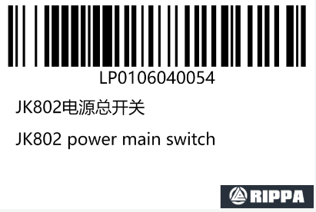
Supervision of Original Manufacturer Parts Services
● RIPPA and all service providers commit to using original manufacturer parts for services and will not use counterfeit or inferior components.
● RIPPA and all service providers commit to ensuring that the origin and quality of original factory parts are transparent and guaranteed, and shall never use non-original factory parts without authorization; when non-original factory parts are used, the reasons must be explained to the customer, and the procurement sources and quality assurance materials for the non-original factory parts must be disclosed. Non-original factory parts may only be used with the customer's consent after consultation.
● If users find that the acquired parts are inconsistent with the original manufacturer's service commitment while maintaining the machinery and equipment, they can directly contact the RIPPA customer service hotline or email. We will respond immediately and prioritize resolving user issues.
● The above content includes the latest information available as of the printing of this manual. For any updates, please refer to the physical item or contact us for consultation.

Warranty Certificate
Product Information
Product Brand：RIPPA | Product model: | Manufacturing Number: | Engine number:
Machine complete unit code: |  |  | Production date:
Producer Information
Name: Shandong Lipai Machinery Group Co., Ltd. |  | Postal code:
Address: Guang'an Road, High-tech Zone, Jining City, Shandong Province. |  | Customer service phone/email:
Seller Information
Name: |  | Postal Code: | Contact Information:
Address: |  | Delivery date: Year Month Day
User Information
I have read the Customer Information Policy of RIPPA Company presented by the seller and fully understand and agree to its terms.
Purchaser Information: £individual £unit |  | Name/Company Name:
Contact: |  | Contact Number:
Address:（Nation）______________ (Province/State)_________________（District/City/County）_____________________________________。 User signature:_________________________________
RIPPA Complete Machine Quality Assurance Period Table
NO. | Quality assurance period: from the date of machine delivery. | Machine Model
j | Complete machine warranty: 2 years/2000 hours. | Brand Model ECO
j | Main assembly component warranty: 3 years/3000 hours | Brand Model ECO
k | Complete machine warranty: 3 years/3000 hours. | Brand Model PRO
k | Main assembly component warranty: 4 years/4000 hours | Brand Model PRO
l | Overall machine warranty: 1 year/unlimited hours of use. | Other models
l | Main assembly component warranty: 1 year/1000 hours. | Other models
The warranty claim period is determined by the earlier of the years of purchase or the hours of operation.

Agreement on the Warranty Period for Special Components
Warranty Period for Easily Damaged and Consumable Special Parts
period | List of Components Under Warranty
3 months | Seat
6 months | Rubber tracks, shock-absorbing pads, engine-mounted diesel tank, fuel injectors, electronic diesel pumps, actuators, ECU, speed sensors, mufflers, cylinders, crankshaft bearings, connecting rod bearings, master power switch, ignition lock, relays, wiring harness assemblies, instruments, odometers, indicator lights, headlights, oil level sensors, water temperature sensors, oil pressure sensors, batteries, pins, and bushings.
12 months | Support wheels, sprockets, guide wheels, drive wheels, steel tracks, swing supports, swing motors, central swivel joints, complete vehicle oil pipes, complete vehicle oil cylinders, multi-way valves, oil source valves, solenoid valves, overflow valves, pilot handles, foot valves, bulldozer valves, travel motors, hydraulic pumps, integrated hydraulic oil tanks, diesel tanks, fan blades, connecting rods, pistons, crankshafts, flywheels, water pumps, oil pumps (listed as individual items), chassis, remote control rods, boom bucket rods, upper and lower vehicle frames, boom supports, throttle pull wires, bulldozer blade pull wires, water dispersers, oil dispersers, couplings, nylon plates.
Remarks | All the warranty repair items mentioned above are predicated on the absence of human causes. Any faults and losses caused by human factors are not covered under the warranty scope, as detailed in the warranty claim management regulations. Structural components are not covered by the warranty, primarily focusing on welding.
Notice of Submission of After-Sales Warranty Service Documentation
Thank you very much for your support and trust in our company's products. In order to more efficiently and accurately handle your product after-sales warranty service, we kindly ask for your assistance in providing some photos and video materials related to the product issues to initiate our after-sales service process. This information will help us quickly and accurately determine the cause of the product fault, thus providing you with a higher quality warranty service experience. Please refer to the specific submission requirements and examples in the attachment.● After-sales service repair example 1:
Machine information
Model 机型 | Factory serial number nameplate  出厂编号铭牌 | Engine number plate  发动机号铭牌
 | 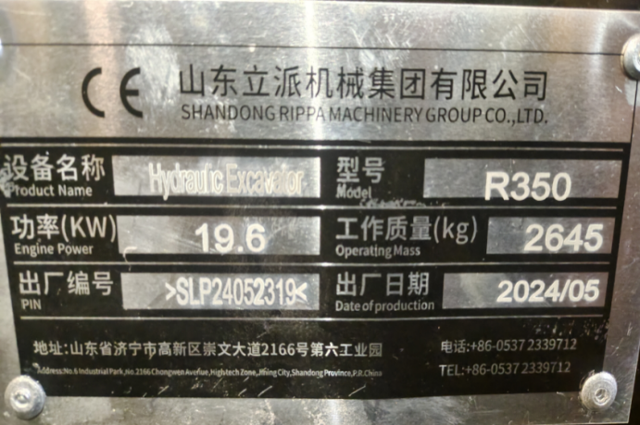 | 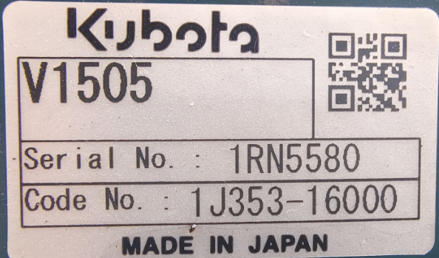
Detailed description of machine failure (can attach pictures and videos)
机器故障详述（可附图片、视频）
●After-sales service repair example 2：

Please provide the corresponding component code according to the parts catalog that comes with the machine
请根据机器随附的零件目录提供相应的部件代码
Accessories requirements配件需求
Accessory name/problem point配件名称/问题点 | Photos of the fault point  故障问题点照片 | Faulty parts label/steel stamp numbe  r故障配件标签/钢印号
 | 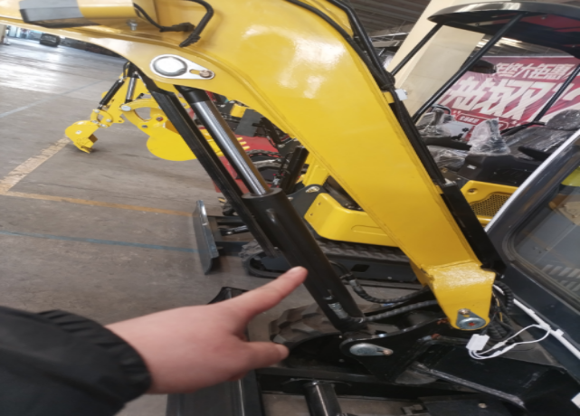 | 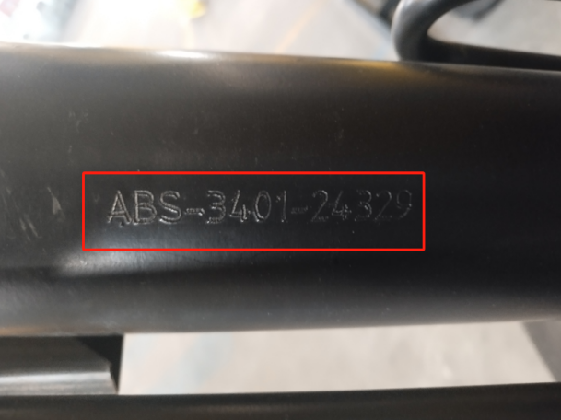
Warranty Description
Regulations for Quality Assurance Services
◆During the quality assurance period, vehicle defects arising from factors such as product design, manufacturing, assembly, and raw material defects will be assessed by the Service Division or the Research and Development Technical Center. To protect the environment and promote sustainable development, the primary approach will be to repair defective components free of charge. Only when defective components cannot be repaired or are deemed to have no repairable value will the replacement of components be considered. The components used for repair or replacement will be those provided or recognized by the manufacturer and deemed to meet quality standards.
◆During the warranty period, if repairs are necessary due to defects covered under the warranty service scope, please allow the service department or authorized service center sufficient time to conduct the necessary repairs. The service center will return your equipment or machine to you as swiftly as possible, and any parts replaced under the warranty will remain the property of our company.
◆Except for the mandatory provisions of Chinese law, the quality assurance services provided by this manual are the only responsibility that our company undertakes towards the user.
◆The transportation time for components and the time spent on external rescue operations are not included in the maintenance time.
The rights and fundamental obligations of users.
For new machinery, complete parts, and self-funded components, users have the right to quality assurance services provided they fulfill their basic obligations in accordance with the other relevant provisions of this manual. The following are the basic obligations that users must fulfill in order to enjoy the rights to quality assurance services.
1. During the quality assurance period, conduct regular maintenance of the machine in accordance with the provisions of this manual, and use and operate it correctly as specified in the user manual.
2. Use genuine parts provided by our company, and all maintenance, repairs, and replacement of components must be carried out in accordance with the specified requirements and accompanied by valid proof.
3.In order to protect the safety of users and machines, users should maintain the original state of malfunctioning machines as much as possible and contact our company or the service center promptly. Unauthorized disassembly or repair is prohibited.
Not within the scope of quality assurance services.
- Falsifying or illegally obtaining relevant purchase certificates, vehicle manual materials, etc.
- Failing to provide the necessary documentation such as proof of purchase, proof of faulty parts, user information, and vehicle model in a timely manner.
- Beyond the quality warranty period, or failure to provide relevant explanation for component failures and missing failure documentation.
- Failure to fully fulfill the user's basic obligations;
- Failures caused by unauthorized modifications, installations, or additions to the original machine structure without permission.
- Any acts of cheating during the warranty period, including but not limited to the intentional alteration of the usage schedule, are prohibited.
- Refusal to accept the quality assurance services of the company's service division or authorized service centers.
- In the event of a machine or equipment malfunction, any subsequent failures caused by continued operation or use, including but not limited to engine damage resulting from the water temperature gauge indicating high engine temperature while continuing to operate or use.
- Damage to the product or loss of components caused by improper use, storage, or maintenance by the user, including but not limited to damages resulting from theft, overloading, abnormal operation, exposure to sunlight, prolonged inactivity, etc;
- Damage caused by traffic accidents, natural disasters, or other force majeure events, including but not limited to car accidents, floods, sandstorms, earthquakes, hail, mudslides, military actions, etc.
- Maintenance requirements include the regular replacement of maintenance materials such as oils, filters, sealing rings, gaskets, and safety plates.
- Damages, corrosion, discoloration, blemishes, and other defects caused by human factors or external influences, including but not limited to scratches from foreign objects, pollution from emissions, environmental pollution, etc.
- Under normal circumstances, perceptible phenomena that do not affect the quality or functionality of the machine, including but not limited to minor noise or vibrations;
- Economic losses or additional costs incurred due to machinery and equipment not being able to operate normally, such as time loss, personal property, and income loss.
- The machine or equipment is used in a harsh environment with significant pollution and dust, and maintenance has not been conducted ahead of the required schedule by shortening the maintenance cycle as mandated.

Maintenance and Maintenance Standards
Standard Maintenance Protocol:
Initial maintenance service for the new machine: 50 hours after sale.
Routine maintenance and upkeep items | First Usage Time (H) | Regular usage time interval (H) | Maintenance Method
Oil, oil filter, air filter, diesel filter | 50H | 200H | Replacement
Walking motor gear oil | 50H | 500H | Replacement
Hydraulic oil, hydraulic return oil filter, hydraulic suction filter. | 300H | 300H | Replacement
Pilot filter element | 500H | 1000H | Replacement
Antifreeze | Supplementation/Daily | One year/Replacement | Supplement/Replace
Butter | New machine / Refueling | 8H | Inspection/Refueling
Cooling tanks and hydraulic oil coolers | 50H | 50H/Cleaning, airblowing or high-pressure water jetting.
(Rotary motor, slewing bearing, engine) fixed bolts | 30H | 30H/Inspection, tighten immediately if there is any looseness.
Track Tensioning Device | Before each work session.
1. Please perform regular maintenance in accordance with the maintenance specifications. The company will not provide warranty for equipment failures caused by untimely maintenance or lack of maintenance.
2. Please perform regular maintenance in accordance with the maintenance specifications. The company will not provide warranty for equipment failures caused by untimely maintenance or lack of maintenance.
3. Due to the failure to regularly inspect the fixed bolts of the swing motor, swing bearing, and engine, issues such as gear grinding of the swing motor, flange damage, gear grinding of the swing bearing, engine fan cage damage, and radiator leakage may occur. The company will not provide warranty for any component damage resulting from these incidents.
Regularly replace safety-critical components
1. Ensure that the machinery can be used safely for an extended period by regularly lubricating and inspecting for maintenance. To enhance safety, please regularly replace critical safety components such as hoses and safety belts.
2. "Regularly replaced safety-critical components" refer to parts that undergo aging, wear, and functional degradation after repeated use, and whose performance changes over time. The characteristics of these components can lead to significant mechanical damage or personal injury, and it is often challenging to assess their remaining useful life based solely on visual inspection or operational feel.
3. If there are any damaged visual appearances, please replace the 'safety-critical parts that are regularly replaced,' even if the specified replacement interval has not been reached.
4. Regularly replace the fuel hose of the track tensioning device. The fuel hose wears down over time, even in the absence of any visible signs of wear.
5. Replace any signs of wear, regardless of the replacement plan.
6. For the safe use of the machine, please conduct regular inspections and maintenance. The following critical safety components must be replaced regularly to enhance safety. Damage to these components may lead to serious personal injury or fire.
7. Engine maintenance includes the following components:
1）Care during the engine break-in period.
2）The oil change interval should be observed, and oil should be replenished as necessary (engine oil will gradually be consumed with the use of the machine, so it is essential to regularly check the oil level. It is not sufficient to simply add oil once and wait until the next change; timely replenishment is necessary when oil levels are low. Failure to do so may result in serious consequences such as cylinder damage, and any engine damage caused by insufficient oil will not be covered under warranty by the manufacturer).
3）The replacement cycle for the oil filter and the diesel filter element.
4）Air filter replacement cycle. When inspecting or maintaining the machine, mark a 'Do Not Operate' warning message to prevent unauthorized individuals from starting the engine or touching the control handles. Before maintenance, please turn off the engine, remove the key, and keep it with you. Mark a 'Do Not Operate' warning message at conspicuous locations such as the starting switch or control lever.

List of Safety-Critical Components
Subject | Safety-critical components that are replaced periodically |  | Change of Time
Fuel System | Fuel pipe |  | Once every two years
Fuel System | Filler on the fuel tank cap |  | Once every two years
Hydraulic System | Main Pump | Hydraulic Hose (Pump Outlet) | Every two years.
Hydraulic System | Main Pump | Hydraulic pipe (pump suction inlet) | Every two years.
Hydraulic System | Main Pump | Hydraulic hose (swivel motor) | Every two years.
Hydraulic System | Main Pump | Hydraulic Hose (Stroke Motor) | Every two years.
Hydraulic System | Working equipment | Hydraulic Hose (Boom Cylinder Hose) | Every two years.
Hydraulic System | Working equipment | Hydraulic pipe (rod cylinder pipe) | Every two years.
Hydraulic System | Working equipment | Hydraulic Hose (Bucket Cylinder Hose) | Every two years.
Hydraulic System | Working equipment | Hydraulic piping (Yaw cylinder piping) | Every two years.
Hydraulic System | Working equipment | Hydraulic hose (bulldozer cylinder pipe) | Every two years.
Hydraulic System | Working equipment | Hydraulic Hose (Pilot Valve) | Every two years.
Hydraulic System | Working equipment | Hydraulic pipe (auxiliary pipe) | Every two years.

Common Faults and Solutions
一、Common faults of excavators and their solutions：
Common Failures | Cause of the malfunction | Solution measures
The mechanical power is weak, resulting in slow movement | Overflow valve blockage or excessive looseness | Disassemble and clean the device or tighten the overflow valve
The mechanical power is weak, resulting in slow movement | Pump damage | Replace the hydraulic pump
The mechanical power is weak, resulting in slow movement | The oil pump intake pipe is blocked | Clean or replace the intake pipe
The mechanical power is weak, resulting in slow movement | Engine malfunction | Please contact the manufacturer to repair the engine
The machine is unable to function | Pump damage | Replace the hydraulic pump
The machine is unable to function | The spline of the connector is damaged | The spline of the connector is damaged
The machine is unable to function | The tilt of the fuselage causes the hydraulic oil to shift to one side | Add hydraulic oil or adjust the machine to a level position
The machine cannot operate | The gear of the rotary motor has come off | Install the oscillating gear in position
The machine cannot operate | The rotary motor is damaged. | Replace the rotating motor
The engine emits a faint blue smoke | Excessive lubrication | Adjust the oil quantity according to the upper and lower limits of the oil gauge
The engine emits a faint blue smoke | Engine malfunction | Please contact the manufacturer to repair the engine
The engine is emitting faint black smoke | Air filter blockage | Clean or replace the air filter
The engine is emitting white smoke | Mix water and diesel | Add oil and rinse once with oil
The engine cannot rotate | The overflow valve is jammed | Remove the overflow valve, install the gasoline, and add gasoline
The engine cannot rotate | The relief valve is adjusted too tightly | Adjust the loose overflow valve
Common Failures | Cause of the malfunction | Solution measures
The engine cannot be started | Battery Voltage Loss | Charge or use an external battery for charging
The engine cannot be started | The diesel cannot be delivered to the pipeline, as there is air within it | Remove the diesel pipe from the engine, discharge the air, and install or press the oil pump exhaust
The engine cannot be started | Diesel freeze | Select the appropriate diesel grade based on the local temperature
The engine cannot be started | Engine malfunction | Please contact the manufacturer to repair the engine
The engine cannot be started | Nozzle blockage | Replace the nozzle
The engine cannot be started | Air Filter Plug | Replace the air filter
The engine cannot be started | The high-pressure oil pump is damaged | Replace the high-pressure oil pump
The engine cannot be started | The fuse has blown | Inspect and replace the fuse
The engine cannot be started | Electronic fuel pump malfunction | Replace the electronic oil pump
The engine cannot be started | The high-pressure oil pump is damaged | Replace the high-pressure oil pump
The engine cannot be started | Low temperatures cause the engine oil to become excessively thick | Replace with the appropriate grade of engine oil
The engine throttle valve can be large or small | The folding of the diesel fuel pipe has caused an obstruction in the fuel supply | Inspect the diesel fuel pipes, adjust the direction, and ensure smooth fuel supply
Continue to increase the throttle | The engine throttle valve actuator has been locked | Matsumoto Engine Throttle Body Bracket
It is not permissible to accelerate the throttle | The throttle valve pull wire is loos | Tighten the throttle valve pull wire
The front light is not working, and the speedometer or display is not functioning | The power line plug has become detached | Check whether the line connector is loose or detached
 | Component damage | Replace the components
Common Failures | Cause of the malfunction | Solution measures
The battery has not been charged | Generator disconnection | Inspect the engine wiring and reconnect
The battery has not been charged | The fuse is damaged | Replace the fuse
The battery has not been charged | Regulator malfunction | Replace the regulator
The battery has not been charged | Battery damage | Replace the battery
Caterpillar tracks detached | Mechanical Tension Relaxation | Support the machine by placing the tracks into the tensioning wheel to start the machine. Utilize the rotational force of the drive wheel to adjust the mechanical tensioning device until the tracks are elevated
High engine temperature | Lack of antifreeze | Add antifreeze
High engine temperature | The cooling tank is blocked | Cooling holes for the water tank cleaning
High engine temperature | The thermostat is malfunctioning | Replace the thermostat
Oil pressure alarm | Lack of oil | Add engine oil
Oil pressure alarm | Engine overheating | Inspect the coolant
Oil pressure alarm | Sensor damage | Replace the sensor
Oil pressure alarm | Line malfunction | Inspect the circuit
The oil tank cannot operate | Break the lever ball shaft or the base | Replace the ball axis or base
The joystick operation is abnormal when pushed or returned | The fixing screws of the multi-way valve stem reset spring are loose or have fallen off | Reinstall the reset spring or tighten the fixing screws
The joystick operation is abnormal when pushed or returned | The valve core is stuck | Disassemble the valve core, clean the surface dirt, add an appropriate amount of lubricating oil, and then reinstall
List of Random Accessories and Spare Parts
NO. | Random items | Details | Quantity |  | Model type
1 | Decorative item | Foot mat | One | ⃝
2 | Spare Parts and Components | Right-angle socket | One | ⃝
3 | Spare Parts and Components | 14-inch toolbox | One | ⃝
4 | Spare Parts and Components | Right-angle socket | One | ⃝
5 | Spare Parts and Components | Butter gun | One | ⃝
6 | Spare Parts and Components | Adjustable Wrench | One | ⃝
7 | Spare Parts and Components | Toolbox | One | ⃝
8 | Spare Parts and Components | Filter cartridge wrench | One | ⃝
9 | Spare Parts and Components | Internal hexagon wrench | Group 1 | ⃝
10 | Document | Operational and User Manual | One portion | ⃝
11 | Document | Engine Manual | One portion | ⃝
12 | Document | Certificate of Compliance and Three Guarantee Card | One portion | ⃝
13 | Document | Maintenance and Warranty Manual | One portion | ⃝

User Support
User satisfaction is of utmost importance to Shandong Lipai Machinery Group Co., Ltd. Generally, any issues related to the maintenance, usage, and claims of machinery and equipment should be addressed by our company's service department or authorized service centers. However, if your issue is not satisfactorily resolved, you may take the following measures:
Step One - Communicate with the service engineer of our company.
Communication with our service engineers usually allows for a swift resolution of your issues. If you still have questions regarding the handling of your case, you may contact the head of the head of the service division.
Step 2 - Seek assistance from the Customer Support Center of the Customer Service Division.
If you feel that your issue has not been satisfactorily resolved after contacting the head of our service division, please reach out to our customer service department. We will do our utmost to ensure that your issue is satisfactorily addressed. When you write or call, please provide the following information to the customer service staff:
●Your name, address, and contact information (including phone number, email, WeChat, and WhatsApp);
●Vehicle nameplate (chassis number, equipment name, model);
●Purchase date and current duration of use.
●Problem Description:
●Additional information that customer service staff need to understand to help resolve issues.
Annex:
● Contact information for the head of the service department:
Whatsapp:+86 18853708983. Email:service@rippa.com
●Contact information for the Customer Support Center：Whatsapp：+86 18863723638.
Email：customerservice@rippa.com.

