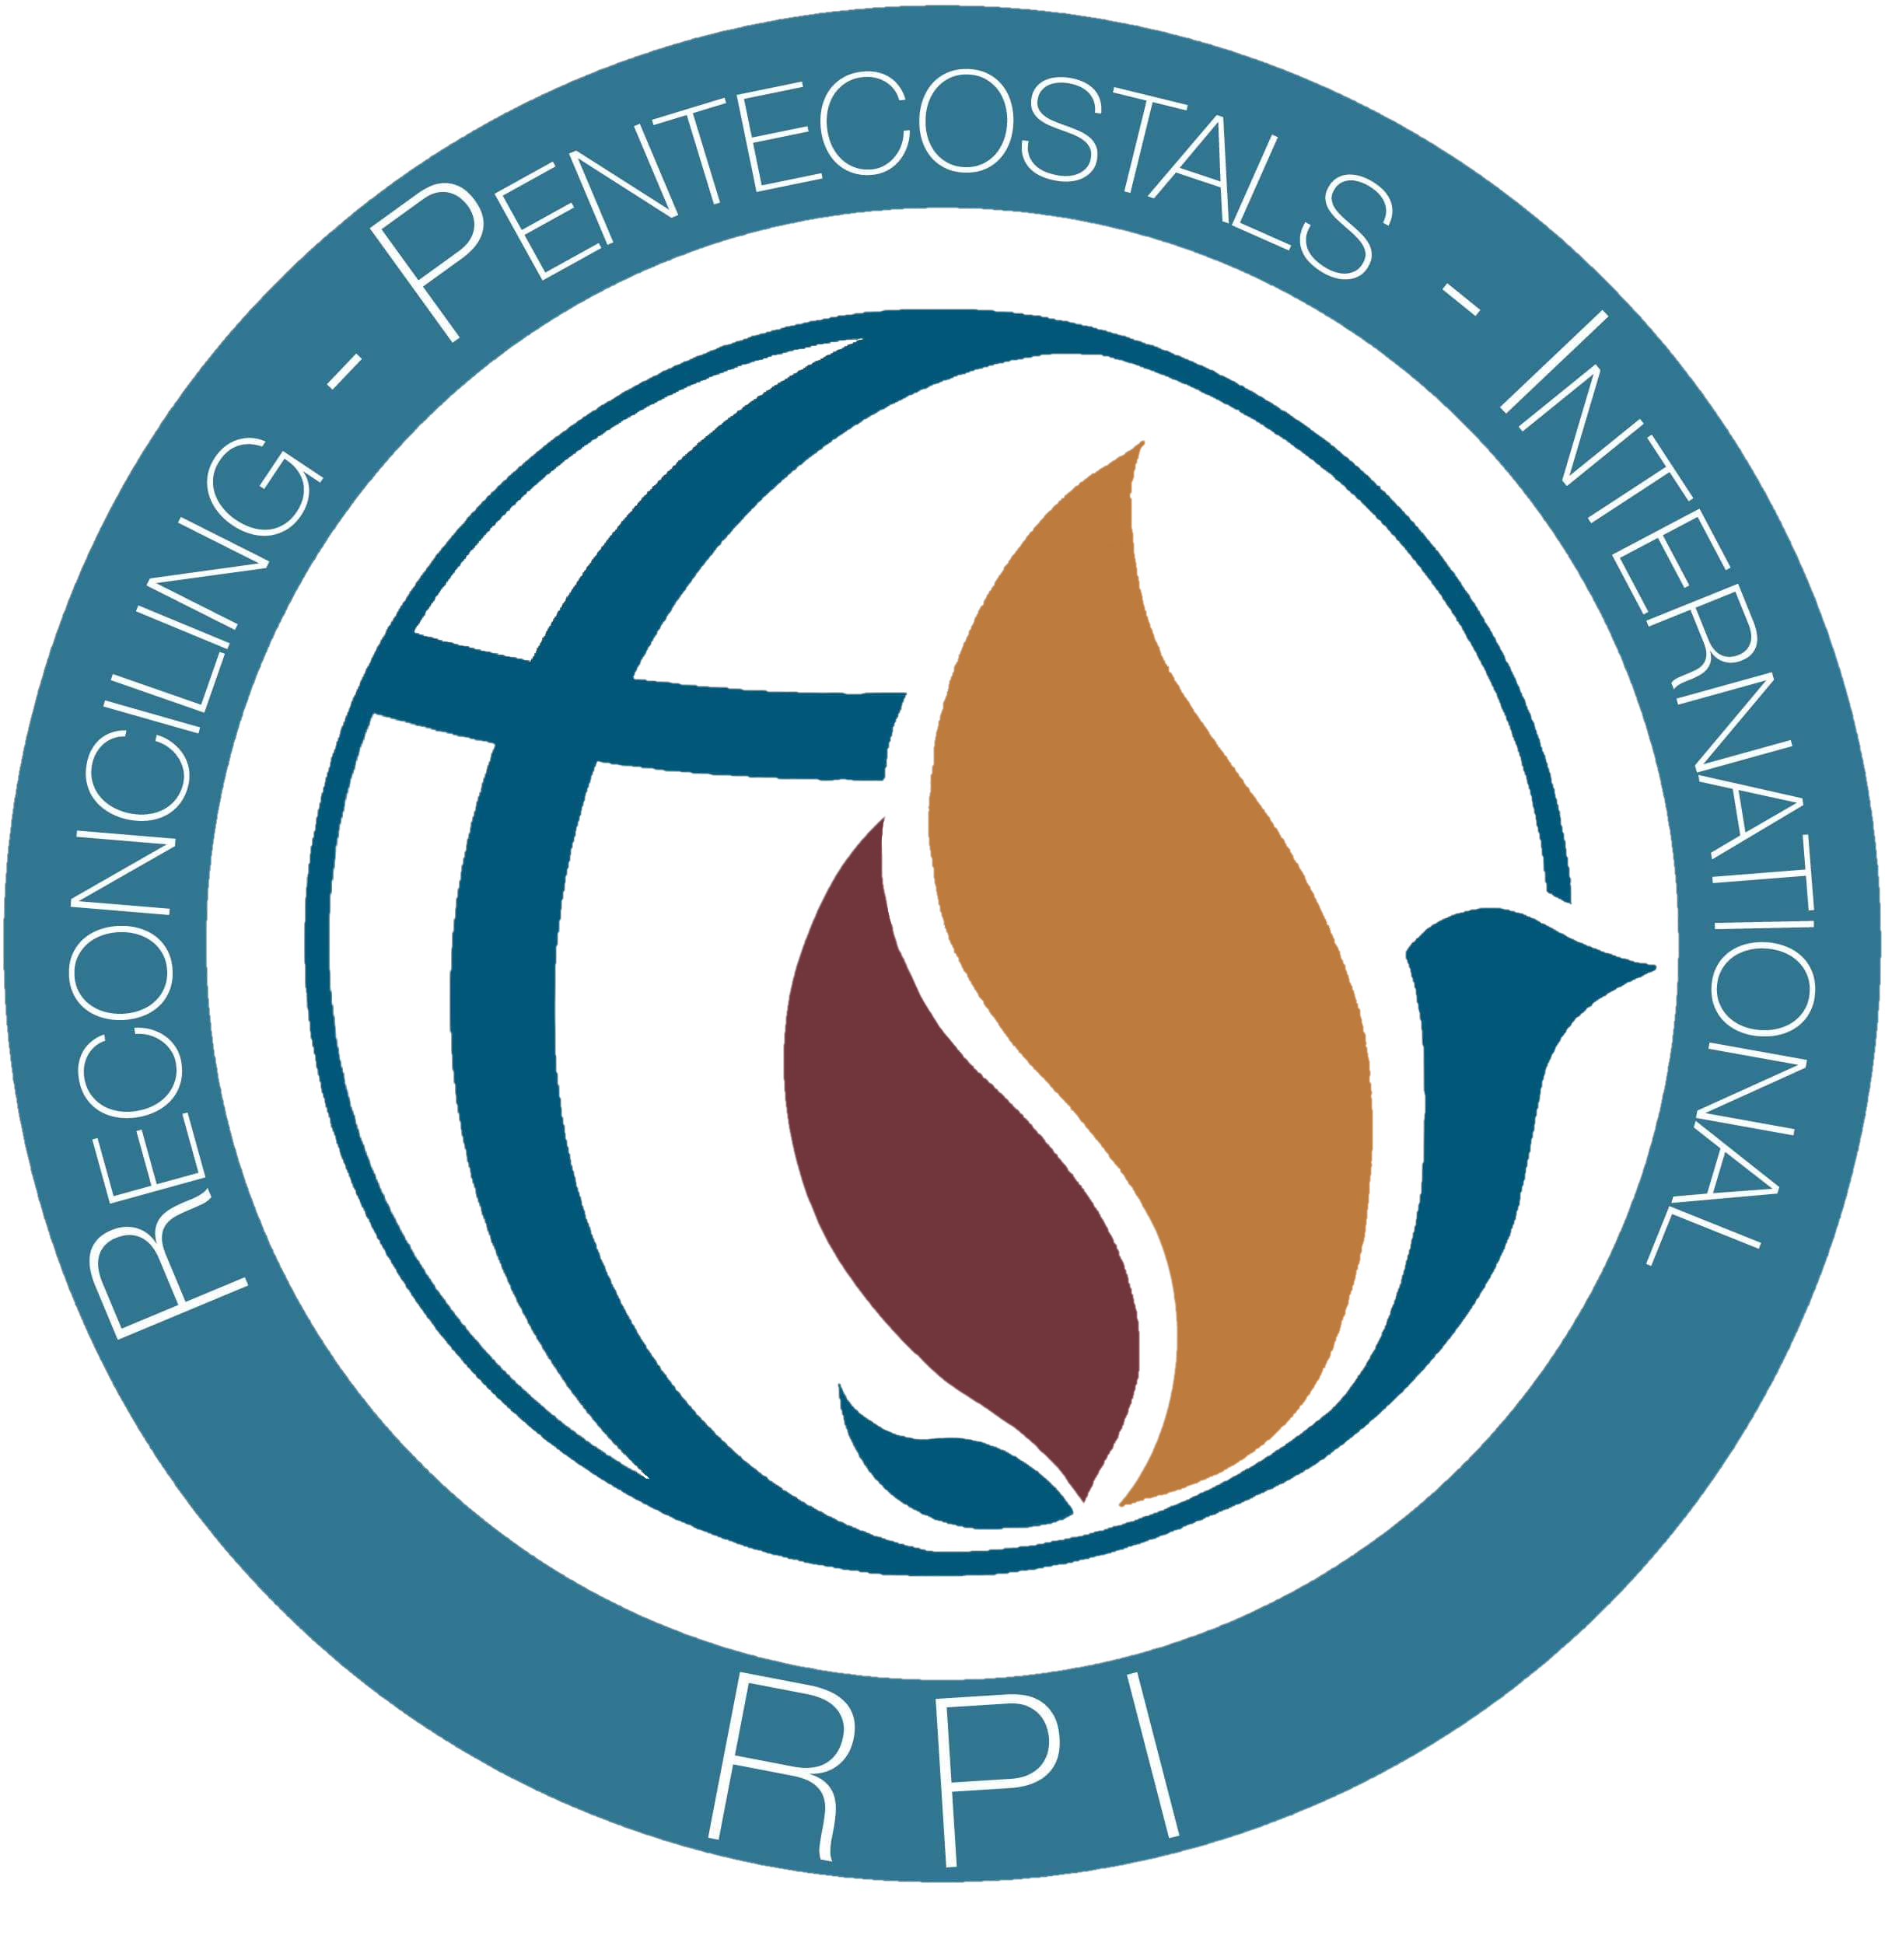
Fellowship of Reconciling Pentecostals International
Application for Church/Ministry Affiliation
Revised January 2022

Name of Church or Ministry: _______________________________________________________

Address: ________________________________________________________________________

_______________________________________________________________________

Phone Number(s): ________________________________________________________________

Email Address: __________________________________________________________________

Website Address: _________________________________________________________________

Name of Pastor or Contact Person: __________________________________________________

Present Membership or Average Weekly Attendance: ___________________________________
Do you hold any other credentials? yes no Answer the following if “yes.”

Affiliation? _____________________________________________________________________

Address: ________________________________________________________________________

_____________________________________________________________________________

Phone Number(s): ________________________________________________________________

Email Address: __________________________________________________________________

Contact person: __________________________________________________________________

Reason for leaving:________________________________________________________________
(Use more paper if necessary)

________________________________________________________________________________
Why are you seeking affiliation with RPI? ____________________________________________

________________________________________________________________________________

________________________________________________________________________________
Do you embrace and agree fully with the Mission Statement, Statement of Faith and Covenant as set forth in the RPI Bylaws? yes no

If not, please explain: ______________________________________________________________

Are you willing to uphold and promote the RPI Statement of Faith? yes no
Are you applying for Associate or Full Membership? __________________________________
(Article 9, Affiliating Churches)

Do you baptize by immersion? yes no Other____________________________________

Which baptismal formula is used? In the Name of Jesus Christ
In the Name of the Father, Son, and Holy Ghost

Do you teach and encourage new converts to receive the Holy Ghost with the evidence of speaking in other tongues? yes no
Explain your position on this subject:________________________________________________

What is the nature of your ministry? (e.g., Church, mission, school, Music Ministry, etc.)

_______________________________________________________________________________

What is your belief regarding Homosexuality and the Scriptures? ________________________

(Use additional paper and attach to application wherever necessary including any documents)

Please describe your standards/guidelines for:

membership? ____________________________________________________________________

________________________________________________________________________________

leadership? ______________________________________________________________________

________________________________________________________________________________
Does your church ordain ministers under your own 501(c)3? yes no

Is your church/ministry incorporated? yes no If so in which state? __________________

Is your church/ministry willing to support RPI financially? yes no
RPI affiliate churches are requested to pay $200 annually, or 5% of their income (Whichever is greater) to the fellowship, on a monthly or quarterly basis. (Article 7, Finances)

If accepted, you will be allowed to have an additional delegate for voting purposes at our General Conference Business Meetings. Please give us your selection. We realize this is subject to change.
RPI Delegate from your church or ministry:

Name:

Phone: E-Mail: ___________________

Position (if any) held in your local ministry: _______________________________________

I hereby certify all information contained in this application to be true and correct to the best of my knowledge.

__________________________________________ ____________________
Pastor/Legal Designee signature Date

__________________________________________ ____________________
Associate or Board Member signature Date

RPI APPLICATION INSTRUCTIONS

- Fill out application completely (please print clearly or type).
Use additional paper when needed or attach documents.
Please answer all questions sincerely and honestly. Though you may have questions or
differences of opinion, it is important that you be forthright on this application.

- Submit three typewritten letters of recommendation from other ministers familiar with your church or ministry. (If unable to obtain 3 letters, please explain. In some cases, governmental or social agents may be acceptable as references.)

- Submit a brief typewritten history of your church or ministry.
(No more than two pages in length)

- Please enclose a copy of your Constitution and By-Laws, Articles of Incorporation and Statement of Faith. Mail all of the above to the following address (materials should arrive at least two full months prior to scheduled licensing/ordination service):

RPI Credentialing Committee
Rev. Daniel Parnell
1909 S. East Street
Indianapolis, IN. 46225

You may email all documents to:
reconcilingpentecostalsint@gmail.com

5. A Check or Money Order in the amount of $50.00 must be attached to this application.
This is a non-refundable application fee and will be applied to the first-year dues/tithes for
this church or ministry.
Make check payable to: Fellowship Of RPI, in memo: Affiliation application

