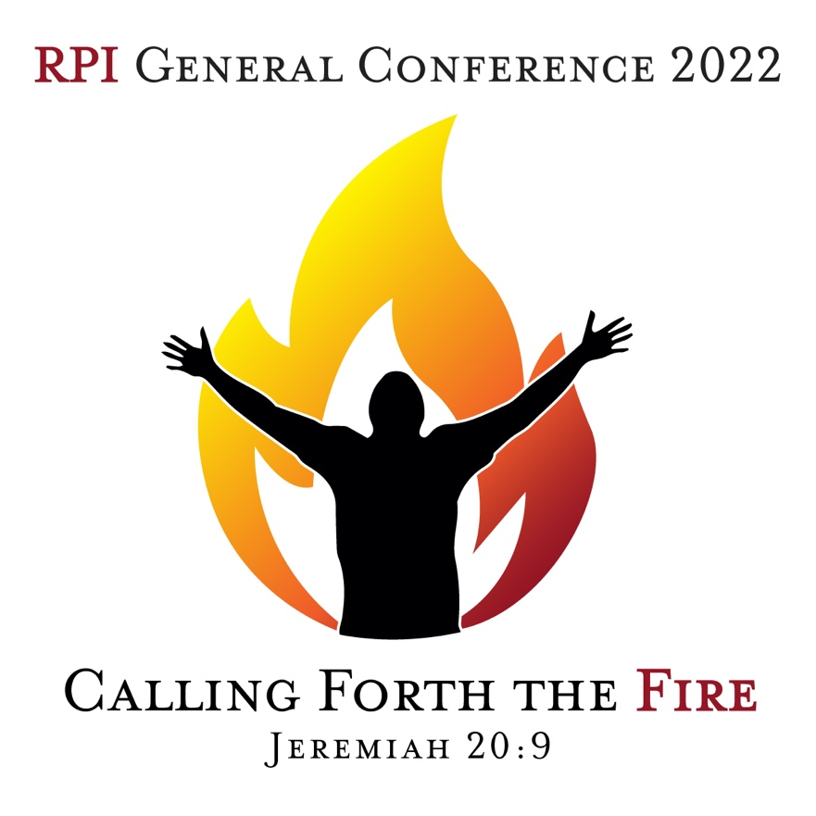

All events will be held at the
East Street Apostolic Church
1909 South East Street, Indianapolis, IN 46225

Thursday, 9/1/22

11:30 – 1:00 pm RPI Board Luncheon
1:00 – 4:00 pm Ministerial Credentialing Interviews
5:00 pm Registration Open
6:00 pm Welcome Dinner
7:30 pm Worship & Prayer

Friday, 9/2/22

*Child-care will be provided during the luncheon and business meeting*

12:00 PM – 1:30 PM Ministers & Spouses Luncheon
1:30 – 3:00 pm RPI Minister’s Business Meeting
5:00 pm Registration Open
5:30 pm Pre-Service Prayer (Fellowship Hall)

6:00 pm Opening Service with Round-Robin Preaching

Pastor Laveta Shelton, Limitless Grace Worship Center, Odessa, TX
Rev. Andrew Schad, Kingdomgate Pentecostal Church, Phoenix, AZ

7:00 pm Worship Service

Service MC Pastor Doug Clanton
Offering Rev. Linda Adkins
Speaker Chief Presiding Presbyter Pastor Daniel Parnell
East Street Apostolic Church, Indianapolis, IN

Saturday, 9/3/22

1:30 pm Pre-Service Prayer (Fellowship Hall)

2:00 pm Credentialing Service

Minister’s Photo will be taken between these services

3:00 pm Worship Service

Service MC Rev. Latricia Douglas
Offering Rev. Howard Hall
Speaker Pastor Doug Clanton
Kingdomgate Pentecostal Church, Phoenix, AZ

Sunday, 9/4/22

10:30 am Pre-Service Prayer (Fellowship Hall)

11:00 am Worship Service

Service MC Pastor Daniel Parnell
Offering Rev. Jasmine Bell
Speaker Pastor Shawn Key
Faith, Hope, & Love Fellowship Church,
Bella Vista, AR

