Fellowship of Reconciling Pentecostals International
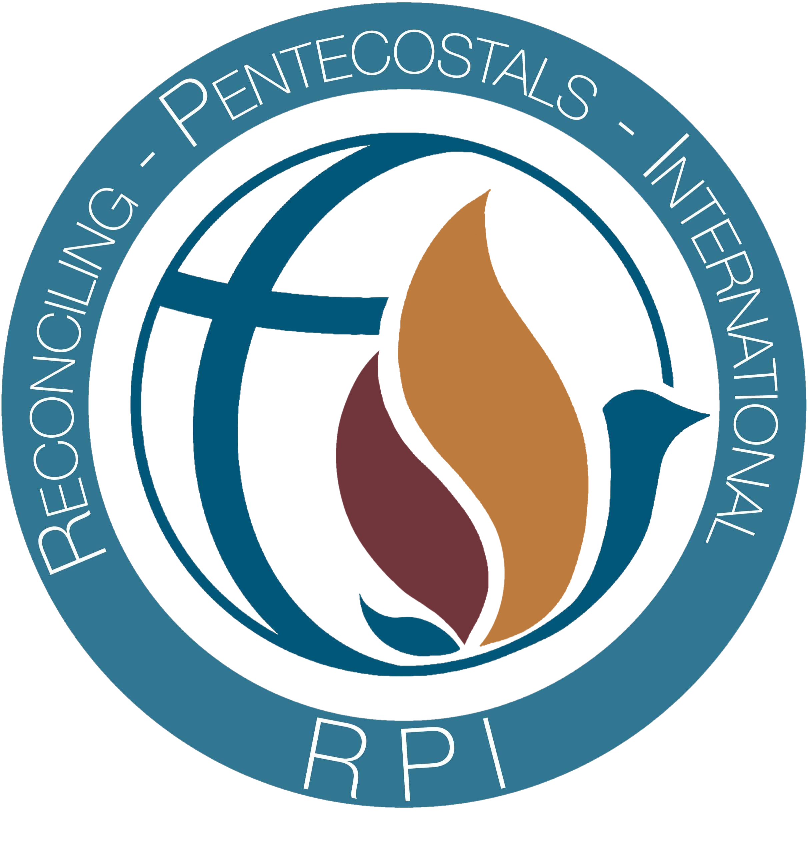
Application for
Minister in Training
Program

(recent photo)

Name: _________________________________________Preferred Pronouns:_______________

Address: ________________________________________________________________________

Home Phone: ____________________________Cell: ___________________________________

Emergency Contact:__________________________Phone:_______________________________
Can you receive documents via email: yes no
Email Address: _______________________________@________________________

Personal Information
Age: ______ D.O.B. _________________ Do you have a partner/spouse? yes no
If yes, spouse's name:______________________________________________________________
If yes, have you had a public holy union, commitment, or marriage ceremony? yes no
When? __________________ Where? ________________________________________________
Who performed the ceremony?______________________________________________________
Have you had ceremonies with other partners besides your current partner? yes no
Explain: ________________________________________________________________________
Why did you choose RPI for your ministerial training? Explain:_________________________ ________________________________________________________________________________________________________________________________________________________________
Who referred you to RPI? Or, how did you hear about RPI? ____________________________
________________________________________________________________________________

Ministerial Information

Are you presently involved in ministry? yes no Full time? Part time? (circle one)
What position(s) do you hold? _____________________________________________________

Are you currently licensed or ordained with another church or organization? yes no
If yes, by what ministry or organization? _____________________________________________
Their contact information: _________________________________________________________
Reason for leaving:________________________________________________________________

List all other past licenses or ordinations you have held, including dates and organizations: ________________________________________________________________________________
________________________________________________________________________________
________________________________________________________________________________

Educational experience: (Secular and/or Religious)
What level of schooling did you complete? High School College: 2-year 4-year (Circle all that apply)
Name of school of highest level: ____________________________________________________________
City or contact information: ________________________________________________________________
Did you graduate? Degree? _______________________________________________________

Please provide copies of all diplomas, license and ordination certificates or documents if possible. Use additional paper where needed, or attach copies of documents.

RPI Licensing Process
Article 8 of the RPI Constitution & Bylaws gives complete information concerning requirements for each level in the licensing process. PLEASE READ Article 8 to become familiar with the requirements.
Article 8 can be found at www.rpifellowship.com/bylaws.pdf

The RPI Minister Training program and licensing process contains specific ongoing educational requirements including reading assignments, seminar training and preaching experience, as part of the overall educational process. We encourage each minister to continue in this process until they attain the level of full ordination. Your assigned mentor or presbyter, along with your pastor, will be involved with this process as set forth by the RPI Education Committee. Reading requirements can be modified, however, all reading requirements should be met prior to meeting with the General Board for approval of the level you are working to achieve.

You will be working on your own. Therefore, it is suggested that each level in the educational process be designed to be completed over a period of 2 years. When all requirements have been met, including experiential goals, the Educational Director will issue a Certificate of Completion. After that, the minister will be allowed to begin work on the next level of licensure.

The Minister in Training program is designed for those who feel a call to the ministry but need preparation and experience.

Are you in agreement with this policy? Yes No

PLEASE READ the Mission Statement, Statement of Faith and Covenant as set forth in the
RPI Constitution & Bylaws. (View on RPI Website: www.rpifellowship.com/about-us )

Do you embrace and agree FULLY with these? yes no
If not, please explain: _____________________________________________________________

Please answer the following questions sincerely and honestly. Even though you may have questions or differences of opinion, it is important that you be forthright on this application.

Have you been baptized by full immersion? yes no Other_____________________
If so, when? __________________ By whom? __________________________________________
Which words or baptismal formula was used? In the titles Father, Son, and Holy Ghost In the Name of Jesus Christ Other ____________________________________

Have you received the baptism of the Holy Ghost with the evidence of speaking in other tongues? yes no
If so, when? _____________________________________________________________________

Where? __________________________________________________________________________
Have you read the Bible through in its entirety? yes no
About how many times? ________
How much time do you spend in prayer and how often? ________________________________________________________________________________
Why do you wish to be licensed/ordained by RPI? _____________________________________

________________________________________________________________________________________________________
To what specific ministry do you feel called at this time? ________________________________ (e.g., pulpit ministry, teaching, youth, music, evangelism, outreach, counseling, other, etc.)

What ministerial experience do you have? ____________________________________________

Have you been preaching? yes no If so, how often? _____________________________
Give examples:
Where? When?

Where? When?

Have you ever been arrested or convicted of a crime? no yes Please explain: _________

________________________________________________________________________________

Are you willing to have a background check performed? yes no

Please explain your views on holiness and godly living. __________________________________

________________________________________________________________________________________________________________________________________________________________

What is your belief regarding homosexuality and the Scriptures? _______________________ ________________________________________________________________________________________________________________________________________________________________
________________________________________________________________________________

PLEASE READ the RPI Statement of Faith (Article 4-J), regarding Intimate Relationships, Marriage & Divorce? Do you agree FULLY with this? yes no
If not, please explain why? ________________________________________________________________________________
________________________________________________________________________________
________________________________________________________________________________
________________________________________________________________________________

What is your PERSONAL belief regarding sexual conduct? _________________

What is your PERSONAL belief about a marriage covenant between two members of the same sex? ____________________________________________________________________________
________________________________________________________________________________

________________________________________________________________________________________________________________________________________________________________

How do you feel about ministerial accountability? _____________________________________
________________________________________________________________________________

Are you willing to be accountable to leadership, presbyters and fellow ministers?
yes no

Are you willing to maintain frequent contact with your mentor/presbyter and participate willingly in quarterly and annual reviews and monthly calls? yes no

Financial Obligation:
Candidates approved for the RPI Ministers in Training Program are required to pay $200.00 per year, $50.00 per quarter, or monthly at $17.50 per month.
Will you agree to this financial obligation? yes no

A $50.00 non-refundable application fee is due with this document. When your application is approved, the fee will be applied to your first annual dues.

Your application will be reviewed by the RPI Educational Committee. It will then be presented to the RPI Board of Presbyters for final review. You will then be notified at which time a meeting will be set up for you to come before the RPI Board of Presbyters. The ceremony is held annually at the general conference.

How should your name appear on your Certificate of Completion?

Please sign below:

I hereby certify all information contained in this application to be true and correct to the best of my knowledge.

________________________________________ ____________________
Signature Date

__________________________________________ ___________________
Signature of Referring Minister or Pastor Date

RPI APPLICATION INSTRUCTIONS

- Fill out application completely (please print clearly or type). Documents are acceptable.

- Submit two typewritten letters of recommendation from other ministers or family members familiar with your ministry. If you have a pastor, one should be from them. Each letter must include contact information of the referring party.

- Submit typewritten personal testimony explaining why you want to enter the RPI Minister in Training Program. (No more than two pages in length).

- If you have a partner or spouse, submit a letter of endorsement from them.

- Submit copies of all ministerial degrees, diplomas, certificates, licenses and ordinations.

- Make a check/money order to RPI in the amount of $50.00. If you would like to pay online, please visit www.rpifellowship.com and go to the giving section. This is a non-refundable application fee. If approved, the fee will be applied to your first annual dues.

- Deadline for submission is 45 days before annual RPI Conference.

- Mail all of the above to the following address:

RPI Credentialing Committee
Rev. Daniel Parnell
1909 S. East Street
Indianapolis, IN. 46225

Or you can Email it to: reconcilingpentecostalsint@gmail.com

Your application will be reviewed by the RPI Credentialing Committee. It will then be presented to the RPI Board of Presbyters for final review. You will be contacted within 30 days at which time a meeting will be set up for you with RPI Representatives. References will be checked. Any questions or concerns regarding requested information can be addressed by email at: reconcilingpentecostalsint@gmail.com

In the interim, it is suggested that you begin reading the books for Level II of the RPI Bible College.

revised 01/26/2022

