Fellowship of Reconciling Pentecostals International
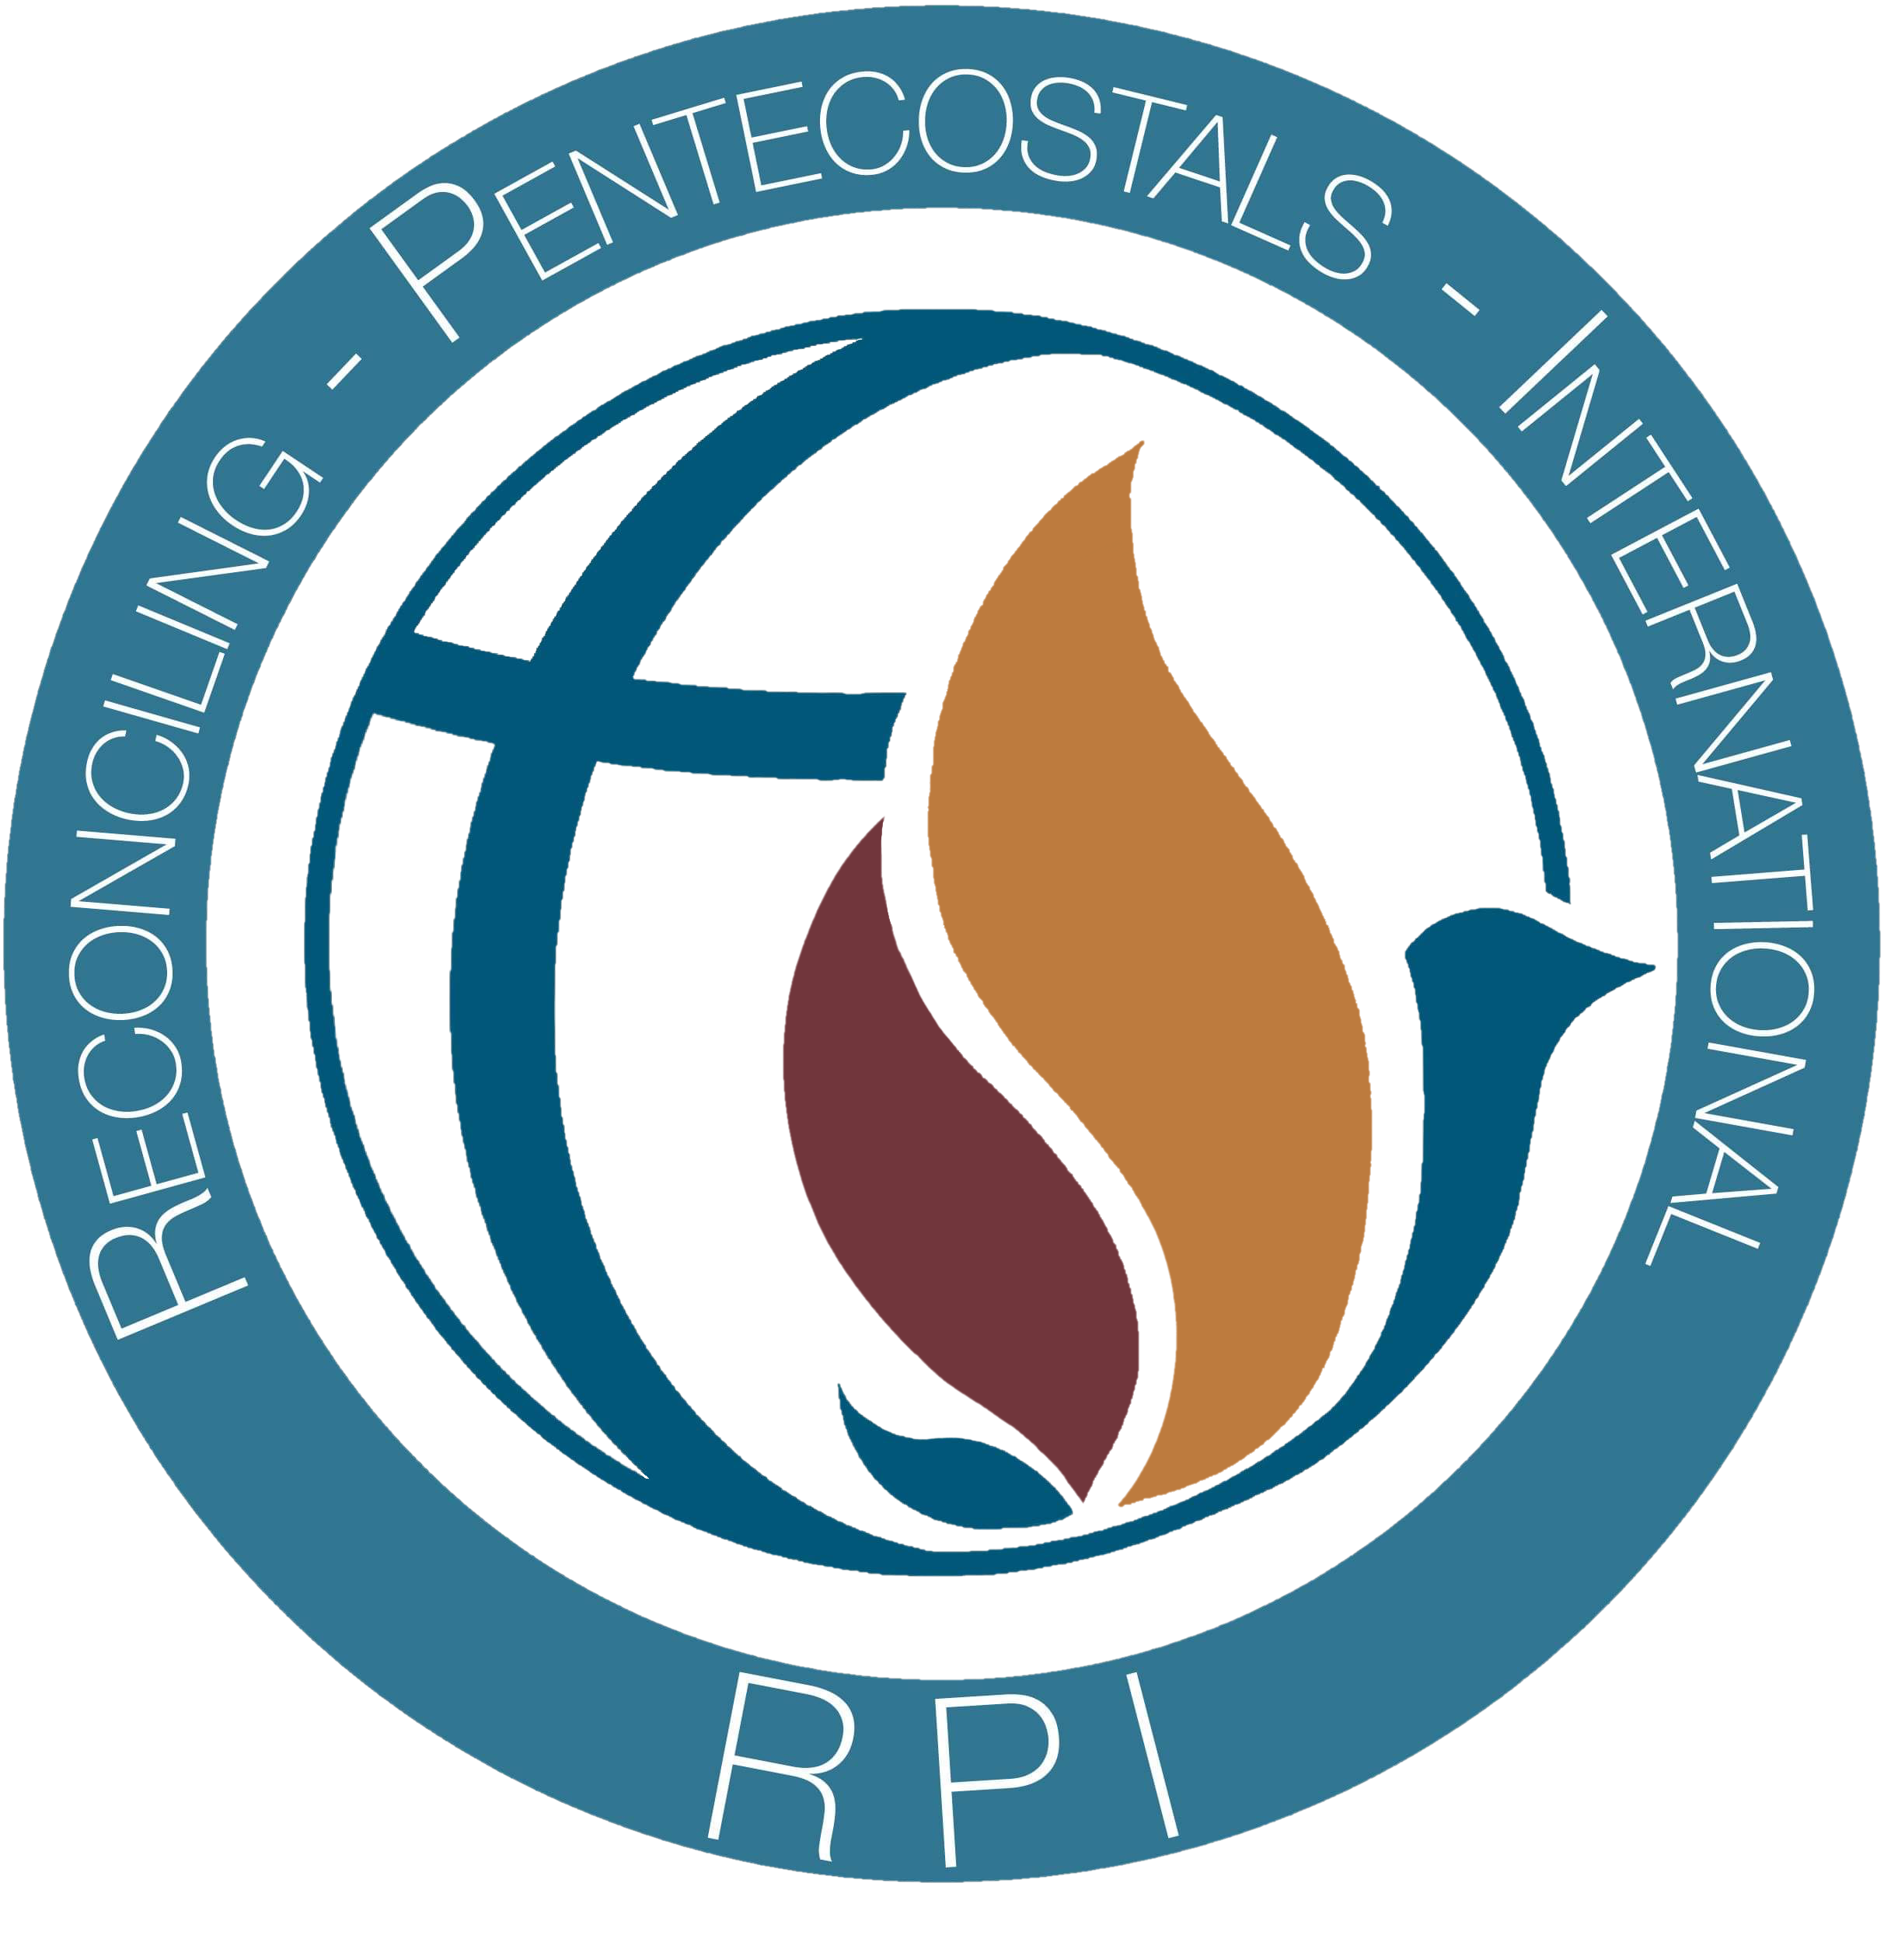
Application for RPI Bible College

Provide a current photo

(recent photo)

Name: __________________________________________________________________

Address: _______________________________________________________________

Home Phone: _______________________Cell: ________________________________

Age: ______ D.O.B. __________ Do you have a partner/spouse? yes no

If yes, spouses name: ______________________________________________________

Does your Spouse support your enrollment in RPI Bible College yes no

I can receive documents via email: yes no
Email Address: __________________________________________________________________

If you were referred to RPI Bible College, who referred you?_______________________
Relationship to you: _______________________________________________________

Are you presently involved in any Christian ministry? yes no Full time?
Part time? (circle one) Where or what is this ministry? ___________________________
_______________________________________________________________________

What position(s) do you hold? _____________________________________________

Do you currently hold credentialing from another church or organization: yes no

Explain: ________________________________________________________________

Why do you want to study at RPI Bible College? ________________________________
______________________________________________________________________________________________________________________________________________________________________________________________________

Have you received Jesus as your personal Savior by believing and repenting of all sins and have you been baptized by immersion? yes no
Have you received the baptism of the Holy Spirit? yes no

My studies through RPI Bible College are for:

Future Credentialing
Personal Achievement

To what specific ministry do you feel called? __________________________________
(pulpit ministry, teaching, youth, music, evangelism, outreach, counseling, etc.)

What ministerial or Christian Worker experience(s) do you have?___________________ ________________________________________________________________________________________________________________________________________________

________________________________________________________________________
________________________________________________________________________
________________________________________________________________________

Your RPI Bible College application will be reviewed by the RPI Education Committee. You will then be notified of courses and time, as well as contact information on others in the cohort.

I hereby certify all information contained in this application to be true and correct to the best of my knowledge.

________________________________________ ____________________
Signature Date

__________________________________________ ___________________
Signature of Referring Minister or Pastor Date

Please enclose a check or money order for twenty-five ($25.00) USD with this application.
Make check payable to RPI Bible College.
Please DO NOT send cash through the mail.

