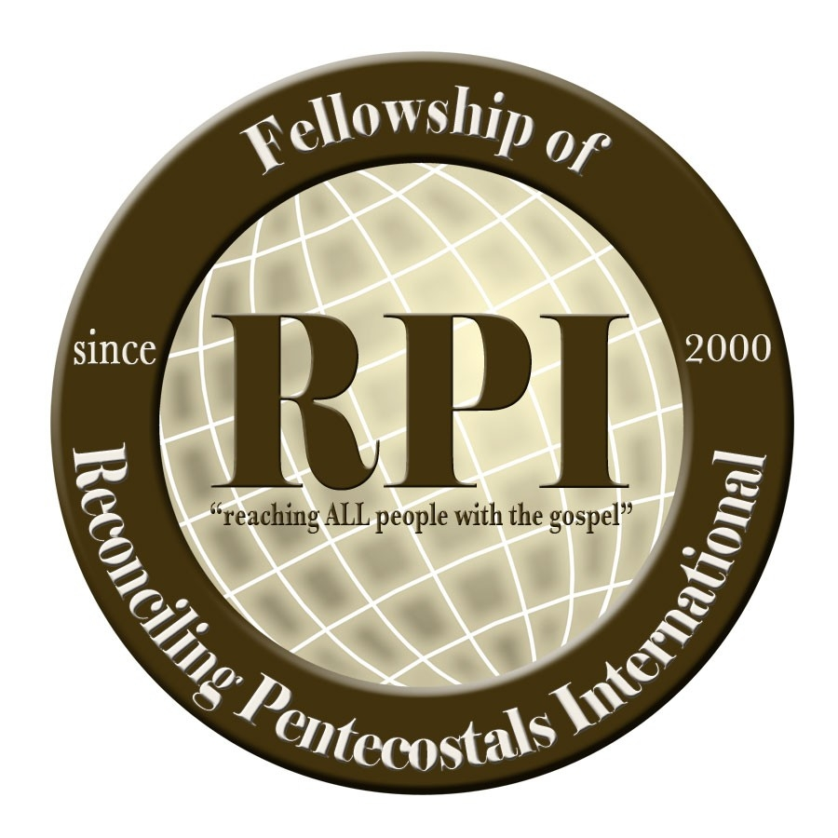

General Conference Schedule
November 11 – 14, 2021
KingdomGate Pentecostal Church
Phoenix, Arizona
(All activities hosted on the Campus of KPC unless otherwise noted)

Theme: Let the Church Say Amen!
Nehemiah 8:5-6

Local Hotel Information

Fairfield Inn and Suites 9033 W McDowell Rd Tolleson, AZ 85353 United States $158 per night
Victory Inn 1520 N 84th Dr Tolleson, AZ 85353 United States $99.95 per night
Comfort Suites 9824 W Camelback Rd Glendale, AZ 85305 United States $124 per night

Thursday:

7:00 PM – KingdomGate Pentecostal Church 20th Anniversary Celebration Service
Service Coordinator: Pastor Doug Clanton, Phoenix, AZ

*Meal provided in the fellowship hall following service

Friday:

*Coffee, fruit, and donuts available at the church

9:30 AM - RPI Presbyter Board Meeting
10:00 AM - Ministerial Candidate Interviews
10:00 AM – Lance Pence
10:30 AM – Diane Dunn
11:00 AM – Linda Adkins
11:30 AM – Maria Alkire
12:00 PM – 1:00 PM – Break for Lunch
1:00 – 2:30 PM - RPI Minister’s Business Meeting (closed session for credentialed ministers)

Friday Evening:

5:00 PM - Registration Open
5:30 PM - Prayer in the Sanctuary
6:00 – 6:45 PM - Kick-off Rally
Tag-Team Preachers:
Rev. Jasmine Bell
Rev. Drew Schad
Rev. Latricia Douglas
7:00 PM - Worship Service
Key Note Speaker: Pastor Randy Duncan

Saturday Morning:

*Coffee and donuts available at the church

11:00 AM - Mid-day Worship
Speaker: Pastor Michael Edward

12:30 PM – Picnic Lunch & Fellowship at KPC Fellowship Hall

Saturday Evening:

5:00 PM Registration Open
6:00 PM Credentialing Service
7:00 PM Worship Service
Speaker: Pastor Doug Clanton

The GC Minister’s Group Photo will be taken
Saturday Evening before the main service.
We invite all ministers in attendance to be included in this photo.

Sunday Afternoon:

2:00 PM Sunday Worship Service
Speaker: Pastor Daniel Parnell

*Meal provided in the church fellowship hall following service

