Frequently Asked Questions and tips for enjoying your Sandhopper®

- How far can I go with my fully charges Sandhopper? The standard Sandhopper is designed to operate when fully charged for 4 to 5 miles. This distance can change based on the cargo weight, surface it will be operated on and whether the surface is flat or has hills. If you plan to carry heavy loads or plan to use Sandhopper in areas of significant elevation change, we recommend the optional larger controller. If you simply need to operate for longer distances, we recommend the larger battery.

- Why does my rear tire spin and sink into the sand? Your Sandhopper® equipped with the Wheeleez brand tires is designed to float over sand. Bear in mind though, that a lightly loaded wagon may display some rear wheel spin in sand due to a lack of weight over the rear drive wheel. This may be more pronounced when going up-hill. It will help to “feather” the throttle so that enough power is provided to the drive wheels to move the wagon but not so much that the wheels spin. Also, giving the wagon a gentle tug can help it regain traction if the wheels are spinning. Also consider adding some weight / cargo to the rear of the wagon. Adding about 50 pounds to an empty wagon and located in the rear of the wagon will make a big difference in Sandhopper’s ability to gain traction. If you will be using your Sandhopper to climb small dunes regularly, consider simply leaving the extra weight in the wagon.

- How do I install the railing system? The side rails (single and double rail) as well as the surf rack system are all designed to be used as a complete set and of course work best when they are properly installed. First, make sure that nothing on the wagon deck is restricting the railing posts from inserting as far as possible into their appropriate openings. A rubber mat or build-up of sand could keep the post from fully inserting into the deck. Next make sure each railing corner has properly mated together. Always insert the front and rear rails first, the sides last. Mate the corners while releasing the spring-loaded button at the base of the side rail post. Make certain the button pops out once the side gate is installed. If it doesn’t, the railing system is in danger of coming out.

- Why is there a delayed response when I turn on the key? This is normal. The thumb controller takes a few seconds to respond after turning on the key.

- Why won’t my Sandhopper respond when the key is in the on position? Most likely you left the key in the on position for 5 to 10 minutes after using it previously. Simply cycle the key off and then back on again to reset the controller. This “sleep” mode is a programed feature to protect the battery and accidental use by someone not familiar with the operation.

- Why won’t my Sandhopper move even with the key cycled off and back on? If your Sandhopper does not respond even after cycling the key off and back on again, one of three issues may have occurred. First, check to see if the parking brake is on. Release the brake by squeezing the brake handle until the parking brake button pops out. If this is not the issue, next, if the wagon stopped while climbing a steep incline, then the smart controller’s thermal coupling turned off the power to allow the system to cool down. You can confirm this by checking to see if the battery level is indicated on the battery meter as it would normally. Your wagon will operate normally within 2 -3 minutes. Third, with the key on, check to see if the battery meter indicates a level of charge. If there isn’t any level of charge showing whatsoever, the battery circuit breaker may have tripped. This typically would only happen when operating your Sandhopper at the top end of its pre-programmed performance settings. For example, a circuit breaker may trip after climbing a significant incline while heavily loaded. Those wagons equipped with the optional 160 Amp controller are less likely to trip in these conditions. To re-set the tripped circuit breaker, look under the wagon near the battery tray and locate the circuit breaker re-set button. Simply push the button back in.

- Why do I hear a noise when I operate my Sandhopper in forward or reverse?
Most likely the parking brake is on. Release the brake by squeezing the brake handle until the parking brake button pops out. Also, check underneath the wagon to see if a branch or other debris has become caught and is dragging as you move the wagon.

- Why do the rear wheels on my Sandhopper drag/slide when descending a hill or handicap style ramp? Your Sandhopper has regenerative braking which is used to recharge your battery when descending an incline. If the wagon’s rear wheels loose traction descending a ramp they simply will slide from the regenerative braking restricting them from turning freely. This will be the case even when you remove thumb pressure on the throttle, the regenerative braking restricts the wagon from rolling as freely as might down a hill. Remember, this feature only works with the key on. When descending a hill with the key off, you will need to use the hand brake.

- How will I know when I need a new battery? Typically, a battery as reached the end of its useful life when it won’t hold a charge. If you notice a significant change in your useable range, you may need a new battery. See FAQ regarding how to replace battery.

- May I replace the battery myself? Yes, but first make certain the battery needs to be replaced and that you know the replacement specifications and model.

- My parking brake is not holding the wagon in place, what is wrong?
Your parking brake may need to be adjusted. The brake system uses a brake cable similar to the brake cables on a bike. Try adjusting the cables first.
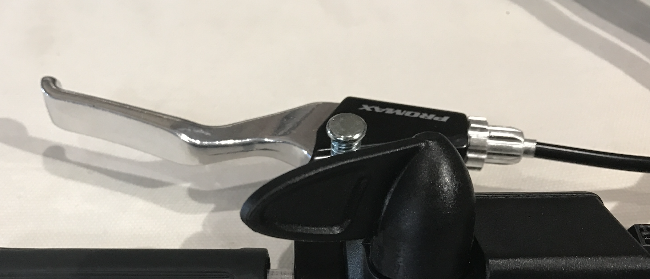

The brake adjustment is located at the end of the brake cable on the handle. To adjust the brake, simply unscrew the thumb screw until brake force is achieved then screw in the lock ring until it mates with the brake handle. If the rear brake wheel still rotates with the brake fully applied your Sandhopper® may need brake service from a certified Sandhopper® service center.

Rear disk brake maintenance

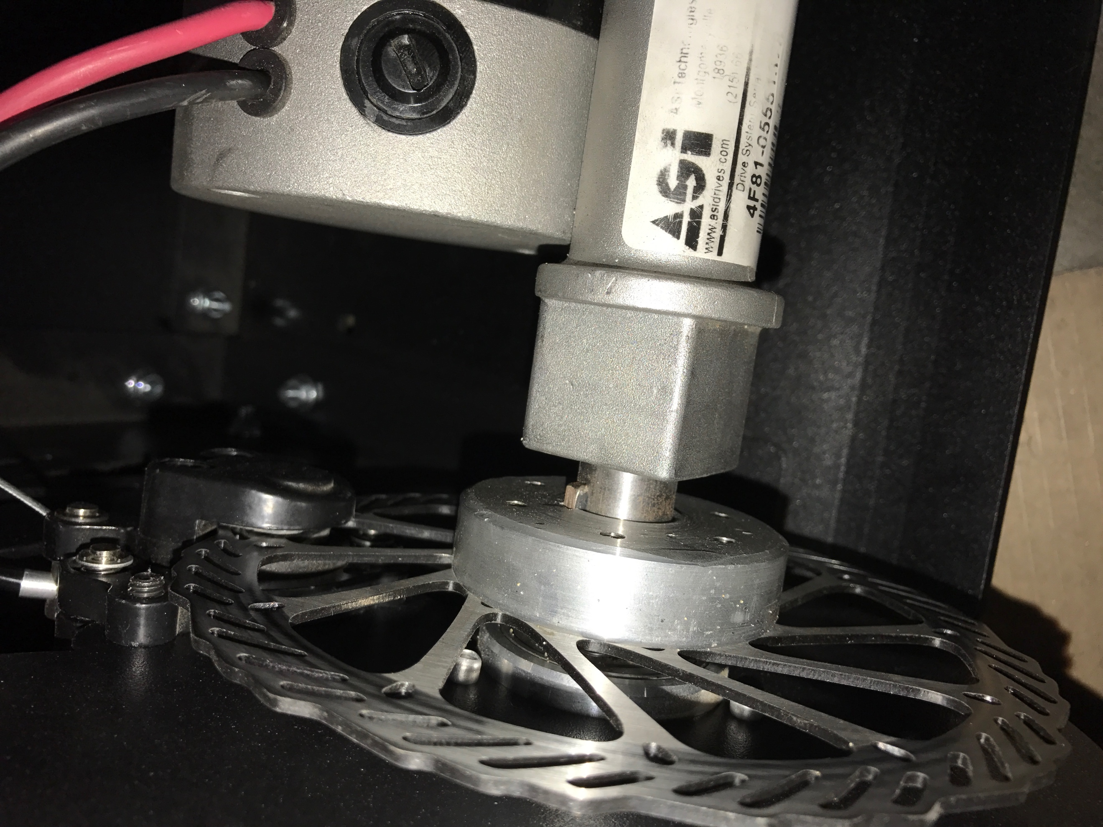

To maintain top performance of the Sandhopper® brake system, the stainless disk brake and brake pads must be clean and dry. First make sure the key is in the off position. Do not spray any type automotive brake cleaner directly as the over spray may damage the painted parts. Using clean work gloves, first spray a clean dry rag and then wipe the disk brake. Roll the wagon forward or backwards to make certain to clean the entire disk brake.

Accessory Instructions
Cooler tray is installed on the rear part of the Sandhopper® only. The support hinges are placed on the rear lip of the Sandhopper deck. DO NOT EXCEED the 50 LBS maximum capacity of the tray.

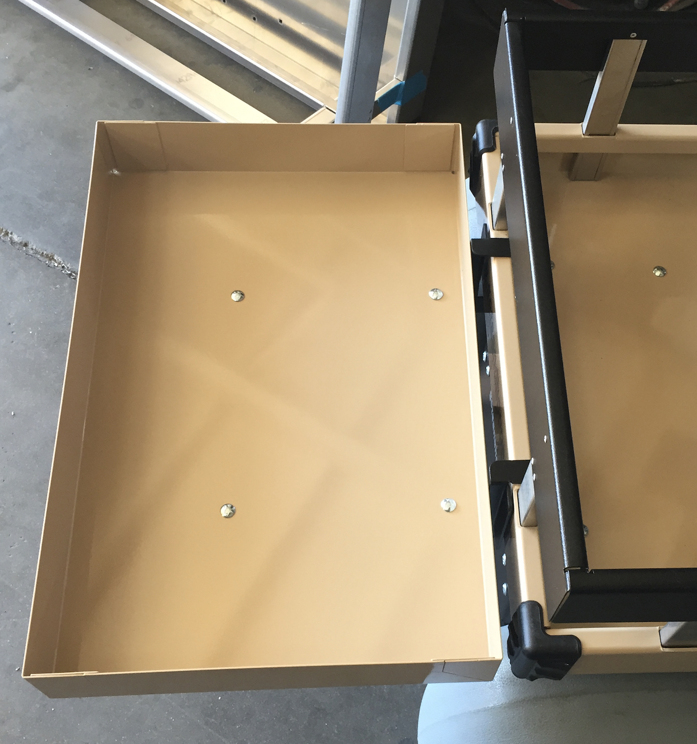

Umbrella Mount/Dual cup holder and side table option
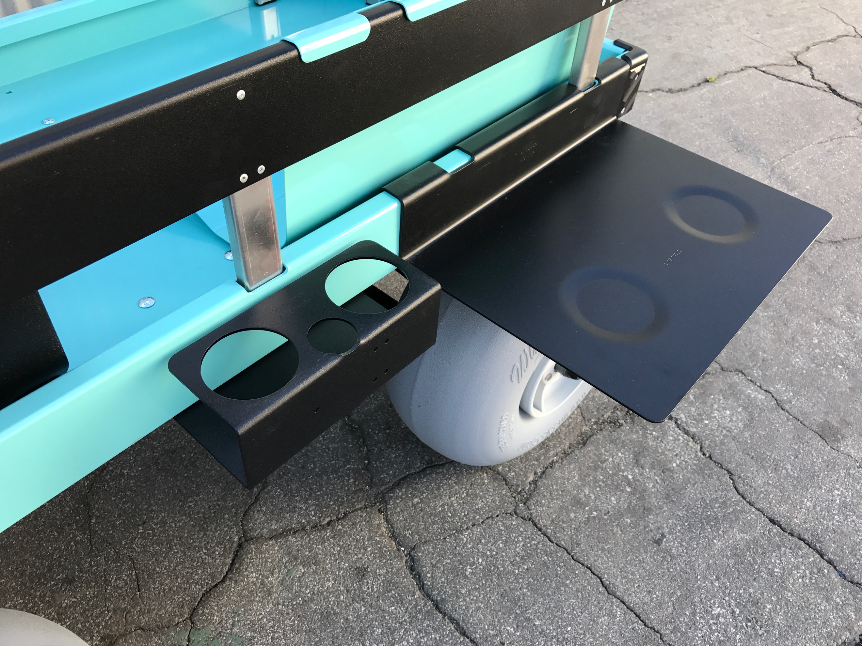

The umbrella mount has a 1.5” through hole that can be used to insert a flag pole or a standard umbrella post. (Warning: do not use in high winds or when lightning may occur)
Side table option can be placed on any side of the Sandhopper® deck. When not in use the side table can be placed on the inside of the deck.

Side rack option

Side-racks may be used to carry umbrellas, 10 x 10 pop up tents, foam surfboards, corn hole, etc. Typically, they should be placed on the right-hand side of the Sandhopper so they won’t interfere with the optional umbrella mount. There are cut outs for bungie cords should you wish to hold down the contents you are placing in the racks. Long cargo placed in the side-racks may restrict the operator somewhat from steering the wagon. For example, a long surfboard that surpasses the length of the wagon.

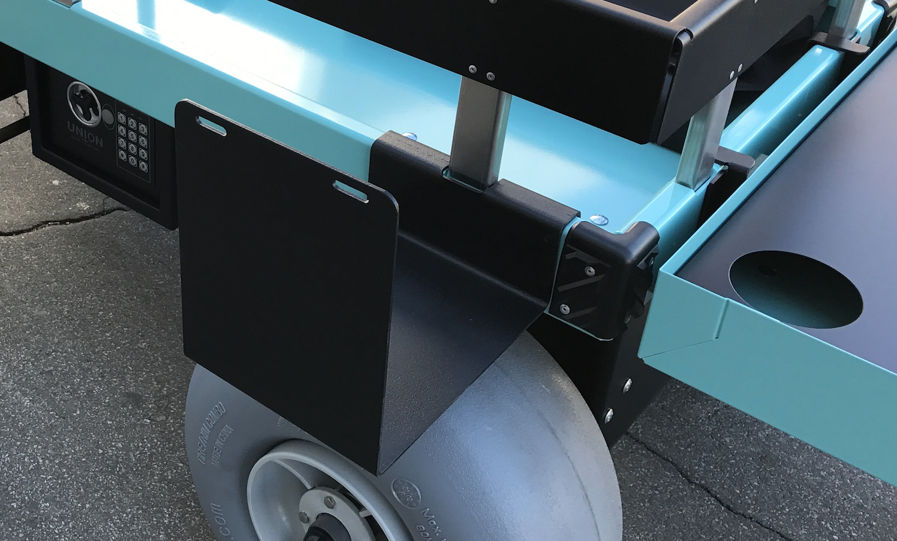

Digital Keyless lockbox

The keyless digital lockbox option comes with 2 keys that are unique to your lock box and are not replaceable. DO NOT LOSE THE KEYS. The lockbox comes with a default combination code. (159#) It is recommended that you reset the code upon receipt. (instructions provided with the lock box). On the inside of the lock box there is a button to reset the code. It is located on the inside of the door. You can use up to 6 digits as an entry code. If you forget your code and also the default code you may use the provided key to unlock the door. To do so follow these instructions:
- Remove dust cap on the door
- Insert bypass key to unlock the door.
- Locate the reset button on the inside of the door.
- Press the reset switch button.
- Punch in your new code.
- Press #
- Test the new code before closing the door.
- DO NOT Lock your keys in the lockbox.
- The 4 AA batteries are located in the door compartment.

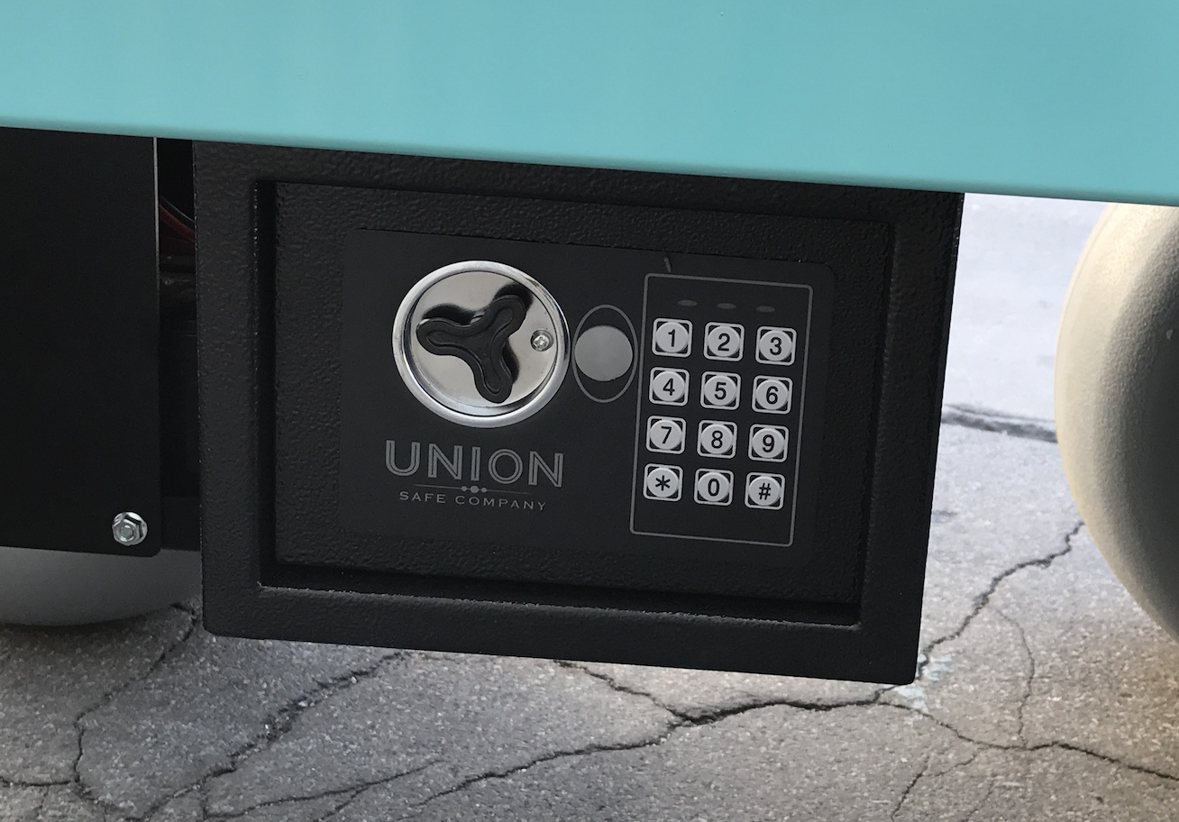

The lock box is not water proof! Do not spray water directly on the lockbox as it may damage the electronics and void the warranty.

