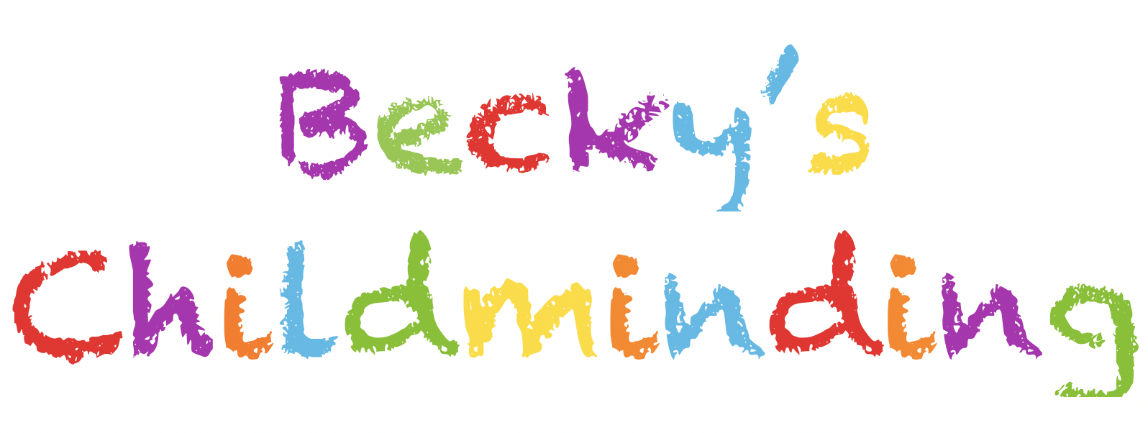**Consent Form**

Name of Child………………………………………………………….

I/We hereby give Rebecca Dodd and Richard Dodd permission to;

1. Take my child on outings. E.g. park, toddler groups, childminding support groups, indoor play places etc.

Signature(s*)…………………………………………………………………….. ……………………………………………..*

1. Let my child have supervised access to play on large play equipment.

Signature(s*)…………………………………………………………………………………………………………………*

1. Take my child in their car, using appropriate car seats/ belts for child’s age and weight. we have business use car insurance.

Signature(s*)…………………………………………………………………………………………………………………*

1. Transport my child in a private vehicle, using appropriate car seats/belts for child’s age and weight.

*Signature(s)………………………………………………………………………………………………………………………*

1. Take my child on public transport with prior arrangement.

Signature(s*)………………………………………………………………………………………………………………….*

1. Seek emergency medical advice or treatment for my child. (I will contact you at soonest possible time)

Signature(s)……………………………………………………………………………………………………………………..

1. I understand that in the event of an emergency, my child may be left in the care of a responsible adult, if possible one of those listed below, until you can arrange for them to be collected.

Vicky Perry childminder, Emma Jarvis childminder, Jo Morey childminder, Kate Mitchell Becky’s mum

Signature(s) *……………………………………………………………………………………………………………………*

1. Administer the following non-prescription medicines to my child, providing that I am contacted beforehand and that I complete a medication form on my return. (I understand that separate, *prior* written permission is required for prescription medications)

# Named medicines……………………………………………………………………………………………………………..

Signature(s) *…………………………………………………………………………………………………………………..*

10) Apply my child’s sun cream when necessary or apply the Childminder’s own sun cream/lotion of factor 50+

Signature(s*)……………………………………………………………………………………………………………………..*

11) use social media platforms for sharing photographs of my child on Whatsapp, Messanger and Becky’s childminding Facebook page, which is only for parents and is a strictly private group which only Becky Dodd is the administer of.

Signature(s*)……………………………………………………………………………………………………………………..*