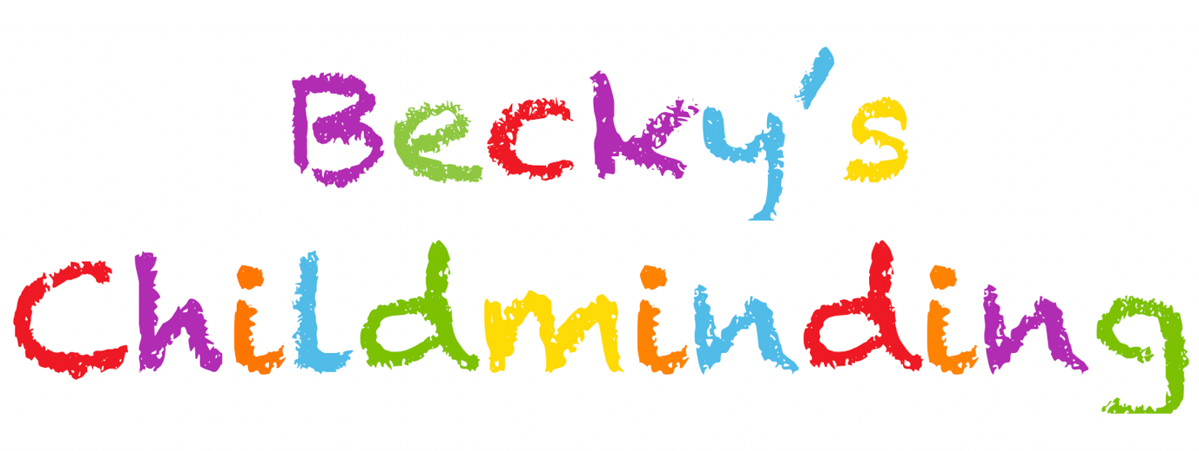

**Pet Policy**

I own the following pets: Dotty a Labrador retriever

As the owner of a dog, I have written this policy to share information about how I protect child/ren from harm when there are pets in the house.

Children learn from handling and coming into contact with pets and I will ensure they have a sustained learning experience by planning activities to help the children get to know the pets and how to manage them safely.

Children will have contact with Dotty on a day-to-day basis and will be taught to treat her with respect. They will learn how to handle and play with Dotty safely under careful and constant supervision.

Children will be taught to wash their hands thoroughly after handling pets.

Food for Dotty is stored out of sight and reach of the children. Dotty is fed outside of childminding hours. If eating treats etc children will be encouraged to leave ger alone. She is not protective over food as we have taken food away regularly since a pup to ensure she is used to it.

Constant risk assessment will ensure children are safe in the house and garden: for example, I risk assess through the day to ensure pets have not soiled parts of the garden where children play.

**Meeting other animals** - children are taught that not all animals are friendly. My rule is that they need to be with an adult and to ask before touching animals if they do not know their name.

Outings to see animals - I sometimes take children on outings to meet animals – for example, to watch feeding time at the petting zoo or on a farm visit. I take every precaution to keep children safe