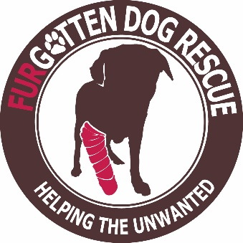

Agreement to Relinquish

I _________________________________ hereby agree to relinquish the following pets to Furgotten Dog Rescue (names and descriptions):
1. _______________________________________________________________________________________________________
2. _______________________________________________________________________________________________________
3. _______________________________________________________________________________________________________
4. ______________________________________________________________________________________________________

By signing this document, I now, in good faith:
*Certify that I am the sole owner of above pet/s.
*Turn over veterinary records for the pet/s thus far, and certify that (to the best of my knowledge) the pet/s are disease and pest free.
*Agree to release all rights and responsibilities for said pet/s, realizing that I will have no say about future placement, and cannot come back to "re-claim" the pet at a future date.
*Understand that said pet/s will be evaluated by a trainer and/or veterinarian, before being placed in suitable homes at the sole discretion of Furgotten Dog Rescue.
*Make the following donation for the care and upkeep of pet/s until placement: ______________

Signature: _______________________________________ Date: _______________

Contact information (for questions only):
Phone Number: ________________________________________
E-mail address: ________________________________________

