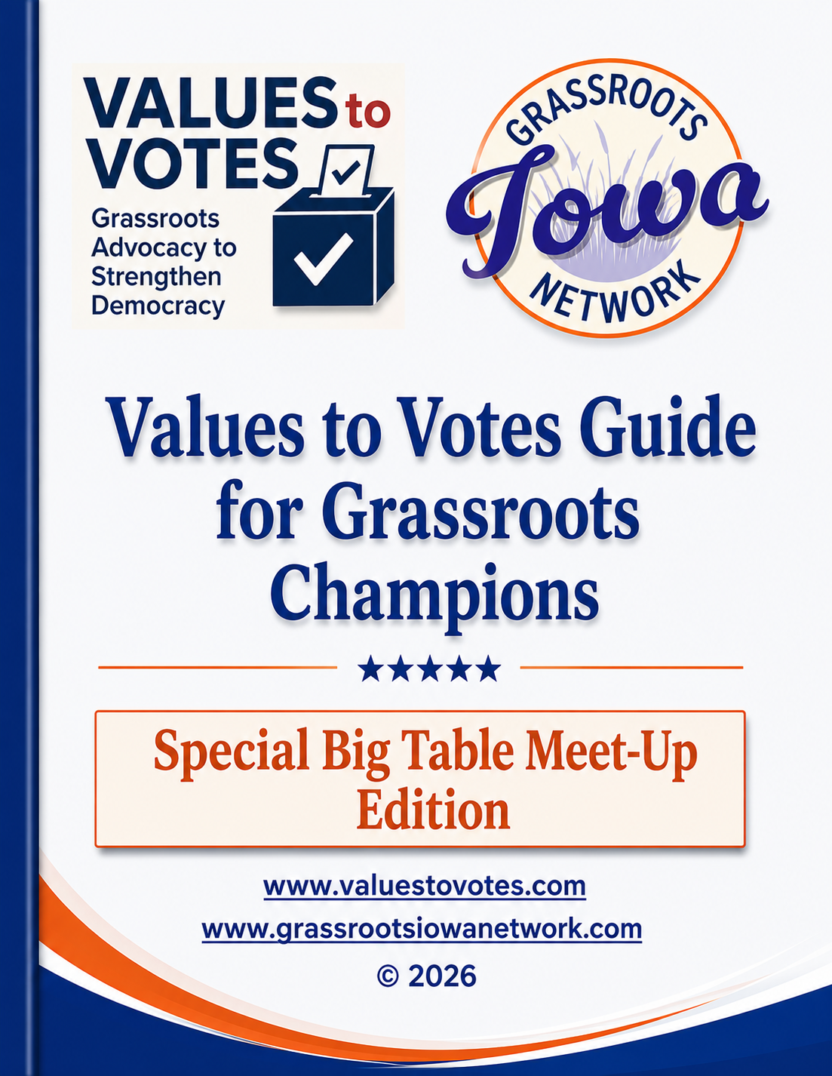
Preface: A Guide on Grassroots Superpowers and How to Use Them
Across Iowa and the nation, in communities large and small, grassroots leaders are stepping up. They recognize that “democracy is not a spectator sport” and are taking independent political action – many with a focus upon the upcoming 2026 elections. This guide is for you.
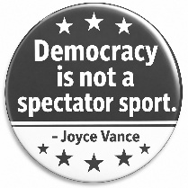
Most guides to electoral campaigning begin in the same place: with partisan campaigns, candidates, messaging strategies, fundraising, and turnout operations. They emphasize raising money then directed to paid media and mobilizing the electoral base to get out the vote of political supporters. They assume that influence flows downward—from professionals to volunteers and from institutions to individuals. They emphasize professionally designed partisan messages and repetition of talking points.
This guide is different. It begins with the simple truth that the most powerful force in a democracy is not the professional campaign – it is the active participation of people at the grassroots. This involves sharing your views and dialoguing with, educating, and influencing those you know.
This guide recognizes grassroots leaders can do things that partisan political campaigns cannot and have superpowers in doing so:
- The values you hold about the way elected officials and government need to respond to defend and advance those values
- The trust people place in you in practicing those values
- The relationships you’ve built over time
- The knowledge you have about your community and its uniqueness
- The credibility you carry in your community
- Your ability to listen, to ask, and to connect with others around those values.

It recognizes that different grassroots leaders have different superpowers, different constituencies, and different ways to take action. Its seven chapters seek to support grassroots leaders in building on your own unique superpowers and enlisting others in doing the same.
Simply put, this guide emphasizes that campaigns are too important to be left solely in the hands of candidates, parties, and political consultants. It offers practical tools, ideas, and advice to enable grassroots champions to realize your own superpowers in the ways that make sense to you, those you seek to engage, and your communities.
- Charlie Bruner, manager, Values to Votes Initiative of the Grassroots Iowa Network, former Iowa legislator and nonpartisan advocacy organization director (Child and Family Policy Center), and grassroots electoral activist for fifty years
© June, 2026 -- Prototype Edition (Comments and Edits Welcome)
www.valuestovotes.com bruner@childequity.org

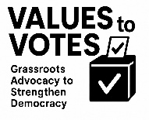
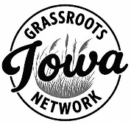
Values to Votes Guide
for Grassroots Champions

Table of Contents

Preface 2
Table of Contents 3
Introduction 4
Chapter One: Know and Use Your Superpowers 8
Chapter Two: Use Shared Values to Engage Voters 14
Chapter Three: Grow Your Influence While Keeping It Personal 20
Chapter Four: Focus on Voters You Can Persuade 27
Chapter Five: Get the Help You Need 38
Chapter Six: Cultivate Organizational Growth 44
Chapter Seven: Ensure the Right to Vote, Defend Democracy, and Preserve the Rule of Law 53
Acknowledgements and For More Information 63
Appendices. Available on the Values to Votes website (www.valuestovotes.com/guide)

About the Grassroots Iowa Network and the Values to Votes Initiative. The Grassroots Iowa Network (GIN) is an all-volunteer group of volunteers working together to build a stronger network of progressive grassroots organizations in Iowa that focus on politics, issues, and winning elections. Founded in January 2025, we work to facilitate the growth, learning, and mutual support of grassroots organizations. GIN is nonpartisan and not aligned with any political party. The GIN website maintains information on grassroots Iowa organizations by Congressional district and statewide organizations supporting them (www.grassrootsiowanetwork.com). The Values to Votes Initiative was launched by GIN to be a resource of information about building strong grassroots organizations and produced this guide (www.valuestovotes.com)
Introduction

This Guide is for people who value our democracy and want elections to result in leaders who will work to ensure a government that supports both individual opportunity and the public good. That means recognizing both our individual rights and our shared responsibility to promote the public welfare. It is not a partisan campaign playbook or strategy for electing a particular candidate. It is a guide for grassroots leaders to engage, educate, dialogue with, and inform voters and use their own relational and people-centered superpowers in doing so. It is based upon the following four key beliefs:
- Elections matter.
- People vote their values.
- Democracy is not a spectator sport.
- Grassroots activism is key to an informed electorate and democracy.
Simply put:
Elections are too important to rely solely upon candidates, political parties, consultants, and megadonors. Grassroots advocacy holds the key to preserving a vibrant democracy.
This guide emphasizes the unique and critical roles grassroots champions possess – beyond partisan campaign volunteers – to ensure elections reinforce our values and elect the public officials who support them. Each of its chapters addresses specific ways grassroots advocates and champions can do so – according to the relational and people-centered superpowers they possess.
People listen most carefully to those they know and trust: friends, coworkers, neighbors, fellow parents, fellow volunteers, and respected members of their community. When trusted people talk about shared values and the role government can play in supporting them, they create opportunities to inform and influence voting choices.
Many grassroots leaders also will contribute to and volunteer for candidates or work within a political party to canvass voters and get out the vote – but this is only one part of what needs to happen to create an informed and engaged electorate. There are many things that independent, grassroots advocacy does best (for a graphic description, see the charts at the end of this introduction).
This guide offers ideas and resources to help people use their own grassroots superpowers—their credibility, relationships, knowledge, and experience – to engage, educate, network, dialogue with, and ultimately influence voters. It doesn’t require that everyone do everything, but it does encourage everyone to do something that works for them.
The guide is organized around seven chapters. These do not have to be read sequentially and should be adapted to reflect the skills of grassroots champions, the capacities of grassroots organizations, and the values of the community.
Chapter One: Know and Use Your Superpowers. Grassroots champions already possess superpowers—the relationships, experiences, credibility, and community connections that allow them to influence others. This chapter helps advocates identify their own strengths and the networks where they can have the greatest impact. It introduces relational campaigning and provides a worksheet to help grassroots champions inventory their superpowers and develop a simple game plan for using them.
Chapter Two: Use Shared Values to Engage Voters. Most voters respond first to values, not to policy details or partisan arguments. This chapter explores how grassroots advocates can begin conversations around shared values—fairness, opportunity, security, freedom, dignity, and community—and connect those values to what voters want candidates and government to do.
Chapter Three: Grow Your Influence While Keeping It Personal. Grassroots advocacy can grow over time as people build networks, invite others into conversations, and expand their reach. This chapter explores ways grassroots champions can strengthen and sustain their influence while keeping their work personal, positive, and rooted in relationships.
Chapter Four: Focus on Voters You Can Persuade. Grassroots champions do not need to reach everyone. In today’s polarized environment, a one-percent shift in voting can be decisive. This chapter focuses on persuadable voters – those who are open to dialogue and who may reconsider their choices when trusted voices connect public issues to their values and everyday concerns.
Chapter Five: Get the Help You Need. Grassroots champions do not need to do this work alone. Many organizations – local, state, and national – offer research, training, messaging guidance, and tools to support relational campaigning. This chapter highlights resources available to help grassroots advocates strengthen their efforts and avoid reinventing the wheel.
Chapter Six: Cultivate Organizational Growth. While grassroots relational campaigning is based upon personal relationships, cultivating organizational growth requires thoughtful organizational design and strategy. This chapter discusses the mechanics of building strong grassroots organizations from the perspective of organizations committed to relational electoral advocacy and relying upon people power to achieve their goals.
Chapter Seven: Ensure the Right to Vote, Defend Democracy, and Preserve the Rule of Law. Grassroots engagement depends on a functioning democracy in which people can safely vote, speak, and participate. This chapter provides practical guidance for ensuring the right to vote, supporting peaceful civic participation, responding to misinformation, and addressing intimidation. Grassroots leaders do not need to be legal experts, but they should understand basic civic rights, share accurate information, and connect people with trusted nonpartisan resources.

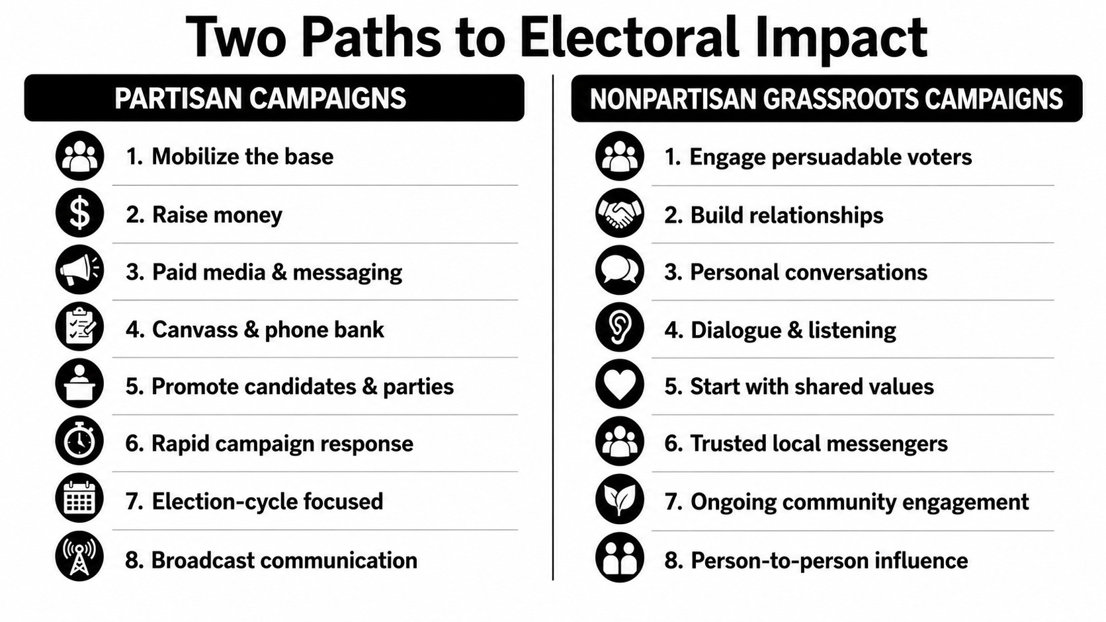
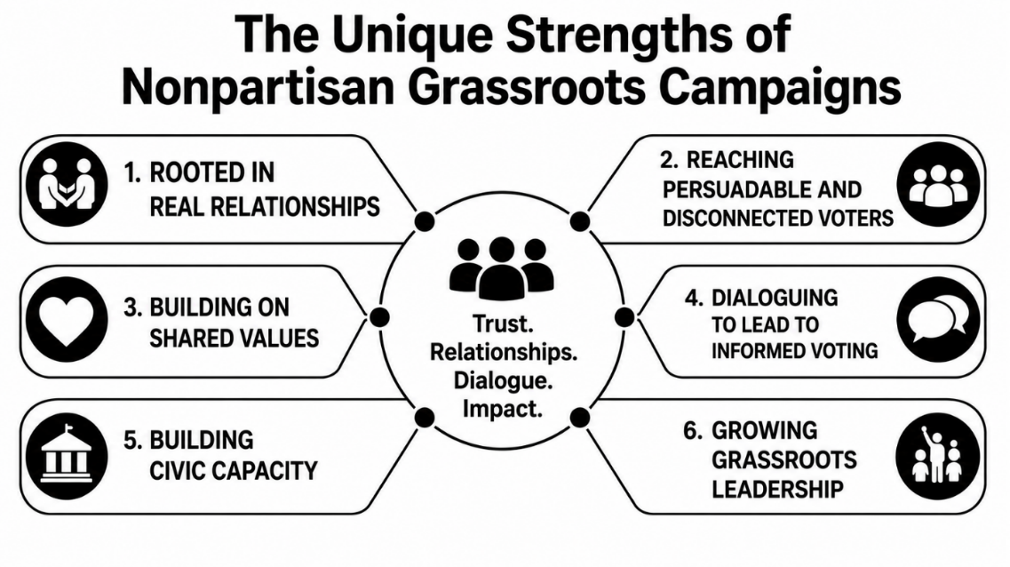

Introduction: Three Takeaways
Elections matter because government and democracy matter.
Partisan campaigns play an important role in who is elected.
Grassroots nonpartisan advocacy contributes something distinct and are indispensable: trusted relationships, dialogue, persuasion, civic engagement, and long-term democratic capacity.

Chapter One: Know and Use Your Superpowers
Grassroots champions have superpowers, and those superpowers can be game changers in elections. Different champions have different superpowers and unique contributions they can make with them. Working together with other grassroots leaders can enhance them. This chapter is directed specifically to identifying and then activating the superpowers individuals have as they work at the grassroots level.
Many people think election work only means participating in partisan campaign activities—canvassing voters, making phone calls, writing postcards, distributing literature, attending rallies, or donating money. Those activities matter and many of us will continue to participate in them.
But those activities represent only one part of the influence we have.
Each of us also has influence through the relationships we already have in our communities—with friends, coworkers, neighbors, fellow volunteers, fellow congregants, professional peers, and social networks. These are relationships built over time through shared work, shared experiences, and shared values.
People may know how we vote and which candidates we support, but they also know us as people who contribute to community life—through our work, volunteer efforts, and participation in civic life. Because of this, they will listen to us in ways they would not listen to a campaign advertisement or a stranger at the door.
Many voters are skeptical of candidates and exhausted by partisan messaging. Mass media campaigns and impersonal outreach often create more noise than understanding.
The Power of Relational Organizing
That is where the superpowers of grassroots champions come in. In electoral organizing, this approach is called relational campaigning and it is where grassroots champions are most essential.
In relational campaigning, the grassroots advocate is not simply repeating campaign talking points. Instead, they draw on their own credibility, lived experience, and community knowledge to help others see how elections and public policy affect the values they already hold.

Relational Campaigning in a Nutshell
Relational campaigning is grassroots electoral advocacy rooted in trust, shared values, and personal connection.
Instead of relying primarily on mass messaging, paid media, or cold contacts, relational campaigning invites advocates to engage the people they already know—friends, family members, coworkers, neighbors, fellow congregants, and professional peers—in conversations grounded in authentic relationships.
At its core, relational campaigning:
• Starts with shared values (fairness, opportunity, security, freedom, family, community, dignity)
• Uses personal storytelling about why those values matter in lived experience
• Emphasizes listening and dialogue, not just persuasion
• Finds common ground, even when political labels differ
• Connects those shared values to public policy and elections
In this role, the advocate becomes a translator, helping connect:
what we care about → what government can do → who will help make that happen.
Relational campaigning rarely happens in a single conversation. People often need to hear ideas multiple times, from trusted voices and in different settings.
Conversations may begin around everyday concerns—child care, water quality, wages, schools, health care—and gradually expand to how elections shape those issues.
These conversations can happen in many ways:
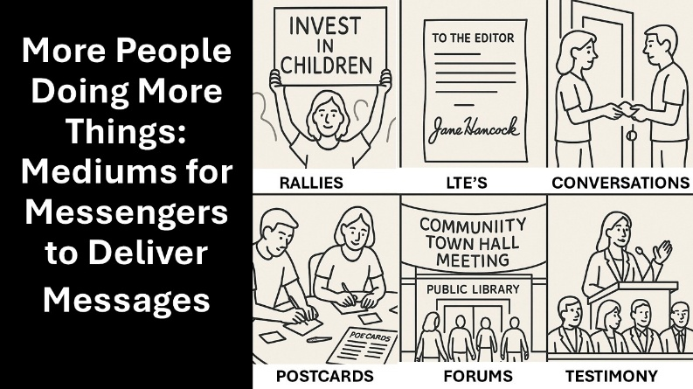
• over coffee with a friend
• in a conversation with a coworker
• during a community meeting
• through a social media post
• by sharing an article with a personal note
• in a letter to the editor
• at a small neighborhood gathering
What matters most is not the format but the foundation: trusted relationships and shared values.
Grassroots Champions as Core to Effective Relational Campaigning
Most of us are already part of communities and networks where people know and trust us.
We may serve on volunteer boards, belong to faith communities, participate in civic organizations, or interact with colleagues through our work. These spaces are often built around shared interests and shared values.
In these settings, people sometimes turn to us for advice or perspective, including issues that involve public policy.
These are natural opportunities to engage, educate, network, and dialogue with others in ways that partisan campaigns cannot replicate.
The most effective grassroots advocacy usually occurs around the issues that advocates themselves care about most deeply and understand best. Those are the areas where they have the greatest credibility and trust with others who share those concerns.
The chart below distinguishes between partisan campaigns and grassroots organizing and the unique contributions each makes.
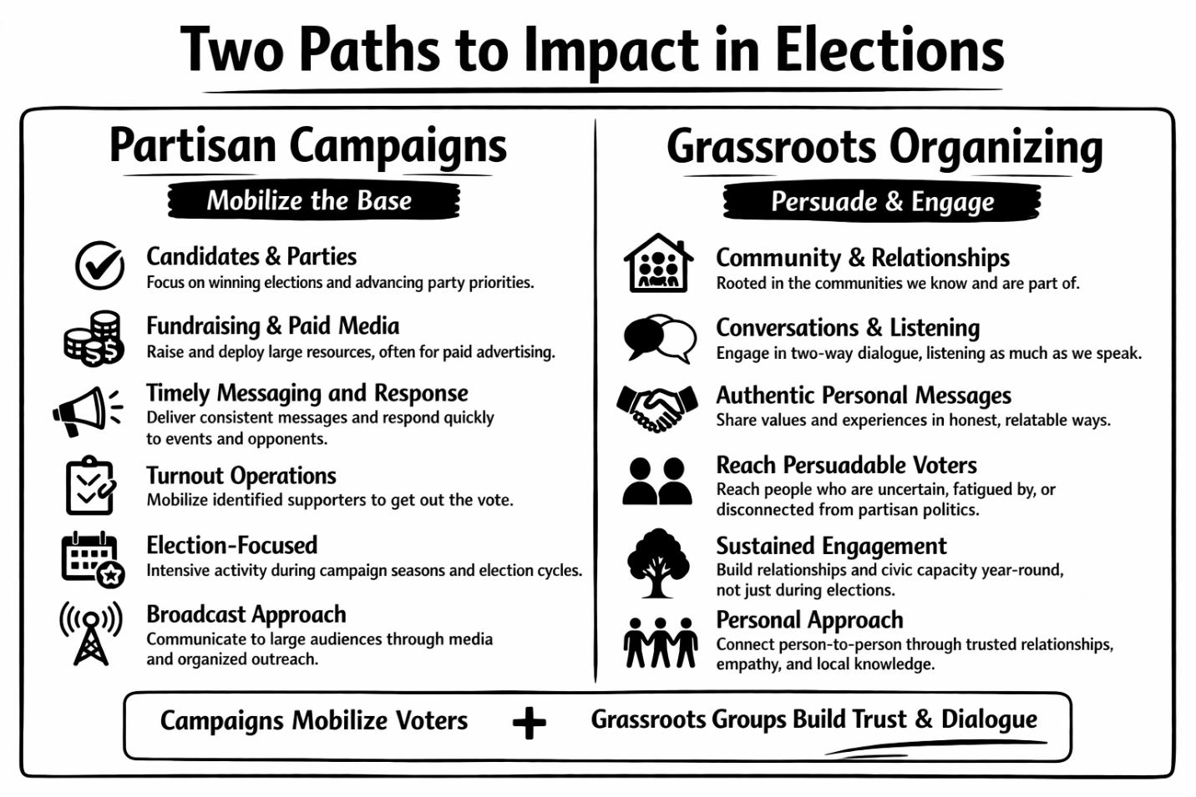
This chapter concludes with a simple first step: inventorying your own superpowers. Below is a short-form Self-Assessment to help you do so (a longer version is in Appendix A).
Short-Form Grassroots Self-Assessment
- What Do You Specifically Most Have to Offer? When it comes to doing things politically, what comes to mind as one or two of your “superpowers”? Be creative and don’t feel shy about bragging (all answers are good answers!).
_____________________________________________________________________________________________________
- What Keeps You Going? What most motivates you to be active politically and keeps you going and gives direction to your work, e.g.:
- What issues or concerns most motivate you to be involved?
- What personal experiences shape your perspective on these issues?
- What kind of change would you most like to see in your community?

___________________________________________________________________________________________________
- Who Can You Engage to Help? When it comes to politics, who can you most count on and like to work with, and have camaraderie?
- List up to 5-7 people you know and trust who are on your political wavelength.
- Star those among them with knowledge and credibility on specific community issues.
- Check mark those who are natural connectors (people who know many others).

_____________________________________________________________________________________________________
- What Are Your Current Strengths and Comfort Zones? Check all that apply.
- ☐ One-on-one conversations
- ☐ Listening and asking questions
- ☐ Speaking to small groups
- ☐ Organizing events
- ☐ Writing or social media
- ☐ Researching issues
- ☐ Organizing and making sure the work gets done
- ☐ I’m a techie(social media, zoom/webinars, database management, website and facebook/bluesky, etc. – all high demand!)
- ☐ Other _____________________________

- What Are Specific Things You Are Ready to Do or Already Doing? Check all that apply.
- ☐ Engaging in conversations with people you know
- ☐ Participating in rallies or events
- ☐ Helping organize activities or events
- ☐ Sharing information and resources
- ☐ Taking a leadership role in your grassroots group
- ☐ Taking on assignments and following up with others
- ☐ Canvassing in my community
- ☐ Messaging on social media or with letters to the editor
- ☐ Writing or signing petitions and/or contacting candidates
- ☐ Supporting behind the scenes (incl. making cookies for or cleaning up after a potluck)
- ☐ Other _______________________________

- How Can You Make You Make It Specific to Your Community? What should you keep in mind about connecting with people in your community overall?
- What are the top 2–3 concerns (and the values behind them) people in your community are talking about that relate to politics?
- Where do people naturally gather (in person or online)?
- Are there existing groups or organizations already active?
_____________________________________________________________________________________________________

7. Based Upon the Above, What’s One Additional Next Step You Will Take? Review how you have responded and think of one thing you will do to follow-up. (Examples: have one conversation, attend one meeting, invite two people to talk, join an existing group, get two friends to complete this self-assessment and brainstorm next steps with them)
____________________________________________________________________________________________________

Final Thoughts
Remember, different champions have different superpowers in who they engage, what values and issues they engage them on, and how and where they deliver messages and foster dialogues that lead to votes. This means we all can contribute to a more informed electorate and the elections we want.
Even small efforts can make a difference.
In today’s polarized environment, a one-percent shift in voting can change an election. Conversations within trusted relationships are often the most powerful way to help voters think about issues and choices.
Your voice, your experience, and your relationships are your grassroots superpowers.

1-2-3
Start where you are.
Build from your strengths.
Grow through relationships.

Chapter Two: Use Shared Values to Engage Voters
Political strategist James Carville once famously said about campaigns:
“It’s the economy, stupid.”
Clearly, economic security matters to voters. People often vote based on whether they believe candidates will “have their backs” in supporting jobs, wages, and financial stability—especially when families feel economic pressure.
But voters do not make decisions based only on their pocketbooks.
At a deeper level, people make decisions based on their values—the beliefs and priorities that shape how they see their families, their communities, and their future.
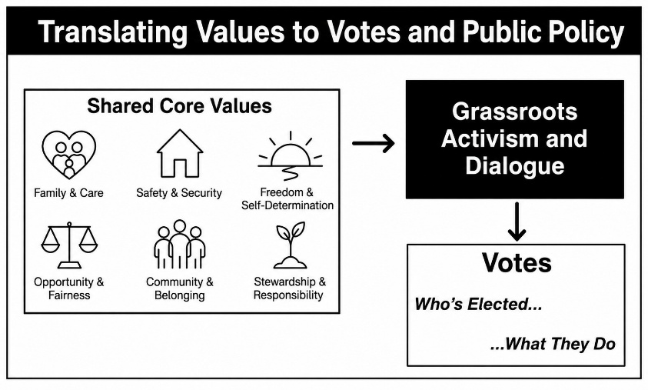
These values include ideas such as:
- Family and care
- Safety and security
- Freedom and self-determination
- Opportunity and fairness
- Community and belonging
- Stewardship and responsibility

These shared values also are the foundation of our democratic system and our Constitution. Shared values have the power to bring people together rather than divide them.
Research across fields such as psychology, cognitive science, and political communication shows that effective persuasion usually begins with shared values—not facts, statistics, or arguments. When people hear a message that conflicts with their values, they often reject not only the message but also the evidence supporting it.
This insight has important implications for grassroots advocacy.
If we want voters to make decisions based on their values, we must start with values in our conversations about elections.
The Special Role of Grassroots Champions
Grassroots champions are uniquely equipped to deliver value-based messages.
- They live in the communities where voters live.
- They share the experiences and concerns of the people they talk with.
- They are present year-round, not only during election season.
Candidates and political campaigns simply cannot match this kind of presence. Even when campaigns try to reach voters directly, their messages often arrive through advertisements, mailings, or brief contacts with strangers. These interactions can feel impersonal or partisan.
Grassroots champions operate differently.
They engage voters through relationships built on trust—relationships with friends, neighbors, coworkers, fellow volunteers, and community members.
Because of these relationships, grassroots champions can:
- engage voters in meaningful conversations
- connect shared values to everyday concerns
- help people understand how elections affect those concerns
- foster dialogue rather than argument

In short, grassroots champions can do things that partisan campaigns cannot.
Moving from Values to Dialogue
The phrase “people vote their values” is often repeated in politics. But there is an important qualifier:
People vote their values only to the extent they understand how candidates and policies relate to those values.
Helping voters make those connections requires dialogue and reflection, not just slogans or campaign messages.
Too often, partisan campaigns focus on “hot button” issues designed to divide voters or create negative impressions of opponents. These “wedge issues” may generate headlines, but they rarely lead to deeper understanding. Examples include messages like:
- “My opponent is soft on crime.”
- “My opponent wants to take away your freedoms.”
- “My opponent is corrupt or dishonest.”

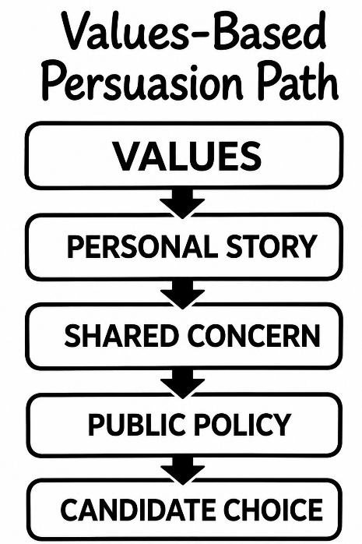
Both parties often rely on these tactics. While they may energize supporters, they rarely help voters think more deeply about what they actually want government to do. They often build a skepticism about politicians, campaigns, and government itself.
Grassroots champions can offer something different.
They can create opportunities for values-based conversations that invite people to reflect on:
- what they care about most
- how government can support those values
- how candidates and policies affect those goals

The Power of Story and Conversation

When people care deeply about an issue, they often feel compelled to present the strongest possible arguments—facts, statistics, and policy proposals.
Those tools are important.
But when beginning a conversation with someone who may not yet share your perspective, it is more effective to start somewhere else.
Start with values and personal experience.
Personal stories can communicate values in ways that facts alone cannot. Stories help people connect emotionally and understand how policies affect real lives. Research shows that when people become engaged in a narrative, they are more open to considering new perspectives.
For grassroots champions, storytelling can be particularly powerful.
Examples might include:
- a parent describing the importance of affordable child care
- a worker explaining how workplace protections helped their family
- a neighbor discussing the impact of clean water protections
- a caregiver explaining the importance of health services for aging parents

The key is to connect the story to shared values and then to the public choices that affect those values.
Reclaiming the Role of Government
A challenge in American politics is that many voters express distrust of government while at the same time valuing services and protections that government provides.
People may criticize “government” in the abstract while supporting:
- public schools
- Social Security and Medicare
- clean water protections
- safe roads and infrastructure
- public health systems
- disaster relief
- affordable housing, child care, health care, and home and community-based services for those with special health care needs
- A tax system where the wealthiest pay their fair share (e.g., more)

In short, they may criticize “government” while supporting the majority of the work that government needs to do to support its citizens.

This apparent contradiction reflects decades of political messaging that portrays government as ineffective or intrusive. Yet government remains the primary way communities organize collective solutions to shared challenges. A values-first approach helps reconnect these ideas.

Instead of debating “government” as an abstract institution, the conversation begins with the values people already share:
- protecting children
- building strong communities
- ensuring fairness and opportunity
- creating safe and healthy environments
- ensuring a strong economy with good jobs and opportunities

From there, grassroots champions can help voters explore how public policies and institutions help advance those values.
Appendices B and C of this Guide provide practical guidance on how to reframe conversations about government using a values-based approach.
The Foundations of Effective Values-Based Engagement
Values-based relational campaigning is surprisingly simple. To rise above partisan noise, three elements must come together.
1. Shared Values. Conversations begin with values that people already hold.
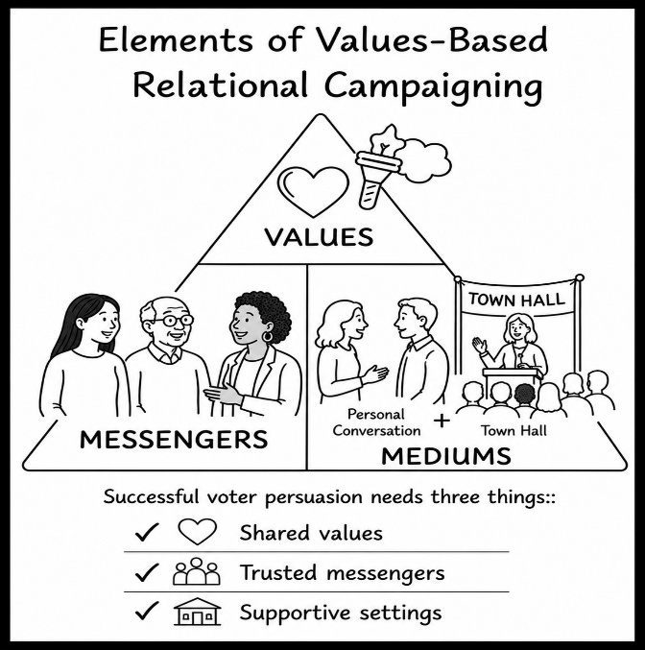
2. Trusted Messengers. Messages are delivered by people who have credibility and trust within their communities.
3. Supportive Settings. Discussions occur in settings where people feel comfortable asking questions and sharing views.
These settings may include:
- one-on-one conversations
- neighborhood coffees
- small community gatherings
- workplace discussions
- civic or faith group meetings
- community forums
- social media exchanges
- letters to the editor

When these three elements come together—values, trusted messengers, and supportive settings—voters are far more likely to engage thoughtfully with political issues. This is where the superpowers of grassroots champions, described in Chapter One, become most powerful.
Looking Ahead
Values-based relational campaigning does not end with a single conversation. It often unfolds over time as people continue discussing issues with those they trust.
The next chapter explores how grassroots champions can apply these strategies with specific persuadable constituencies, focusing on the values and concerns most central to them.

For More on Using Values
The ideas in this chapter introduce the importance of beginning political conversations with shared values and using trusted relationships to connect those values to public policy and elections. For readers who would like to explore this approach in greater depth, two appendices provide additional background and practical guidance.
Appendix B: Using Values to Influence Political Views
This appendix summarizes research from psychology, cognitive science, and political communication on how people form and change their political views. It explains why values often shape political attitudes more strongly than facts alone and why people may resist information that appears to challenge their core beliefs. The appendix also reviews communication strategies that have proven effective in helping people reconsider political issues through values-based framing and storytelling.
Appendix C: Using a Values Framework to Shift Thinking About Government
This appendix focuses specifically on how conversations about government can be reframed using shared values. Many voters express skepticism toward “government” in the abstract while supporting many of the services and protections government provides. This appendix offers practical guidance and examples showing how grassroots advocates can start with widely shared values—such as fairness, opportunity, security, and strong communities—and then connect those values to the role public policies and institutions play in advancing them.
Together, these appendices provide deeper context and tools for those who want to strengthen their ability to engage voters through values-based relational campaigning.

Chapter Three: Grow Your Influence While Keeping It Personal
Using Your Own Superpowers.
Many ways of exercising your civic superpowers do not require organizing other people. Wearing a button or displaying a yard sign signals what you believe and invites conversation. These can be explicitly partisan, but they can also highlight broader values. They can be an explicit statement of one’s own values; or they can invite dialogue (see below). They both represent valid and effective ways to express one’s views, but they have different purposes and reach different voters in different ways.
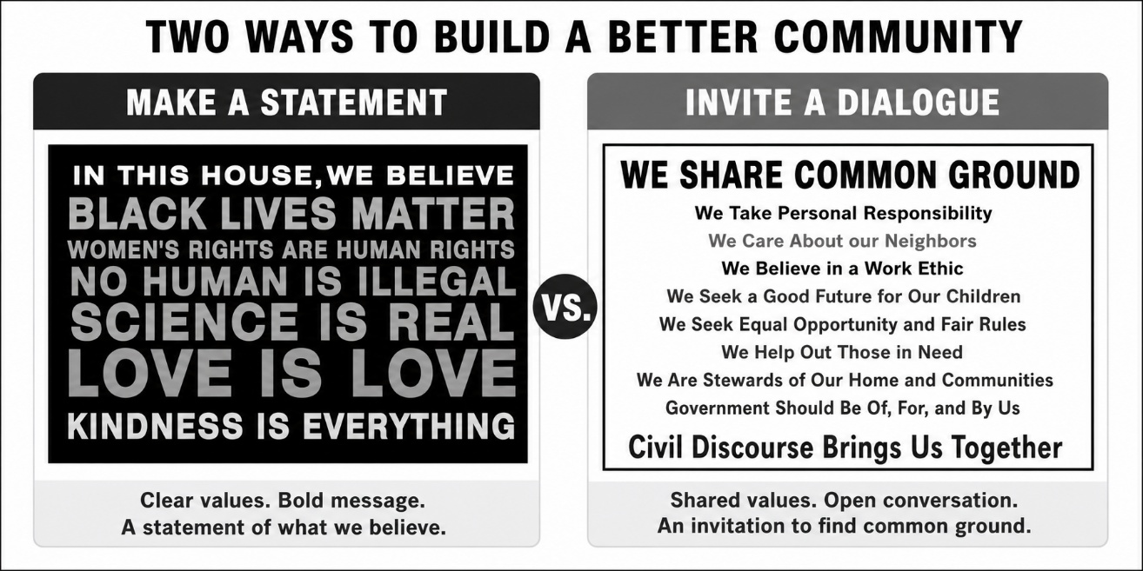
Writing a letter to the editor, speaking at a meeting, or discussing issues with friends or colleagues over coffee are also powerful personal actions. Correcting misinformation or expressing appreciation for public services in everyday conversation can make a difference. People—especially those who may not initially agree with us—often need to hear ideas from multiple sources and in multiple ways before reconsidering their views.
In addition, however, legal scholar and author Joyce Vance states (in Giving Up is Unforgivable: A Manual for Keeping a Democracy):
You don’t have to fix the world alone. It’s more fun, and you’re more likely to succeed, if you get to work with other people who motivate you, teach you, and keep you going. … The important thing is finding the people who sustain you and let you sustain them too.
Often, that can be best done through taking on roles within an existing grassroots organization or establishing your own grassroots group. If you already are a leader of a grassroots group, it can mean recruiting new volunteers and making space for new activities. The more different options there are for people to volunteer and participate, the more their different superpowers can be exercised. Working together not only increases impact—it also sustains motivation.
Using Your Superpowers to Enlist Others to Use Theirs.
You may be reading this guide because you want to expand your own influence—and help others do the same. That impulse is itself an organizing skill. Building grassroots capacity often begins with recognizing the talents of people around you and helping them find meaningful ways to contribute. This section discusses how to help expand activities and build organizational capacity to support and sustain activity.
Some people feel comfortable speaking out forcefully—at rallies, on social media, or through direct advocacy for candidates and policies. Their voices energize supporters and help mobilize action.
Others play a different but equally important role. They are respected community members who prefer not to engage in overtly partisan or combative politics. Their strength lies in fostering dialogue, sharing information, and connecting with neighbors who may be turned off by partisan messaging. These volunteers often have unique credibility with persuadable voters. Their superpower is the ability to create respectful conversations around shared values and community concerns.
Some people are skilled at making phone calls or canvassing door-to-door and even raising money for organizational efforts. These skills are always in demand. If your own organization or groups are not engaged in such activities, you can help identify ways for people with these skills to use or start them in your organization. Similarly, some people can’t or don’t feel comfortable door-knocking or canvassing, and others don’t use social media or electronic databases (and some do and often can add that skill to your organization’s repertoire).
In short, organizing and expanding the level of grassroots electoral activity requires that you value what volunteers have to bring and cultivate them to take action around their own strengths and skills.
Simply put, as you are expanding your own influence, you can help others do so as well. The box below puts this in terms of effective (and common sense) strategies to volunteer recruitment and retention.
Growing a Grassroots Volunteer Base

Grassroots organizations grow strongest when they recognize that volunteers bring different strengths, motivations, and comfort levels. Some people are energized by direct advocacy and partisan campaigning, while others prefer to engage neighbors in thoughtful, nonpartisan conversations about shared concerns. Both roles are essential. When volunteers feel their strengths are recognized and their contributions matter, they are far more likely to remain active and to recruit others into the effort.
The following are key tips to maximize volunteer activity and effectiveness.
- Recognize different strengths. Volunteers bring a wide range of skills—organizing events, advocacy, communication, research, facilitation, and relationship-building.
- Match roles to comfort levels. Some volunteers thrive in direct partisan advocacy; others are more effective in engaging persuadable voters in community-based conversations.
- Create multiple pathways to participate. Not everyone needs to promote candidates. Some can serve as hosts, moderators, presenters, or trusted issue resources.
- Start with shared values and lived experience. Conversations grounded in common concerns—education, health, farming, family wellbeing—often open doors that partisan messaging cannot.
- Provide positive feedback and recognition. Simple appreciation, public acknowledgement, and stories of impact help retain volunteers and sustain motivation.
- Encourage growth over time. Volunteers who start in small roles can gradually take on greater leadership as their confidence and commitment grow.
- Respect different motivations. Some volunteers are motivated by advocacy, others by community service, learning, or dialogue.

A grassroots organization expands not just by adding more people, but by creating a culture where everyone’s strengths are welcomed and put to good use.

Getting Going: Expanding Your Grassroots Base and Activities (Think PDSA)
One of the most common barriers to grassroots organizing is the belief that everything must be fully planned before action begins. In practice, successful grassroots efforts rarely start with a perfect operational plan. They begin with a few people willing to take the first step, try something, learn from the experience, and improve over time.
A helpful framework for this approach comes from the work of management and organizational development expert W. Edwards Deming. Deming emphasized continuous learning through a simple cycle often called Plan–Do–Study–Act (PDSA). Organizations improve and grow by testing ideas, learning from real experience, and adjusting accordingly rather than waiting for perfect plans. The cycle works as follows:
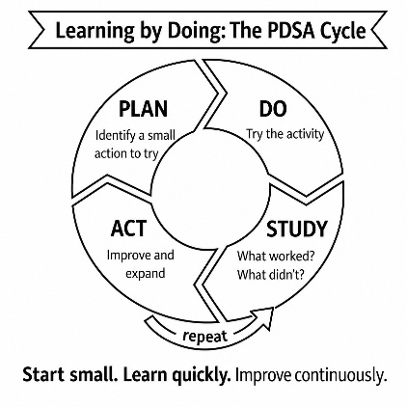
- Plan – Identify a small action to try. This might be hosting a discussion, inviting a few neighbors together, or testing a new outreach approach.
- Do – Carry out the activity. Keep it manageable and treat it as a learning opportunity rather than a final solution.
- Study – Reflect on what happened. What worked well? What surprised you? What could be improved?
- Act – Use what you learned to refine the next effort and expand what is working.
Grassroots organizations grow stronger when they adopt this mindset. They start small, learn quickly, and improve as they go. Each activity becomes a chance to build relationships, discover new volunteer strengths, and refine approaches for engaging the community.
In short, grassroots organizing is inherently experimental. Communities differ, volunteers differ, and political moments differ. The PDSA approach allows organizations to adapt quickly while continuing to grow.
The next section outlines different types of grassroots activities that can help organizations begin this cycle while engaging volunteers with a wide range of interests, skills, and comfort levels.
Opportunities for Growth
Many grassroots electoral organizations began when a small number of people recognized a need to act. National networks—such as Indivisible and the 50501 Movement—have often provided early guidance, resources, and encouragement for local action, although often focused upon particular activities.
The Women’s Movement helped pioneer this model, emphasizing local initiative and creativity. National organizations offered guidance and visibility, but local groups determined the activities that worked best for their communities.
As will be discussed in Chapter 5, there are a large number of different national and state organizations that can provide assistance and support to grassroots organizing and recognize the values and needs for ground-up advocacy. At the same time, however, what is most effective is action that is tailored to the specific culture and identity of the community and that builds upon ways the community and its different organizations and constituencies get together – and that builds upon the energy, credibility, and leadership of people in the community.
Providing Multiple Options to Say Yes.
The best way to recruit new volunteers begins with understanding their values and recognizing the skills, experience, and community knowledge they already possess. When people feel that their abilities are respected—and that they are being asked to contribute in ways that matter—they are far more likely to say yes.
Sometimes you may have a specific activity in mind and simply need to identify people who have the talents or experience to help make it successful. At other times, you may know individuals who are willing to help but only in ways that feel comfortable and authentic to them. In both situations, expanding beyond your current base is easier when you offer multiple entry points for participation.
Effective grassroots organizations therefore create a menu of opportunities. Some activities emphasize advocacy and mobilization. Others emphasize education, dialogue, or community connection. Some require leadership and public speaking; others simply involve helping make an event welcoming and successful. The more varied the opportunities, the more likely people are to find a role where they can contribute confidently and effectively.
Examples of Grassroots Activities that Invite Participation
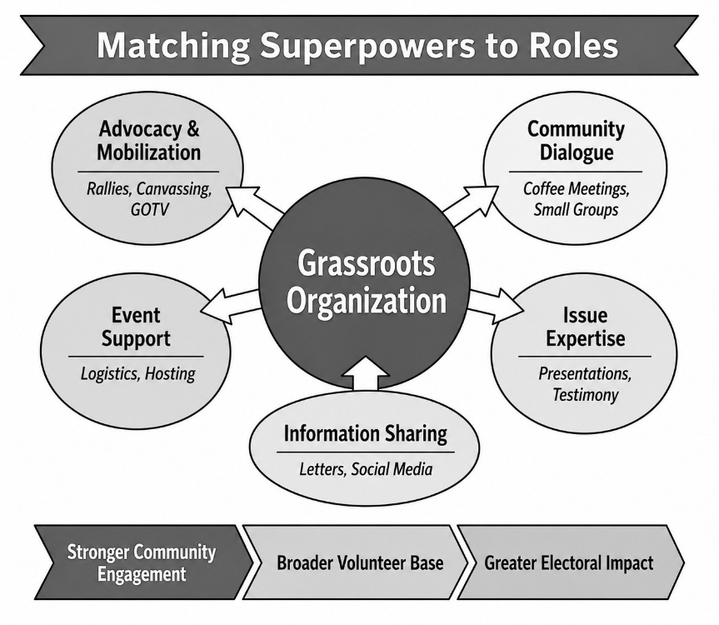
Often, those PDSA activities offer an opportunity for engaging new volunteers and also getting feedback from them. The following examples of activities that allow volunteers with different skills, interests, and comfort levels to participate in strengthening grassroots efforts.
Co-host or present at a neighborhood coffee or small gathering. Small group conversations are widely recommended in grassroots organizing guides because they build trust and allow people to explore issues in a relaxed setting. Volunteers can co-host or co-sponsor a coffee, invite neighbors or co-workers, or share their own experience or expertise on a topic of interest.
Help place an educational presentation on a community organization’s agenda. People who serve on local boards, professional associations, faith communities, or civic groups often have the ability to help place speakers or educational discussions on meeting agendas. This creates opportunities to share nonpartisan information about community issues or upcoming elections.
Join or circulate a request for candidates to share their positions. Community members can sign or help circulate a request asking candidates for a particular office to explain their positions on issues important to local residents. This approach emphasizes accountability and informed voting rather than partisan advocacy.
Help make gatherings welcoming—bring refreshments or assist with logistics. Grassroots activities often succeed because people help with the practical details. Bringing refreshments, helping set up chairs, greeting participants, or assisting with a postcard-writing event are important contributions that make events possible and welcoming.
Share announcements or information through social media networks. Many volunteers are comfortable amplifying events and messages through their personal networks. Sharing notices of rallies, meetings, or discussions helps extend the reach of grassroots efforts far beyond the initial organizing group.
Moderate or testify at a community meeting or public forum. Volunteers with knowledge or professional experience can play an important role in moderating discussions, providing testimony, or helping identify credible speakers for community forums on issues of concern.
Distribute information in their own neighborhood. Some volunteers prefer quiet, direct outreach such as distributing literature, sharing information with neighbors, or helping ensure that people in their community know about upcoming events or opportunities to participate.
Write a letter to the editor or community publication. Local newspapers and community newsletters remain influential forums for discussion. Letters from respected community members often carry particular weight because the author’s identity and experience lend credibility to the message. In many respects, the most important aspects of a letter are the letter writer’s name and the authenticity of the message provided. In some instances, letters can even be describing a community issue or concern and inviting people to the community event!
A Conversation About Their Own Ideas
Sometimes the best way to engage a new volunteer is simply to ask what they would like to do. Meeting with someone to discuss their interests, concerns, and ideas can reveal opportunities that organizers might never have considered.
Many grassroots initiatives begin when individuals feel encouraged and supported to take action on issues they care about. By offering encouragement, resources, and organizational support, grassroots groups can help people turn their own ideas into activities that strengthen the broader movement.
Focusing Upon Persuadable Constituencies
Many of the activities that grassroots volunteers can pursue have a community-wide focus. At the same time, some activities are most effectively targeted to specific constituencies within the community and around the values and concerns they most want government to address. The next chapter discusses specific organizing to engage, educate, foster dialogue, and persuade different groups of voters.

Chapter Four: Persuading Persuadable Voters
While the voting public shares broad values, different people place different emphases upon what they value most and what their greatest concerns are about the future.
Voters are most open to dialogue—and most persuadable—when issues directly connect to their lived experience and deeply held values.
Partisan campaigns often describe this as “micro-targeting” or “relational campaigning,” but its most effective form occurs at the grassroots level—through trusted relationships.
This chapter focuses on two questions:
- Who are the most persuadable voters, and what values matter most to them?
- How can grassroots leaders effectively engage, inform, and persuade them?

While this guide takes an approach to electoral advocacy that is grounded in shared values, it also recognizes that candidates and elected officials differ in how they interpret and act upon those values. The role of grassroots engagement is not to tell people what to think, but to help voters:
- Clarify values
- Understand policy choices that relate to those values
- Evaluate which candidates’ actions best align with those values.
This can be achieved, and often is best provided, in nonpartisan ways that foster dialogue with those who are in that most persuadable category.
Who’s Persuadable and How Are They Persuadable?
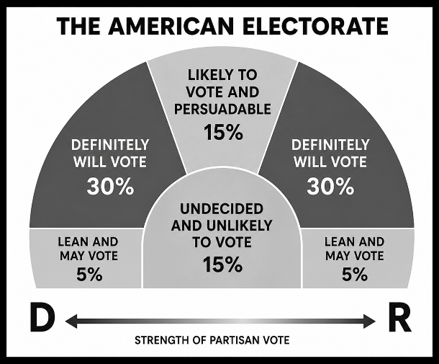
In most competitive elections, roughly 15–25 percent of voters are meaningfully persuadable (either who to vote for or whether to go to the polls), while the majority are firmly aligned. Even small shifts within the group of persuadable voters can determine election outcomes.
The chart provides this simplified representation of where the electorate is today. As we only have so much time, the chart suggests that we prioritize those who are in the likely voter and persuadable category (engage, educate, dialogue with, and persuade) or those who are in the leaning but not committed to voting (to get them out to vote). Partisan campaigns spend much of their time and resources mobilizing their own base and working to get out those who are soft supporters or leaning voters to make sure they vote. Their broader messages try to reach persuadable voters, but largely on a one-way messaging level that often is simply discounted as partisan by voters or cancels out their opposition’s efforts.
Grassroots leaders have a different capacity to reach voters and to do so in a more value-based way, one that is not discounted as simply partisan.
While we cannot perfectly identify those in the persuadable group, we often do know where to look for them and on what values and issues they are most likely to relate to.
First, grassroots leaders both know people and know things. They can be "influencers" within their social and professional networks. They can identify people they know are in the persuadable category. One of the most important things grassroots organizations can do is support their members in engaging, educating, and influencing people they know. Grassroots organizations can be particularly impactful when they provide recognition, feedback, and support for doing so.
In addition, there are particular constituencies within communities that are more likely to be those swing voters and persuadable constituencies, provided they are engaged on the core values they hold. Often, they are in networks or work settings or identifiable in other ways. Even if grassroots leaders do not know them personally, they may be in a good position to reach them and influence them around common values.
In campaigns, a one percent change in voting can be decisive. The biggest potential for making gains is with that 15 percent in the chart who are likely to vote and persuadable. One common value they have is that they do believe in exercising their civic responsibility to vote!
Identifying Specific Persuadable Constituencies and the Values and Issues That Can Persuade Them
While not the only constituencies, this section describes several constituencies which deserve particular attention, particularly if there are members of the grassroots organization with particular ties to them.
It can be overwhelming to grassroots leaders as well as the voters they are trying to reach, to keep up with everything going on in politics and in campaigns, let alone to be able to have the information and evidence to explain them in the context of people’s values. No grassroots leader can or has to know everything, many leaders do know a lot about particular constituencies of voters and the issues that most affect them. The following provides particular constituencies where “values to votes” actions at the grassroots level can pay particularly large dividends.
Parents (and Grandparents). When one becomes a parent, life changes. Time becomes more precious as nurturing and managing more household demands are new responsibilities. New expenses require more attention to breadwinning to meet basic needs. Even the actual architecture of the brain changes, from thinking primarily in terms of "me" to now thinking in terms of "we."
Polls show that parents (and grandparents) rank parenting at the top of the list of core ways they define themselves, far more than they do career, faith, class, gender, race, and party affiliation – and it's not even close. Polls also show they are more persuadable than nonparents in terms of voting and particularly around parenting issues and their children. This showed in the vote for President between 2020 and 2024, where 10 percent of parent voters changed their vote (but only 3 percent of nonparent voters).
ParentsTogether has excellent resources on the persuadability of parents in voting, and Values to Votes has specific resources on how to reach parents through their values about children and the policies that support them. MomsRising and ParentsTogether Action both have active virtual grassroots networks focusing upon issues important to
While parents strongly believe they have the right and responsibility to raise their children according to their values and beliefs, they also know they cannot do it alone. Moreover, in today’s world, they know they face stresses and pressures in doing so and need more, not less, recognition of and support for fulfilling their roles.
Rural and Small Town Voters. When looking at battleground states and their composition, it is clear that the shifts in rural and small town voting in Midwestern states has had a profound impact upon Presidential and Congressional races. Between 2012 and 2024 in Iowa, for instance, voters in the 89 rural counties in the state shifted over 18 points in voting for President by party, while the 10 most urban counties shifted less than 5 percent. Iowa moved from being considered a bluish-purple state in who it elected to being a red state. If Iowa is to again become a competitive state by party, a good share of those who switched their votes in those rural counties will need to switch again.
While these rural and small town communities were once considered core to the economy and society, economic changes have created many challenges to sustaining them and their way of life. Many find themselves with declining and aging populations (particularly their children leaving for jobs in more urban and metropolitan communities). Large agribusiness has threatened family farming and local businesses and economic activity has faced competition from multi-state corporate interests.
Rural, white, working class residents find they need to work two or more jobs and still live paycheck to paycheck. There are reasons that many residents feel at risk of being left behind in the economy and discounted in Washington, D.C.
New emphases are needed in reaching agricultural and small town voters that speak to their values and concerns for the threats to their way of life. Agricultural policy has tended to support large-scale farming (get big or get out) and economic development policy has tended to support high tech and high growth industries and not sustainable small town and rural communities.
Rural and small town voters often place value on their communities and don’t necessarily see their goal as getting rich, but they do fear that the stability and neighborliness of their communities are disappearing. They need a way of translating these values around themselves and sustaining their communities with actions that government needs to take in those.
Simply put, engagement with rural and small town voters is most effective when it begins with respect for community identity and lived experience and then connects those values to concrete policy choices that affect economic stability, health care access, and community sustainability. Grassroots champions have that lived experience and respect for community identity. In those communities, there are “pick-up truck progressives” and “grassroots democracy advocates” who can do so.
Young and First-Time Voters. Young people not only are the economic future of the country, but also new voters and the future electorate of the country. They are looking to whether government will support them as they build their careers and their own future families.
Young and first-time young voters are least likely to identify with a particular party and often are the biggest swing voters. Moreover, their first votes often set their pattern of voting for many elections to come. Engaging young voters has both immediate and long-term consequences.
When youth go away to college or get their first job and apartment, they are likely to be engaged in more social activities with peers and to shape their political identities as well (if they are to change from those of their parents). Polls show much greater concern among younger voters on what the future holds for them from global warming and a changing job structure that emphasizes automation and many fewer full-time jobs with expected upward mobility opportunities.
Many are skeptical that either Social Security or Medicare will be available to them or that owning a home is within reach. They are more diverse by race and ethnicity, more likely to have friends who are LGBTQ, and more likely to view gender roles and relationships in a much more egalitarian way. They are more likely to get their information from social media (much beyond Facebook). Young people listen to their parents and other generations, but much of their engagement and relational campaigning is going to be through peers.
They also are at a time in their lives with generally more social connections and generally more time devoted to engaging in discussions about themselves and their opportunities. Engaging them, particularly with and through their peers, is, at its core, relational campaigning and value-based advocacy.
Caregivers and Helpers and Those They Serve. Rosalynn Carter devoted her own advocacy to caregiving and advancing mental health, essential services that often are taken for granted or neglected in discussions of public policy. She worked to elevate that role of government, stating, “There are only four kinds of people in the world – those who have been caregivers, those who are caregivers, those who will be caregivers and those who will need caregivers.”
Those who provide care and help to others were recognized during the Covid-19 pandemic as being part of the nation’s “most essential workforce,” but they are needed not just during pandemics or national disasters. They are sometimes considered “the workforce behind the workforce,” enabling others to work and know their family members receive the care they need, AND they are a workforce in their own right.
Including health care, child care, social workers, and educators, they represent one in six workers and voters today. They are only going to be in increasing demand in the future, and primarily rely upon public funding to employ them and do their jobs. Further, those providing direct care – nursing home staff, hospital nurses’ assistants, home care providers, and child care workers – alone are eight percent of the workforce and the electorate, yet among the lowest paid workers in society.
Candidates and campaigns seldom speak to them or what role government must play in recognizing their value and supporting their work. They have chosen their work because of their values—and often struggle to balance that work with nurturing their own families. These caregivers and helpers live in urban and rural communities, red and blue states, and vibrant and struggling communities.
They can be a force in elections, not only with their own votes but with the votes of those they care for and serve. Moreover, attention to them can bring people together to appreciate and support the integral role government needs to play in supporting them, the people they serve, and the community as a whole.
Supporting caregivers and caregiving represents a core value across political affiliations, economic status, and geographic location, but is seldom translated into the essential role that government must play in supporting that workforce and the degree to which doing so benefits those providing that care, those receiving it, and the communities in which that care exists.
Caring Across Generations and the Care Can’t Wait Coalition are national organizations that work with and provide a base of support for this caregiving workforce. Congress now is at a crossroads in whether to scale up investments in the caregiving community (both to meet demand and to pay the workforce what it deserves) or to cut back on providing support. The stakes in doing so extend beyond the workers themselves and are particularly important for rural communities and poorer urban areas where they are most needed.
Civically Attuned Voters Respecting Individual Rights and the Rule of Law. Most Americans value American society precisely because it is democratic and recognizes differences of views, works to resolve them through civic institutions, recognizes the rule of law in doing so, and believes that government should be fair and elected officials honest. It is what makes many proud to be Americans.
Polls show, however, that voters – across political parties and philosophies – do not feel elected officials are meeting their responsibilities or campaigns contribute to doing so. They want government to do more to support them – but they lack faith that it is going to do so. Voters are frustrated by what they see as gridlock in Congress and in state capitals and want more bipartisanship.
At the same time, however, they may be led to conclude, particularly through partisan campaign messaging, that “both parties do it” and that office holders share equal blame in that gridlock. The fact, however, is that being value-based and approaching elections and advocating for policies can be nonpartisan, but that does not always mean that there must be bipartisan agreements to move forward. Moving from such values in democracy and the rule of law to insisting candidates embrace that requires breaking down where candidates and office-holders are working to uphold those values and where they are working to subvert them.
Colleagues, Co-workers, and Members of Groups and Boards. The above examples of persuadable voters and constituencies and the values and issues around which they can be reached apply across states and regions of the country and represent particularly persuadable groups of voters. These are not the only such persuadable voters, however, and different grassroots leaders and their organizations often can identify and reach others where they can best use their relational and value-to-votes skills to engage, inform, and ultimately persuade voters.
Relational Campaigning with Persuadable Voters – Using Parents and Grandparents as an Example
Each of the constituencies above requires different foci and involves different people and different issues, but it also shares common elements.
First, moving from values to votes with a particular constituency around its most core values is more than a single action. At its core, effective relational campaigning involves five elements:
- Starting with shared values
- Serving as a trusted messenger
- Connecting values to policies and candidate choices
- Creating safe, dialogue-based settings
- Drawing on credible information and expertise.

The following discusses how to do so around a particular constituency, using parents and grandparents as an example.

Starting with Shared Values as a Trusted Messenger. Introductory discussions may be a simple comment or question in a conversation that starts with the value and responsibility of parenting. In the case of reaching parents or grandparents, this may simply be an add-on to a discussion about your kids or grandkids with a parent or grandparent or your child’s or grandchild’s friend. That can then lead to a longer discussion, an invitation to a neighborhood coffee to discuss children and the election more specifically, a town-hall meeting on the subject with community or state presenters, or sharing of resources from organizations about electoral policy issues on the subject. As a fellow parent or grandparent, you already have the credibility to do this, but you also may have connections through your work or volunteer activities to do so with other parents or grandparents.

Connecting Values to Policies and Candidate Choices. What you can provide that those you want to persuade are not likely to have is the policy issue content related to the value. One framing and messaging related to Congressional family policy is found in Appendix E. You don’t need to be the expert on this subject, but you do need to be knowledgeable enough to have a discussion and be able to find answers to questions from others when they raise them.

Creating Safe, Dialogue-Based Settings and Drawing Upon Credible Information and Expertise. Hosting neighborhood coffees, inviting parents to library programs, or organizing town halls or community meetings all are ways to foster dialogue and to bring into them credible resources and information.

For parents, providing child care or finding comfortable and easy gathering places can both increase participation and demonstrate your own valuing of parenting and its demands. Broadly inviting people is a sign of both respect and inclusivity, whether or not parents or grandparents are able to participate. Follow-up, even when those invited aren’t able to participate, further reinforces your work.

Different parents and grandparents will respond to different types of outreach, engagement, and participation. They also will talk with one another. Those who do participate in neighborhood coffees, library programs or community meetings will talk about what they heard. Word will get around.

Below is a description of some of the content elements of relational campaigning focusing upon parents and grandparents, but a similar description can be developed for any other persuadable group. Think about this as a way to begin your own identification of and outreach to a group of persuadable voters you can reach, inform, and persuade.

- Starting With Shared Values: Broadly Shared Values Related to Parenting (and Grandparenting)
- (Parents) Raising my children to be healthy, good, and to succeed.
- (Parents) Being economically secure and able to balance breadwinning and caregiving roles.
- (Grandparents) Being able to see and contribute to my grandchildren’s well-being.
- (Both) Having affordable health care for my child and family that responds to any special health needs.
- (Both) Being in supportive communities so my child/grandchild has the attention, care, and education to meet her dreams.

- Serving as a Trusted Messenger: Community Members with Special Credibility and Trust to Engage and Dialogue with Parents and Grandparents and Connect Values to Issues and to What Candidates Support Them
- Parents and grandparents, particularly through parents of their children’s or grandchildren’s friends
- Teachers and health practitioners serving children
- Home visitors and community centers and libraries providing child and youth programming
- Child care and preschool teachers
- Board members from community nonprofit organizations serving children and families
- Volunteers working with children’s services or programs in faith communities
- Senior leaders recognized for their work for children in the community.

- Connecting Values to Policies and Candidate Choices: Parenting-Related Policy Issues Related to those Values to Raise in Discussions (below specific Congressional issues that are on the table today)
- A family-fair tax system that recognizes costs of raising children (e.g. a refundable and expanded child tax credit to $3000 for an older child and $3600 for an infant or toddler).
- Affordable child care and appropriate subsidies credits so families don’t have to expend more than 12 percent of their income on child care.
- Paid family leave (supports for the first three months after birth to stay at home)
- Affordable health care for families (restoring cuts to Medicaid and ACA and providing care that meets the developmental and special health care for children and other family members)

- Creating Safe, Dialogue-Based Settings: Places to Engage, Educate, and Dialogue with Parents and Grandparents
- Comments or questions introducing subject with other parents or grandparents when talking with them about their children or grandchildren
- Person-to-person talks to promote interest and attention, often starting with a personal story that invites response
- Neighborhood coffees inviting parents and grandparents for discussion of child policy
- Town meetings or forums with community presenters focusing upon policy issues related to children and families
- E-newsletters or messages providing information and updates to those who have shown interest
- Resources for sharing at other meetings and events, with a roster of community members (see above) who helped develop those resources

- Drawing Upon Credible Information and Expertise: Resources (and their Members) to Draw Upon for More Detailed Policy Information and Expertise
- State child policy advocacy organizations (e.g. Common Good Iowa) and coalitions (e.g. Iowa Children’s Policy Coalition) and state Kids Count chapters and other organizations (Early Childhood Iowa)
- National virtual grassroots networks of parents – ParentsTogether and MomsRising
- National organizations engaged in federal child advocacy – First Focus, Children’s Budget Coalition, Women’s Law Center, National Collaborative for Infants and Toddlers, etc.

Again, grassroots champions do not have to do all this alone and don’t have to do all of it at once. In fact, one of the best ways to learn and hone your own skills is to talk about what you are doing with others who are also doing it. It often helps to have a mix of people – with different backgrounds and connections – engaged. Relational campaigning involves relationships and you will not always connect with every individual you try to connect with nor will others necessarily be able to make connections with those you can. Sometimes, your first effort will end up laying the groundwork for someone else’s second effort. The important thing is to be true to who you are as you engage, educate, and persuade.

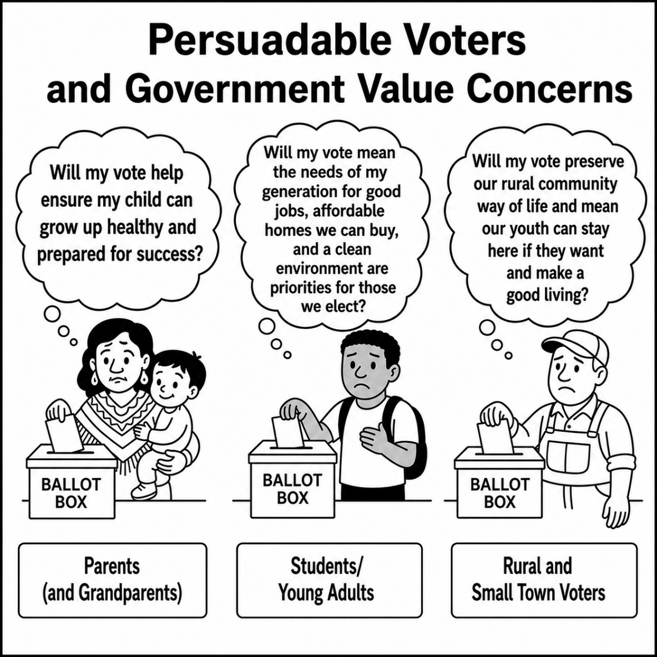

Chapter Five: Get the Help You Need from Those Who Can Provide It
As the preceding chapters emphasized, grassroots champions possess “superpowers” that allow them to influence their communities in ways others cannot. They also benefit from learning from one another and sharing ideas with other grassroots leaders across their state. One purpose of the Grassroots Iowa Network is to support those exchanges and highlight the work that grassroots champions are already doing.
State and National Organizations Who Can Help
At the same time, a wide range of organizations operate at the state and national levels whose missions include strengthening grassroots advocacy. These vary in the roles they play:
• some provide policy expertise and research
• some train grassroots organizers
• some fund local organizing efforts
• some mobilize volunteers and voters
• some provide tools such as voter lists, messaging guidance, or training materials
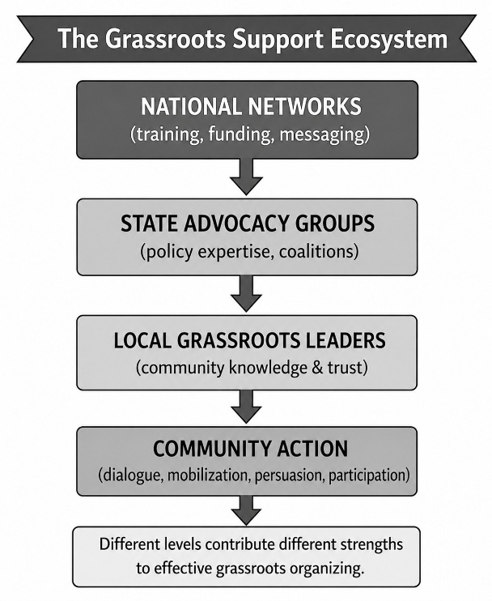
While none of these organizations has the local knowledge that grassroots leaders possess, many offer resources that can make local organizing easier and more effective. Together, this helps to create a powerful advocacy ecosystem, as the chart shows.
Some national groups have identified specific Congressional races where they are devoting their time and effort, and Iowa is at the top of the list of states with key Congressional. Some of these organizations recruit staff and activists at the community level whose role is to support grassroots leaders and organizations.
Some raise contributions to provide financial aid to grassroots groups or individuals (particularly around canvassing and getting out the vote). Some provide online trainings on organizing or messaging or responding to specific issues. Some offer postcards for sending messages to persuadable voters (even ones with addresses already provided). Some have voter lists and databases to share with grassroots organizations of persuadable voters in their communities. Some keep close tabs on Congressional and White House actions or state legislative ones and can provide timely information for responses. Particularly through social media connections, some have developed grassroots membership that can run into the millions of voters.
At the state level, some groups have local chapters which can provide speakers or advocates and whose staff can present on topics of particular community interest. Some are engaging in direct advocacy work in specific communities or with specific constituencies.
None of these groups can have the level of knowledge about your community or the people who live there, but some have additional knowledge and information or resources and staff that can help grassroots leaders.
Grassroots leaders often want information to help them in taking action and learning from others and not “trying to reinvent the wheel.” Often, there are national and state organizations whose purpose is to provide such help. While the remaining sections have a specific focus upon national and state organizations involved in Iowa, many also are active in other states or have counterparts in those states.
National Organizations and the Different Roles They Play
Direct Funding for Grassroots Action. Some organizations have been developed specifically to provide funding support directed to advocacy organizations, for both 501c3 and 501c4 work. The Movement Voter Project (particularly through the Battleground Alliance), the Force Multiplier Project, and Good Nation Action all have made investments in people or organizations in Iowa. The Open Society Foundations funds in the area of voting rights and organizing; Arabella Advisors funds large progressive funding vehicles; Way to Win funds grassroots organizing in battleground states.
Virtual Training on Grassroots Advocacy. Empower America and Deep Canvass offer virtual training and guidance on relational campaigning and, in particular, fostering conversations and dialogue that lead to persuasion. Activate America is doing so on organizing and building a grassroots presence. Families Over Billionaires provides regular zoom calls updating Congressional actions and, in particular, the tax and spending cuts included in the One Big Beautiful Bill Act and their consequences to states. Campaign for a Family Friendly works to expand grassroots dialogues on the importance of creating an economy that works for families. Economy Arena Academy trains progressive campaign and organizing staff; Wellstone Action is a long-standing training organization; and the Midwest Academy offers additional training around progressive issues and campaigns.
Information and Resources on Key Congressional Issues. On a 501c3 basis, different organizations offer regular e-newsletters and zoom calls and updates on key Congressional issues and sometimes technical assistance and information on how actions specifically impact various issues:
- The Center on Budget and Policy Priorities, Citizens for Tax Justice, and Institute on Taxation and Economic Policy all offer reports and analyses, often with state-by-state examples, on federal tax issues and the impact of federal tax policies.
- The Brookings Institution, the Urban Institute, and the Economic Policy Institute offer reports and resources particularly related to working families.
- First Focus, the Coalition on Human Needs, the Georgetown Center for Children and Families, the Food Research and Action Center, the Center for Law and Social Policy, and the Women’s Law Center all have been connecting with state advocacy groups around the budget cuts to Medicaid and SNAP and other children’s issues (child care and preschool) and Congressional efforts to restore them.
- The same holds in terms of national organizations around issues of agricultural policy, voting rights and the rule of law (e.g. Brennan Center for Justice and Common Cause), environmental policy, and workforce rights and jobs.
- Many of these have resources that speak to core electoral issues the Congressional candidates should be asked to address.
National Virtual Grassroots Leader Networks. In addition to the above, there are a growing array of national organizations which have created virtual Grassroots Leader Networks. Moms Rising and ParentsTogether and the National Collaborative for Infants and Toddlers do so specifically for parents. Young Invincibles and MoveOn do so with younger voters and Next Century Forum and Voters of Tomorrow have activities in Iowa with a young voter and college student focus. The Women’s March and Indivisible do so around local rallies and activities, often in conjunction with national publicity. Swing Left and Vote Forward are very active in postcard writing and volunteer organizing.
Depending upon the forms of action grassroots leaders want to take, the topical or constituency base of their actions, and the degree to which they want to remain nonpartisan or get into partisan work, there are organizations who often can provide expertise and support that grassroots organizations don’t then need to try to do themselves.
State Organizations and the Different Roles They Play
On the nonpartisan and 501c3 side there are many state organizations with state policy agendas and a state legislative and executive branch presence who often also have either national partners or sponsors who have federal policy agendas. Some, such as the Iowa Environmental Council, the Children’s Policy Coalition, the Iowa Hunger Coalition, and the Medicaid Coalition are sources for networking and advocacy around both state and federal policy issues. They frequently have fact sheets and policy briefs that provide detailed and credible information and often do so from a values-framing perspective. The League of Women Voters and the Iowa Interfaith Alliance, the Iowa Civil Liberties Union, and Common Cause Iowa have particular standing and credibility around civic issues, voting issues, and civil discourse.
In addition, some state organizations, such as the Iowa State Education Association, the Iowa Federation of Labor and other labor organizations, the Iowa affiliate of the National Association of Social Workers, and the Iowa Farmers Union have active 501c4 agendas and endorse candidates and engage in substantial grassroots lobbying activities. These organizations also have local members who often can be enlisted for rallies, town meetings, or other local activities.
Others, such as Iowa LIFT, Progress Iowa, the Iowa Citizen Action Network, and Iowans for Community Improvement, place major emphasis upon grassroots organizing and mobilizing and around elections. These organizations often offer training and information sharing to others.
Accessing and Getting What You Want
The previous chapters have focused upon what grassroots leaders are uniquely equipped to do, recognizing the importance of grassroots leaders organizing and taking action according to where they can have the biggest community impact. Many of the organizations described above won’t be able to provide much assistance and may be mostly geared to marketing their own agendas, but some will have something to offer. The challenge is finding them when they can be most helpful. Some can actually offer financial help and resources. Others can provide important information or have members at the grassroots to participate and support local actions and/or to be recruited as members of grassroots organizations and coalitions.
The Values to Votes website, www.valuestovotes.com, has additional information on national organizations and the Grassroots Iowa Network website, www.grassrootsiowanetwork.com, has additional information on state (Iowa) ones.. The following are some practical tips for getting what you need from them.
- Start with Connections You and Your Grassroots Members Already Have. Relational campaigning involves building upon and strengthening relationships, so making sure they know you exist and establishing a point of contact for further communication is important and best done through people who already have some connection.
- Sign Up and Become a Member or Affiliate or Encourage Other Members of Your Group to Do So. Almost all of these organizations want to share their resources and information broadly, and particularly with people at the grassroots level – through e-newsletters and updates, zoom calls and webinars, and social media feeds. They usually have ways to sign up on their websites or facebook pages.
- Participate in a Zoom Call or Webinar They Offer to Determine What They Can Provide. One way to get to know organizations and what they do is to participate in a webinar or zoom call that they are offering to grassroots leaders and advocates. This can also be a way to then follow-up with a request for additional help around something they discussed.
- Identify and Invite a Member of the Group to be a Representative on Your Group. As you find you want to grow the people in your group or grassroots organization, many of these organizations have local chapters and literally millions of members across the country (and likely someone in your community). Inviting people who are members of the organization and asking them to be liaisons is a good way to make connections and grow your base. State organizations, in particular, often have local chapters and boards with members from around the state.
- Ask for Help in Areas They Can Help. Some organizations are more than willing to work with you to contour messages or present information or reach out to constituency groups adapted to your particular grassroots’ constituencies. Others have more boilerplate information and resources. When organizations have information that you feel needs more focus on the values and issues in your community, reach out and ask.
- Alert Other Grassroots Leaders in your own Organization or Network to Opportunities You Discover that Seem Most Relevant to Them. In making connections with national and state groups, you may also become something of a “maven” who knows about opportunities others in your community may not yet have discovered.
- Put any contacts you develop into your database and include them on updates you send about meetings, events, or activities. This can be a quick and easy way to keep in touch and at least cc: them when you are sending out notices, invitations, or announcements of activities.
- Approach This as a Two-Way WIN/WIN Undertaking. Most of these organizations recognize that grassroots action is critical and are looking for grassroots activists who can to carry out their agendas. You want this to be a two-way street. You likely have as much to share with them as they have to share with you.
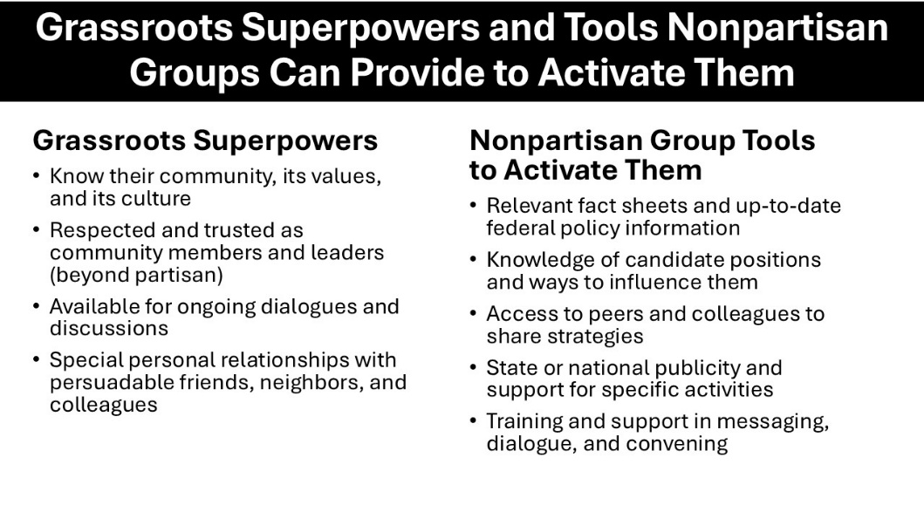
Summary
When it comes to superpowers, you have many that are particularly applicable to local action and influence. At the same time, no one knows everything, and grassroots leaders can’t be expected to know everything, particularly about what is going on at the state or national capital.
You can magnify your own superpowers by connecting with people and organizations whose expertise lies at the state or national level. When grassroots knowledge and broader resources come together, both become more powerful and the impact of local action grows.

Chapter Six: Cultivate Grassroots Organizational Growth
There are many guides on organizational development, including some specifically for grassroots organizations that are largely volunteer-based. It may seem strange that a chapter on organizational strategy is the sixth and not the first chapter of the guide. This, however, is for a reason. Too often, while the motivation to organize is based upon a specific desire and energy to do something, focusing upon organizational issues (creating bylaws, getting a tax I.D. number, creating a website or social media sites, doing a comprehensive scan of voting information, etc.) can drain energy and delay action on the reasons for getting together in the first place.
From Individual Action to Sustainable Impact
Grassroots organizing often begins with individual action—conversations, small gatherings, and shared concerns. It grows with the learning and initial successes that such action produces. As it grows, sustaining impact and activity requires something more: structure, coordination, and intentional growth. People will still participate and sustain their participation because they feel what they are doing is valued and they feel part of something – but the work must continue to be personal and relational.
Growing an organization involves retaining the informal and personal but also constructing a strong organizational base and presence. This chapter focuses on how grassroots efforts can evolve into strong, sustainable organizations—without losing their relational foundation.
The first five chapters covered the relational heart of grassroots work; this chapter is about the organizational muscle. As one begins to tackle particular issues, other organizations and their resources and guides can be accessed. An organization need never build in a vacuum. A short list of such organizations and resources (and their particular strengths) is provided at the end of this chapter. Here, however, are some core points to guide organizational growth and development:
Core Practices to Cultivate Grassroots Growth
1. Start with Strategy Discipline. Strong organizations do not grow by accident. They grow when people are clear about:
- what they are trying to accomplish
- who they are trying to reach
- how they will assess their progress and decide what to do next
- what particular space they fill amidst other work that is going on in their communities (their special role), and
- relevant time frames for meaningful action.

This does not require a complicated plan. It begins with being clear on simple questions:
- What change are we trying to make?
- Who do we most need to engage?
- What are the most urgent actions?
- What actions will make us more effective?
- When should we stick to our work even when there seems to be a lot of other action around us?

Without this kind of clarity, activity can feel busy—but not effective. Clarity also makes it easier to decide what not to do—an essential part of staying focused and avoiding burnout.
Particularly today, grassroots organizations can get caught up in and overwhelmed by issues of the moment and not what they are best equipped to impact. Too often, organizations may feel that they have to do it all and there is no one who knows how to do it.
As Chapter Five described, there are other organizations – at the local, state, and national level – that often have resources that fit what you want to do. In addition, there may be other organizations in your own community that can provide some of the answers and do some of the work. Before you conclude that “nobody knows how to do this,” do a little homework and at least look for someone with some answer or insight.
2. Organize and mobilize – but recognize the difference. Both organizing and mobilizing are important—but they are not the same.
Organizing:
- builds relationships over time
- develops trust and leadership
- expands the number of people involved
- focuses on persuasion and connection
- builds with a long-term goal or goals in mind

Mobilizing:
- activates people for specific actions
- often focuses on rallies and turnout efforts directed to the already committed
- generally is short-term and time-bound.
- demonstrates intensity and provides emotional, social, and cultural connection points

Strong organizations do both—but organizing comes first. Mobilizing without organizing can generate activity but often does not build lasting capacity. Organizing creates the foundation that makes mobilizing effective. In practice, many groups default to mobilizing because it is more visible and immediate – but organizing is essential to truly be effective at relational campaigning. Mobilizing provides the flash, but organizing provides a sense of belonging and supplies meaning for members.
3. Recruit and Grow Volunteers. People join for different reasons—and stay for different reasons. This starts with recruitment, but always with an eye to retention and opportunities for growth.
Recruitment. Recruitment can be done through multiple appeals, but should begin with and be based upon personal invitations, shared values, and existing relationships

The most effective question is often simple: “Would you be willing to help with this?” Recruitment is most effective when it is personal rather than general. People are far more likely to say yes when asked directly and asked about things they are particularly equipped to do.
Retention. People stay involved when they feel valued, they are doing something that fits their strengths, and they see that their contribution matters. This includes making sure they are thanked and valued for what they do.

Growth. Over time, some volunteers will be ready to move into deeper roles. There is often a general progression of roles that volunteers can take on, as both their experience grows and the organization grows. One of the most impactful elements of leadership at the early stage is making an ask of a member that fits the person’s skillset and interests.

Level | Examples
Initial | Attend, listen, participate
Active | Help with events, have conversations
Engaged | Take responsibility for tasks
Leadership | Organize others, lead efforts

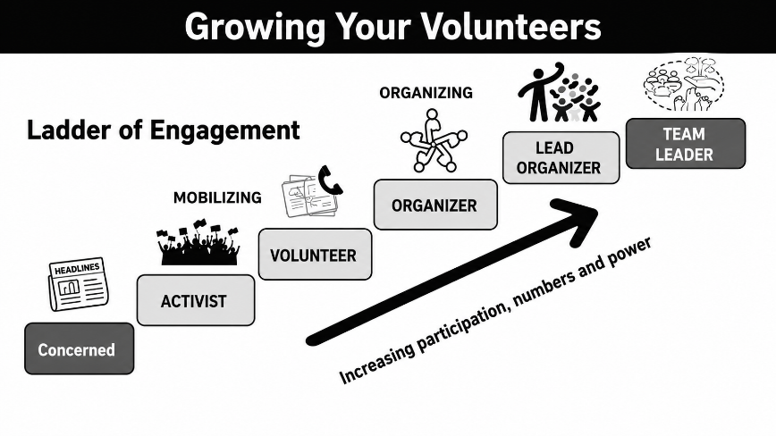
The goal is not to push people—but to create opportunities to grow. The volunteer ladder chart, from Activate America, shows such opportunities for growth, as the organization itself grows. A key is to make sure that volunteers are valued and supported as they take on roles and given the mentoring or support to do so.
4. Match People to Roles. A strong organization recognizes not everyone contributes in the same way.
Some people:
- persuade
- organize
- connect
- manage details
- provide credibility
- speak out and put themselves on the line
- post on social media
- provide support behind the scenes
- just want to contribute on assigned tasks – to stuff envelopes or answer the phone

Your role is to: recognize these strengths, invite people into roles that fit, and find a suitable volunteer activity and support them in that role.

This is how organizations expand naturally. It is particularly important as organizations do develop and branch off into new activities. It also is important to recognize that grassroots campaigning often offers many more avenues for participation than partisan campaigns (see below). Clearly, political campaigns are significant organizing opportunities – or at least they should be. But many people who are not comfortable with partisan advocacy are highly effective in relational engagement and community dialogue roles.
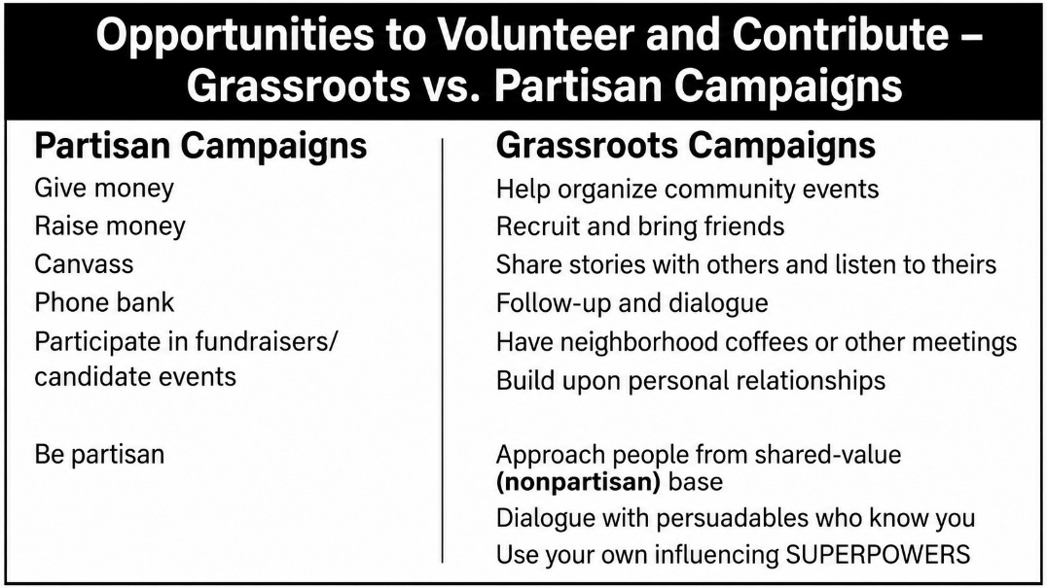
5. Build Data and Communication Systems—and Use Them. As grassroots activity grows, informal communication becomes harder to sustain. Even small organizations benefit from simple systems that help them stay organized, connected, and effective.
Data Systems. At the heart of grassroots organizing is building and maintaining relationships over time. A basic data system helps you keep track of who you are engaging, what you are learning, and how people want to stay involved.
For people connected to your organization, it is useful to track:
- names and contact information (including preferred method of contact)
- how people are connected to you or your network
- their interests and areas of concern
- their strengths and skills
- their level of involvement and what they are willing to do

This can begin simply—with a spreadsheet, shared document, or basic database—but it should be designed to grow with your needs.
In grassroots political work, this also applies to voters you are engaging. Tracking conversations, interests, and follow-up needs helps build ongoing relationships rather than one-time contacts. Some organizations, such as Indivisible, offer tools that local groups can adapt for this purpose.
Communication Strategy. People receive and share information in different ways. A strong communication strategy meets people where they are and uses the methods they are most comfortable with.
For example at present, most organizations benefit from using a mix of: email updates, text messages or small group chats, personal outreach and follow-up, and social media.

The goal is not simply to send information, but to keep people meaningfully connected to the work. In today’s environment, people are selective about what they read and respond to. Messages that feel impersonal or overly frequent are often ignored.
Grassroots organizations have an advantage: their communication can be more personal, relevant, and trusted – and not about raising campaign funds! Members will want to hear from you even when there is not a specific ask related to the outreach.
Grassroots organizations can be the exact type of organizations that many people are seeking for their political advocacy, provide they recognize the two following truths:
- People stay engaged through personal contact—not just mass messaging
- Relational campaigning requires relational organizing
6. Fill Organizational Gaps and Take on New Organizational Opportunities. As you grow, you will sense gaps in your work, and people in your organization or outside groups will have ideas about things they would like to see you do which you don’t have the ability or resources to do now. Filling organizational gaps is key to being effective and maintaining momentum, acting on new opportunities is key to growth.
Filling gaps. Filling gaps really is a two-step process – identifying them and then filling them. This can be individual or group work, but it should be done on a periodic basis, even when things seem to be going along smoothly. It is much easier to fill a small gap than one that has grown to become a huge one.
Identifying gaps. Some of the gaps that organizations often face related to people taking on specific responsibilities to ensure they are completed, e.g.:
- no one organizing events
- no one is managing communications
- no one connecting with relevant groups
- no one comfortable with persuasion conversations
- no one seriously looking at the work and identifying gaps which need to be filled.

Filling them. The key to filling these gaps is to find someone who will be responsible for addressing them and take responsibility for reporting back. Some rules of thumb in doing s include:
- look within your network first
- ask people directly
- connect with outside organizations (Chapter Five)
- invite people into specific roles, not general asks, where they can fill those gaps.

Taking on New Opportunities. Taking on new organizational opportunities also involves a two-step process – determining whether doing so will advance the organization’s overall mission or deflect from it and finding a person or small group that will truly take it on. Often groups find reaching some kind of consensus on an opportunity provides both legitimacy for the work and greater personal investment from the volunteers who will be supporting it.

Assessing the opportunity involves determining how it:
- fits into and will enhance other work we are doing
- fills a gap in our community and is not being done by other groups
- is feasible to pull off
- (in the case of outside requests from other organizations) advances our agenda and not just theirs

Finding the leader(s) to make it happen involves assessing whether the person or group who has proposed it themselves can and will take it on or there are others who will do so,
the outside group has real resources that make it doable for us and strengthens our own organization as a result, and it creates new energy.

As described in “Recruit and Grow Volunteers” and “Match People to Roles”, grassroots organizations are relationship-based and fueled by “people power.” They operate best when they are avenues for volunteers to gain experience and grow and take on new roles. Gap filling and taking on new opportunities both offer that growth opportunity and for more people to do more things around what they care about and want to do most. But enthusiasm and energy alone won’t make the happen – it requires “Strategy Discipline.”

7. Build for Sustainability. Almost by definition, grassroots organizations start small, with a few seeds sprouting. Sometimes, they have a single goal, and once that is achieved people who organized them can move onto other things. In the political electoral arena, however, what is really needed is a sustained grassroots advocacy presence that extends beyond one election and operates on an ongoing basis, not just when partisan campaigns heat up and people take the most notice. They may not meet as often or be as active in election off-years, but their roots need to remain strong and connected. Simply put, sustainable grassroots organizations:
- share leadership
- develop new leaders
- document what they learn
- stay active between elections
- keep their footprint in their communities on a continuous basis

Sustainable grassroots organizations do not rely upon one person, one moment, one type of activity, or one election.

Summing Up: Bringing It All Together

Simply put, strong grassroots organizations:
- start with relationships
- grow through shared action
- strengthen through structure
- sustain through leadership

They combine:
- values (why we act)
- relationships (how we connect)
- strategy (what we do)
- structure (how we sustain it)

They don’t need to be perfect, they just need to:
- use people’s strengths
- remember their value and importance and celebrate it
- grow over time
- get help from those who can help
- keep moving forward.

Chapter Five discussed getting help from those who can help in the heart of grassroots advocacy. The list that follows describes some of the organizations and resources that can help on the mechanics of building strong grassroots organizations. The focus of all these organizations relates specifically to political organizing and electoral advocacy.

For More Information: Further Resources on Grassroots Organizing
Training and Organizing Resources
Midwest Academy. One of the most established training organizations for grassroots organizing. Offers practical frameworks for strategy, coalition-building, and campaign planning, particularly around issue advocacy and community organizing.
Wellstone Action. Provides training for candidates, campaign staff, and grassroots leaders. Strong on leadership development, messaging, and campaign planning with a progressive focus.
Arena Academy. Focuses on training campaign staff and organizers in modern electoral strategy, including digital organizing, field operations, and communications.
Industrial Areas Foundation (IAF). A long-standing model of relational, institution-based organizing. Emphasizes leadership development, power analysis, and sustained community organizing rooted in local institutions.
Relational Campaigning and Persuasion
Deep Canvass Institute. Provides training in deep canvassing—structured, empathetic conversations that focus on listening, storytelling, and persuasion.
Empower Project. Offers tools and training for relational campaigning, especially using digital platforms and personal networks to influence voters.
Grassroots Mobilization and Volunteer Engagement
Activate America. Provides structured volunteer opportunities, training, and pathways for engagement—particularly useful for understanding volunteer progression and scaling activity.
Swing Left. Focuses on mobilizing volunteers in key districts. Offers tools, messaging, and structured ways for individuals to take action.
Vote Forward. Specializes in letter-writing campaigns to voters. Demonstrates how structured volunteer activities can scale outreach efforts.
Chapter Seven: Ensure the Right to Vote, Protect Democracy, and Defend the Rule of Law
Grassroots engagement does not occur in a vacuum. It depends upon a functioning democracy—one in which people are free to speak, assemble, vote, and participate without fear or intimidation.
Many grassroots champions are already active in:
- organizing and attending rallies
- encouraging voter registration and turnout
- observing elections and supporting voters
- standing in solidarity with those facing intimidation

Often, grassroots organizations include in their mission statements a commitment to civil discourse and nonviolent action and provide specific trainings to do so in public events and spaces. As these activities have become more central to civic life, so too has the need to understand and exercise one’s rights—and to help others do the same.
At the same time, uncertainty about changes in voting laws, election administration, and enforcement practices has increased concern that some voters may face new barriers to participation. This chapter provides practical guidance on how grassroots leaders can:
- protect the right to vote
- support safe and lawful civic participation
- respond to misinformation and intimidation
- connect with trusted legal resources when needed

Guiding Principles for Defending Democracy
At a basic level, legal scholar and author Joyce Vance offers the following underlying practical advice on defending democracy in her book, Giving Up is Unforgivable: A Manual for Keeping a Democracy. A condensed version is shown in the insert.
These principles align closely with the “values-to-votes” approach: democracy is sustained not only through institutions, but through active, informed, and connected citizens.
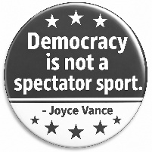
Democracy is not a spectator sport. [It] is an ongoing experiment, which means you have to prepare for it like a marathon.
Be Smart. Understand the forces that don’t have your best interests at heart will try to manipulate you. They will do it with misinformation. Our job is to resist being manipulated. We can and should develop our own information literacy programs.
Be in Community. Being in a community is part of how we survive the damage that is being done in our country. Especially if you’re frequently among people who don’t share your concerns, surround yourself with people who take what we’re facing seriously, and who can buoy your spirits.
Never Bet Against America. Refuse to believe that government doesn’t work. We elect representatives to do a job. It’s time to make demands on the people who are supposed to be representing us. Be heard.
Understand that Defending Democracy Comes in a Lot of Colors. Democracy is about the ability of individuals to act on their own views and beliefs. Different issues matter to different people. If everyone devotes their time to the issue that matters most to them, then all the work gets done.
Decide Who You Are and Stick to It. Know your personal red lines. Be prepared to make a stand for them. Once you cave in, like some law firms and universities did when Trump came to them with demands, that’s who you are.
Be the Hope. Help others get over the rough patches. We all have them. If you give up hope, there is no chance of succeeding at the end.
Take Baby Steps. It might not seem like enough, but it can be the slow, individual, person-to-person conversations that matter most. Plant seeds that might grow down the road. Believe that the work you do is important, because it is.
Exercise Your Rights. Protest works. It is quintessentially American. We have a First Amendment right to peacefully assemble and petition the government, to speak freely, to associate with whom we choose. Exercise [your rights] early and often. And take your friends along with you.
Joyce Vance, Giving Up is Unforgiveable

Registering to Vote and Voting
Ensuring that eligible voters can register and vote is one of the most fundamental contributions grassroots leaders can make. That means knowing the laws and practices followed in one’s state and being attuned to any actions that may be taken at the federal level and in the courts. The fact is, there could be state or federal action even late in the campaign that could impact voting rights and requirements.
What Grassroots Leaders Can Do. Many grassroots organizations engage in voter registration and get-out-the-vote activities. This includes action to:
- Share accurate, up-to-date information on: voter registration deadlines, identification requirements, and early and absentee voting options
- Encourage people to check their registration status regularly
- Help voters make a plan to vote (when, where, and how)
- Organize or support nonpartisan voter registration drives
- Provide transportation or logistical support where appropriate
- Connect voters with trusted assistance resources if problems arise

Anticipating Changes in Voting Laws. Voting rules can change—sometimes quickly. Grassroots leaders should:
- Avoid relying on outdated information
- Refer people to official or trusted nonpartisan sources
- Be especially attentive to changes affecting: identification requirements, mail-in voting, and registration procedures

Where to Get Help. Trusted state and national resources include:
- Election Protection (866-OUR-VOTE)
- League of Women Voters
- Vote.gov
- State and local party organizations
- Civic and legal groups specifically focused upon voting, including the American Civil Liberties Union and its state affiliates and associations of nonprofit organizations

Peaceful Assembly: Knowing and Exercising Your Rights.

The right to peaceful assembly is protected under the First Amendment. Grassroots leaders often play a key role in organizing and participating in such activities.
Core Rights include:
- The right to peacefully assemble and protest
- The right to speak and express views
- The right to associate with others
- The right to petition government for redress of grievances

Practical Guidance for Organizers and Participants. When grassroots organizations are engaging in rallies and other public events, they need to:
- Understand local permitting requirements where applicable
- Establish clear expectations for nonviolence
- Designate and train individuals responsible for communication. de-escalation, and coordination with authorities (if needed)
- Encourage participants to remain calm if confronted, avoid escalation, and follow lawful instructions.

Common sense de-escalation basics include: Do not engage aggressively with counter-protesters; Use calm language and tone; Step back from heated interactions; and Seek support from trained organizers when needed. Being prepared beforehand is important, rather than trying to figure it out in the heat of the moment.

Serving as Witnesses and Countering Intimidation. Grassroots leaders may encounter situations where individuals feel intimidated or unsafe while exercising their rights.

What you can do if this occurs is:
- Serve as a visible, calm presence
- Document incidents when safe and lawful to do so
- Support individuals who may feel targeted or intimidated
- Avoid direct confrontation when it could escalate risk
- Report serious concerns to appropriate authorities or hotlines

In terms of fights related to documentation, in general, individuals may record video in public spaces and document interactions with public officials.

At the same time, laws vary by state and recording should never interfere with law enforcement operations. When in doubt, prioritize safety over documentation. There likely are both state legal and nonprofit organizations which can provide guidance in this area, as well as national organizations such as the Brennan Center for Justice, the Southern Poverty Law Center, the Center for Constitutional Rights, and Democracy Forward.

Educating and Supporting Others. One of the most important roles grassroots leaders play is ensuring that others feel informed, confident, and safe in participating.
Grassroots Leaders can do so when they:
- Share simple, clear “know your rights” materials
- Brief participants before events or activities
- Model personal engagement that demonstrates respect
- Provide contacts for assistance if problems arise
- Encourage a culture of respect, safety. and mutual support In
In doing so, grassroots leaders also can build internal capacity through identifying members willing to serve as resource contacts, developing or adapting from others simple guides or checklists, and partnering with organizations that are providing training.

Combating Voter Misinformation and De-escalating Tension

Misinformation can discourage participation, create confusion, and increase conflict.
Misinformation about voting rights can include incorrect voting requirements , false deadlines or procedures, misleading claims about eligibility, and rumors about enforcement actions or risks (which can depress voter turnout).
Grassroots leaders can combat and correct such misinformation by sharing information only from trusted sources, correcting misinformation calmly and respectfully. avoiding amplifying false information unnecessarily and further heightening uncertainty, and encouraging others to verify before sharing.
On a personal level in conversations, de-escalation is important in all situations – around peaceful assembly and voting and around responding to any types of misinformation. As described in other chapters of this Guide, this involves the following:
- Listen first and acknowledge concerns even when the specific statements made represent misinformation
- Provide clear, factual information
- Avoid arguing or shaming
- Focus on shared values (fairness, participation, safety)
- Respectfully disengage (some people are not persuadable or willing to engage in dialogue)

Conclusion: Democracy Depends on Participation

The work of grassroots champions—to engage, inform, and persuade—depends upon a functioning democracy in which people can safely participate. Protecting that democracy is not separate from the work of relational campaigning—it is foundational to it.

Grassroots leaders do not need to be legal experts. But they do need to understand basic rights. help others access accurate information, act calmly and responsibly in challenging situations, prepare by anticipating likely issues early, and connect with trusted resources when needed.
As this guide has emphasized throughout: Relationships matter. Values matter. Small personal actions matter. This is equally true in protecting democracy itself.
While democracy has been challenged at a number of times in our country’s history, it is important to recognize that, historically, there has been bipartisan commitment to fair and impartial elections, the rule of law, and the independence of the U.S. Department of Justice and the courts from partisan influence. The insert below shows how different Presidents – Democratic and Republican – have expressed these values and tenets.

Presidential Statements on the Rule of Law and The Independence of the Justice Department
Dwight D. Eisenhower. Speech to the American Bar Association, 1958
“The clearest way to show what the rule of law means to us is to demonstrate that we ourselves respect it.”
Context: Eisenhower frequently emphasized that constitutional government requires public officials— including presidents—to be constrained by law and by respect for legal institutions.
Jimmy Carter. Remarks at the Department of Justice, 1978
“We must restore complete confidence in the integrity of our system of justice and in the independence of those who administer it.”
Context: Speaking in the aftermath of the Watergate scandal, Carter stressed rebuilding public trust in the impartial administration of justice and reaffirming the independence of federal law enforcement.
Ronald Reagan. Remarks to U.S. Attorneys, 1985
“The independence of the courts from improper political influence is a sacred principle of our system of justice.”
Context: Reagan emphasized that prosecutors and courts must uphold the law free from political interference, reinforcing the traditional norm of institutional independence.
Barack Obama. Remarks to Department of Justice employees, 2015
“I appointed you, but you don’t serve me. You serve the American people. I expect you to act with independence and integrity.”
Context: Obama used this line to underscore that Justice Department officials represent the Constitution and the public interest rather than the political priorities of the president.

These protections have been enshrined in law. One of the most powerful and frequently cited passages comes from United States v. Cruikshank, where the Supreme Court described peaceful assembly as fundamental to republican government itself:
“The very idea of a government, republican in form, implies a right on the part of its citizens to meet peaceably for consultation in respect to public affairs and to petition for a redress of grievances.” — United States v. Cruikshank, 92 U.S. 542, 552–53 (1876)
Another especially stirring defense appears in Thomas v. Collins, where Justice Rutledge emphasized how inseparable assembly is from democratic liberty:
“It was not by accident or coincidence that the rights to freedom in speech and press were coupled in a single guaranty with the rights of the people peaceably to assemble and to petition for redress of grievances. All these, though not identical, are inseparable.” — Thomas v. Collins, 323 U.S. 516 (1945)
And for protest specifically, De Jonge v. Oregon contains one of the Court’s clearest affirmations:
“The holding of meetings for peaceable political action cannot be proscribed. Those who assist in the conduct of such meetings cannot be branded as criminals on that score.” — De Jonge v. Oregon, 299 U.S. 353, 365 (1937)
The last passage is especially popular in modern organizing, protest, and civil-liberties contexts because it directly links peaceful political gathering to constitutional protection.
*****
Above all, there is a wealth of common ground on these issues. Grassroots organizing and electoral advocacy is the best line of defense in preserving democracy and the greatest opportunity for realizing our expectations for government and our elected officials.

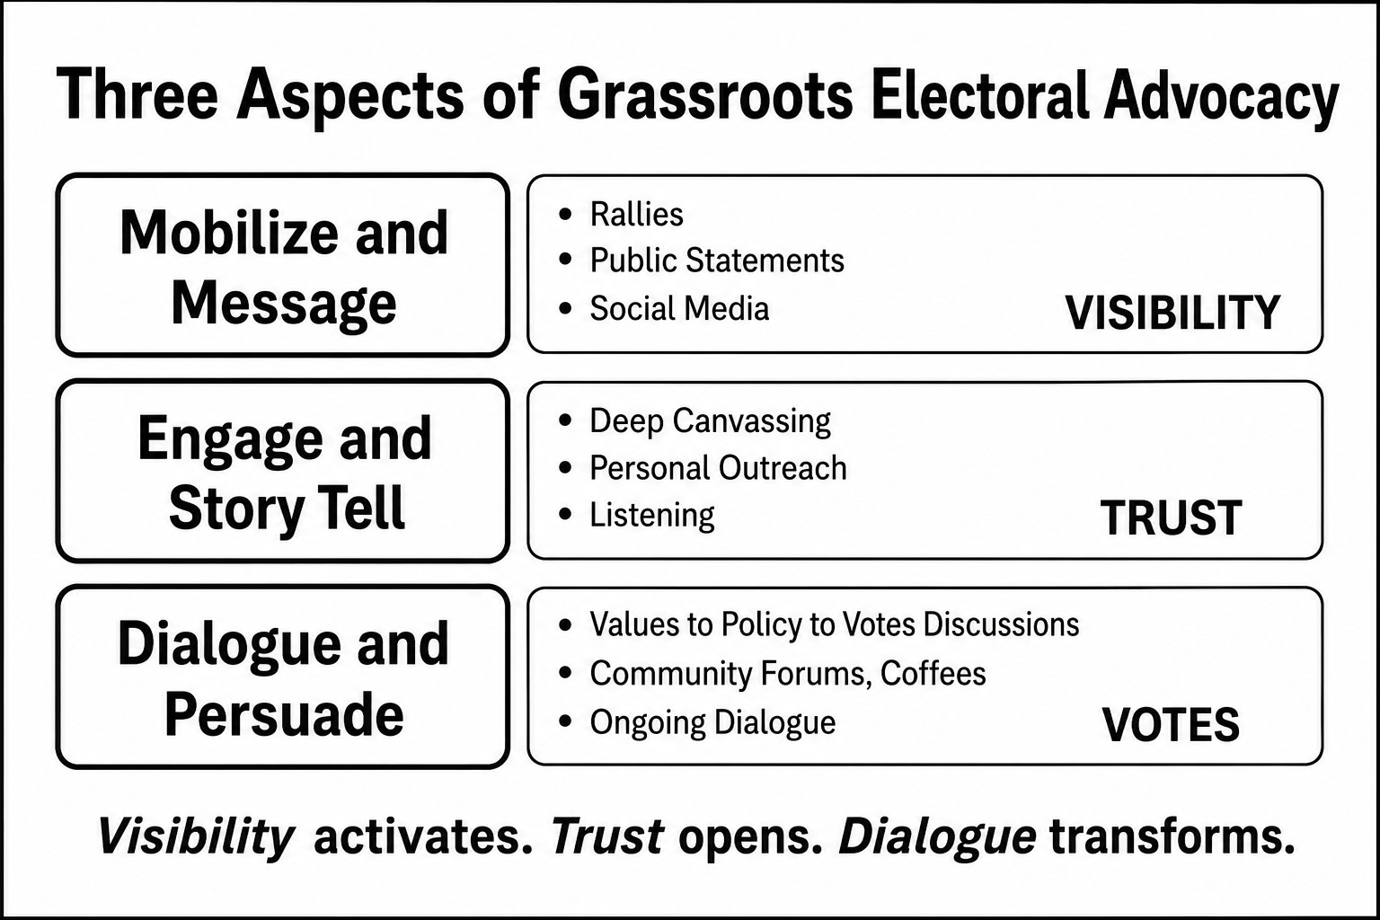

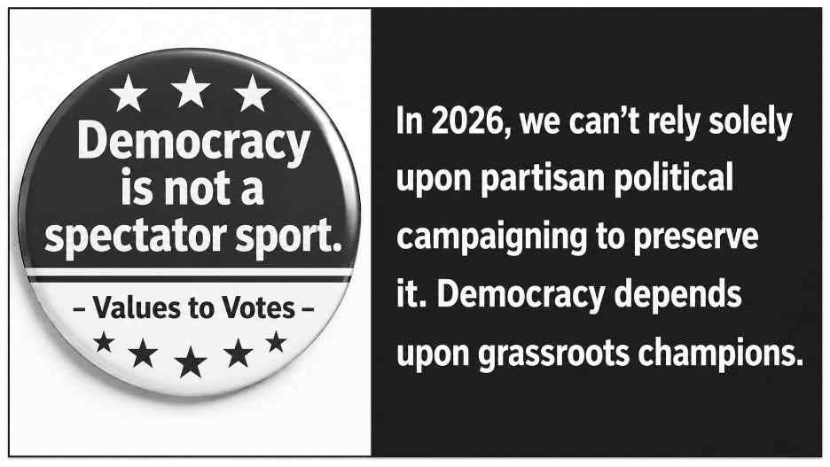

Notes

Notes

Acknowledgements
The Grassroots Iowa Network and its Values to Votes Initiative are extremely grateful to the Alliance for a Better Iowa in serving as a sponsor and financial supporter for GIN’s Big Tent Meet-Up on June 6th, 2026, where this Guide was disseminated. We also are extremely grateful to Pam and Harry Bookey for their support in publishing the Guide.
The Alliance for a Better Iowa aims to bring about civic betterments and social improvements by advocating for public policies that further social and racial justice, affordable health care, equitable taxation, quality education, a healthy climate, and other changes benefiting Iowans. The Alliance for a Better Iowa supports coordination and synergy across grassroots and state activists and fosters connections with like-minded national organizations.

For Further Information
The Grassroots Iowa Network (GIN) is an all-volunteer network working together to build a stronger network of grassroots organizations in Iowa that focus on politics, issues, and winning elections. Our objective is to showcase, enhance, and empower grassroots leaders and the organizations they establish and connect them with state and national organizations and resources doing the same. Our initial planning committee consists of Charlie Bruner, Kathy Focht, Jack Hatch, John Hedgecoth, Joe Enriquez Henry, Anne Kinzel, Mary Weaver, and Tim Winter.
This special first edition of the Guide was produced by the Values to Votes Initiative of GIN. We welcome comments and ideas for improvement or expansion for future editions. We also welcome ideas for additional materials to include on the Values to Votes website (www.valuestovotes.com). Those comments and ideas should be sent to bruner@childequity.org.

