# ER Diagrams

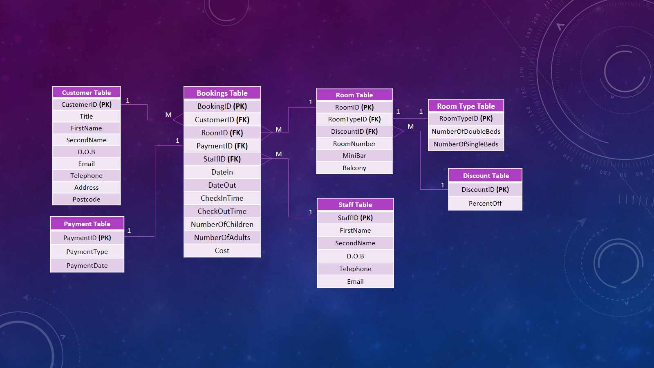

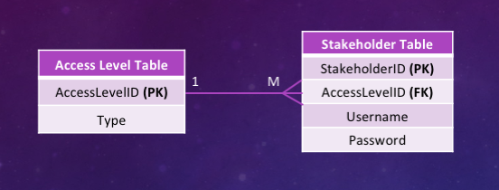

# Customer Table

|  |  |  |  |  |  |  |
| --- | --- | --- | --- | --- | --- | --- |
| **Data Item** | **Data Type** | **Data Format** | **Size for Display** | **Description** | **Example** | **Validation** |
| CustomerID **(PK)** | String | XNNNNNN | 7 | Unique Identifier for a Customer | C123456 | Is it a string? |
| Title | String | SSSSS | 5 | Name that describes someone’s position or job | MR. | Is it null? |
| FirstName | String | SSSSSSSSSSSSSSSSSSSSSSSSS | 25 | The first name of customer | John | Is it in title case? |
| SecondName | String | SSSSSSSSSSSSSSSSSSSSSSSSS | 25 | The second name of customer | Smith | Is it in title case? |
| D.O.B | Date | DD/MM/YYYY | 10 | Date of birth | 23/06/1980 | Format check: in the format dd/mm/yyyy? |
| Email | String | SSSSSSSSSSSSSSSSSSSSSSSSS  SSSSSSSSSSSSSSSSSSSSSSSSS | 50 | Customer’s personal email address | [John.smith@email.com](mailto:John.smith@email.com) | Is it null? |
| Telephone | String | SSSSSSSSSSSSSSS | 15 | Customer’s preferred telephone number | 07123456789 | Is it **NOT** alphanumeric? |
| HouseNumber | Integer | NNNNNN | 6 | Number of Residency | 2503 | Is it numeric? |
| Street | String | SSSSSSSSSSSSSSSSSSSS SSSSSSSSSS | 30 | Street Address | Lincoln Street | Is it a string? |
| TownCity | String | SSSSSSSSSSSSSSSSSSSS | 20 | Town or City | Newtownabbey | Is it within the range of 0 to 20 characters? |
| Postcode | String | SSSSSSSS | 8 | Postal address | BT359AD | Is it alphanumeric? |

# Payment Table

|  |  |  |  |  |  |  |
| --- | --- | --- | --- | --- | --- | --- |
| **Data Item** | **Data Type** | **Data Format** | **Size for Display** | **Description** | **Example** | **Validation** |
| PaymentID **(PK)** | String | XNNNNNN | 7 | Unique Identifier for a Payment | P123456 | Is it a string? |
| PaymentType | String | SSSSSSSSSS | 10 | Method of payment | Card | Is it null? |
| PaymentDate | Date | DD/MM/YYYY | 10 | Date of Payment | 16/10/2018 | Format check: in the format dd/mm/yyyy? |

# Discount Table

|  |  |  |  |  |  |  |
| --- | --- | --- | --- | --- | --- | --- |
| **Data Item** | **Data Type** | **Data Format** | **Size for Display** | **Description** | **Example** | **Validation** |
| DiscountID **(PK)** | String | XNNNNNN | 7 | Unique Identifier for a Discount | D123456 | Is it a string? |
| PercentOff | String | SSS% | 4 | Percent of discount off | 10% | Is it in the format of SSS%? |

# Staff Table

|  |  |  |  |  |  |  |
| --- | --- | --- | --- | --- | --- | --- |
| **Data Item** | **Data Type** | **Data Format** | **Size for Display** | **Description** | **Example** | **Validation** |
| StaffID **(PK)** | String | XNNNNNN | 7 | Unique Identifier for a Staff member | S123456 | Is it a string? |
| FirstName | String | SSSSSSSSSSSSSSSSSSSSSSSSS | 25 | The first name of customer | John | Is it in title case? |
| SecondName | String | SSSSSSSSSSSSSSSSSSSSSSSSS | 25 | The second name of customer | Smith | Is it in title case? |
| D.O.B | Date | DD/MM/YYYY | 10 | Date of birth | 23/06/1980 | Format check: in the format dd/mm/yyyy? |
| Email | String | SSSSSSSSSSSSSSSSSSSSSSSSS  SSSSSSSSSSSSSSSSSSSSSSSSS | 50 | Customer’s personal email address | [John.smith@email.com](mailto:John.smith@email.com) | Is it null? |
| Telephone | String | SSSSSSSSSSSSSSS | 15 | Customer’s preferred telephone number | 07123456789 | Is it **NOT** alphanumeric? |

# Room Type Table

|  |  |  |  |  |  |  |
| --- | --- | --- | --- | --- | --- | --- |
| **Data Item** | **Data Type** | **Data Format** | **Size for Display** | **Description** | **Example** | **Validation** |
| RoomTypeID **(PK)** | String | XNNNNNN | 7 | Unique Identifier for a Room Type | T123456 | Is it a string? |
| NumberOfSingleBeds | Integer | NN | 2 | The number of single beds in the room | 2 | Is it > 0? |
| NumberOfDoubleBeds | Integer | NN | 2 | The number of double beds in the room | 1 | Is it <= 3? |

# Room Table

|  |  |  |  |  |  |  |
| --- | --- | --- | --- | --- | --- | --- |
| **Data Item** | **Data Type** | **Data Format** | **Size for Display** | **Description** | **Example** | **Validation** |
| RoomID **(PK)** | String | XNNNNNN | 7 | Unique Identifier for a Room | R123456 | Is it a string? |
| RoomTypeID **(PK)** | String | XNNNNNN | 7 | Unique Identifier for a Room Type | T123456 | Is it a string? |
| RoomNumber | Integer | NNNN | 4 | The number of the room | 430 | Is it an integer? |
| MiniBar | Boolean | X | 1 | Minibar availability in room | T | Length check:  Is it == 1? |
| Balcony | Boolean | X | 1 | Balcony availability in room | T | Length check:  Is it == 1? |
| Rate | Float | £MMMM.MM | 8 | Rate of the Room | £123.45 | Is it a float value? |

# Booking Table

|  |  |  |  |  |  |  |
| --- | --- | --- | --- | --- | --- | --- |
| **Data Item** | **Data Type** | **Data Format** | **Size for Display** | **Description** | **Example** | **Validation** |
| BookingID **(PK)** | String | XNNNNNN | 7 | Unique Identifier for a Booking | B123456 | Is it a string? |
| CustomerID **(FK)** | String | XNNNNNN | 7 | Unique Identifier for a Customer | C123456 | Is it a string? |
| RoomID **(FK)** | String | XNNNNNN | 7 | Unique Identifier for a Room | R123456 | Is it a string? |
| PaymentID **(FK)** | String | XNNNNNN | 7 | Unique Identifier for a Payment | P123456 | Is it a string? |
| StaffID **(FK)** | String | XNNNNNN | 7 | Unique Identifier for a Staff member | S123456 | Is it a string? |
| DiscountID **(PK)** | String | XNNNNNN | 7 | Unique Identifier for a Discount | D123456 | Is it a string? |
| DateIn | Date | DD/MM/YYYY | 10 | Date of check-in | 12/12/2018 | Format check: in the format dd/mm/yyyy? |
| DateOut | Date | DD/MM/YYYY | 10 | Date of check-out | 30/12/2018 | Format check: in the format dd/mm/yyyy? |
| CheckInTime | DateTime | HH:MM | 5 | Time of check-in | 10:15 | Format check: in the format HH:MM? |
| CheckOutTime | DateTime | HH:MM | 5 | Time of check-out | 15:30 | Format check: in the format HH:MM? |
| NumberOfChildren | Integer | NN | 2 | Number of Children | 3 | Is it an integer? |
| NumberOfAdults | Integer | NN | 2 | Number of adults | 2 | Is it an integer? |
| Cost | Float | £MMMM.MM | 8 | Room rate + additional costs (damages, or extras) | £500.55 | Is it a float number with two decimal places? |

# Access Level Table

|  |  |  |  |  |  |  |
| --- | --- | --- | --- | --- | --- | --- |
| **Data Item** | **Data Type** | **Data Format** | **Size for Display** | **Description** | **Example** | **Validation** |
| AccessLevelID **(PK)** | String | XNNNNNN | 7 | Unique Identifier for an Access Level | A123456 | Is it a string? |
| Type | Integer | N | 1 | Number indicating access level | 2 | Is it an integer? |

# Stakeholder Table

|  |  |  |  |  |  |  |
| --- | --- | --- | --- | --- | --- | --- |
| **Data Item** | **Data Type** | **Data Format** | **Size for Display** | **Description** | **Example** | **Validation** |
| StakeholderID **(PK)** | String | XNNNNNN | 7 | Unique Identifier for a Stakeholder | H123456 | Is it a string? |
| AccessLevelID **(FK)** | String | XNNNNNN | 7 | Unique Identifier for an Access Level | A123456 | Is it a string? |
| Username | String | Firstname + ‘.’ + Lastname | 40 | Username of stakeholder | john.smith | Is it hashed? |
| Password | String | SSSSSSSSSSSSSSSSSSSS SSSSSSSSSSSSSSSSSSSS | 40 | Password of stakeholder | Apples_are_nice1 | Is it hashed? |