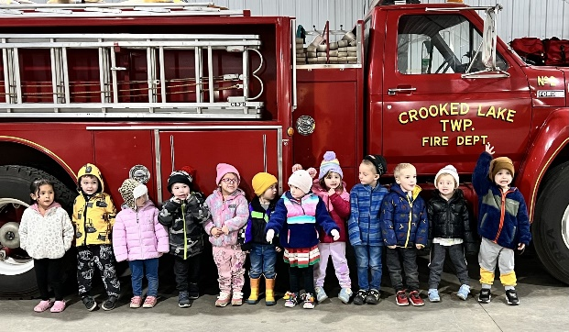

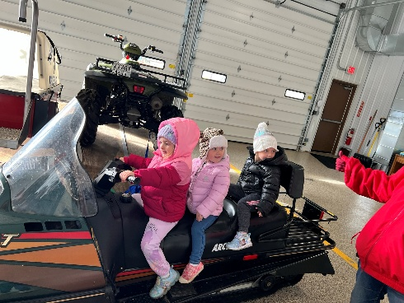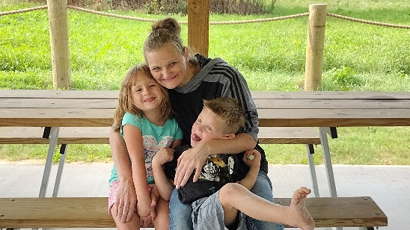

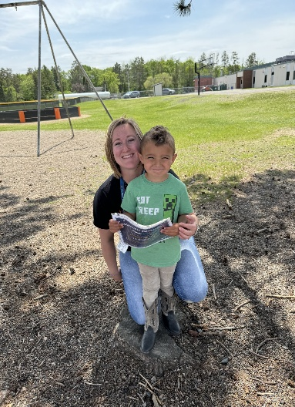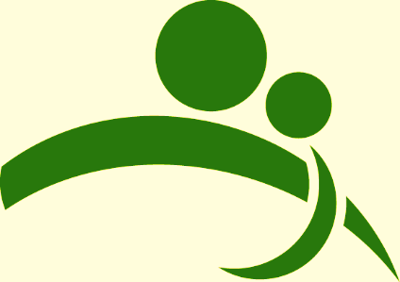

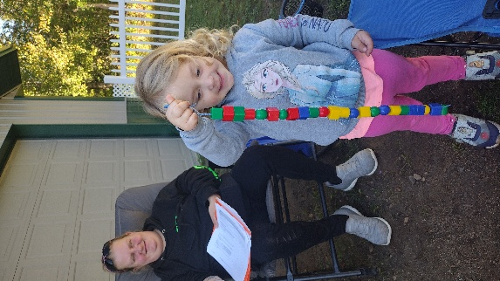

**Northland Area Family Center**

**Annual Report**

**2024**

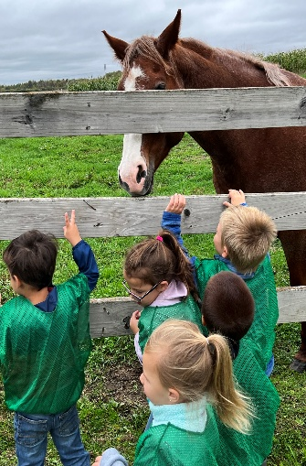

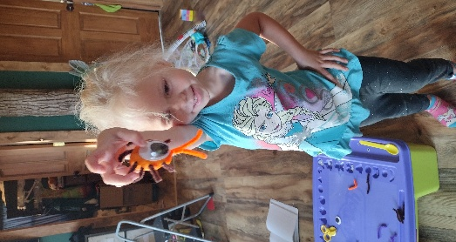

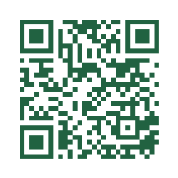

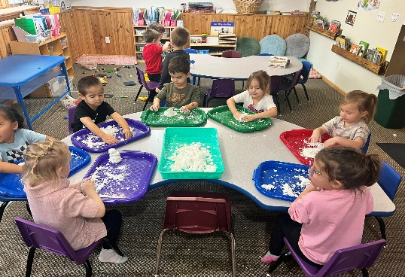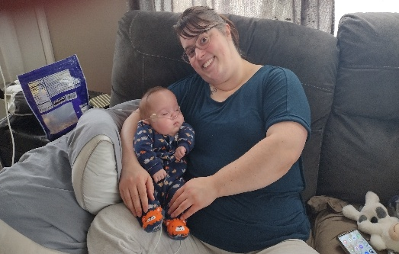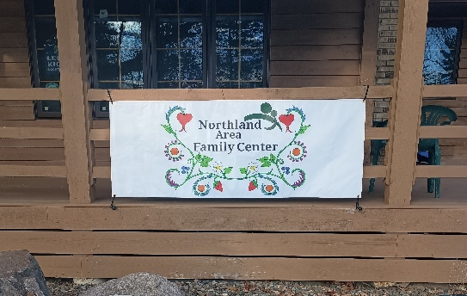

**Mission: “With compassion and respect, we provide education, mentoring, and support services that build strong individuals and families in the Northland Community.”**

**Vision: “We empower Northland Families to realize their full potential, enrich their lives and shape their future.”**

**We Value: “All People, Education, Partnerships and Community”**

Northland Area Family Center is an independent non-profit agency physically located in Remer, Minnesota serving residents living in the entire Northland School District. Begun by a group of concerned citizens whose goal was to support families in our area by making them more resilient, the Family Center has continued to serve area residents through the collaborative efforts of public and private agencies, community members and Northland Community Schools. The Family Center continues to reach out to the community by developing programs that build on the strengths of all participants.

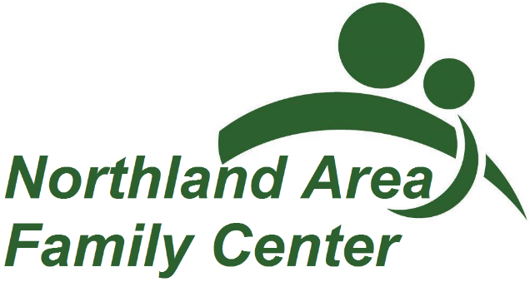

We would like to take this opportunity to thank those who have partnered with us on our work during 2024. The board of Directors continues to be instrumental in leading our organization. We appreciate the gifts of money, talents and volunteer hours in helping us provide education, mentoring and support services that build strong individuals and families in the Northland community. Volunteers provided 70 service hours.

If you would like to learn more, check out our website:

www.northlandfamilycenter.org

Leslie Bouchonville, Executive Director

218-566-3636

director@northlandfamilycenter.org

*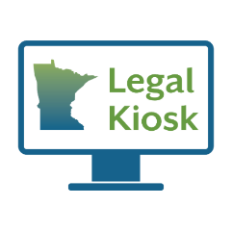****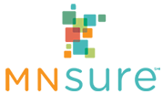********Family Support***

**During 1642 open hours we:**

* Made 161 total connections.
  + - * Assisted 23 neighbors with MNSure applications or questions.
      * Provided 6 neighbors access to the legal kiosk.

*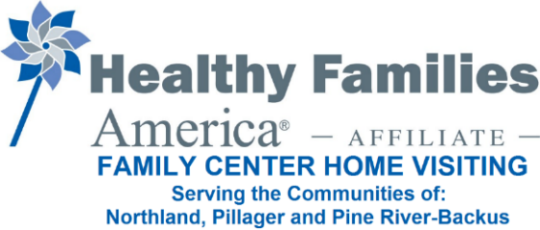****Family Center Home Visiting***

**Program Goals:** Build and sustain community partnerships to engage overburdened families in home visiting services prenatally or at birth, cultivate and strengthen nurturing parent-child relationships, promote healthy childhood development and growth, and enhance healthy family functioning by reducing risk and building protective factors.

* Northland Center staff completed 202 visits during 2024 with 9 families and 10 target children.
* The program is guided by an Advisory Board, that meets quarterly.
* Retention rates are high for the families currently involved.

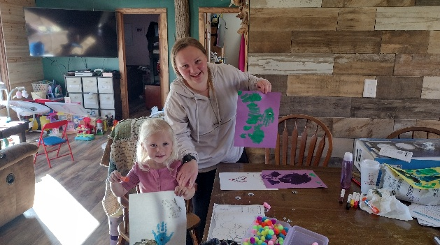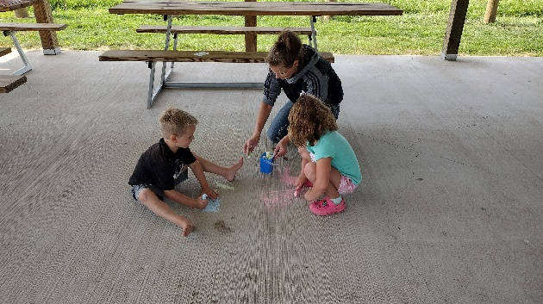

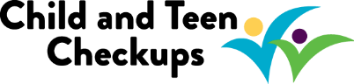

***Child and Teen Check Ups (C&TC) Outreach***

**Outreach efforts**

* **Mailed health checkup reminder letters to families in the Northland school district who are on Medical Assistance.

***Toys For Kids***

The Family Center collaborates with volunteers to help area children have a brighter holiday. The Family Center served as the fiscal host for donations. Volunteers coordinated the program and distributed the gifts to families before the Holidays. This program is exclusively donation-funded.

* In 2024 we served 52 Families – 136 children.

*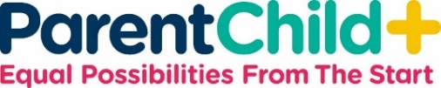****ParentChild+***

**Parent Child+, is a program of Northland Area Family Center and Jewish Family and Children's Service of Minneapolis. Early Learning Specialists meet with families twice weekly with carefully selected toys, books, and activities to work with parents/caregivers and children to support not only early literacy and school readiness, but also early opportunities. Our service area covers the Northland and Pine River/Backus school districts.**

* In 2024, we completed 961 visits with 33 families.
* In May of 2024, seven children graduated from the two-year program that runs from September through May.

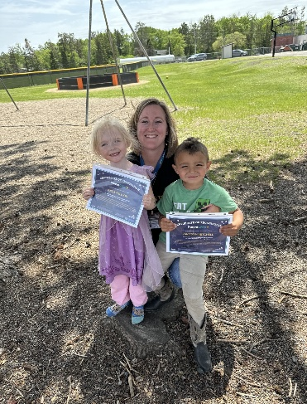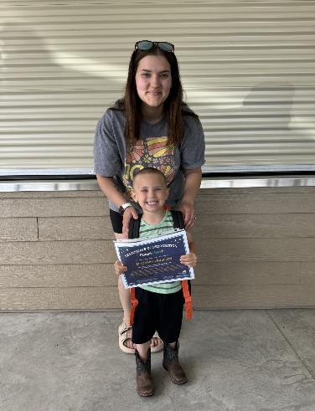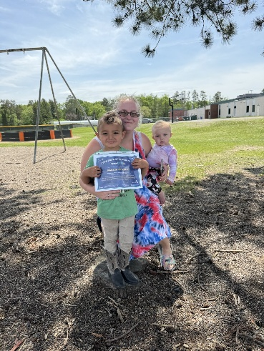

***Family Center Preschool***

As part of the Northland Early Childhood Collaborative, the Family Center Preschool provides a center-based program for 3-year-olds in the Northland community. Our mission is to have all children ready to learn as they enter kindergarten and be successful learners throughout their educational year- regardless of any perceived or real barriers such as economic-status, culture, or level of ability or disability.

* In 2024, we had 14 preschool students.

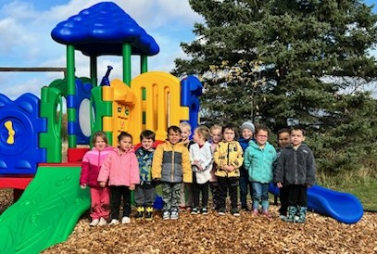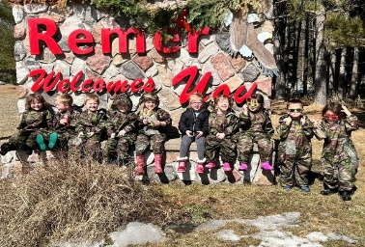

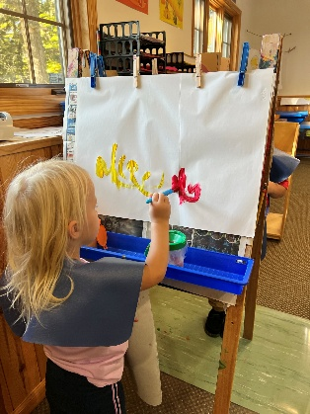

***Diaper Hub***

Since April of 2024, the Northland Area Family Center has partnered with the Diaper Bank of Minnesota. Our goal is to provide diapers to Northland area families in need, increase awareness about diaper need in Minnesota, and advocate for changes to improve conditions for babies who need diapers. The Family Center acts as main storage, coordination, tracking, reporting, ordering, and also provides diapers directly to any child or family in need.

In it’s 3 quarters of 2024 operations we:

* Partnered with 12 agencies, with 17 points of dissemination.
* Dispersed diapers, pullups and wipes across 7 counties with points of dissemination in 11 counties.
* Dispersed 30,447 Diapers and pullups (25,398 diapers and 5159 pullups).
* Dispersed 1247 packages of wipes (99,773 individual wipes).
* Served 1309 families, 1752 children (repeat families and children)

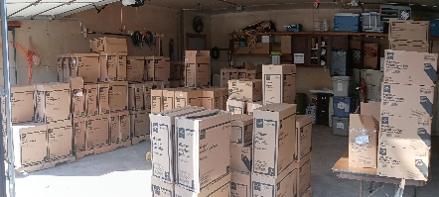

***Financial***

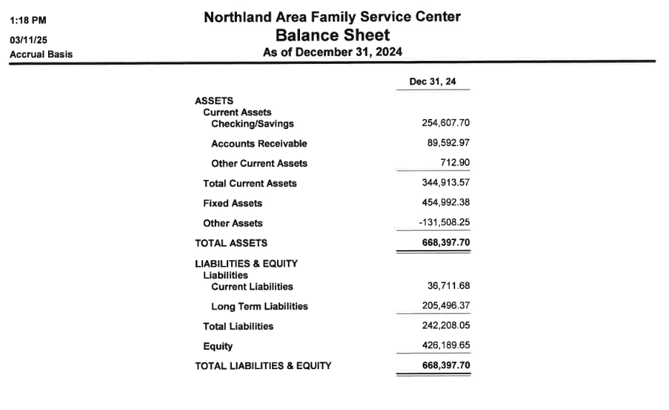

***About us- who and where we are:***

**Family Center Board Members**

*Officers:*

Chair: Heidi Holz

Board of Director: Marlyn Holman

Vice Chair: Kit Arnquist

Financial Officer: Cheryl Desoto

Secretary: Faye Zorman

**Staff**

*Executive Director:*

Leslie Bouchonville

*Home Visiting:*

Lee Anne Bettenberg

Renee Bettenberg

Ashley Hesse

*Preschool:*

Stacey Barrick

Randi Robison

Courtney Heide

*Administrative Manager/Program Support:*

Linda Leverty/Angela Zwart

**Our Service Area**

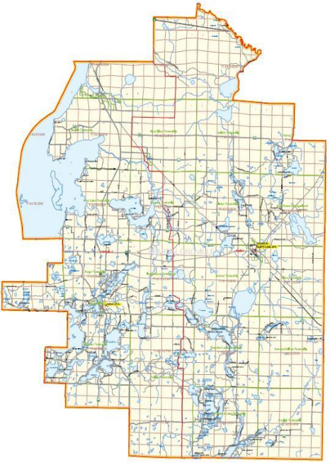

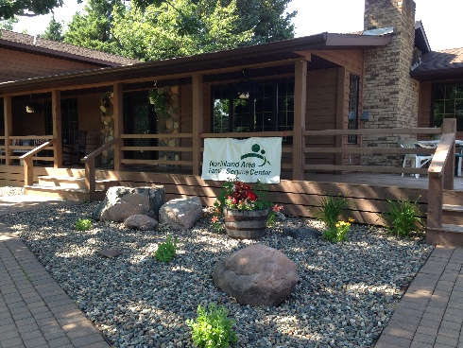

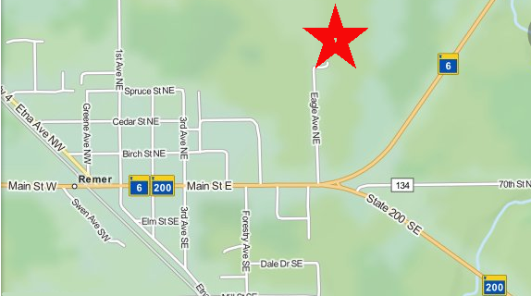

***Our location***

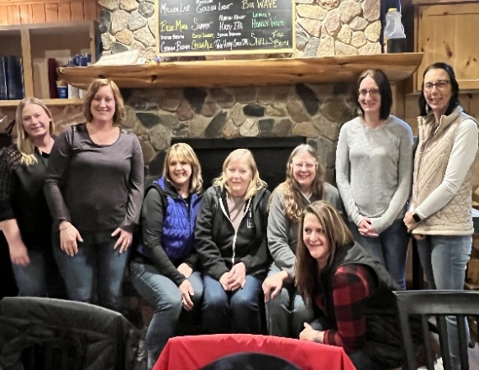

Phone: 218-566-3636

Fax: 218-566-1303

320 Eagle Ave NE,

PO Box 304,

Remer MN 56672