**LATITUDE RACING CLUB MEMBERSHIP APPLICATION www.latituderacing.com**

Latitude Racing is a nonprofit corporation dedicated to the sport of cycling to keep our community moving and to provide our youth with the experience of riding a bike in a safe and supported community. We are here to support where YOU want to be in your cycling journey. The club is for riders at any age, and experience and for all. We provide options for those who want to learn, grow or challenge themselves competitively. Educating our riders and providing the best support possible is what we aim to do. We will provide a women’s ride weekly with various levels for you to enjoy. Latitude will also have a club/team ride one day a week. Our club also has a Little Riders Ride for youth 7-13 YOA every other week. Please feel free to join our weekly rides. We also conduct monthly meetings so be sure to sit in and join those sessions. If you would like to be a member of our board or would like to get involved in our organization, please let us know how you would like to help. All club members/racers/participants MUST wear a helmet during any club rides/events.

**GENERAL INFORMATION (ENTER NAME, DATE AND ONLY INFO CHANGED FROM PRIOR YEARS)** Date:____/____/__________ Name:______________________________________________________ Gender: ______Birthday:__ __/____/_____ Street:__________________________________________City:_____________________ST:___ ZIP:________-_____ Home Phone:(______)________________ Work:(______)___________________ Mobile:(______)________________ Email (print legibly!):_________________________________________________________________________________ Emergency Contact (name):______________________________________

Emergency Phone:(_____)______________

**MEMBERSHIP DUES:** Valid for one year from the date of sign-up. (Check one and attach the correct dues amount.) Fees will be waived for any Junior Rider participating on our race team.

Single Member $40.00 _____

Family Membership $50.00_____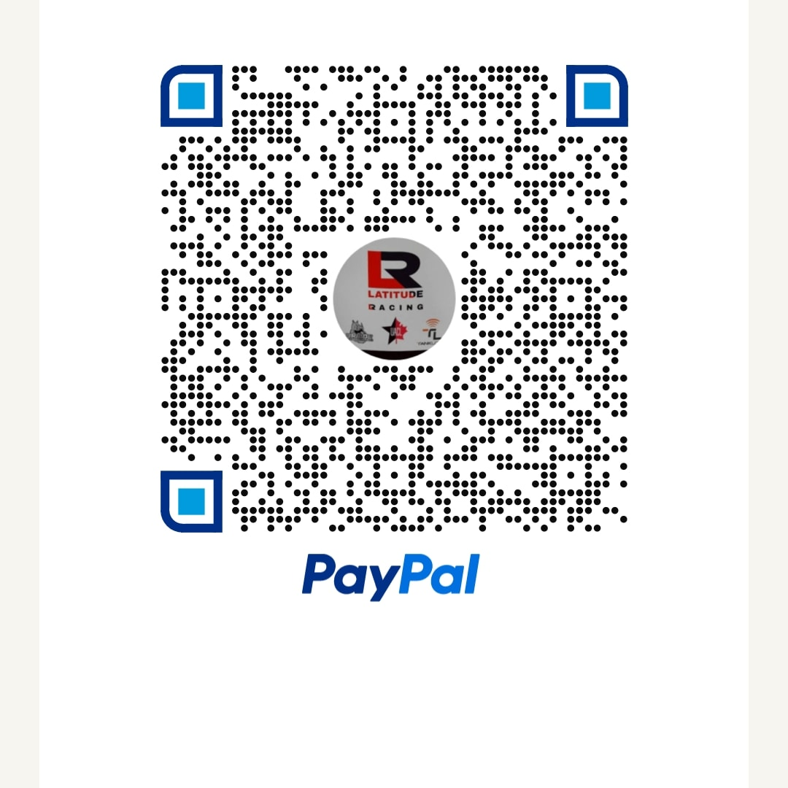

**MEMBER PROFILE:** (optional)

Riding Interests: ROAD__ TRACK__ CROSS__ GRAVEL__ RD__ TRK__ MTN__TRI__

* What year did you start riding? ________
* How many miles do you average each week? _______________
* Can you help organize or help during our races or other fundraising events? YES NO
* Would you like to volunteer in other Club duties: Monthly? YES NO Occasionally Other _____________
* What could the Club do to increase membership participation, increase revenues, attract new members, etc.? _______________________________________________________

RELEASE AGREEMENT PLEASE READ CAREFULLY AND SIGN. I ACKNOWLEDGE THAT BY SIGNING THIS MEMBERSHIP APPLICATION I AM RELEASING LATITUDE RACING CLUB ("CLUB,") ITS RESPECTIVE AGENTS, OFFICERS, MEMBERS, VOLUNTEERS, SPONSORS AND ADVERTISERS AND ANY SPONSORS, ORGANIZERS, PROMOTING ORGANIZATIONS, PROPERTY OWNERS, LAW ENFORCEMENT AGENCIES, PUBLIC ENTITIES, SPECIAL DISTRICTS AND PROPERTIES, AND THEIR RESPECTIVE AGENTS, OFFICIALS, AND EMPLOYEES which are in any way associated with any Club promoted or co-promoted, recreational or competitive cycling event (COLLECTIVELY "RELEASEES") FROM LIABILITY. THIS APPLICATION AND RELEASE IS A CONTRACT WITH LEGAL CONSEQUENCES. I HAVE BEEN ADVISED TO READ IT CAREFULLY BEFORE SIGNING. In consideration of the Releasee's issuance of membership to me I hereby freely agree to and make the following contractual representations and agreements: I acknowledge that cycling is an inherently dangerous sport and fully realize the dangers of participating in recreational, performance, and/or competitive cycling (collectively "Cycling") and FULLY ASSUME THE RISKS ASSOCIATED WITH SUCH PARTICIPATION INCLUDING, by way of example, and not limitation, the following: the dangers of collision with pedestrians, vehicles, other cyclists and fixed or moving objects; the dangers arising from surface hazards, equipment failure, inadequate safety equipment, THE RELEASEES' OWN NEGLIGENCE OR GROSS NEGLIGENCE and weather conditions; and the possibility of serious physical and/or mental trauma or injury associated with the sport of Cycling. For myself, my heirs, executors, administrators, legal representatives, assignees, and successors in interest (collectively "Successors") I HEREBY PROMISE NOT TO (continued on back) SUE THE RELEASEES FOR, AND HEREBY WAIVE, RELEASE, DISCHARGE, HOLD HARMLESS AND PROMISE TO INDEMNIFY THE RELEASEES FROM ANY AND ALL RIGHTS, CLAIMS OR CAUSES OF ACTION which I have or which may hereafter accrue to me or to my Successors for any and all damages which may be sustained by me directly or indirectly in connection with, or arising out of, my participation in or association with any Club promoted or co-promoted, recreational or competitive Cycling event (collectively "event"), INCLUDING BUT NOT LIMITED TO, ANY CLAIMS WHICH I MAY HAVE OR WHICH MAY HEREAFTER ACCRUE TO ME OR TO MY SUCCESSORS AGAINST ANY OF THE RELEASEES ARISING EITHER DIRECTLY OR INDIRECTLY FROM ANY OF THE RELEASEES' OWN NEGLIGENCE OR GROSS NEGLIGENCE; ALL SUCH CLAIMS ARE HEREBY WAIVED, RELEASED AND DISCHARGED BY ME. I understand and agree that situations may arise during an event that may be beyond the immediate control of the Releases and I must continually participate so as to neither endanger myself nor others. I accept responsibility for the condition and adequacy of my own Cycling equipment. I will at all times while riding properly wear a helmet that satisfies the requirements of the ANSI Snell regulations that can reduce the risk of serious head injury and I assume all responsibility and liability for the selection of such a helmet. I have no physical or mental condition which to my knowledge would endanger myself or others if I participate in an event or would interfere with my ability to participate in such events. I agree for myself and my Successors that the above representations are contractually binding and are not mere recitals and that should I or my Successors assert any claim in contravention of this agreement the asserting party shall be liable for the expenses (including legal fees) incurred by the other party or parties in defending such claim. This agreement may not be modified orally and a waiver of any provision shall not be construed as a modification of any other provision herein or as a consent to any other provision herein or as a consent to any subsequent waiver or modification.

Member Signature: ___________________________________________________

Date: ___________________

Total Paid:________________

CONSENT AND RELEASE OF PARENT OR GUARDIAN PLEASE READ CAREFULLY AND SIGN. I am the parent or guardian of __________________________________________ ("Child.") My Child is fit for Cycling and I consent to my Child's membership in Latitude Racing Club. I HAVE READ AND I UNDERSTAND THE CLUB'S MEMBERSHIP APPLICATION AND RELEASE AGREEMENT. In consideration of allowing my Child to join the Club, I consent to it and agree that ITS TERMS SHALL LIKEWISE BIND ME, MY CHILD, my heirs, legal representatives and assignees. I HEREBY RELEASE AND SHALL DEFEND, INDEMNIFY AND HOLD HARMLESS THE RELEASEES FROM EVERY CLAIM AND LIABILITY that I or my Child may allege against the Releases (including legal fees) as a direct or indirect result of injury to me or my Child because of my Child's membership in the Club or arising directly or indirectly out of my child's participation in or association with any Club promoted or co-promoted, recreational or competitive cycling event, WHETHER CAUSED BY THE NEGLIGENCE OR GROSS NEGLIGENCE OF THE RELEASEES or others. I PROMISE NOT TO SUE RELEASEES on my behalf or on behalf of my Child regarding any claim arising from my Child's membership in the Club.

Parent/Guardian Signature: _____________________________________________

Date: ___________________

You may email or mail the release form to (Please do not mail cash):

Latitude Racing

612 Veteran Airpark LN

P.O.Box 50967

Midland, Tx 79710