Mass Times This Week

Monday 10.00am Eucharistic Prayer Service
Tuesday - Friday 10.00am Mass
Wednesday 7.00pm Novena Service
Saturday 5.00pm Vigil
Sunday 11.00am Mass

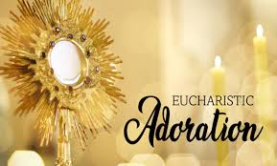
Adoration of The Blessed Sacrament will take place after 10.00am Mass on Wednesday & Friday


Sunday evenings from 6.00-7.30pm, a time of intercession for vocations, with a special hour of prayer and reflection. Adoration of the Blessed Sacrament throughout. All are very welcome.
St Michael the Archangel Parish Bulletin
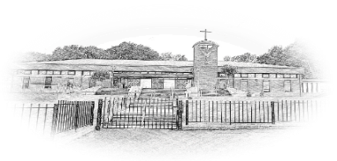
25th May 2026
Pentecost Sunday
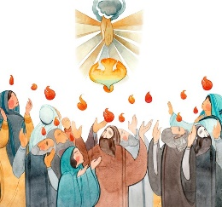
Parish Contact Options
CALL 02895 904304 To connect
and choose the option for the assistance you require
PARISH OFFICE Option 1
IN THE CASE OF A SICK CALL Option 2
FUNERAL ARRANGEMENTS Option 3
MASS TIMES AND INFORMATION Option 4
FOR FATHER CIARAN FEENEY Option 5
The Parish Office will be open Monday – Thursday 9.30am -12.00pm

In the event of an emergency please call the Vicariate Mobile on 07549209775
Webcam: Churchmedia.tv or saintmichaelthearchangel.godaddysites.com
Facebook Saint Michael the Archangel Parish
Twitter/X @St-MichaelArch
Email: stmichaels@downandconnor.org

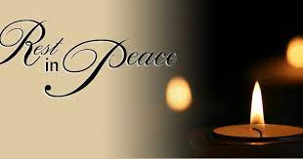

We pray for all our deceased relatives and friends and for those whose anniversaries occur at this time.

Anniversaries: Philip Doyle, Jim Feeney, Rita Roper, Eugene & Mary Boyle, Liam Hamill, Owen Doyle, Maura & Denis Wood, Florence Rafferty, Jacqueline Angelone

Months mind: Kieran Osborne (Spain)

Recently Deceased: Maureen McShane, Marek Kazmierczak

You can book an anniversary Mass or give an anniversary intention for this section of the bulletin by calling or e-mailing the parish office 02895 904304 (Option 1)
Email: stmichaels@downandconnor.org

The Offertory Collection for the 17th May amounted to £2009.20,Education of Diocesan Students £607.10
Thank you
TO MAKE A DONATION TO THE PARISH PLEASE VISIT OUR WEBSITE
stmichaelsbelfast.co.uk and click on the
DONATE BUTTON
Thank you for your continuous support and generosity

☘️ Walk in the footsteps of our Patron Saint on Saint Patrick's Way Pilgrim Walk in Downpatrick with pilgrim guides Martina Purdy and Elaine Kelly on Sat 6 June and 8 August, and Mairead Sweeney on Sat 4 July, begin at Saint Patricks Centre with the fabulous 180° IMAX film of St Patrick, price includes entrance fees, internal bus transfers, pilgrimage lunch at the famous Saul Barn, plus a stamped Camino passport and a 6 mile pilgrimage walk finishing at Saint Patrick’s grave. Come and Be Amazed! (Duration 9am-approx 3pm, all for just £55) To book ring 02844 619000 or go to website www.saintpatrickcentre.com
Divine Inspiration 
You are invited to share their memories of St Michael's parish which is turning 50 this year. We hope to publish the best of them in our parish commemorative magazine. Also if anyone has any memories of the pilgrimage to the Holy Land - and photographs. Parishioners are also invited to say in 100 words or less what their faith means to them. We will endeavour to publish them! Please email or write to martinapurdy1@gmail.com or leave a hand written note with personal details for Martina's attention in the parish office.
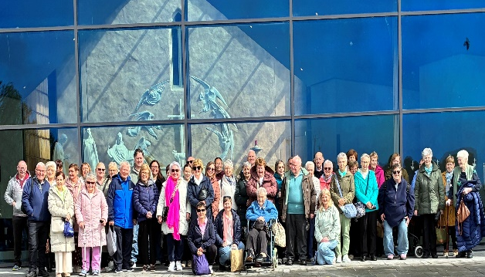
Our Parishes’ pilgrimage to Knock Shrine was very special and prayerful. We remembered everyone who supported the pilgrimage in any way, especially those who entrusted petitions to us. All petitions were brought before Our Lady at Knock and remembered throughout our Masses and prayers. We pray that Our Lady of Knock will continue to watch over all our parishioners and families with her loving care☘️

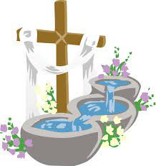 This week we welcome into God’s family Primrose Pollock



Cemetery Sunday Dates
Sunday 31st May – St Joseph’s
Sunday 7th June – St Peter’s The Rock
Sunday 14th June – Tullyrusk

St Michael’s Prayer Group

meet in the Parish Centre Sunday evenings after the Holy Hour. All are very welcome.



Congratulations to all our winners this month!

Parish Draw for May 2026

1st Prize £500.00 Michael Penney

2nd Prize £100.00 Susan Gannon

3rd Prize £100.00 Mairead O’Neill

4th Prize £100.00 Elizabeth Crossey

5th Prize £100.00 John McCrea

Promoters Prize £50.00 Anne Duffy

Thank you to all who contribute to the parish draw.



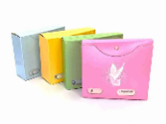
2026/27 Offertory Envelopes
If you have not received a box of envelopes for the current tax year and would like a box, please contact Catherine in the parish office or complete one of the forms in the porches after Mass and pop it in the wooden box at the Altar.
Thank you.

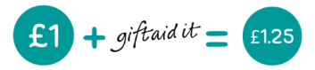
Making your donations go further with no extra cost to you!
Did you know you can GIFT AID your collections to the Parish? Donating through Gift Aid means we can claim an extra 25p for every £1 you give. It will not cost you any extra. If you pay tax, even a tiny amount on a small pension, we can claim an extra 25p in each £1 you donate to St Michael’s Parish.

Interested in hearing more? Call in or give us a call.

If you already contribute through the envelope system or by standing order and are a tax payer who would like to gift aid your donations please complete one of the gift aid declarations and return to the office

Down & Connor Pilgrimage to Lourdes 2026
8th/9th – 14th/15th July. 5 & 7 Night options available. Please visit www.downandconnor.org/lourdes for more information or call the Pilgrimage Office on (028) 9077 0162 or email lourdes@downandconnor.org Youth Team (10-17th July): applications now open (see website for details) Application for the Youth Team is online only: The link for application form is https://forms.office.com/e/0P2U1Ku3c8

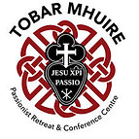

Tobar Mhuire retreat Centre Crossgar
1 Day Retreat
Saturday 6th June 2026
10.00am – 4.00pm
Husband and wife Eamonn and Tina have organised a 1-day retreat at Tobar Mhuire, Crossgar on June 6th which will be guided by Fr John Verghese, who is one of The Passionist priests there. All are welcome!

BLACK MOUNTAIN FAMILY OF PARISHES
Invites you to a three-day Pilgrimage to the Shrines of St Brigid & St Oliver Plunkett on 9th, 10th, & 11th June, staying at the Ballymascanlon Hotel.
Single Room £380, Double Room £450, Twin Room £530.
Price includes bed, breakfast and 2 evening 3 course meals. Transport also included.
The Pilgrimage will be a time of Mass, prayer and fellowship as we journey together in faith and step away from the busyness of life. All are most welcome.

