Mass Times This Week

Monday 10.00am Eucharistic Prayer Service
Tuesday - Friday 10.00am Mass
Wednesday 7.00pm Novena Mass
Saturday 5.00pm Vigil
Sunday 11.00am Mass

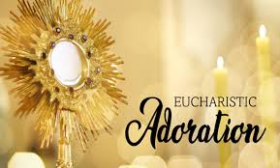
Adoration of The Blessed Sacrament will take place after 10.00am Mass on Wednesday & Friday


Sunday evenings from 6.00-7.30pm, a time of intercession for vocations, with a special hour of prayer and reflection. Adoration of the Blessed Sacrament throughout. All are very welcome.
St Michael the Archangel Parish Bulletin
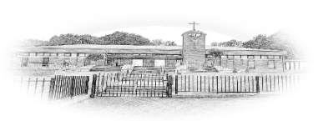

14th June 2026
Eleventh Sunday In Ordinary Time
Sunday Cycle A Psalter Week 3
Parish Contact Options
CALL 02895 904304 To connect
and choose the option for the assistance you require
PARISH OFFICE Option 1
IN THE CASE OF A SICK CALL Option 2
FUNERAL ARRANGEMENTS Option 3
MASS TIMES AND INFORMATION Option 4
FOR FATHER CIARAN FEENEY Option 5
The Parish Office will be open Monday – Thursday 9.30am -12.00pm
In the event of an emergency please call the Vicariate Mobile on 07549209775
Webcam: Churchmedia.tv or saintmichaelthearchangel.godaddysites.com
Facebook Saint Michael the Archangel Parish
Twitter/X @St-MichaelArch
Email: stmichaels@downandconnor.org

St Michael’s Prayer Group

meet in the Parish Centre Sunday evenings after the Holy Hour. All are very welcome.



We pray for all our deceased relatives and friends and for those whose anniversaries occur at this time.

Anniversaries: Josie & Conor McCullagh, Phil Maguire, Kevin Dyerr, Lily & Billy Dyer, Kathleen Gough

Months mind: Maureen McShane

Recently Deceased: Gerard Fleming, Anne McSherry

You can book an anniversary Mass or give an anniversary intention for this section of the bulletin by calling or e-mailing the parish office 02895 904304 (Option 1)
Email: stmichaels@downandconnor.org
The Offertory Collection for the 7th june amounted to £2057.60, The Monthly Collection was £1384.00
Thank you
TO MAKE A DONATION TO THE PARISH PLEASE VISIT OUR WEBSITE
stmichaelsbelfast.co.uk and click on the
DONATE BUTTON

Thank you for your continuous support and generosity

 Cemetery Sunday in Tullyrusk, Sunday 14th June 3.00pm
Parish Commemorative Book & Magazine Sponsorship Would you and your family like the opportunity to be remembered in our Golden Jubilee, Special Edition Commemorative Book & Magazine which are being published this autumn. We are inviting sponsorship at £10 for those who wish to have their names recorded as contributors. The deadline is 25th June and there are envelopes in the porches. If you know any businesses that would like to advertise please pass on our details, more information is available from the parish office. We are also making an appeal for wedding photographs from 1976 and 2026.

Precious Life All-Ireland Rally for Life Takes place in Belfast on Saturday 4th July. Please join us to make a stand for the protection of Ireland’s unborn babies. Coaches will be travelling from towns across Northern Ireland. To book your seat contact 02890278484/07592280522 or email info@preciouslife.com

Sing For Life Choir

Summer Concert

Join us for an evening filled with uplifting tunes in Fisherwick Presbyteriam Church, Belfast, Tuesday 30th June 7.45pm – 9.45pm. Tickets £10 doors open at 7.15pm



Congratulations to all our winners this month!

Parish Draw for June 2026

1st Prize £500.00 Marie Curran

2nd Prize £100.00 Charlie McCann

3rd Prize £100.00 Violett Corbett

4th Prize £100.00 Phyllis Taggart

5th Prize £100.00 Agnes Martin

Promoters Prize £50.00 Tess Molloy

Thank you to all who contribute to the parish draw.

☘️ Walk in the footsteps of our Patron Saint on Saint Patrick's Way Pilgrim Walk in Downpatrick with pilgrim guides Martina Purdy and Elaine Kelly on Sat 8th August, and Mairead Sweeney on Sat 4 July, begin at Saint Patricks Centre with the fabulous 180° IMAX film of St Patrick, price includes entrance fees, internal bus transfers, pilgrimage lunch at the famous Saul Barn, plus a stamped Camino passport and a 6 mile pilgrimage walk finishing at Saint Patrick’s grave. Come and Be Amazed! (Duration 9am-approx 3pm, all for just £55) To book ring 02844 619000 or go to website www.saintpatrickcentre.com
Divine Inspiration 
You are invited to share their memories of St Michael's parish which is turning 50 this year. We hope to publish the best of them in our parish commemorative magazine. Also if anyone has any memories of the pilgrimage to the Holy Land - and photographs. Parishioners are also invited to say in 100 words or less what their faith means to them. We will endeavour to publish them! Please email or write to martinapurdy1@gmail.com or leave a hand written note with personal details for Martina's attention in the parish office.
A TASTE OF SUMMER MADNESS SATURDAY 27th JUNE, 9am–10pm
Koinonia Youth and Antrim, Randalstown & Duneane Youth Ministry invite 11–17 year olds from across the Diocese to a special day of fun, faith and friendship at Summer Madness in Our Lady of Bethlehem Abbey, Portglenone.
Enjoy all the festival action for just £15 (lunch and dinner included). Bishop Alan will be hosting a special Bishop’s BBQ and will celebrate Vigil Mass on Saturday evening. Festival Info: www.SummerMadness.co.uk
Register or more info: Br Darren O’Reilly – 07752154369 / darren@koinonia.ie

Down & Connor Pilgrimage to Lourdes 2026
8th/9th – 14th/15th July. 5 & 7 Night options available. Please visit www.downandconnor.org/lourdes for more information or call the Pilgrimage Office on (028) 9077 0162 or email lourdes@downandconnor.org Youth Team (10-17th July): applications now open (see website for details) Application for the Youth Team is online only: The link for application form is https://forms.office.com/e/0P2U1Ku3c8
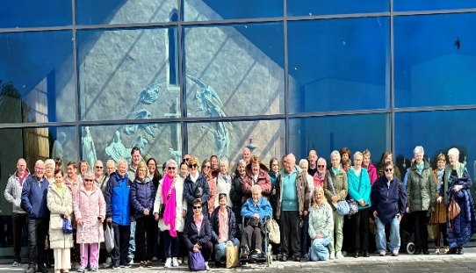
Our Parishes’ pilgrimage to Knock Shrine was very special and prayerful. We remembered everyone who supported the pilgrimage in any way, especially those who entrusted petitions to us. All petitions were brought before Our Lady at Knock and remembered throughout our Masses and prayers. We pray that Our Lady of Knock will continue to watch over all our parishioners and families with her loving care☘️


2026/27 Offertory Envelopes
If you have not received a box of envelopes for the current tax year and would like a box, please contact Catherine in the parish office or complete one of the forms in the porches after Mass and pop it in the wooden box at the Altar.
Thank you.

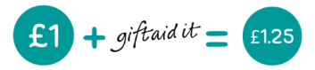
Making your donations go further with no extra cost to you!
Did you know you can GIFT AID your collections to the Parish? Donating through Gift Aid means we can claim an extra 25p for every £1 you give. It will not cost you any extra. If you pay tax, even a tiny amount on a small pension, we can claim an extra 25p in each £1 you donate to St Michael’s Parish.

Interested in hearing more? Call in or give us a call.

If you already contribute through the envelope system or by standing order and are a tax payer who would like to gift aid your donations please complete one of the gift aid declarations and return to the office.

